Assignment –5

Relational and Logical Operators.

Q.1 Write a query that will give you all orders for more than Rs. 1,000.

mysql> select \* from orders

-> where Amt > 1000;

+------+---------+------------+------+------+

| Onum | Amt | Odate | Cnum | Snum |

+------+---------+------------+------+------+

| 3002 | 1900.10 | 1990-10-03 | 2007 | 1004 |

| 3005 | 5160.45 | 1990-10-03 | 2003 | 1002 |

| 3006 | 1098.16 | 1990-10-03 | 2008 | 1007 |

| 3009 | 1713.23 | 1990-10-04 | 2002 | 1003 |

| 3008 | 4723.00 | 1990-10-05 | 2006 | 1001 |

| 3010 | 1309.95 | 1990-10-06 | 2004 | 1002 |

| 3011 | 9891.88 | 1990-10-06 | 2006 | 1001 |

+------+---------+------------+------+------+

7 rows in set (0.00 sec)

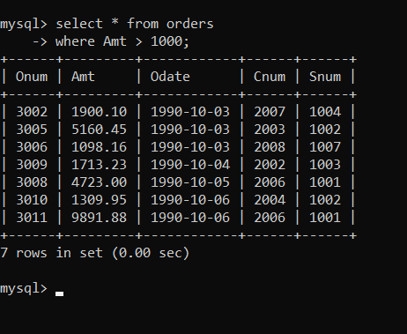

Q.2 Write a query that will give you the names and cities of all salespeople in London with a commission above .10.

mysql> select Sname,City from salespeople

-> where City = 'London'

-> AND Comm >.10;

+--------+--------+

| Sname | City |

+--------+--------+

| Peel | London |

| Motika | London |

+--------+--------+

2 rows in set (0.01 sec)

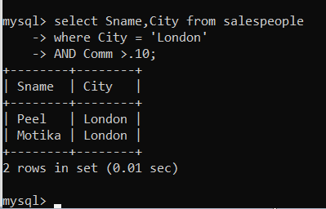

Q.3 Write a query on the Customers table whose output will exclude all customers with a rating <= 100, unless they are located in Rome.

where (Rating > 100) OR (City = 'Rome')' at line 1

mysql> select \* from customers

-> where (Rating > 100) OR (City = 'Rome');

+------+----------+----------+--------+------+

| Cnum | Cname | City | Rating | Snum |

+------+----------+----------+--------+------+

| 2002 | Giovanni | Rome | 200 | 1003 |

| 2003 | Liu | San Jose | 200 | 1002 |

| 2004 | Grass | Berlin | 300 | 1002 |

| 2008 | Cisneros | San Jose | 300 | 1007 |

| 2007 | Pereria | Rome | 100 | 1004 |

+------+----------+----------+--------+------+

5 rows in set (0.00 sec)

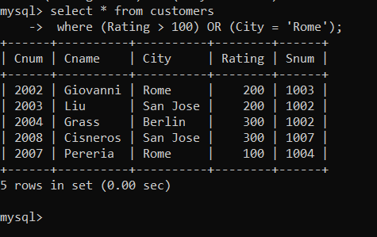

Q. 4 What will be the output from the following query? Select \* from Orders where (amt < 1000 OR NOT (odate = ‘1990-10-03’

mysql> select \* from orders

-> where(Amt < 1000 OR

-> NOT(Odate = '1990-10-03'

-> AND Cnum > 2003));

Answer:

+------+---------+------------+------+------+

| Onum | Amt | Odate | Cnum | Snum |

+------+---------+------------+------+------+

| 3001 | 18.69 | 1990-10-03 | 2008 | 1007 |

| 3003 | 767.19 | 1990-10-03 | 2001 | 1001 |

| 3005 | 5160.45 | 1990-10-03 | 2003 | 1002 |

| 3009 | 1713.23 | 1990-10-04 | 2002 | 1003 |

| 3007 | 75.75 | 1990-10-04 | 2004 | 1002 |

| 3008 | 4723.00 | 1990-10-05 | 2006 | 1001 |

| 3010 | 1309.95 | 1990-10-06 | 2004 | 1002 |

| 3011 | 9891.88 | 1990-10-06 | 2006 | 1001 |

+------+---------+------------+------+------+

8 rows in set (0.01 sec)

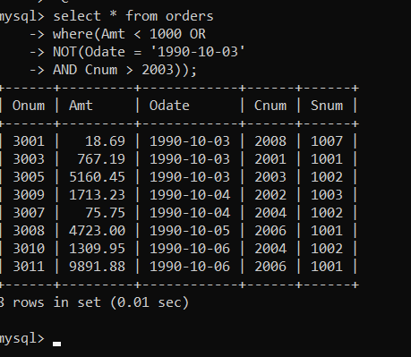

Q. 5 What will be the output of the following query? Select \* from Orders where NOT ((odate = ‘1990-10-03’ OR snum >1006) AND amt >= 1500);

Answer: mysql> select \* from Orders

-> where NOT ((Odate = '1990-10-03' OR Snum

-> >1006) AND Amt >=1500);

+------+---------+------------+------+------+

| Onum | Amt | Odate | Cnum | Snum |

+------+---------+------------+------+------+

| 3001 | 18.69 | 1990-10-03 | 2008 | 1007 |

| 3003 | 767.19 | 1990-10-03 | 2001 | 1001 |

| 3006 | 1098.16 | 1990-10-03 | 2008 | 1007 |

| 3009 | 1713.23 | 1990-10-04 | 2002 | 1003 |

| 3007 | 75.75 | 1990-10-04 | 2004 | 1002 |

| 3008 | 4723.00 | 1990-10-05 | 2006 | 1001 |

| 3010 | 1309.95 | 1990-10-06 | 2004 | 1002 |

| 3011 | 9891.88 | 1990-10-06 | 2006 | 1001 |

+------+---------+------------+------+------+

8 rows in set (0.00 sec)

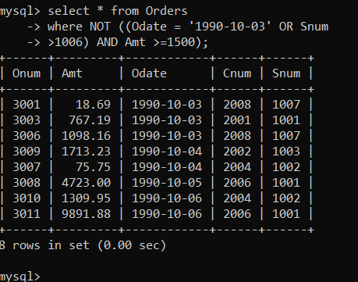

Q.6 What is a simpler way to write this query? Select snum, sname, city, comm From Salespeople where (comm > .12 OR comm<.14);

Answer: mysql> select Snum , Sname , City,Comm

-> from salespeople

-> where Comm NOT BETWEEN 0.12 AND 0.14;

+------+---------+-----------+------+

| Snum | Sname | City | Comm |

+------+---------+-----------+------+

| 1001 | Peel | London | 0.12 |

| 1004 | Motika | London | 0.11 |

| 1007 | Rifkin | Barcelona | 0.15 |

| 1003 | Axelrod | New York | 0.10 |

+------+---------+-----------+------+

4 rows in set (0.00 sec)

