Assignment –6

Using Special Operators in Conditions.

Q.1 Write two different queries that would produce all orders taken on October 3rd or 4th, 1990.

mysql> select \* from orders

-> where Odate='1990-10-03' OR Odate='1990-10-04';

+------+---------+------------+------+------+

| Onum | Amt | Odate | Cnum | Snum |

+------+---------+------------+------+------+

| 3001 | 18.69 | 1990-10-03 | 2008 | 1007 |

| 3003 | 767.19 | 1990-10-03 | 2001 | 1001 |

| 3002 | 1900.10 | 1990-10-03 | 2007 | 1004 |

| 3005 | 5160.45 | 1990-10-03 | 2003 | 1002 |

| 3006 | 1098.16 | 1990-10-03 | 2008 | 1007 |

| 3009 | 1713.23 | 1990-10-04 | 2002 | 1003 |

| 3007 | 75.75 | 1990-10-04 | 2004 | 1002 |

+------+---------+------------+------+------+

7 rows in set (0.00 sec)

mysql> select \* from orders

-> where Odate IN('1990-10-03','1990-10-04');

+------+---------+------------+------+------+

| Onum | Amt | Odate | Cnum | Snum |

+------+---------+------------+------+------+

| 3001 | 18.69 | 1990-10-03 | 2008 | 1007 |

| 3003 | 767.19 | 1990-10-03 | 2001 | 1001 |

| 3002 | 1900.10 | 1990-10-03 | 2007 | 1004 |

| 3005 | 5160.45 | 1990-10-03 | 2003 | 1002 |

| 3006 | 1098.16 | 1990-10-03 | 2008 | 1007 |

| 3009 | 1713.23 | 1990-10-04 | 2002 | 1003 |

| 3007 | 75.75 | 1990-10-04 | 2004 | 1002 |

+------+---------+------------+------+------+

7 rows in set (0.00 sec)

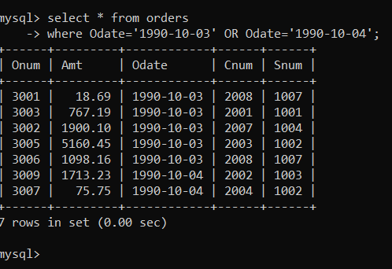

Q.2 Write a query that selects all of the customers serviced by Peel or Motika. (Hint: the snum field relates the two tables to one another).

Solution:

mysql> select c.\* from customers c

-> JOIN salespeople s ON c.Snum = s.Snum

-> where s.Sname IN ('Peel','Motika');

+------+---------+--------+--------+------+

| Cnum | Cname | City | Rating | Snum |

+------+---------+--------+--------+------+

| 2001 | Hoffman | London | 100 | 1001 |

| 2006 | Clemens | London | 100 | 1001 |

| 2007 | Pereria | Rome | 100 | 1004 |

+------+---------+--------+--------+------+

3 rows in set (0.01 sec)

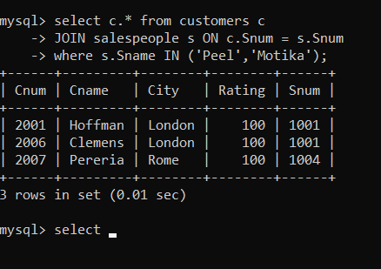

Q.3) Write a query that will produce all the customers whose names begin with a letter from ‘A’ to ‘G’.

Answer:

mysql> SELECT \*

-> FROM customers

-> WHERE Cname LIKE 'A%'

-> OR Cname LIKE 'B%'

-> OR Cname LIKE 'C%'

-> OR Cname LIKE 'D%'

-> OR Cname LIKE 'E%'

-> OR Cname LIKE 'F%'

-> OR Cname LIKE 'G%';

+------+----------+----------+--------+------+

| Cnum | Cname | City | Rating | Snum |

+------+----------+----------+--------+------+

| 2002 | Giovanni | Rome | 200 | 1003 |

| 2004 | Grass | Berlin | 300 | 1002 |

| 2006 | Clemens | London | 100 | 1001 |

| 2008 | Cisneros | San Jose | 300 | 1007 |

+------+----------+----------+--------+------+

4 rows in set (0.00 sec)

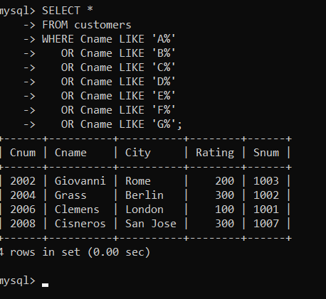

Q.4 Write a query that selects all customers whose names begin with the letter ‘C’.

mysql> select \* from customers

-> where Cname LIKE 'C%';

+------+----------+----------+--------+------+

| Cnum | Cname | City | Rating | Snum |

+------+----------+----------+--------+------+

| 2006 | Clemens | London | 100 | 1001 |

| 2008 | Cisneros | San Jose | 300 | 1007 |

+------+----------+----------+--------+------+

2 rows in set (0.00 sec)

Q.5) Write a query that selects all orders except those with zeroes or NULLs in the amt field.

mysql> select \* from orders

-> where Amt IS NOT NULL

-> AND Amt != 0;

+------+---------+------------+------+------+

| Onum | Amt | Odate | Cnum | Snum |

+------+---------+------------+------+------+

| 3001 | 18.69 | 1990-10-03 | 2008 | 1007 |

| 3003 | 767.19 | 1990-10-03 | 2001 | 1001 |

| 3002 | 1900.10 | 1990-10-03 | 2007 | 1004 |

| 3005 | 5160.45 | 1990-10-03 | 2003 | 1002 |

| 3006 | 1098.16 | 1990-10-03 | 2008 | 1007 |

| 3009 | 1713.23 | 1990-10-04 | 2002 | 1003 |

| 3007 | 75.75 | 1990-10-04 | 2004 | 1002 |

| 3008 | 4723.00 | 1990-10-05 | 2006 | 1001 |

| 3010 | 1309.95 | 1990-10-06 | 2004 | 1002 |

| 3011 | 9891.88 | 1990-10-06 | 2006 | 1001 |

+------+---------+------------+------+------+

10 rows in set (0.00 sec)

