Assignment –7

Summarizing Data with Aggregate Functions

Q.1) Write a query that counts all orders for October 3.

mysql> select count(*) from orders

-> where Odate = '1990-10-03';

+----------+

| count(*) |

+----------+

| 5 |

+----------+

1 row in set (0.00 sec)

Q.2) Write a query that counts the number of different non-NULL city values in the Customers table.

mysql> select count(DISTINCT City) AS distinct_cities_count

-> from customers

-> where City IS NOT NULL;

+-----------------------+

| distinct_cities_count |

+-----------------------+

| 4 |

+-----------------------+

1 row in set (0.01 sec)

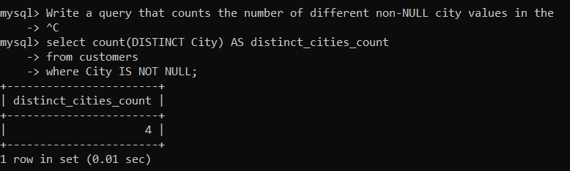

Q.3 Write a query that selects each customer’s smallest order.

mysql> select Cnum , MIN(Amt) AS smallest_order

-> from orders

-> group by Cnum;

+------+----------------+

| Cnum | smallest_order |

+------+----------------+

| 2008 | 18.69 |

| 2001 | 767.19 |

| 2007 | 1900.10 |

| 2003 | 5160.45 |

| 2002 | 1713.23 |

| 2004 | 75.75 |

| 2006 | 4723.00 |

+------+----------------+

7 rows in set (0.01 sec)

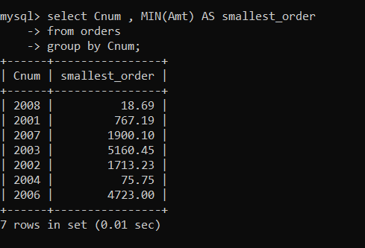

Q.4 Write a query that selects the first customer, in alphabetical order, whose name begins with G.

mysql> select * from customers

-> where Cname LIKE 'G%'

-> order by Cname

-> LIMIT 1;

+------+----------+------+--------+------+

| Cnum | Cname | City | Rating | Snum |

+------+----------+------+--------+------+

| 2002 | Giovanni | Rome | 200 | 1003 |

+------+----------+------+--------+------+

1 row in set (0.00 sec)

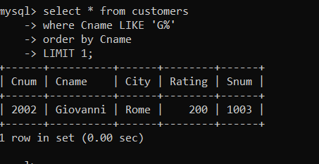

Q.5 Write a query that selects the highest rating in each city.

mysql> select City,MAX(Rating) AS highest_rating

-> from Customers

-> group by City;

+----------+----------------+

| City | highest_rating |

+----------+----------------+

| London | 100 |

| Rome | 200 |

| San Jose | 300 |

| Berlin | 300 |

+----------+----------------+

4 rows in set (0.00 sec)

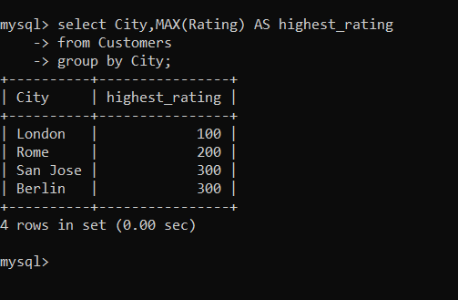

Q.6 Write a query that counts the number of salespeople registering orders for each day. (If a salesperson has more than one order on a given day, he or she should be counted only once.).

mysql> select Odate,Count(DISTINCT Snum) AS salespeople_count

-> from orders

-> GROUP BY Odate;

+------------+-------------------+

| Odate | salespeople_count |

+------------+-------------------+

| 1990-10-03 | 4 |

| 1990-10-04 | 2 |

| 1990-10-05 | 1 |

| 1990-10-06 | 2 |

+------------+-------------------+

4 rows in set (0.00 sec)