**Assignment –8**

**Formatting Query output**

1. Assume each salesperson has a 12% commission. Write a query on the orders table that will produce the order number, the salesperson number, and the amount of the salesperson’s commission for that order.

Answer : mysql> select Onum , Snum,(Amt * 0.12) as Commision from orders;

+------+------+-----------+

| Onum | Snum | Commision |

+------+------+-----------+

| 3001 | 1007 | 2.24 |

| 3003 | 1001 | 92.06 |

| 3002 | 1004 | 228.01 |

| 3005 | 1002 | 619.25 |

| 3006 | 1007 | 131.78 |

| 3009 | 1003 | 205.59 |

| 3007 | 1002 | 9.09 |

| 3008 | 1001 | 566.76 |

| 3010 | 1002 | 157.19 |

| 3011 | 1001 | 1187.03 |

+------+------+-----------+

10 rows in set (0.01 sec)

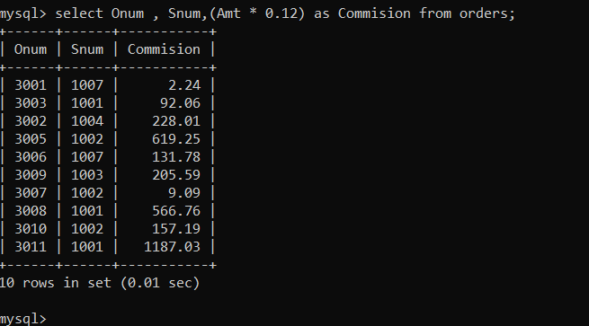

Q.2 Write a query on the Customers table that will find the highest rating in each city. Put the output in this form: For the city (city), the highest rating is : (rating).

mysql> select City,

-> CONCAT('for the city ',City ,', the highest rating is: ',MAX(Rating)) as HighestRating

-> from

-> customers

-> GROUP BY

-> City;

+----------+---------------------------------------------------+

| City | HighestRating |

+----------+---------------------------------------------------+

| London | for the city London, the highest rating is: 100 |

| Rome | for the city Rome, the highest rating is: 200 |

| San Jose | for the city San Jose, the highest rating is: 300 |

| Berlin | for the city Berlin, the highest rating is: 300 |

+----------+---------------------------------------------------+

4 rows in set (0.01 sec)

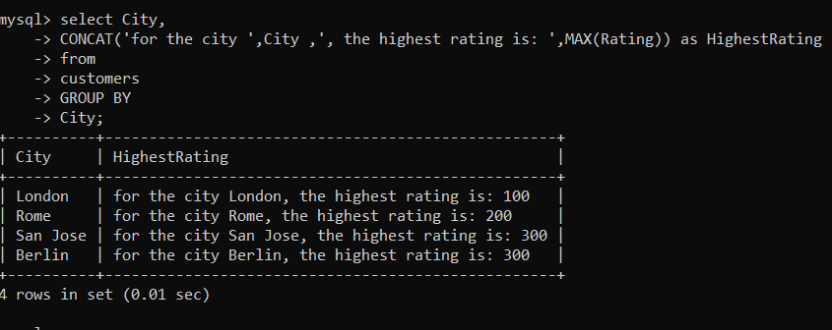

Q.3 Write a query that lists customers in descending order of rating. Output the rating field first, followed by the customer’s name and number.

mysql> select Rating,Cname,Cnum

-> from customers

-> ORDER BY Rating DESC;

+--------+----------+------+

| Rating | Cname | Cnum |

+--------+----------+------+

| 300 | Grass | 2004 |

| 300 | Cisneros | 2008 |

| 200 | Giovanni | 2002 |

| 200 | Liu | 2003 |

| 100 | Hoffman | 2001 |

| 100 | Clemens | 2006 |

| 100 | Pereria | 2007 |

+--------+----------+------+

7 rows in set (0.00 sec)

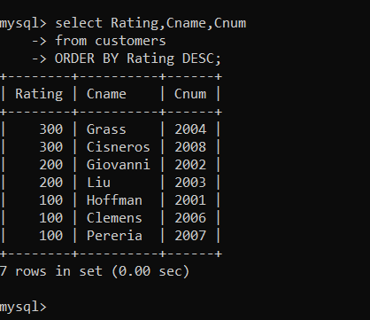

Q.4 Write a query that totals the orders for each day and places the results in descending order.

mysql> select Odate,SUM(Amt) As TotalAmount

-> from orders

-> GROUP BY Odate

-> ORDER BY TotalAmount DESC;

+------------+-------------+

| Odate | TotalAmount |

+------------+-------------+

| 1990-10-06 | 11201.83 |

| 1990-10-03 | 8944.59 |

| 1990-10-05 | 4723.00 |

| 1990-10-04 | 1788.98 |

+------------+-------------+

4 rows in set (0.00 sec)

