Assignment – 9

Querying Multiple Tables at Once

Q.1 Write a query that lists each order number followed by the name of the customer who made the order.

Answer:

mysql> select o.Onum , c.Cname

-> from orders o

-> JOIN customers c ON o.Cnum = c.Cnum;

+------+----------+

| Onum | Cname |

+------+----------+

| 3001 | Cisneros |

| 3003 | Hoffman |

| 3002 | Pereria |

| 3005 | Liu |

| 3006 | Cisneros |

| 3009 | Giovanni |

| 3007 | Grass |

| 3008 | Clemens |

| 3010 | Grass |

| 3011 | Clemens |

+------+----------+

10 rows in set (0.00 sec)

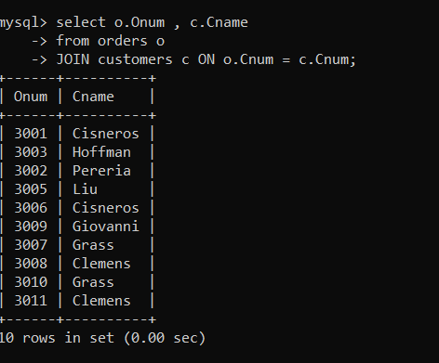

Q.2 Write a query that gives the names of both the salesperson and the customer for each order along with the order number.

mysql> select o.Onum, c.Cname AS CustomerName,

-> s.Sname AS SalespersonName

-> from orders o

-> JOIN customers c ON o.Cnum = c.Cnum

-> JOIN salespeople s ON o.Snum = s.Snum;

+------+--------------+-----------------+

| Onum | CustomerName | SalespersonName |

+------+--------------+-----------------+

| 3003 | Hoffman | Peel |

| 3009 | Giovanni | Axelrod |

| 3005 | Liu | Serres |

| 3010 | Grass | Serres |

| 3007 | Grass | Serres |

| 3011 | Clemens | Peel |

| 3008 | Clemens | Peel |

| 3006 | Cisneros | Rifkin |

| 3001 | Cisneros | Rifkin |

| 3002 | Pereria | Motika |

+------+--------------+-----------------+

10 rows in set (0.00 sec)

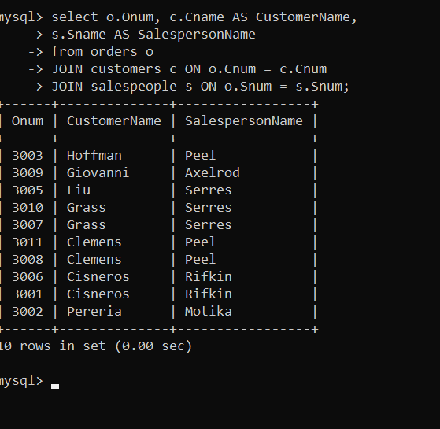

Q.3 Write a query that produces all customers serviced by salespeople with a commission above 12%. Output the customer’s name, the salesperson’s name, and the salesperson’s rate of commission.

mysql> select c.Cname AS CustomerName, s.Sname AS SalespersonName,

-> s.Comm AS CommisionRate

-> from customers c

-> JOIN salespeople s ON c.Snum = s.Snum

-> where s.Comm > 0.12;

+--------------+-----------------+---------------+

| CustomerName | SalespersonName | CommisionRate |

+--------------+-----------------+---------------+

| Liu | Serres | 0.13 |

| Grass | Serres | 0.13 |

| Cisneros | Rifkin | 0.15 |

+--------------+-----------------+---------------+

3 rows in set (0.01 sec)

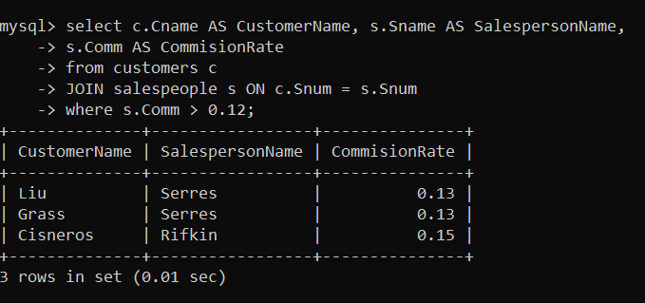

Q.4 Write a query that calculates the amount of the salesperson’s commission on each order by a customer with a rating above 100.

mysql> select o.Onum, c.Cname AS CustomerName,

-> s.Sname AS SalespersonName, o.Amt,

-> (o.Amt \* s.Comm) AS CommisionAmount

-> from orders o

-> JOIN customers c ON o.Cnum = c.Cnum

-> JOIN salespeople s ON o.Snum = s.Snum

-> where c.Rating > 100;

+------+--------------+-----------------+---------+-----------------+

| Onum | CustomerName | SalespersonName | Amt | CommisionAmount |

+------+--------------+-----------------+---------+-----------------+

| 3010 | Grass | Serres | 1309.95 | 170.29 |

| 3007 | Grass | Serres | 75.75 | 9.85 |

| 3005 | Liu | Serres | 5160.45 | 670.86 |

| 3006 | Cisneros | Rifkin | 1098.16 | 164.72 |

| 3001 | Cisneros | Rifkin | 18.69 | 2.80 |

| 3009 | Giovanni | Axelrod | 1713.23 | 171.32 |

+------+--------------+-----------------+---------+-----------------+

6 rows in set (0.00 sec)

