**Design Document**

**Homework 5**

IDS 517 Web Application for Team

**Team Name**: “The Three Musketeers”

**Team Members**: Prajakta Iyer (seat no. 6)

Sowmya Sankranthi(seat no. 11)

Kajol Shaikh(seat no. 13)

**Introduction**

In this project, we have converted our Homework 4 Project into a web application. This web Application is about the health care management. Here we have a clinic called medicare. The application allows Authorized roles to Login to the Application and access the confidential data, search through the information and edit patients,doctors,clerks(update/delete).

**Environment used**:

* Java Servlets and Java Server Pages (JSP)
* JDK version 1.8
* MySQL database 8.0
* Apache Tomcat Server 9.0
* Windows OS

We use **Eclipse IDE** with Maven to develop the project.

We have used **JSP servlets** to extend the application hosted by the web server which handles all the client requests.

**Server Configuration and Integration**

Apache Tomcat 9.0 server is installed using jre 1.8 and the server is integrated with the eclipse using the following link <https://ibytecode.com/blog/how-to-configure-apache-tomcat-in-eclipse-ide/>

**Database Design**

WellnessClinic database is used for the database connectivity and the following tables are populated to use in the project:

**User Management**

Create following tables:

User (Id,Name,Username,Password, Role_Id)

Doctor(Name,Qualification,Reg_id,specialization)

Clerk

Patient(Name,age,sex,height,weight,last_check_up_date)

Patient_History(ID,Disease,date,treatment,doctor,hospital)

Role(Role_name,Role_Id)

**Appointment Management**

Create following tables:

Appointment Table (Date,Time,doctor,Patinet_ID)

Create functions to display available date/time by doctor which can be viewed by patient/clerk.

Give the clerk , a page to open slots and add/remove  appointments.(Suppose they are cancelled on calls)

A page with list of patients should be visible to the clerk.

**Patient Details**

Patient should have a page to schedule an appointment.

Patient should be able to reschedule/cancel appointment.

Doctor should have a page to view patient list and on clicking a patient, he should be able to view history of the patient.

**Project Architecture**

We are using MVC architecture where JSP and HTML files are the VIEWS and ControllerServlet is the controller and ProductDAO is the model.

**Project Development**

A new Java web Application named IMS is created using eclipse IDE and deployed on Apache Tomcat. We used two model classes product.java and user.java which communicates with the Inventory database. We have Data Access Object classes such as ProductDAO.java which fetches data from the database and return to the servlet. Another class ControllerServlet.java is a controller class that manages requests and communicates with DAO layer.

**How to run the project:**

1. Load project into eclipse.
2. Build and Run the IMS web application on the server.

**Application Workflow**

After the IMS web application is run on the server, we will see a login page

**MediCare - Hospital management system project.**

Hospital management system project in java using jsp, servlet, Mysql and eclipse. We are using java as the core technology and Mysql as backend to manage the data records. Medicare is a web application which will help to manage the activity of an hospital Like Patient management, Doctor management, Manage appointments. Manage the records of patients.  
Our main business logic behind this application is to help automate and also speed up the existing processes at the hospitals to increase operational efficiency and improve patient outcomes.

The patient data collected over a period of time can be further used for various analysis and can give insights which prove to be helpful.

The main objective is to develop Hospital management system in java to manage the hospital activity online.

There will be Three main Actor/User of the application

1) Doctor

2) Admin

3) Clerk.

Medicare – web design is as below.

Homepage:



Login Page:

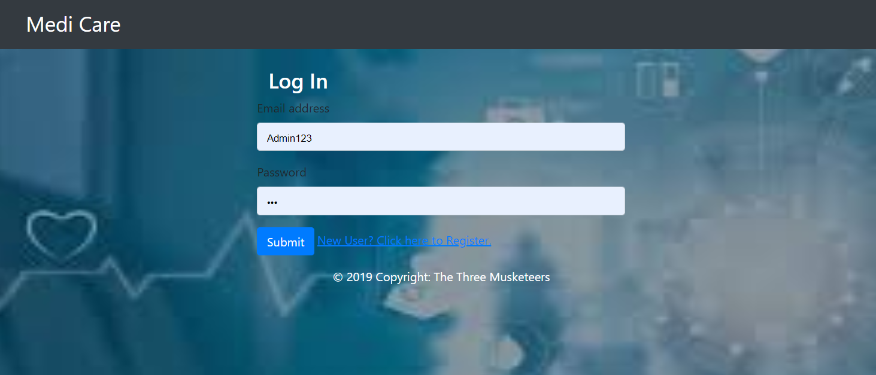

Contact us:

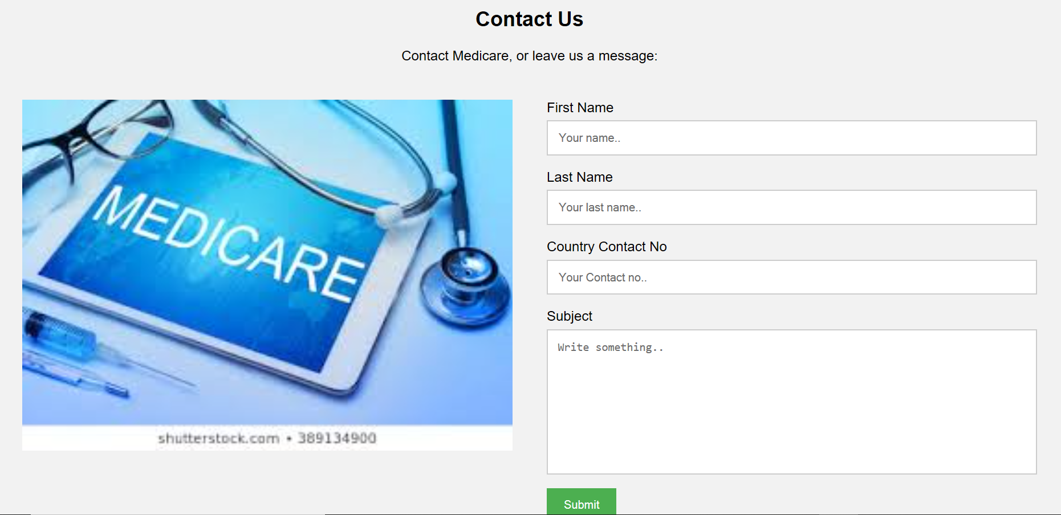

The login form enables different roles(doctors, admin, clerk) to logged in to the system where each of the roles can view/edit the following activities:

i) An admin can view the patient list, doctor list, clerk list and add/delete doctors, patients and clerks.

ii) A doctor can view the patients list and appointment list to check his schedule and corresponding patients.

iii) A clerk can see the patient list and add patient to schedule the appointments.

Following is the admin module which shows various functionalities that an admin can possess

(-----------admin-----------)

The edit option enables you to edit the information and save it.

(------edit------)

Add option enables you to add various roles

(----------add---------)

The following is the query result of the users table

(--------mysql-----)

Following is the doctor module which shows patient list according to the doctor name(--- doctor name---)

(---------doctor module------------)