283- Assignment 1

This document contains the screenshots of the output values read from the MSR to the system displaying if the value can be set or cleared.

Submitted By:

* Prajakta Joshi
* Umashankar Kumar

1. **MSR Name - IA32_VMX_PINBASED_CTLS**

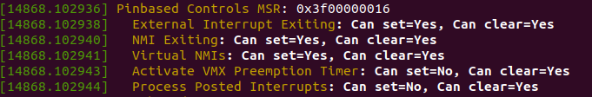

1. **MSR Name - IA32_VMX_PROCBASED_CTLS**

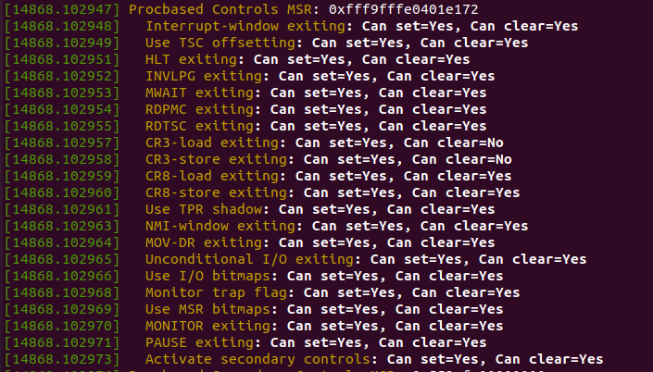

1. **MSR Name - IA32_VMX_PROCBASED_CTLS2**

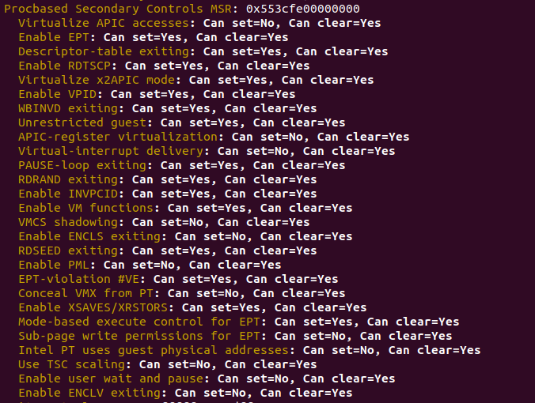

1. **MSR Name - IA32_VMX_EXIT_CTLS**

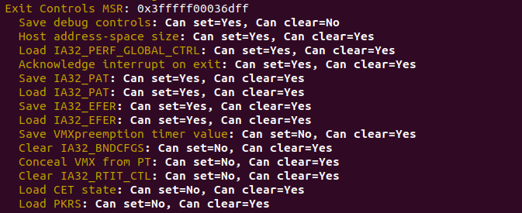

1. **MSR Name - IA32_VMX_ENTRY_CTLS**

