WEEK 3 PROJECT REPORT

Advanced Data Analysis and
Visualization in Logistics
E-Commerce Logistics Data Analytics and Delivery Optimization

Project detail | Description
Dataset | Brazilian E-Commerce Public Dataset by Olist (Kaggle)
Analysis environment | Python, Jupyter Notebook, pandas, NumPy, Matplotlib and Seaborn
Primary notebook | Logistics_Data_Analytics.ipynb
Exported script | Logistics_Data_Analytics.py
Main output directory | outputs/figures/
Analysis scope | Order, delivery, freight, regional, product, seller and customer review analysis

Executive Summary
This report presents an exploratory and advanced analytical review of the Olist Brazilian e-commerce dataset, with a focus on logistics performance, delivery reliability, freight costs, regional demand, product and seller performance, and customer satisfaction. The work uses the real public dataset rather than a simulated dataset; this is a documented adaptation of the task's data-simulation step.
The analysis covers 99,441 orders and 112,650 order-item records. Of the delivered orders, 96,470 had both actual and estimated delivery timestamps and were included in the delivery-performance analysis. The late-delivery rate in this analysed subset was 8.11%. Average actual delivery duration was 12.56 days, while the median was 10.22 days.
Customer review analysis showed an average score of 4.09 out of 5. Early-delivery orders had an average review score of 4.29, compared with 2.57 for late-delivery orders. This is a strong association between delivery performance and customer ratings, but it does not establish causation.
The analysis also found a moderate positive correlation between order item count and total freight (0.437), and between product revenue and freight (0.413). Product revenue and payment total were very strongly correlated (0.996), which is expected because payment totals generally include product value and freight. The findings support targeted delivery monitoring, regional service-level reviews, freight-cost investigation and seller-level performance monitoring.

1. Project Objective and Scope
The objective of Week 3 was to explore logistics-related data using Python, calculate descriptive statistics and correlations, create visualizations, interpret operational patterns, and derive evidence-based recommendations.
The analysis focused on the following questions:
- How do actual delivery times compare with estimated delivery dates?
- How are orders distributed over months, weekdays and hours?
- What patterns exist in freight costs and their relationship with product prices?
- Which customer states contribute the largest order volumes, and where are late-delivery rates higher?
- Which product categories and sellers contribute most to item volume and product revenue?
- How are delivery outcomes associated with customer review scores?
- What relationships exist among order size, product revenue, freight and payment totals?

2. Dataset Description and Structure
The analysis uses the Brazilian E-Commerce Public Dataset by Olist, a real-world public e-commerce dataset. The Week 3 task refers to data simulation and a hypothetical logistics dataset. Instead of creating synthetic records, this project uses the real Olist dataset and treats its order, item, payment, seller, customer and delivery fields as the logistics dataset. This distinction should be retained in any submission explanation.
The original data consists of nine CSV tables. The table below summarises their original row counts and analytical purpose.
Dataset | Original rows | Purpose / important fields
orders | 99,441 | Order status, purchase timestamp, approval, carrier handoff, customer delivery and estimated delivery timestamps.
order_items | 112,650 | Item-level seller, product, price and freight values for each order.
customers | 99,441 | Customer identifiers, ZIP prefix, city and state.
payments | 103,886 | Payment type, sequential payment records, installments and payment value.
reviews | 99,224 | Customer review score, title, message and review timestamps.
products | 32,951 | Product category and descriptive / physical attributes.
sellers | 3,095 | Seller identifiers and seller location fields.
geolocation | 1,000,163 | ZIP-prefix geolocation and latitude/longitude records.
category_translation | 71 | Portuguese product category names and English translations.

The analysis used the original source tables and the cleaned outputs created during Week 2. Geolocation had 261,831 exact duplicate rows removed, leaving 738,332 records in the cleaned geolocation output. Missing values in orders, products and reviews were retained where appropriate rather than being indiscriminately deleted. The cleaned outputs were validated during the prior preprocessing stage.
The delivered-order analysis included 96,470 records with non-null actual customer delivery and estimated delivery timestamps. Eight records from the delivered status group were excluded because an estimated delivery timestamp was missing. This denominator is used consistently for the reported delivery KPIs.

3. Tools and Analytical Methodology
Tool / technique | Use in this project
Python | Main programming language for data analysis and visualization.
pandas | Data loading, cleaning support, joins, grouping, aggregation and summary tables.
NumPy | Numerical operations and support for analytical calculations.
Matplotlib | Figure creation, labels, titles, annotations and saving plots.
Seaborn | Statistical plots, bar charts, scatter plots and correlation heatmaps.
Descriptive statistics | Mean, median, quartiles, minimum, maximum, counts and percentages.
GroupBy and aggregation | Monthly, weekday, hourly, state, category and seller summaries.
Correlation analysis | Pearson correlation coefficients for selected numerical variables.

Delivery duration was calculated as the difference between customer delivery timestamp and purchase timestamp. Delivery difference was calculated as actual customer delivery timestamp minus estimated delivery timestamp. Orders with a positive difference were classified as Late; negative differences were classified as Early; exact timestamp matches were classified as On Time.
For seller delivery analysis, order-level delivery outcomes were joined to order items by order_id. The resulting late-delivery rate is item-weighted: an order containing multiple items from the same seller contributes multiple item records. This is not the same as a distinct-order late rate.
For order-level correlation analysis, order items and payments were each aggregated by order_id before being merged. This avoids multiplying rows when an order contains multiple items and multiple payment records.

4. Exploratory Data Analysis and Findings

4.1 Python Implementation and Code Evidence
4.1.1 Data Loading and Preparation
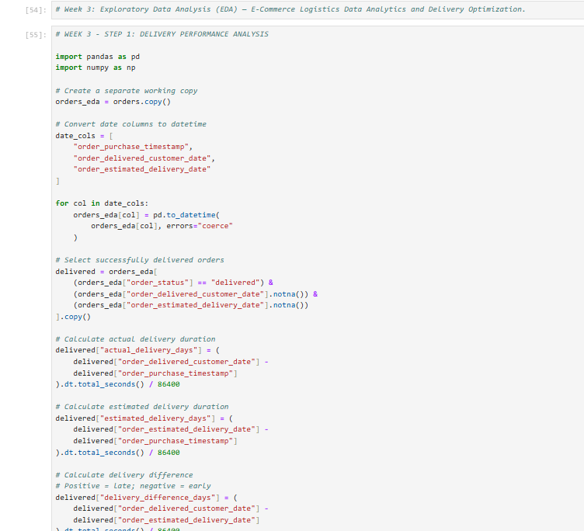
This code imports the required Python libraries and loads the cleaned Olist datasets into Pandas DataFrames. Initial checks are performed to understand the dataset structure and prepare the data for further analysis.

4.1.2 Delivery Performance Analysis
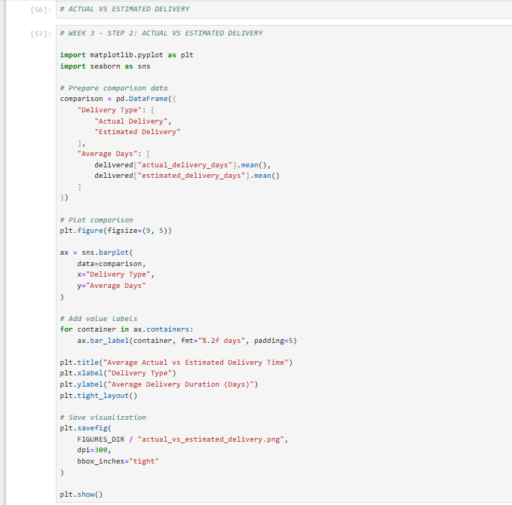
This code calculates actual delivery duration and compares actual delivery dates with estimated delivery dates. It identifies early and late deliveries and calculates the overall late-delivery rate to evaluate logistics performance.

4.1.3 EDA and Visualization
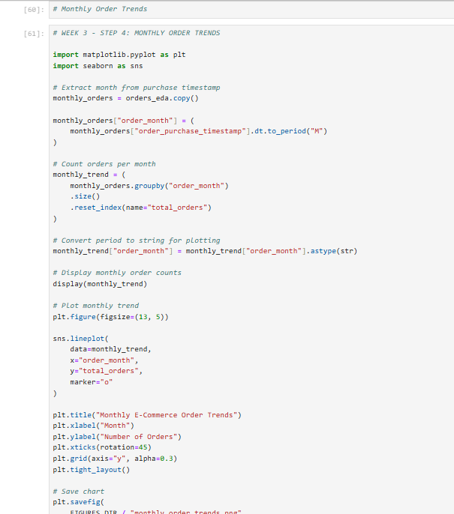

This code performs exploratory analysis of order trends, freight costs and regional delivery performance. It uses Matplotlib and Seaborn to create visualizations that help identify patterns, variations and potential areas for logistics improvement.

4.1.4 Customer Reviews and Correlation Analysis
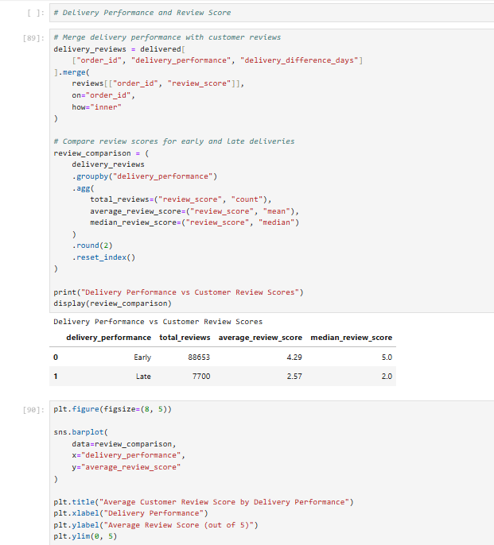
This code compares customer review scores for early and late deliveries and examines relationships between order value, freight cost, item quantity and payment value. The resulting visualizations help identify associations between logistics performance and customer satisfaction.

4.2 Delivery Performance
The delivered-order subset contained 96,470 orders. The average actual delivery duration was 12.56 days and the median was 10.22 days. The average estimated delivery duration was 23.74 days. The average signed difference between actual and estimated delivery was -11.18 days, indicating that deliveries were earlier than the estimate on average.
There were 7,826 late deliveries, producing a late-delivery rate of 8.11%. The remaining 88,644 records were classified as Early. No records had an exact timestamp match between actual and estimated delivery, so the On Time category had zero records under this strict timestamp definition.
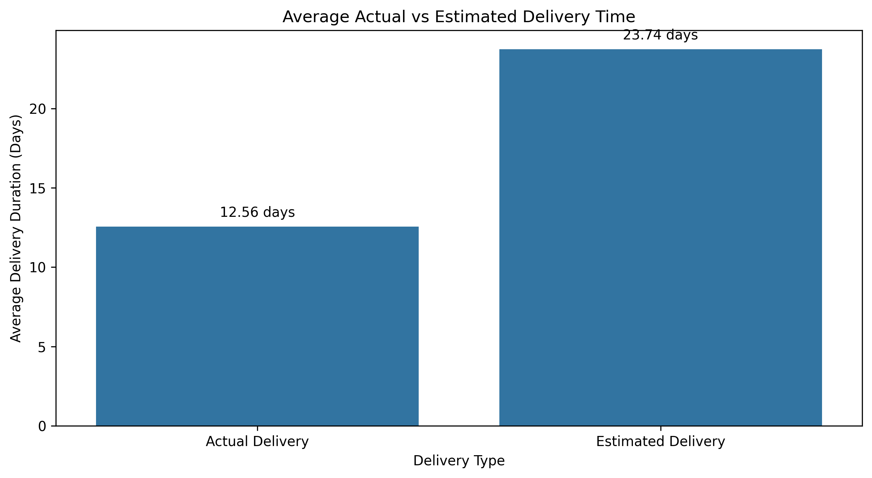Figure 1. Actual versus estimated delivery performance.
The distribution of delay duration among late deliveries was right-skewed. The mean delay was approximately 9.55 days and the median was approximately 5.81 days. The 75th percentile was approximately 11.82 days, while the maximum delay was approximately 188.98 days. The long upper tail indicates a small number of very delayed orders that warrant case-level investigation.
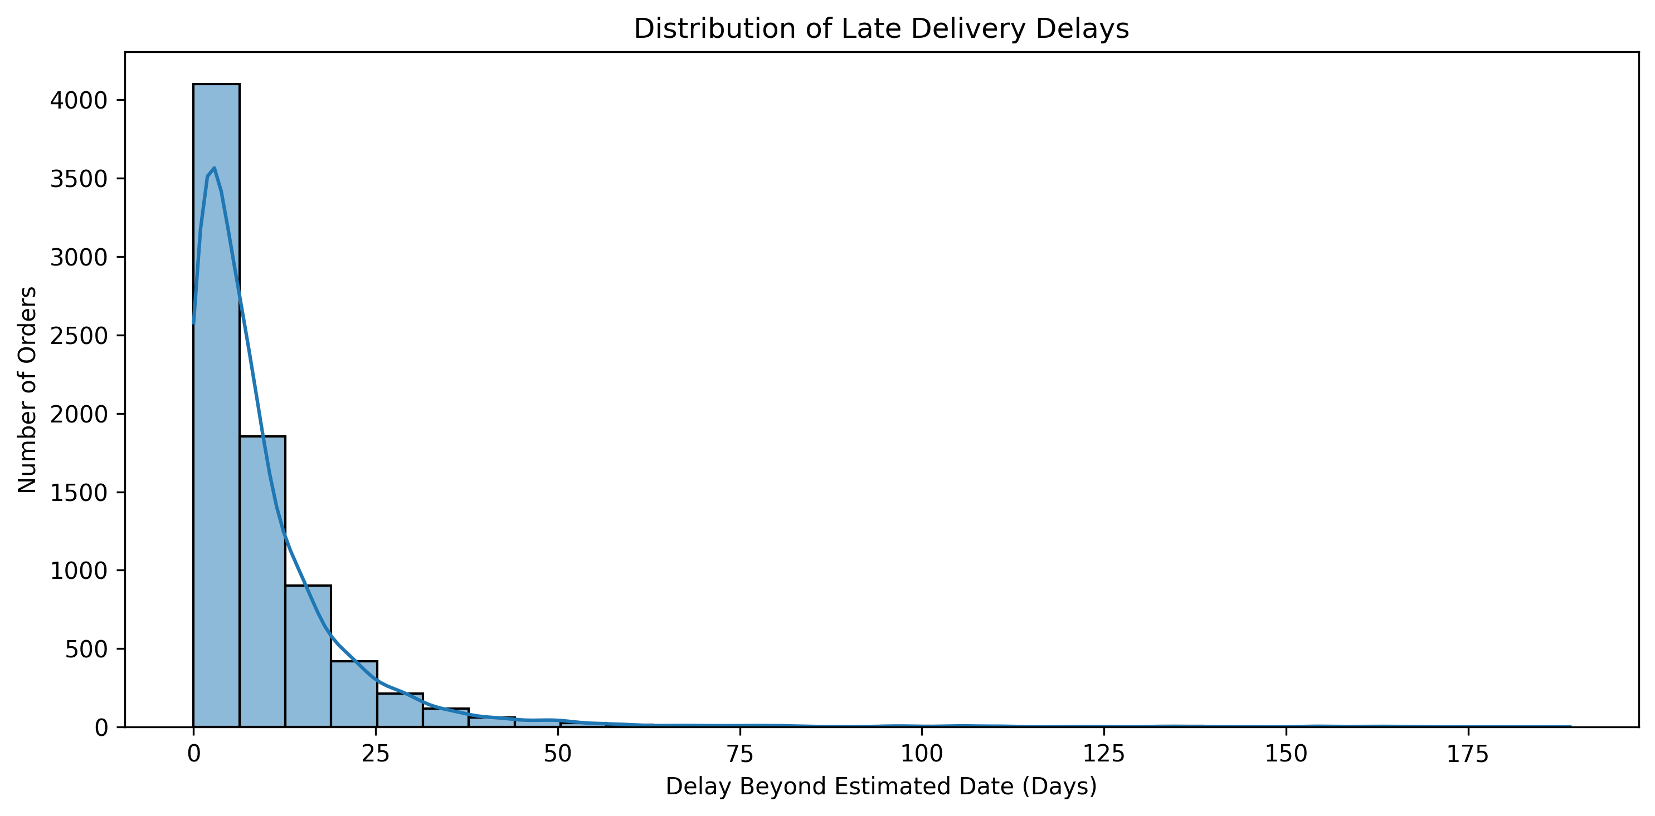Figure 2. Distribution of delivery delay duration for late orders.

4.3 Order Timing Trends
Monthly order counts reached a peak of 7,544 in November 2017, followed by 7,269 in January 2018. Order volume increased from 4,631 in October 2017 to 7,544 in November 2017. The dataset also contains sparse partial periods at the beginning and end of the observation window, so those months should not be treated as complete-month comparisons. The observed November increase is a pattern in the data; no specific promotional event or cause is inferred.
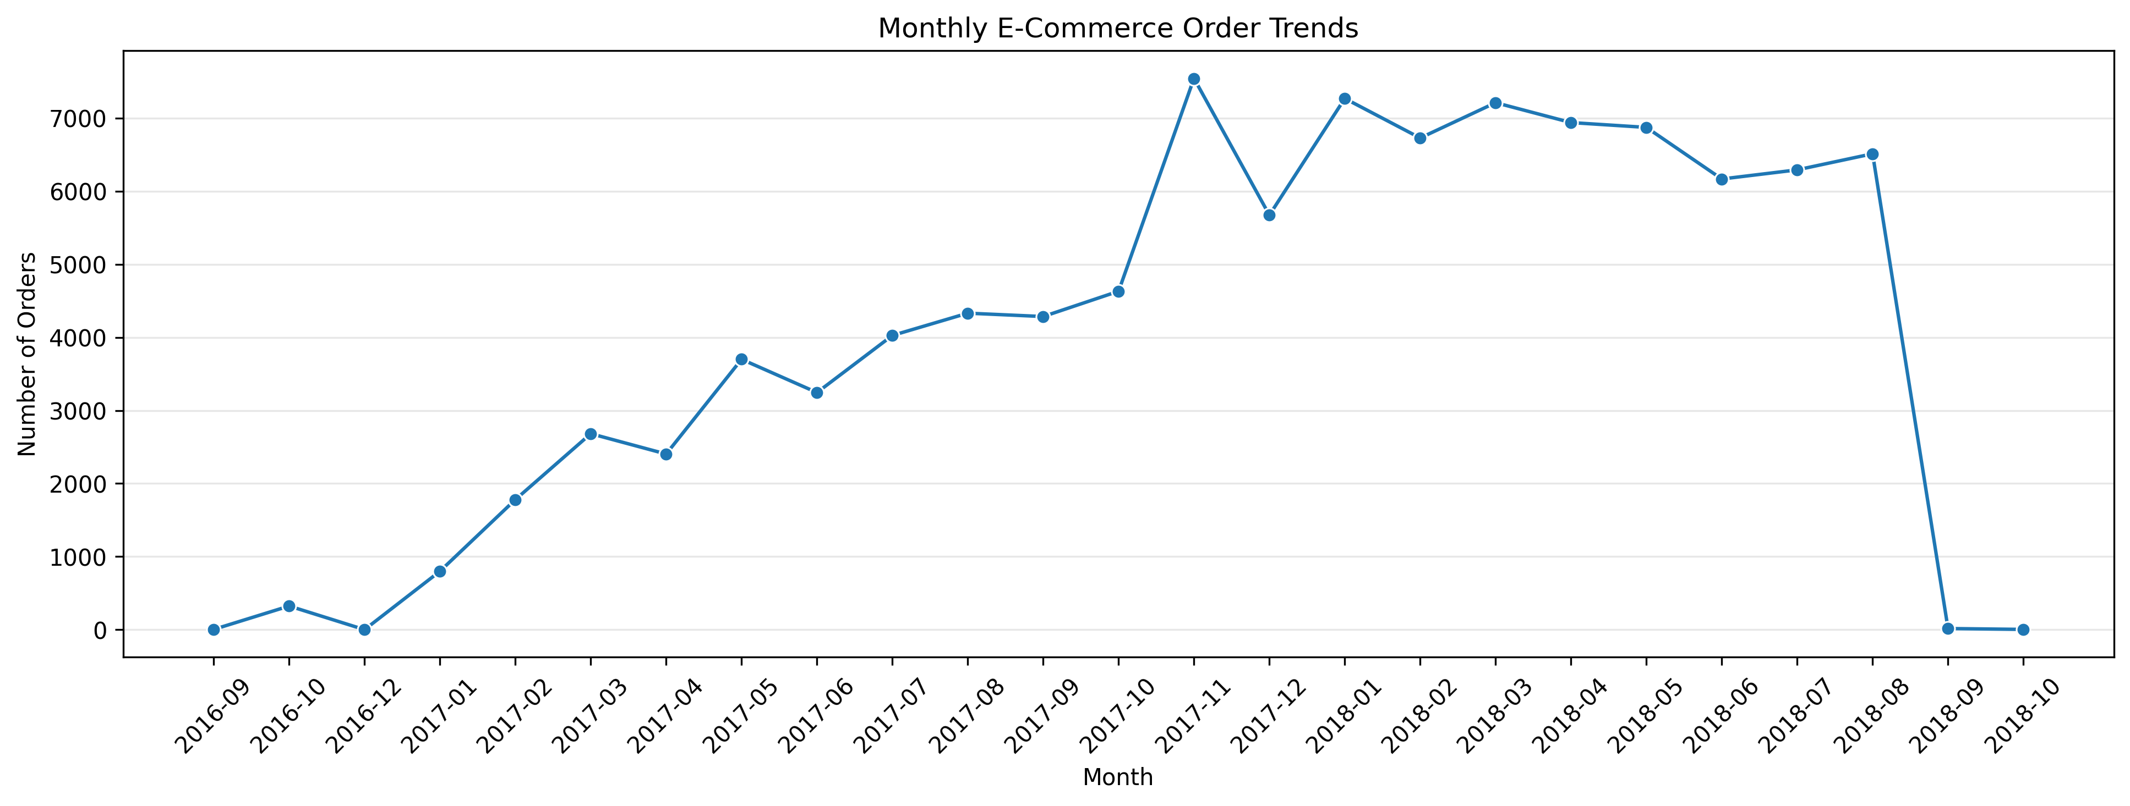Figure 3. Monthly order volume over the available observation period.
Monday had the highest order count (16,196), while Saturday had the lowest (10,887). This indicates higher recorded order activity on weekdays than weekends. These are purchase timestamps and should not be interpreted directly as warehouse dispatch or staffing records.
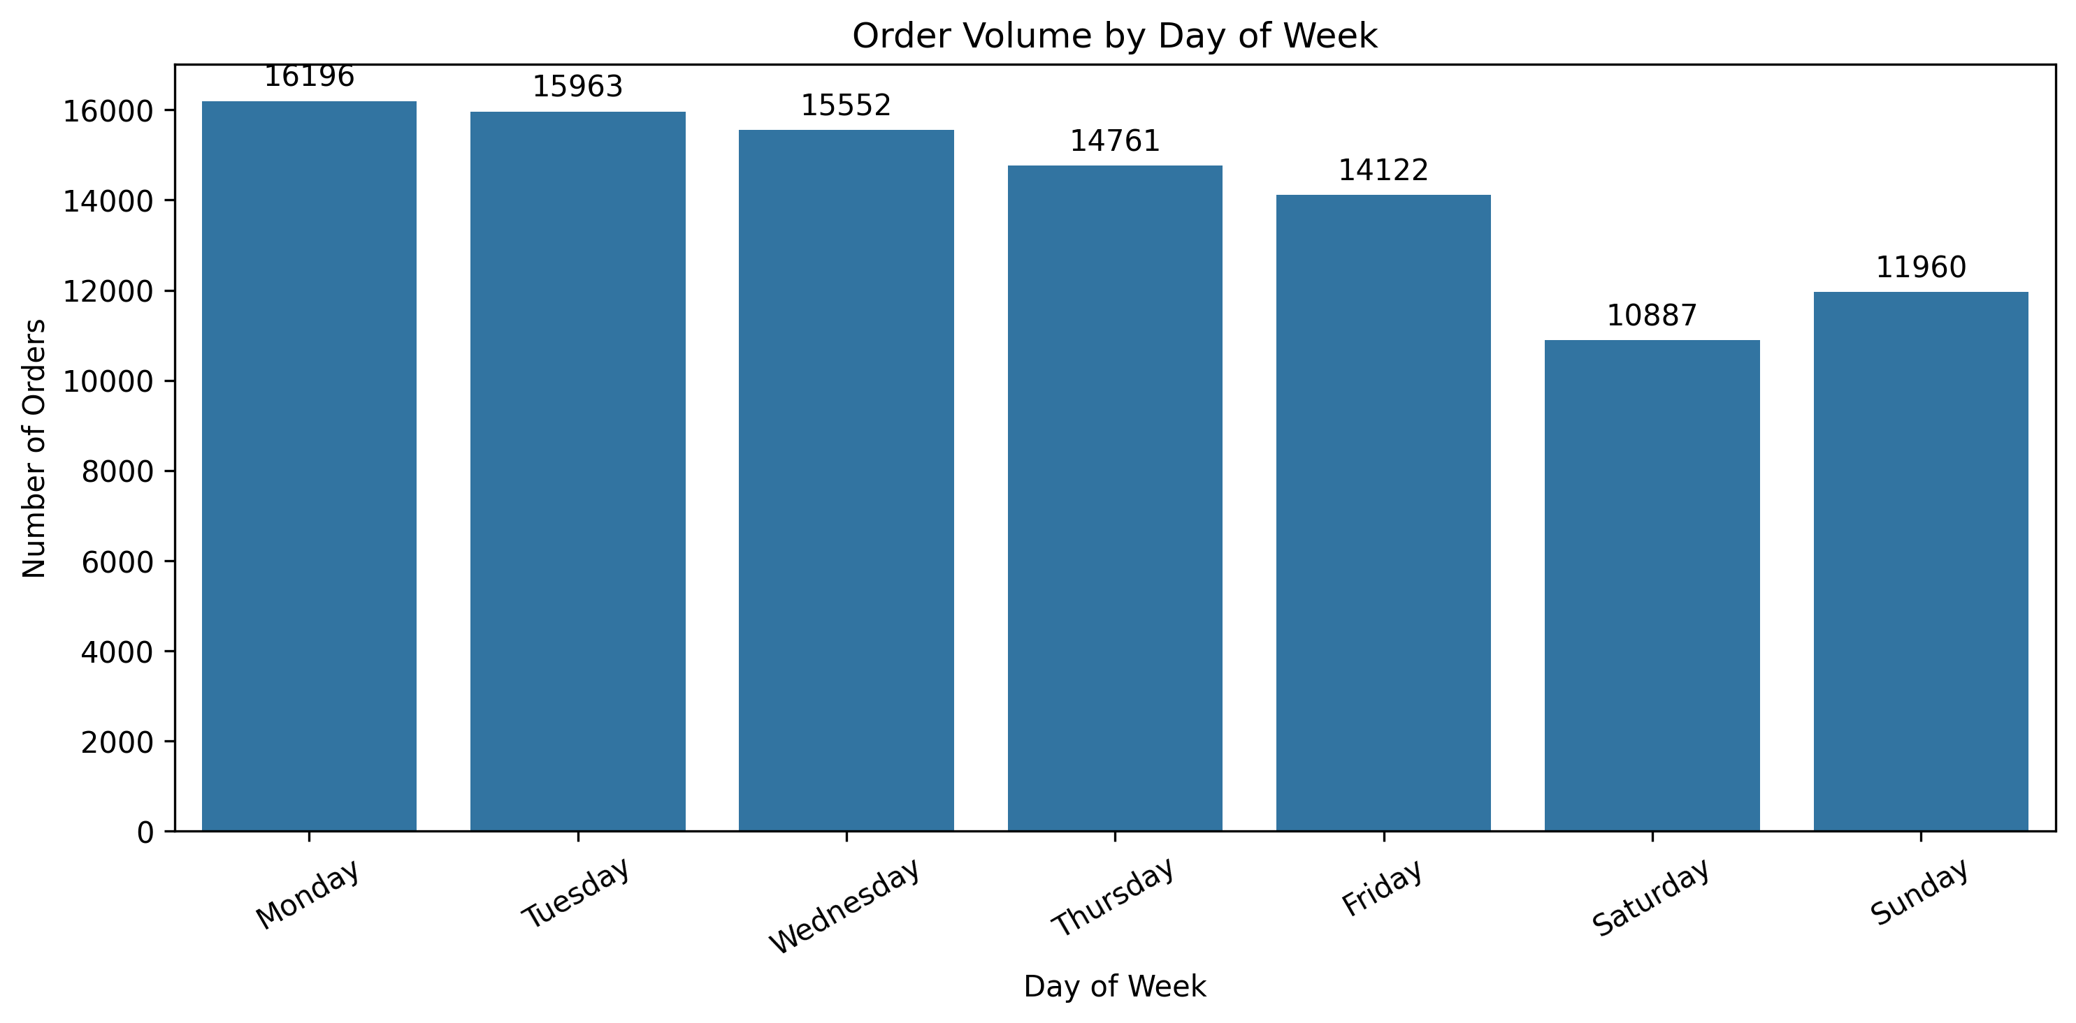Figure 4. Order count by weekday.
The busiest purchase hour was 16:00 with 6,675 orders, while 05:00 had the lowest volume with 188 orders. Activity was high from approximately 10:00 to 17:00, with substantial evening activity as well. These figures describe when customers placed orders, not when warehouse or carrier work occurred.
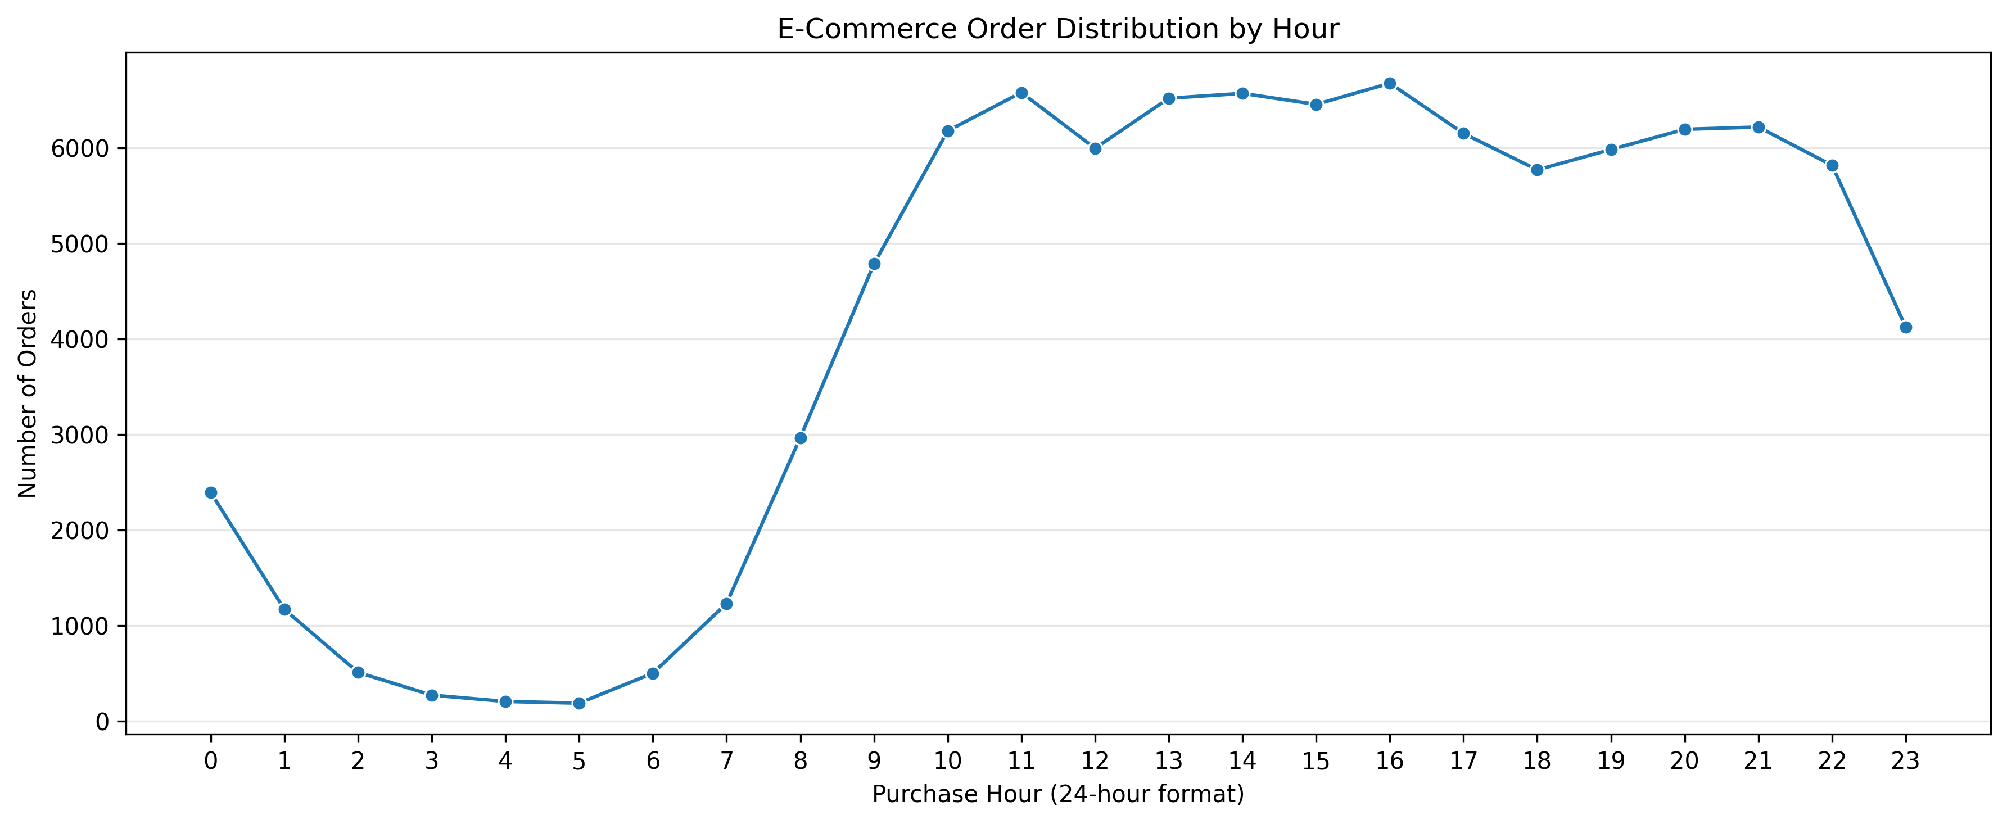Figure 5. Order count by hour of purchase.

4.4 Freight and Cost Analysis
At the order-item level, average freight value was 19.99 and median freight value was 16.26. The first and third quartiles were 13.08 and 21.15 respectively. Total freight value across order items was 2,251,909.54. The maximum observed item freight value was 409.68. The mean being higher than the median indicates a right-skewed distribution with some high freight values.
There were 383 order-item records with zero freight value. These records were retained for investigation rather than removed automatically. The amounts are reported in the dataset's Brazilian currency context (BRL); they are not Indian rupees.
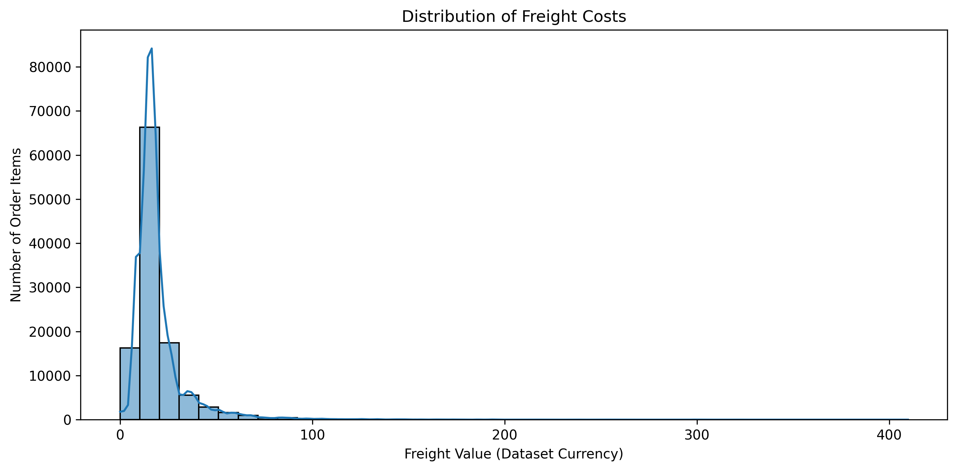Figure 6. Distribution of item-level freight values..
The Pearson correlation between item price and item freight value was approximately 0.414, indicating a moderate positive linear association. Higher-priced items tend to be associated with higher freight values in this dataset, but price alone does not explain freight cost. Product weight, dimensions, origin-destination distance and other operational factors may also matter, but these were not established as causes in this analysis.
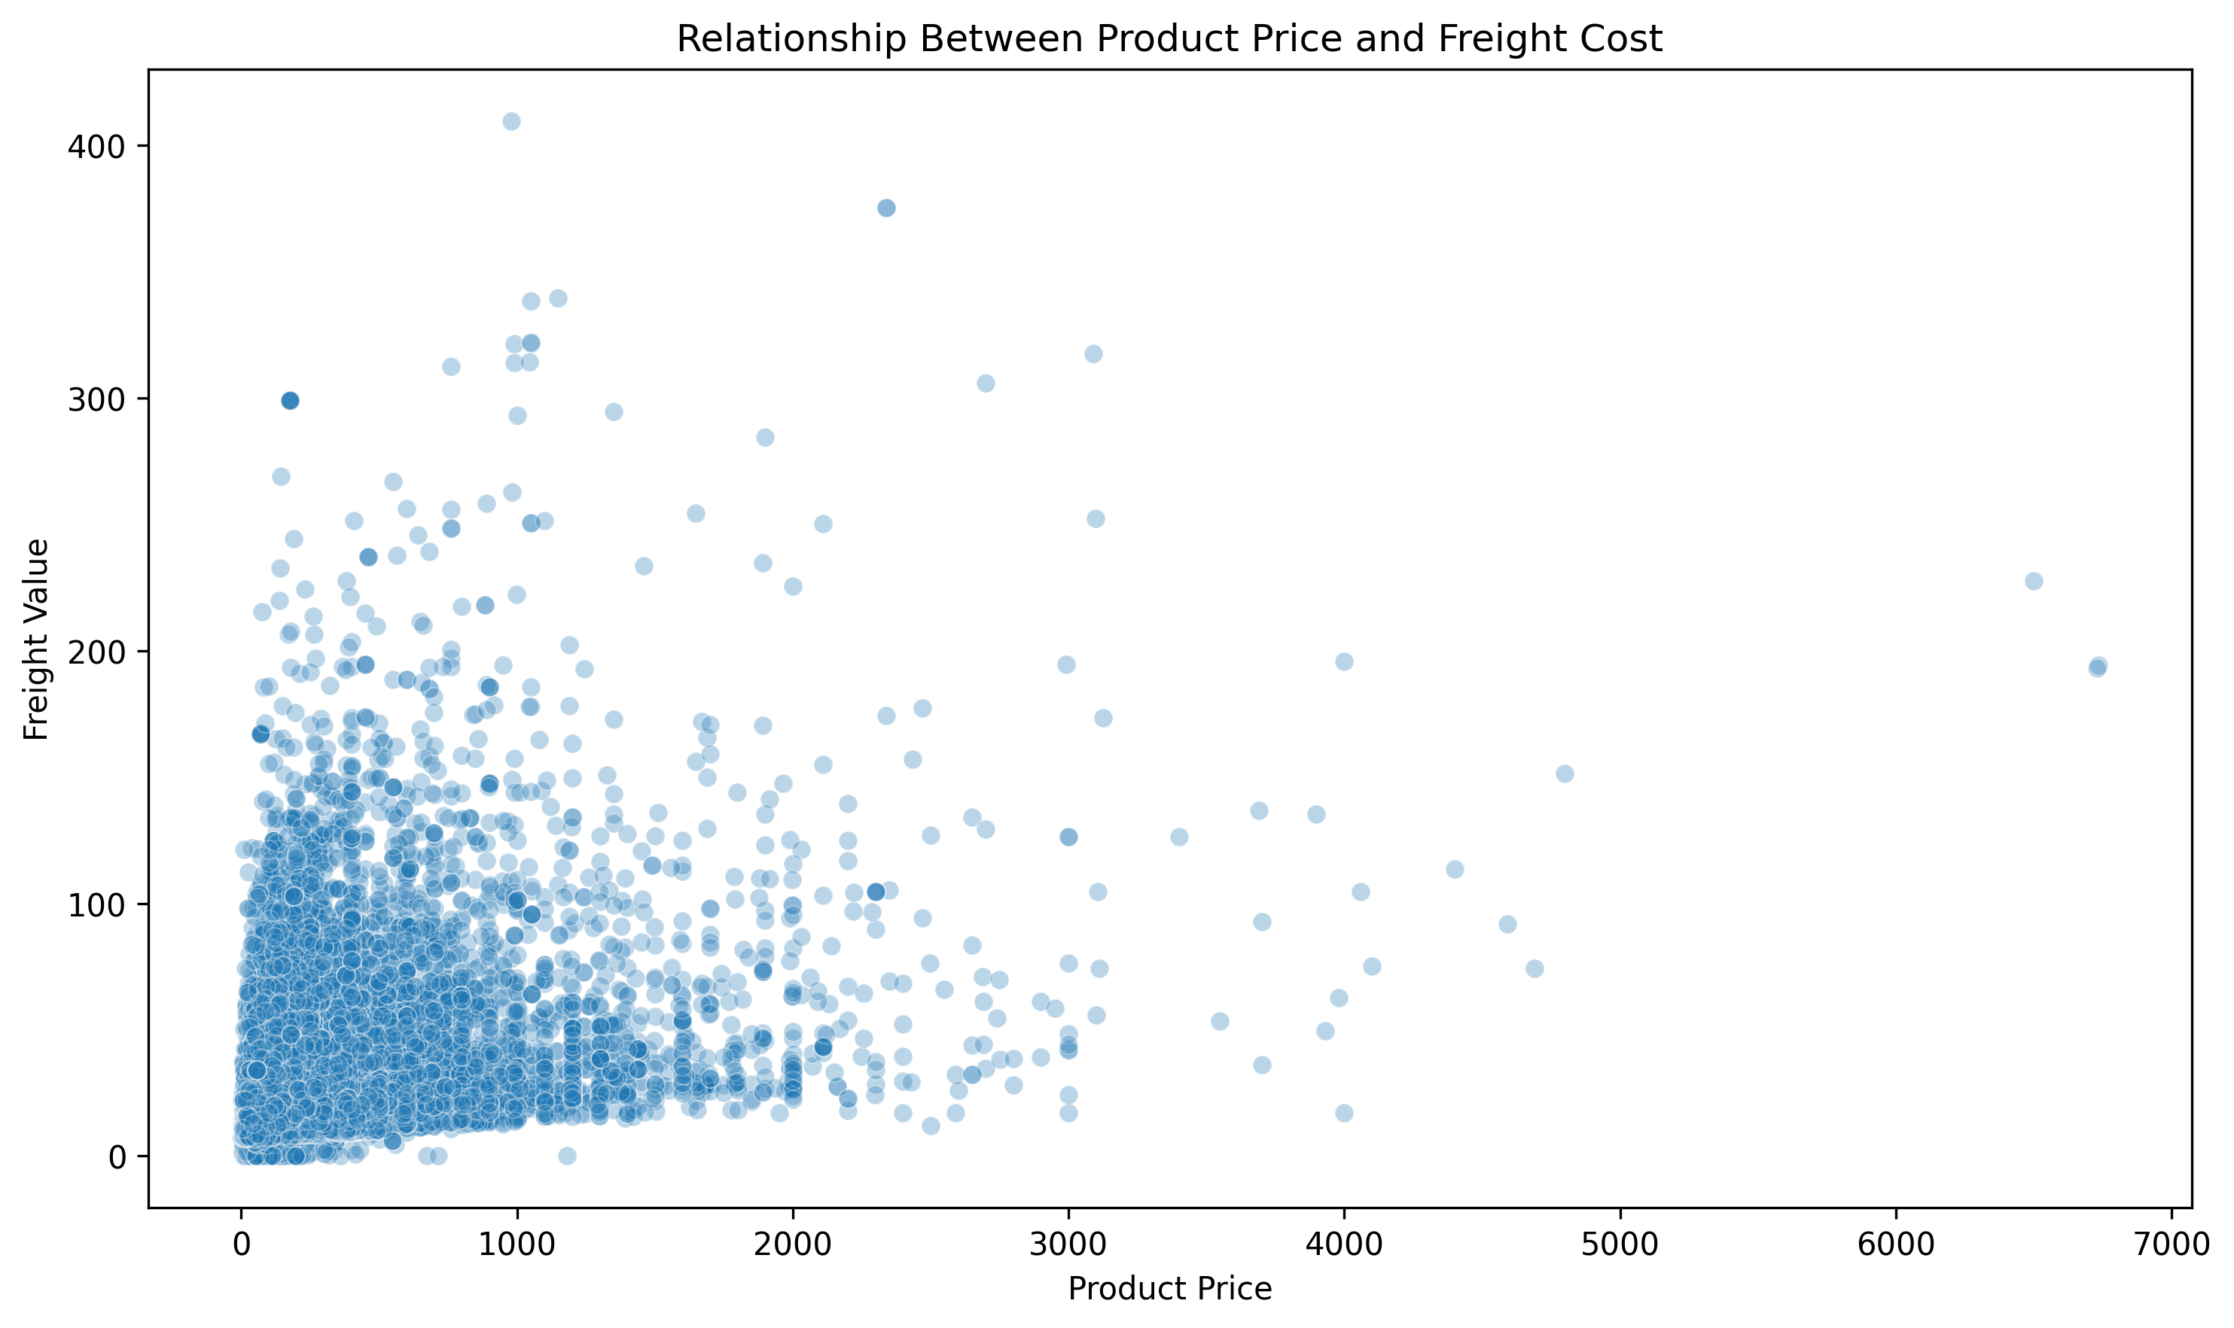Figure 7. Relationship between item price and freight value.

4.5 Regional Analysis
Customer order volume was concentrated in a few states. São Paulo (SP) had 41,746 orders, followed by Rio de Janeiro (RJ) with 12,852 and Minas Gerais (MG) with 11,635. SP accounted for approximately 42.0% of all orders, while the three leading states together accounted for approximately 66.5%. This concentration is relevant to regional capacity planning and service monitoring.
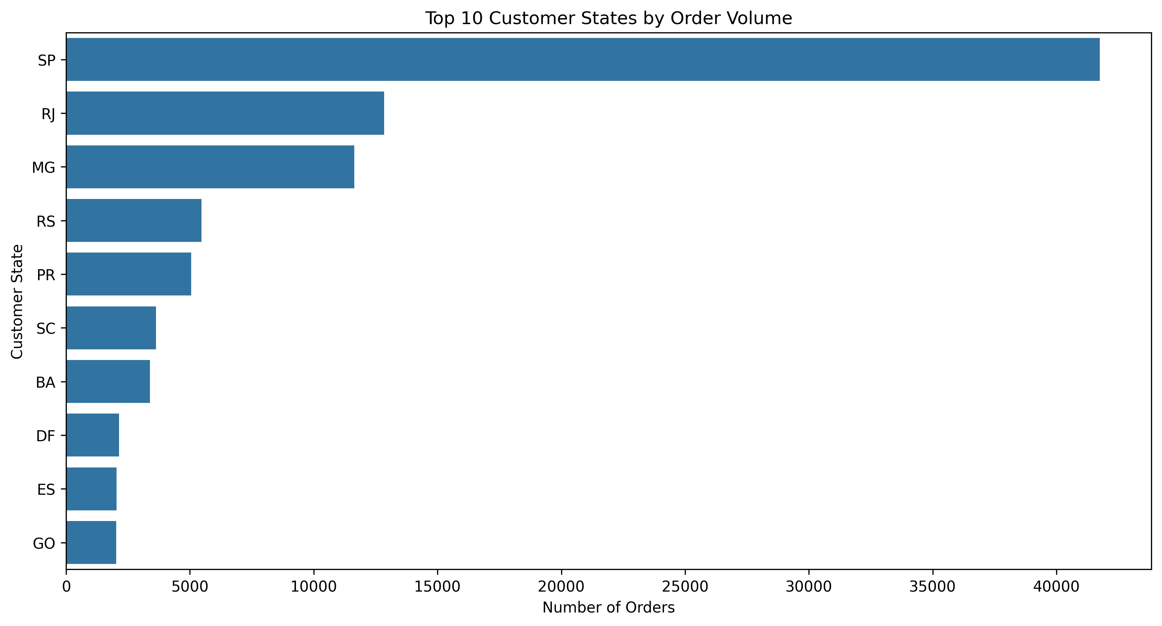Figure 8. Top ten customer states by order volume.
Among the higher-volume states, late-delivery rates varied. For example, SP had 5.89%, RJ 13.47%, MG 5.61%, BA 14.04% and ES 12.23%. When considering states with at least 100 analysed delivered orders, AL had the highest observed late-delivery rate at 23.93% (397 delivered orders, 95 late), followed by MA at 19.67% (717 delivered orders, 141 late). These state-level differences identify areas for further investigation; they do not by themselves identify the operational cause.
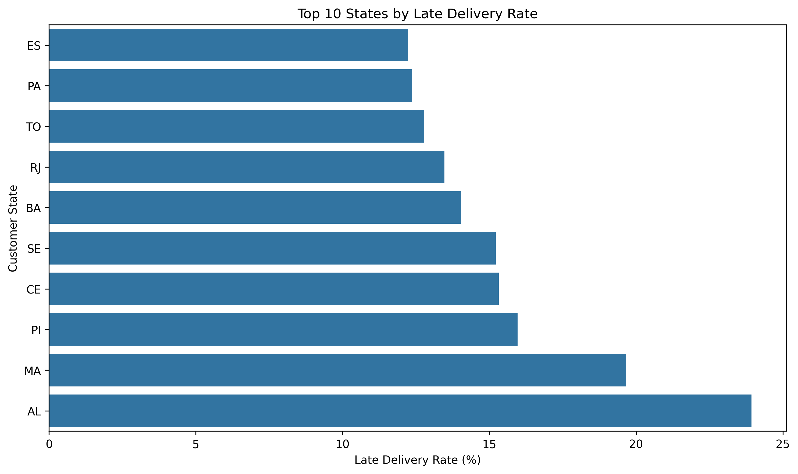Figure 9. State-wise late-delivery rates.

4.6 Product Category Analysis
The product-category analysis covered 112,650 order-item records across 72 category groups, including an Unknown category where an English translation was unavailable. Bed Bath Table had the highest item volume with 11,115 items. Health Beauty generated the highest product revenue at 1,258,681.34, followed by Watches Gifts at 1,205,005.68. Watches Gifts had a higher average item price (201.14) than Bed Bath Table (93.30).
Revenue rankings differed from item-volume rankings. Watches Gifts ranked second in revenue but seventh in item volume, while Cool Stuff ranked seventh in revenue and tenth in volume. This indicates that some categories generate more revenue per item than their volume rank alone would suggest. Product revenue is the sum of item prices; it is not profit and excludes freight.
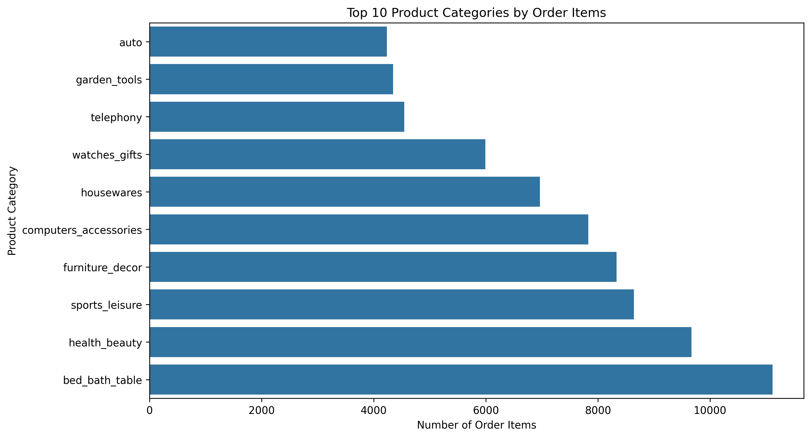Figure 10. Top product categories by item volume.
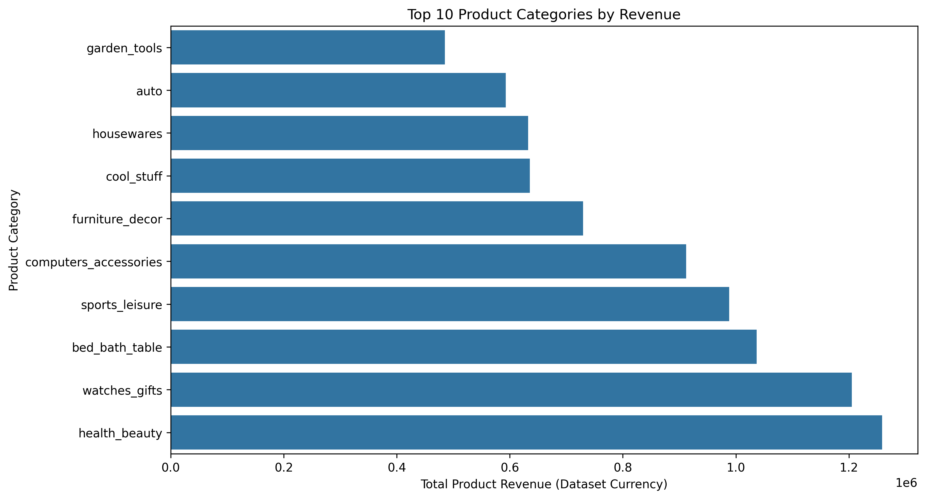Figure 11. Top product categories by product revenue.

4.7 Seller Performance
The dataset contained 3,095 sellers represented in the order-item data. The top ten sellers by product revenue generated 1,787,241.74, approximately 13.15% of total product revenue (13,591,643.70). The top 50 sellers contributed approximately 32.89% of product revenue. This indicates that product revenue was distributed across a broad seller base rather than being dominated by a small number of sellers.
The top-ten revenue sellers showed different item-weighted late-delivery rates. For example, one leading seller had an 11.59% rate, while another had 4.00%. The delivery metric is item-weighted after joining order-level delivery records to item records. It should be used as a screening signal, not as proof that the seller caused a delay, because carrier, distance, product and other factors may affect delivery.
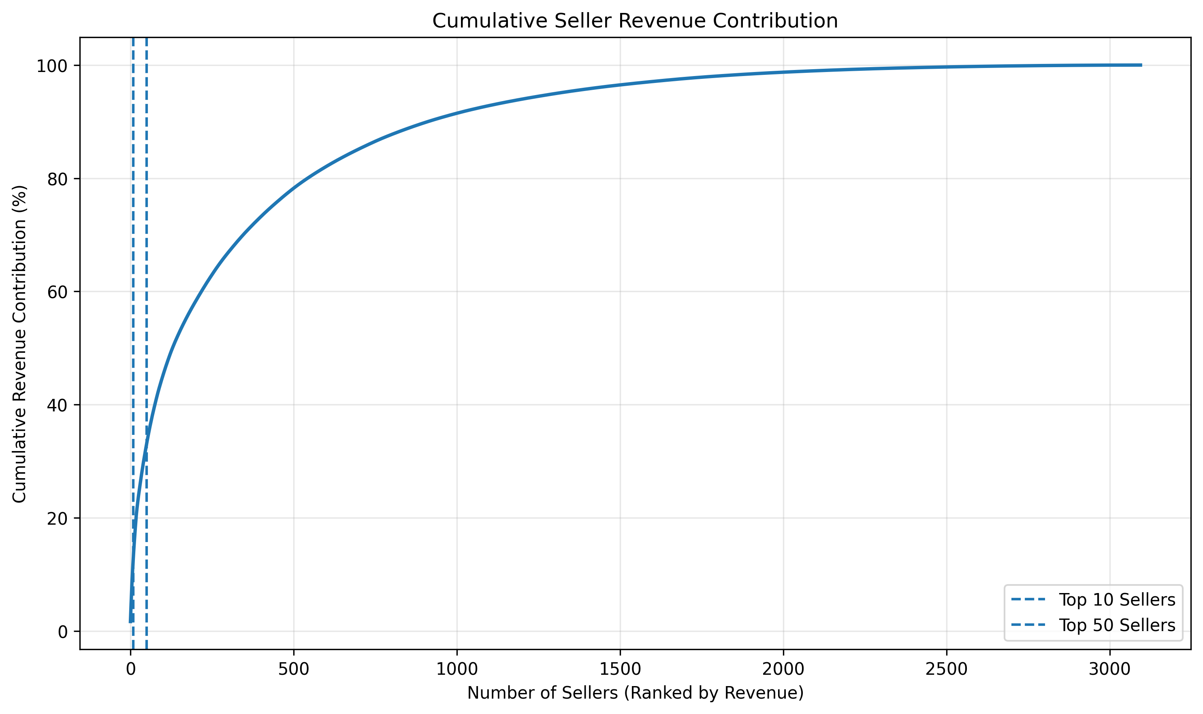Figure 12. Cumulative product revenue contribution by leading sellers.
.
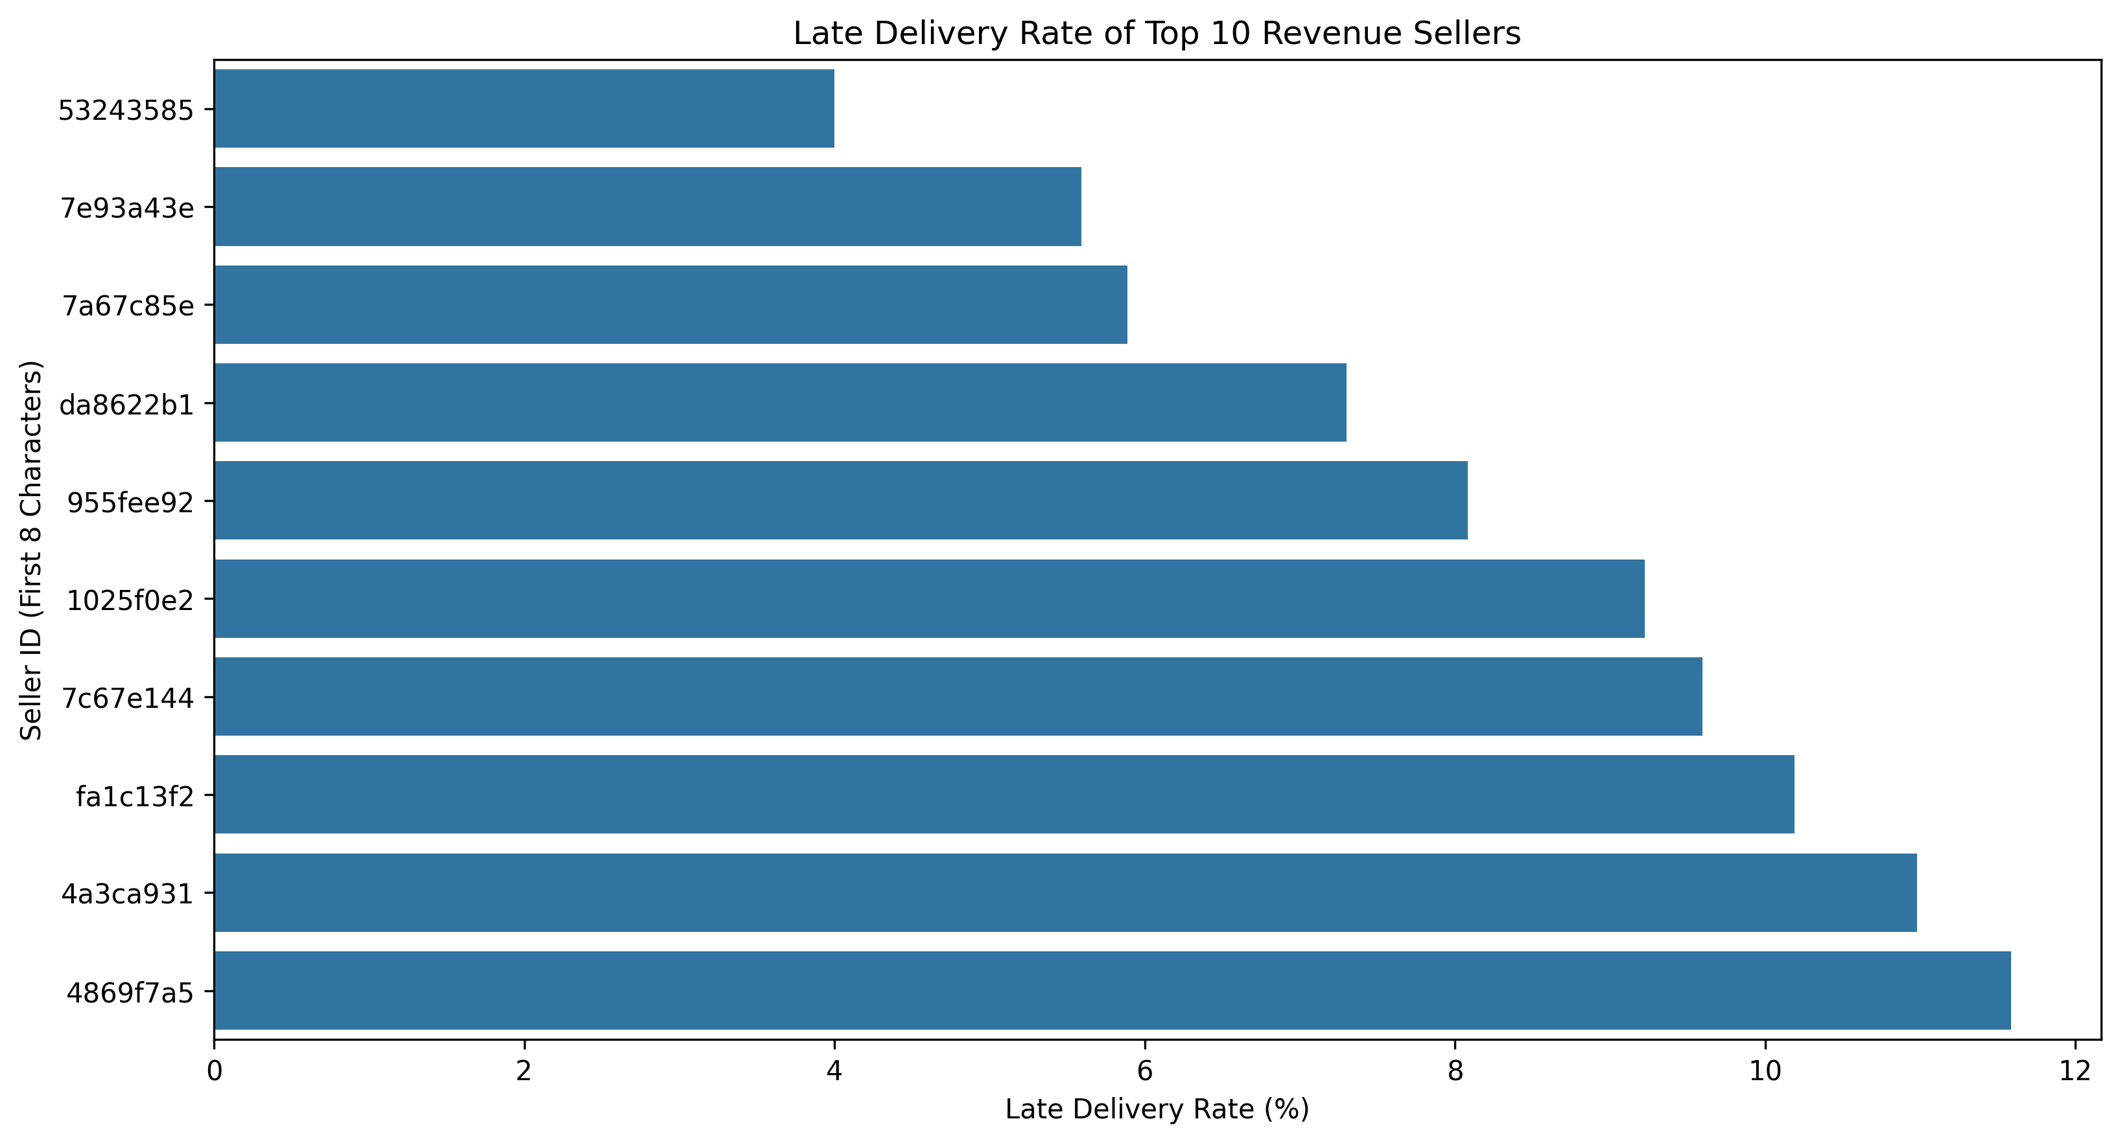Figure 13. Item-weighted late-delivery rates among the top ten revenue sellers.

4.8 Customer Satisfaction and Delivery
Across 99,224 reviews, the average review score was 4.09 and the median was 5. A total of 57.78% of reviews were five-star and 77.07% were four- or five-star. Reviews with scores of one or two represented 14.69% of the total.
Review score | Review count | Share
1 | 11,424 | 11.51%
2 | 3,151 | 3.18%
3 | 8,179 | 8.24%
4 | 19,142 | 19.29%
5 | 57,328 | 57.78%

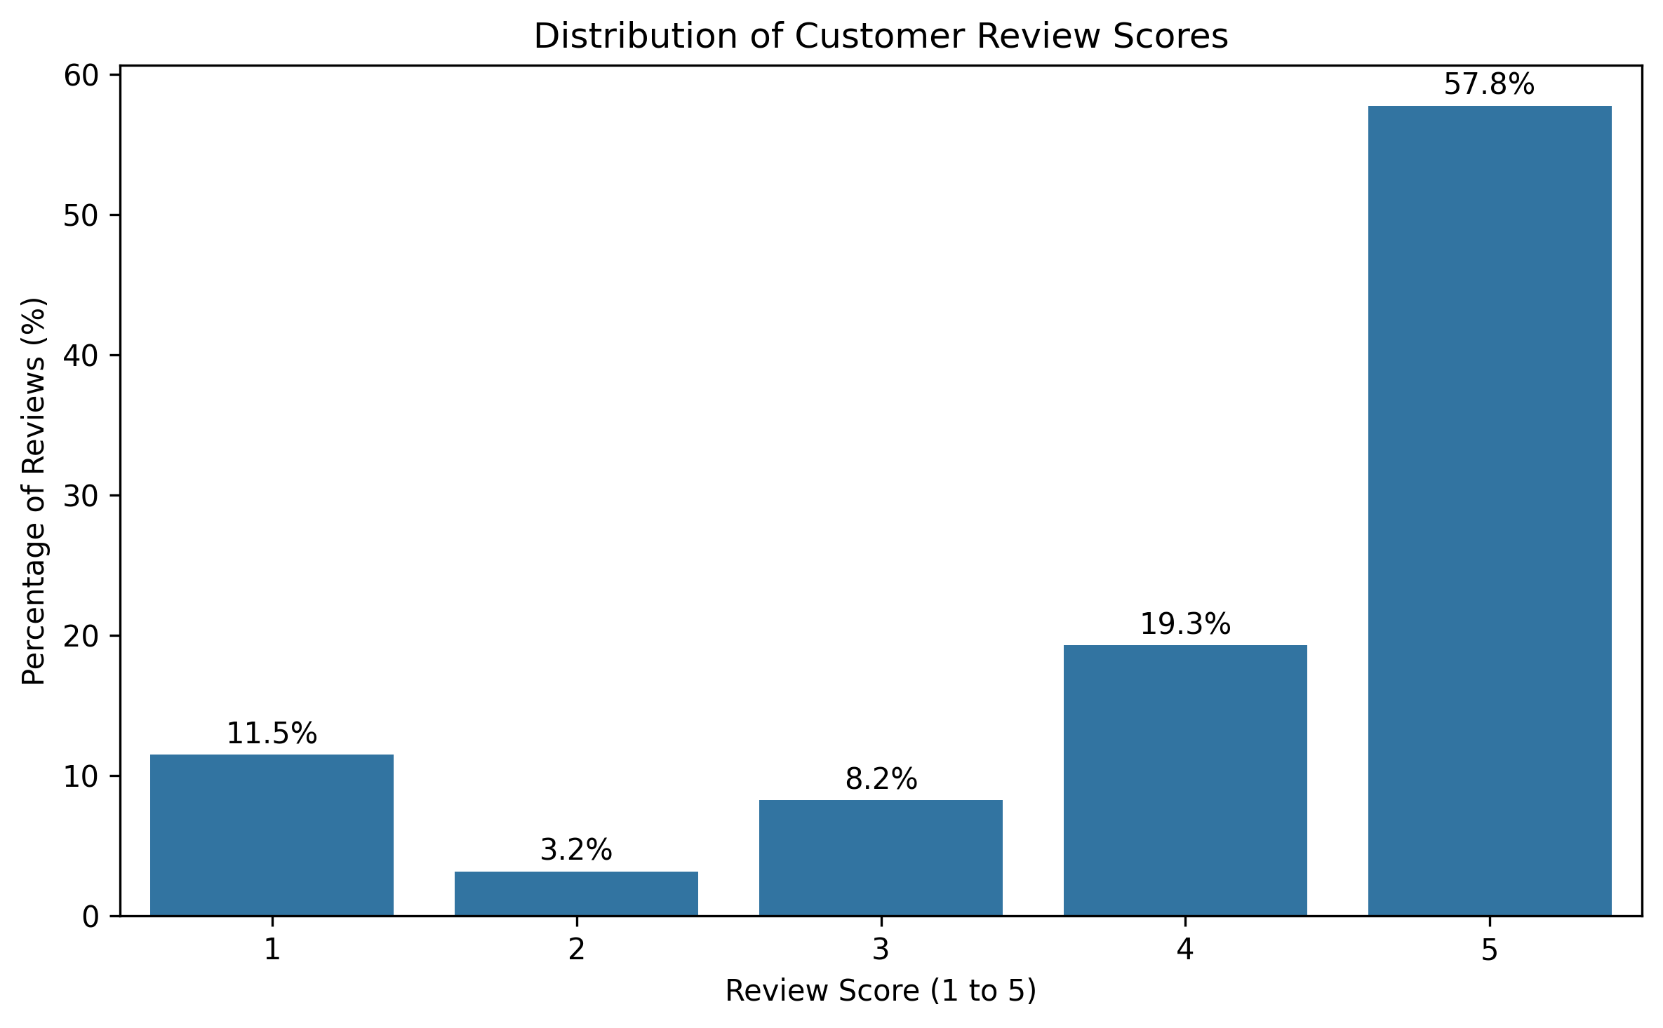Figure 14. Overall distribution of customer review scores.
When review records were joined to the analysed delivered orders, early-delivery records had 88,653 reviews and an average score of 4.29 (median 5). Late-delivery records had 7,700 reviews and an average score of 2.57 (median 2). The 1.72-point difference is a strong association between late delivery and lower customer ratings. It does not establish that delivery delay alone caused the lower ratings; product quality, seller communication and other customer-experience factors may also influence review scores.
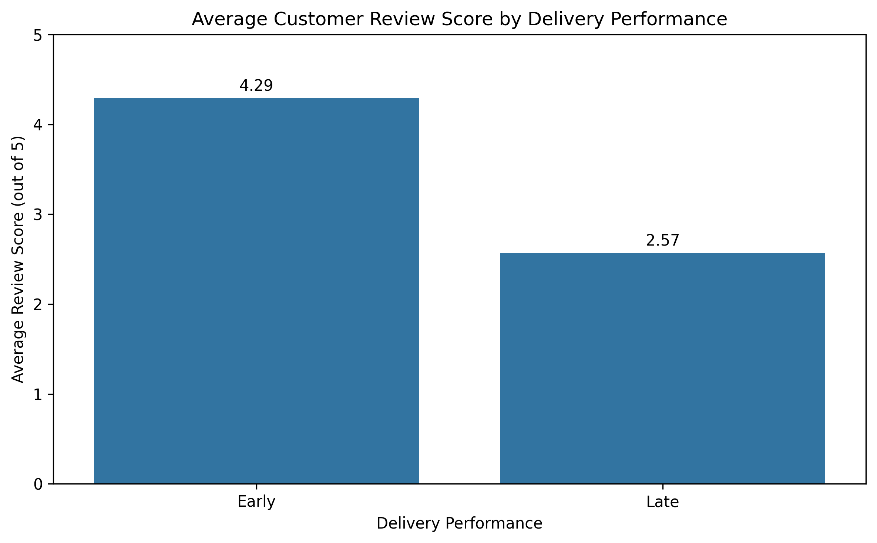Figure 15. Average review score by delivery performance.

4.9 Order-Level Correlation Analysis
Order items were aggregated by order_id to calculate item count, product revenue and total freight. Payments were separately aggregated by order_id and then joined to the item aggregates. The resulting order-level dataset contained 98,665 orders and five columns, including order_id.
Variable pair | Pearson r | Interpretation
Order item count – freight total | 0.437 | Moderate positive association.
Product revenue – freight total | 0.413 | Moderate positive association.
Product revenue – payment total | 0.996 | Very strong positive association.
Order item count – product revenue | 0.153 | Weak positive association.
Order item count – payment total | 0.189 | Weak positive association.
Freight total – payment total | 0.493 | Moderate positive association.

The very strong product-revenue/payment correlation is expected because payment totals generally include product value and freight. The moderate relationship between item count and freight suggests larger orders tend to carry higher total freight, while the moderate relationship between product revenue and freight indicates that higher-value orders tend to be associated with higher freight. Correlation is not causation and does not quantify a causal cost driver.
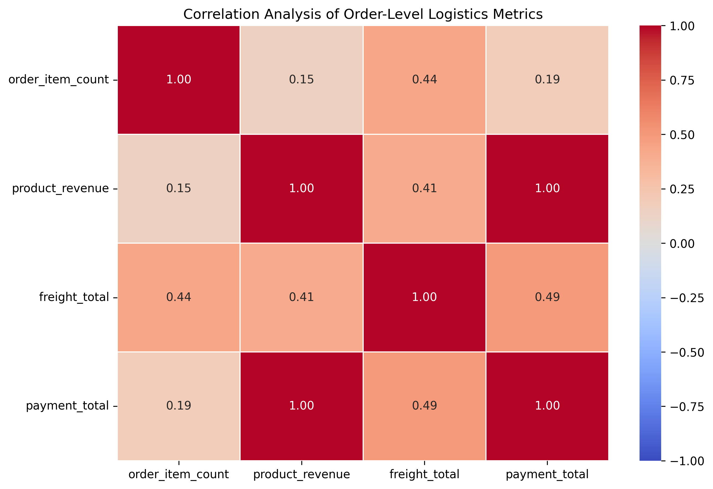Figure 16. Correlation heatmap of order-level item count, product revenue, freight and payment totals.

5. Consolidated Key Findings
- The analysed delivered-order subset had an 8.11% late-delivery rate; average actual delivery duration was 12.56 days and median duration was 10.22 days.
- Late deliveries had a substantially lower average review score (2.57) than early deliveries (4.29), indicating a strong association between delivery performance and customer satisfaction.
- Order demand was concentrated geographically, with SP, RJ and MG contributing approximately 66.5% of all orders.
- Late-delivery rates varied by state, highlighting regions that may benefit from targeted operational investigation.
- Freight values were right-skewed; the mean (19.99) exceeded the median (16.26), and some unusually high freight values require investigation rather than automatic removal.
- Health Beauty and Watches Gifts were leading product-revenue categories, while Bed Bath Table led by item volume.
- The top ten sellers contributed 13.15% of product revenue; seller delivery performance varied, but the observed seller rates should be interpreted cautiously.
- Order-level correlations showed moderate positive relationships between item count and freight (0.437), and product revenue and freight (0.413).

6. Business Recommendations
- Prioritise late-delivery root-cause analysis. Review orders with the longest delays and segment them by state, seller, carrier handoff timing and delivery duration. The current analysis identifies where to investigate but does not establish the cause.
- Introduce regional service monitoring. Track late-delivery rate, average delivery duration and order volume by customer state. Investigate higher-rate states such as AL, MA, PI, CE and BA while considering their sample sizes and operating conditions.
- Use customer ratings as an experience-monitoring signal. Monitor review scores alongside delivery KPIs and investigate low-rated late orders to understand whether delays, communication or other issues are involved.
- Review high freight outliers and zero-freight records. Validate product dimensions, weight, seller origin, destination and freight rules before making pricing or data-correction decisions.
- Plan capacity using order timing patterns cautiously. Monday and the 10:00–17:00 purchase window had higher order volumes. Compare these demand patterns with actual warehouse processing and dispatch data before changing staffing schedules.
- Monitor seller performance using balanced metrics. Consider seller revenue, order/item volume, late-delivery rate and sample size together. Do not rank sellers using a single metric or attribute all delivery delay to the seller.
- Review category-level logistics needs. High-volume categories and high-revenue categories may require different inventory, packaging and fulfilment attention. Product revenue should not be treated as profit.
- Build a recurring logistics dashboard. Track late-delivery rate, average and median delivery duration, freight distribution, state-level performance, seller performance and customer review scores over time.

7. Limitations and Assumptions
- The project uses a real public Olist dataset rather than simulated data. The dataset's coverage and fields define the limits of the analysis.
- Eight delivered-status orders lacked an estimated delivery timestamp and were excluded from the 96,470-order delivery comparison.
- On-time delivery was defined using exact timestamp equality. No exact matches were observed; date-level on-time classification could produce a different result.
- The dataset contains partial months at the beginning and end of the observation window. These periods should not be compared as complete months.
- Purchase hour and weekday describe customer ordering behaviour, not warehouse processing, dispatch or carrier activity.
- Seller late-delivery rate is item-weighted because order-level delivery outcomes were joined to order items. Multi-item orders can contribute multiple records.
- Correlation measures linear association and does not establish causation. Product revenue and payment total are structurally related.
- Product revenue is calculated as the sum of item prices and is not profit. Freight is analysed separately.
- High values and zero values were retained for investigation; they were not automatically treated as errors.
- Some potentially important explanatory variables, such as package dimensions, weight, carrier operational events and route distance, were not fully analysed in this work.

8. Conclusion
The Week 3 analysis applied exploratory data analysis, descriptive statistics, aggregation, correlation analysis and visualizations to identify patterns in delivery reliability, order timing, freight costs, regional demand, product categories, seller performance and customer satisfaction. The results highlight an 8.11% late-delivery rate in the analysed delivered subset and a substantial difference in review scores between early and late deliveries. Regional variation, freight outliers and seller-level differences provide useful directions for further investigation.
The analysis supports evidence-based logistics monitoring and prioritisation. The recommendations should be treated as operational hypotheses to validate with more detailed carrier, warehouse, route, package and service-event data.

