WEEK 4 PROJECT REPORT

Predictive Modeling and
Optimization in Logistics Systems
Delivery-Time Prediction and Operational Risk Prioritisation

Project detail | Description
Dataset | Brazilian E-Commerce Public Dataset by Olist
Business scenario | Illustrative e-commerce logistics operation using real historical observations
Tools | Python, pandas, NumPy, scikit-learn, Matplotlib, Jupyter Notebook
Target | Order-to-customer delivery duration in days
Evaluation | Chronological 80/20 split, MAE, RMSE, R² and TimeSeriesSplit cross-validation

1. Executive Summary
This project develops machine-learning models to estimate the number of days between an e-commerce order being placed and the customer receiving it. The analysis uses historical order, item, customer, product and seller records from the Olist Brazilian E-Commerce Public Dataset. The business scenario is illustrative; the underlying data are historical empirical observations, not newly generated synthetic data.
Linear Regression, Decision Tree Regression and Random Forest Regression were evaluated. The original Random Forest achieved test MAE 4.4113 days. Adding the estimated delivery window available at order placement and explicitly including it in preprocessing produced an updated Random Forest with test MAE 4.2034 days, RMSE 5.7382 days and R² 0.0542. Mean time-series cross-validation MAE was 5.6770 days.
A retrospective risk simulation flagged 755 of 19,294 test orders as medium or high risk. Observed late-delivery rates were 43.90% for high risk, 32.66% for medium risk and 4.08% for low risk. However, the combined alert rule achieved 35.10% precision and 25.95% recall. The model is therefore a prototype for human-reviewed decision support, not an autonomous logistics control system.
Key measure | Result
Eligible delivered orders | 96,470
Updated predictors | 15
Selected model | Updated Random Forest
Test MAE | 4.2034 days
Test RMSE | 5.7382 days
Test R² | 0.0542
Mean time-series CV MAE | 5.6770 days
Medium/high-risk orders | 755 / 19,294 (3.91%)
Risk alert precision / recall | 35.10% / 25.95%

2. Objective and Scope
The objective was to predict order delivery lead time and translate model outputs into practical operational recommendations. Delivery lead time is the elapsed time between purchase timestamp and actual customer-delivery timestamp.
- Prediction point: order placement, using information available at that point.
- Operational use case: flag orders whose predicted delivery duration exceeds the promised window.
- Out of scope: road-network routing, traffic prediction, vehicle routing and fleet-capacity optimisation; the dataset lacks the necessary route, traffic, vehicle and capacity data.

3. Dataset and Preparation
Source table | Loaded records | Use
Orders | 99,441 | Order status and timestamps
Order items | 112,650 | Item count, price, freight, seller/product links
Customers | 99,441 | Customer geography
Products | 32,951 | Weight and physical dimensions
Sellers | 3,095 | Seller geography

After timestamp validation and filtering to delivered orders with valid purchase and delivery dates and non-negative delivery duration, 96,470 orders remained. Item and product data were aggregated to order level: item count, total price, total freight, unique sellers, average product weight and dimensions, and unique product categories. For multi-seller orders, the most frequent seller state was used as the order-level seller-state summary.
The target distribution was right-skewed: mean 12.56 days, median 10.22 days and maximum 209.63 days. Extreme durations were retained because unusually long deliveries are operationally important.

4. Target, Predictors and Leakage Control
The target was delivery_time_days, calculated as actual customer-delivery timestamp minus purchase timestamp, expressed in days. The original predictor set contained 14 variables: item_count, total_price, total_freight, unique_sellers, average product weight/length/height/width, unique_categories, purchase month/day-of-week/hour, customer_state and main_seller_state.
The updated model added estimated_delivery_days, calculated as estimated delivery timestamp minus purchase timestamp. This estimated window is available at order placement and is therefore a valid predictor. Actual delivery timestamp, carrier handoff timestamp and review score were excluded from predictors because they are known only after order placement or delivery and would cause target leakage.
The updated model used 15 predictors. Numerical missing values were imputed using the median and standardised. Categorical state values were imputed using the most frequent category and one-hot encoded with unknown categories ignored.

5. Modelling Methodology

5.1 Chronological split
Records were sorted by purchase timestamp. The earliest 80% (77,176 orders) were used for training and the latest 20% (19,294 orders) for testing. This chronological split better approximates forecasting future orders than a random split.

5.2 Algorithms
Algorithm | Purpose / configuration
Linear Regression | Linear baseline to test whether a simple linear relationship is adequate.
Decision Tree Regressor | Non-linear threshold-based model; depth and minimum leaf constraints used.
Random Forest Regressor | Ensemble model; 100 trees, max_depth 15, min_samples_split 20, min_samples_leaf 5.

Each model was implemented in a scikit-learn Pipeline to fit preprocessing on training data and apply the same transformations to test data. MAE, RMSE and R² were used for evaluation.

6. Model Evaluation

6.1 Initial model comparison
Model | MAE (days) | RMSE (days) | R²
Random Forest | 4.4113 | 5.7968 | 0.0348
Decision Tree | 4.5210 | 5.9663 | -0.0225
Linear Regression | 5.7034 | 7.0190 | -0.4151

The original Random Forest was the strongest initial model. Negative R² for the Decision Tree and Linear Regression indicates that these models performed worse than a constant prediction based on the test-set mean under the R² metric.

6.2 Baseline comparison
A constant median baseline using the training median of 11.18 days achieved test MAE 4.9628 days, RMSE 6.3808 days and R² -0.1695. The original Random Forest reduced MAE by approximately 11.1% relative to this baseline.

6.3 Exploratory Random Forest configuration comparison
Configuration | MAE | RMSE | R²
RF_2 | 4.4363 | 5.8388 | 0.0207
RF_3 | 4.4411 | 5.8421 | 0.0196
RF_1 | 4.5430 | 5.9315 | -0.0106

RF_2 was best among these three configurations, but none outperformed the original Random Forest on test MAE. These configurations were compared on the same test set; this is exploratory comparison, not an independent validation-based hyperparameter search.

6.4 Updated model with estimated delivery window
Metric | Original Random Forest | Updated Random Forest
MAE (days) | 4.4113 | 4.2034
RMSE (days) | 5.7968 | 5.7382
R² | 0.0348 | 0.0542

Adding estimated_delivery_days reduced test MAE by approximately 4.71% and RMSE by approximately 1.01%. R² increased by 0.0194. The updated Random Forest was retained as the best evaluated model. Nevertheless, R² of 0.0542 means that the model explains only 5.42% of test-target variance, so predictive strength remains limited.

6.5 Time-series cross-validation
Fold | Original RF MAE | Updated RF MAE
Fold 1 | 6.8956 | 5.0541
Fold 2 | 6.4461 | 6.4463
Fold 3 | 5.8322 | 5.5306
Mean | 6.3913 | 5.6770
Standard deviation | 0.4359 | 0.5777

The updated model reduced mean CV MAE by approximately 11.2%, although fold-to-fold standard deviation increased from 0.4359 to 0.5777 days. Mean CV MAE of 5.6770 days was higher than test MAE of 4.2034 days, indicating temporal variation and possibly an easier later test period. Both metrics should be reported.

7. Prediction Error by Delivery Duration
Actual group | Orders | Avg. actual | Avg. predicted | MAE
0–7 days | 8,425 | 4.57 | 8.12 | 3.75
7–15 days | 8,852 | 9.88 | 12.55 | 4.05
15–30 days | 1,834 | 19.34 | 16.18 | 5.08
>30 days | 183 | 40.85 | 17.44 | 23.41

The model overpredicted average duration for the two shortest groups and underpredicted the 15–30-day group. Its largest weakness was the >30-day group: actual mean 40.85 days versus predicted mean 17.44 days, with MAE 23.41 days. The model tends to regress towards typical durations and does not adequately capture extreme delays.

8. Feature Importance
Permutation importance was calculated on the held-out test data using negative MAE and five repeats. Values represent the increase in MAE after shuffling a feature; they are not percentages of total importance.
Rank | Feature | Importance
1 | estimated_delivery_days | 0.6106
2 | customer_state | 0.1227
3 | main_seller_state | 0.1073
4 | avg_product_weight | 0.0741
5 | total_price | 0.0602
6 | avg_product_width | 0.0368
7 | avg_product_length | 0.0317
8 | item_count | 0.0282
9 | avg_product_height | 0.0179
10 | purchase_day_of_week | 0.0120
11 | unique_sellers | 0.0105
12 | purchase_month | 0.0069
13 | purchase_hour | 0.0043
14 | unique_categories | -0.0002
15 | total_freight | -0.0076

The estimated delivery window was the most influential predictor, followed by customer and seller geography. Product weight, dimensions and total price also contributed. Near-zero or negative importance indicates that shuffling those features did not worsen test MAE in this experiment. These results are model-specific and do not establish causation. Because the test set was used for iterative analysis, this feature-importance assessment is exploratory.

9. Logistics Risk Prioritisation Simulation
A retrospective simulation compared predicted delivery duration with the estimated delivery window known at order placement. Predicted delay = predicted delivery days − estimated delivery days. Illustrative categories were: High risk if predicted delay >2 days; Medium risk if >0 and ≤2 days; Low risk if ≤0 days.
Risk category | Orders | Share | Avg. predicted delay
High risk | 164 | 0.85% | 2.94 days
Medium risk | 591 | 3.06% | 0.89 days
Low risk | 18,539 | 96.09% | -10.83 days
Total | 19,294 | 100% | —

Actual late delivery was defined as actual delivery duration exceeding the estimated delivery window. Observed late rates were 43.90% for high risk, 32.66% for medium risk and 4.08% for low risk; the overall late rate was 5.29%. The medium/high-risk group contained 265 of 1,021 actually late orders.
Risk category | Orders | Actually late | Actual late rate | Avg. actual delay
High risk | 164 | 72 | 43.90% | -0.14 days
Medium risk | 591 | 193 | 32.66% | -0.25 days
Low risk | 18,539 | 756 | 4.08% | -13.11 days
Overall | 19,294 | 1,021 | 5.29% | —

Average actual delay can be negative in a group even when some orders are late, because the average includes both early and late orders.

9.1 Alert classification performance
Confusion matrix outcome | Orders
True negatives | 17,783
False positives | 490
False negatives | 756
True positives | 265

Metric | Result | Meaning
Precision | 35.10% | About 35% of flagged orders were actually late.
Recall | 25.95% | About 26% of all actually late orders were flagged.
F1-score | 29.84% | Low combined precision and recall.
Accuracy | 94% | Influenced by the large not-late majority; insufficient alone.

The risk bands show separation in observed late rates, but the combined alert rule missed 756 late orders and generated 490 false alerts. It should be an additional signal for human review, not a replacement for existing service-level monitoring or an automated dispatch decision.

10. Business Recommendations
- Use the estimated delivery window as one input to order-level monitoring, while checking whether the model adds value beyond the delivery promise itself.
- Pilot a human-reviewed exception queue for high predicted-delay orders. Verify address issues, seller readiness, fulfilment exceptions and carrier updates before intervention.
- Monitor delivery performance by customer and seller state. Geography ranked highly in permutation importance and may help direct further regional investigation.
- Create a separate escalation process for extreme-delay orders. The current model substantially underpredicts deliveries exceeding 30 days.
- Track MAE, RMSE, R², precision and recall on subsequent time periods; investigate changes in carriers, sellers, regions and fulfilment patterns.
- Set alert thresholds using business costs: the operational cost of a missed late order versus the cost of investigating a false alert.
- Treat route planning and resource allocation as future work requiring road-network distance, traffic, vehicle capacity, warehouse capacity and dispatch constraints.

11. Limitations and Future Improvements
- Low explanatory power: test R² of 0.0542 indicates limited ability to explain delivery-time variation.
- Extreme-delay underestimation: the >30-day segment contains 183 test orders and has MAE of 23.41 days.
- Temporal variation: updated mean CV MAE (5.6770 days) exceeds test MAE (4.2034 days); future-period performance may differ.
- Risk-alert limitations: precision 35.10% and recall 25.95% are insufficient for autonomous late-delivery detection.
- Test-set reuse: model comparisons, feature importance and risk simulation reused the held-out test period. Metrics should be treated as exploratory estimates rather than a pristine one-time final evaluation.
- Production data availability must be verified at order placement, including the availability and timestamp of the estimated delivery promise.
- Carrier, route, traffic, weather, warehouse workload, dispatch capacity and real-time tracking events were not available.
Future Improvements:
- Build a dedicated late-delivery classification model and evaluate its precision-recall trade-off.
- Add carrier, route-distance, warehouse, regional congestion and historical seller-performance features.
- Test robust approaches for skewed targets, including target transformations and quantile prediction.
- Use a separate validation period for model selection and reserve an untouched final test period.
- Evaluate alert thresholds with an explicit operational cost matrix and pilot the workflow with human oversight.

12. Notebook Code Evidence and Screenshot Plan

12.1 Target Construction and Leakage Control
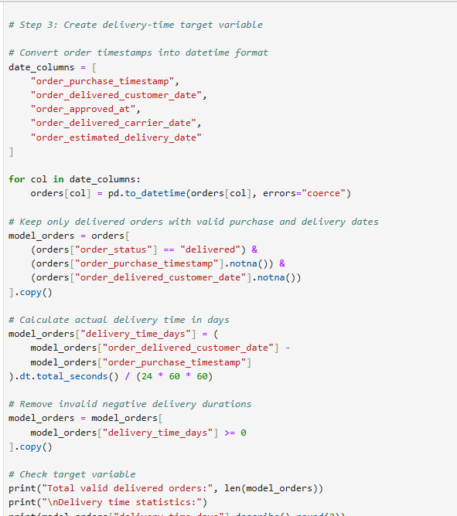

Demonstrates the target definition and shows that post-delivery fields were not used as predictors.

12.2 Order-Level Feature Engineering
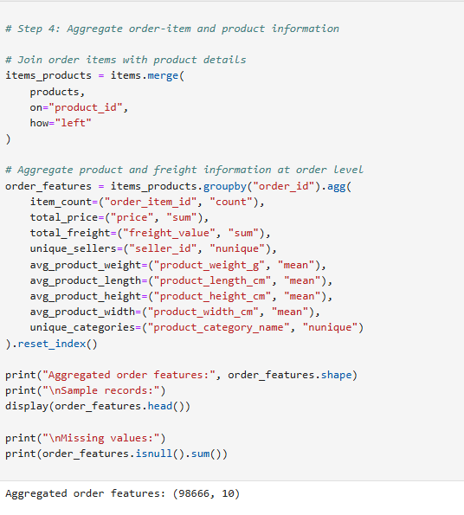
Shows how source tables were transformed into one modelling record per order.

12.3 Preprocessing and Chronological Split
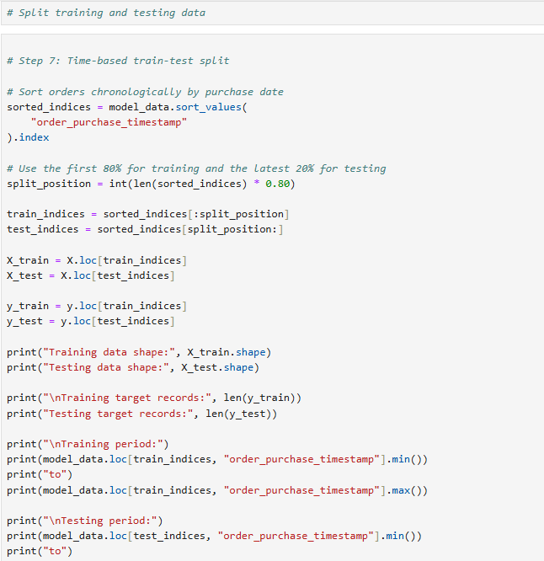

Demonstrates time-aware evaluation, imputation, scaling and one-hot encoding. The new feature must be explicitly included in the numerical transformer.

12.4 Model Training and Evaluation
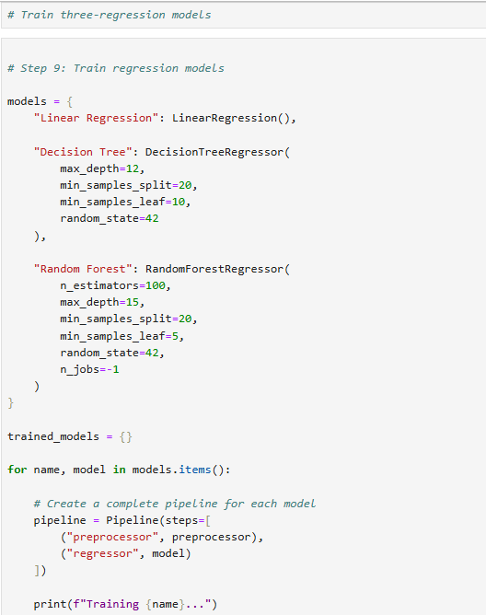

Shows the model development process and the metrics used to select the best candidate.

12.5 Time-Series Validation and Feature Importance
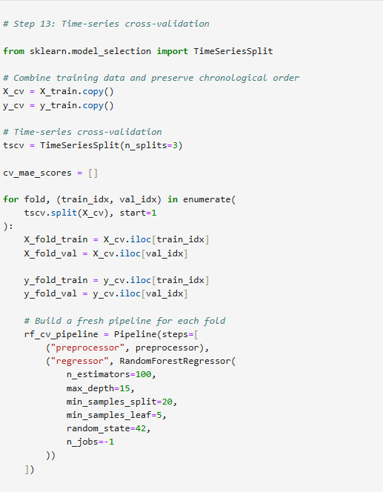.
Shows chronological validation and exploratory identification of influential predictors.

12.6 Operational Risk Simulation
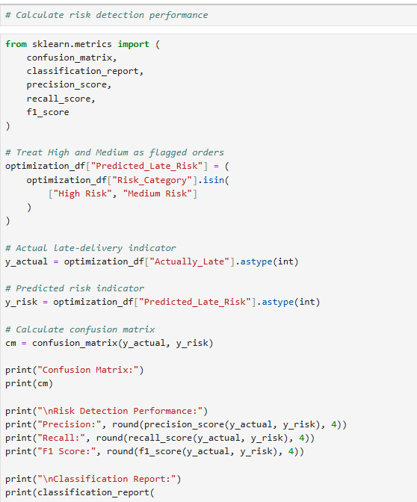.
Connects predictions to a business use case and evaluates alerts against observed late-delivery outcomes.

13. Data Analysis

13.1 Random Forest Model MAE Comparison
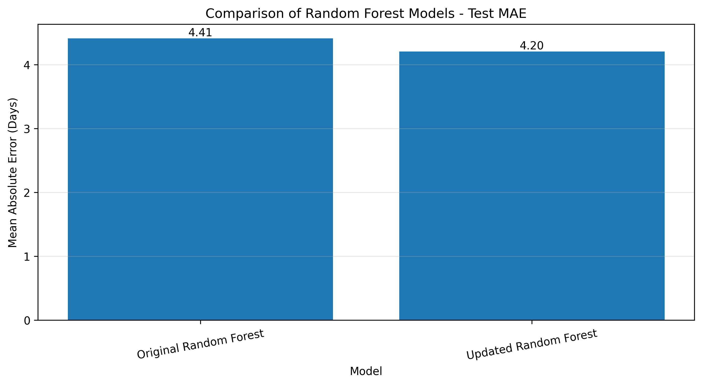1

13.2 Actual Late-Delivery Rate by Predicted Risk Category
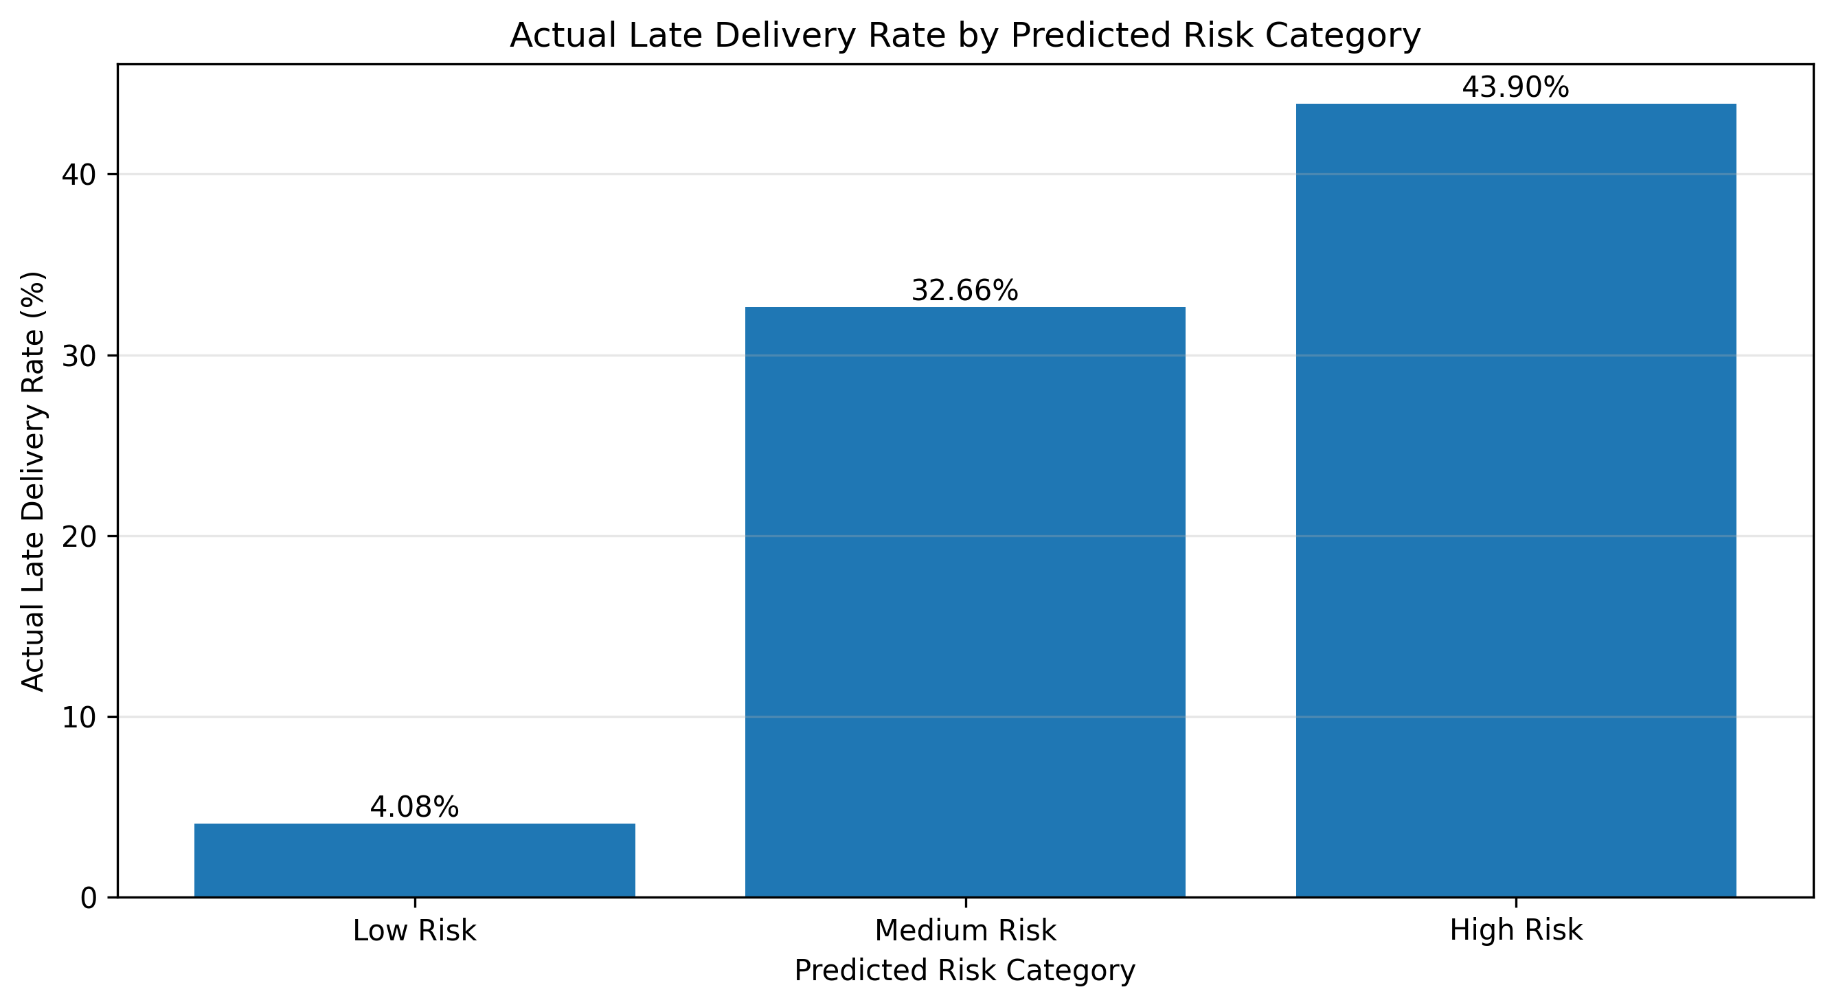 Observed late-delivery rates rise from 4.08% for low risk to 32.66% for medium risk and 43.90% for high risk. The separation may support human-reviewed prioritisation. However, combined alert recall is only 25.95%, so most late orders are not captured.

14. Conclusion
This project completed an end-to-end delivery-time prediction workflow using historical e-commerce logistics data. The updated Random Forest was the best evaluated regression model, with test MAE 4.2034 days, RMSE 5.7382 days and R² 0.0542. The estimated delivery window improved performance modestly and was the most influential predictor in the permutation analysis.
The operational simulation showed that risk categories had different observed late-delivery rates, but alert precision and recall remained limited. The model should therefore be treated as an analytical prototype for decision support and further experimentation—not a production-ready prediction or optimisation engine. Additional operational data, a stricter validation design and cost-aware alert thresholds are required before deployment.

