CS542 Design Patterns
Fall 2013
ASSIGNMENT 2 README FILE

Due Date: 10/13/2013
Submission Date: 10/13/2013
Grace Period Used This Project: 0 Days
Grace Period Remaining: 0 Days
Author(s): Anuj Sethi and Prajakta More
e-mail(s): asethi1@binghamton.edu, pmore2@binghamton.edu

PURPOSE:
Purpose of the project is to develop software that can be used by each attendee of a Design Patterns Conference at Binghamton University

PERCENT COMPLETE: We believe we have completed 100% of this project.

PARTS THAT ARE NOT COMPLETE: None

BUGS: We believe there are no bugs in the project.

FILES:

- Driver.java: Set various inputs to build conference and calls the display method from the result class to display summary of conference.
- ConstructConference.java: Class that have all methods to do setup to build conference.
- IConstructConference.java: Interface for IConstructConference.java class.
- ConferenceBuilder.java: Builder class that calls the methods of ConstructConference.java to sets all values to build conference.
- IConferenceBuilder.java: Interface for ConferenceBuilder.java class.
- DPConference.java: Class that enforces series of steps to build conference.
- IDPConference.java: Interface for DPConference.java class.
- DPConferencePOJO.java: POJO that have simple plain old java objects required in code
- ParametersPOJO.java: stores the parameters like time, cost and co2
- Results.java: stores the records that were searched.
- IResults.java: Interface for Results.java class.
- Debug.java: sets debug values and prints the output based on the values assigned.
  - 0: No output should be printed.
  - 2: One of the type of Conference Factory is called
  - 1: Only output from the Driver code.
  - 3: Conference Builded
  - 4: Constructor is Called
- README: the text file you are presently reading.

SAMPLE OUTPUT:

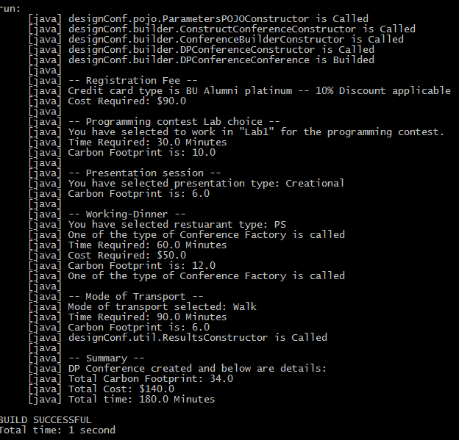

TO CLEAN, COMPILE & RUN altogether: ant
TO COMPILE ONLY: ant compile
TO RUN ONLY: ant run
TO CLEAN ONLY: ant clean
TO TAR & ZIP the tar file thus produced: ant tarzip

