1. **Linkage Ribbon (Example screenshot from Simplilearn)**
   1. **For Students -**

* 1. **For Corporates -**

1. **First Image : Text & Image of globe …**

**Global Training, Certification & Recruitment Expert – helps you from Learning to earning (Value generation)**

1. Our Products (In aggregated Logo Fashion like in screenshot)
   1. SAFe
   2. ICAgile
   3. Scrum Alliance
2. 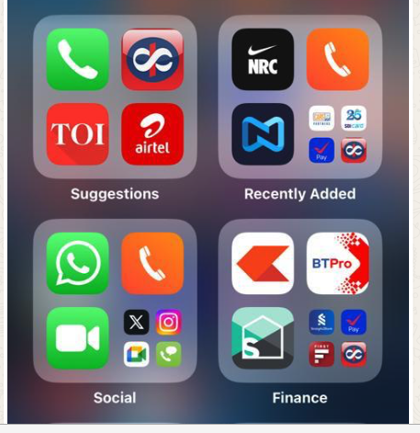
3. Open Positions (Link to recruit and Open Positions page)
4. Recommendations (What our customers say)
   1. Recommendations on LinkedIn, WhatsApp , earlier website
5. Associations (Our Clients Logos)
6. Footer