**Project Structure**

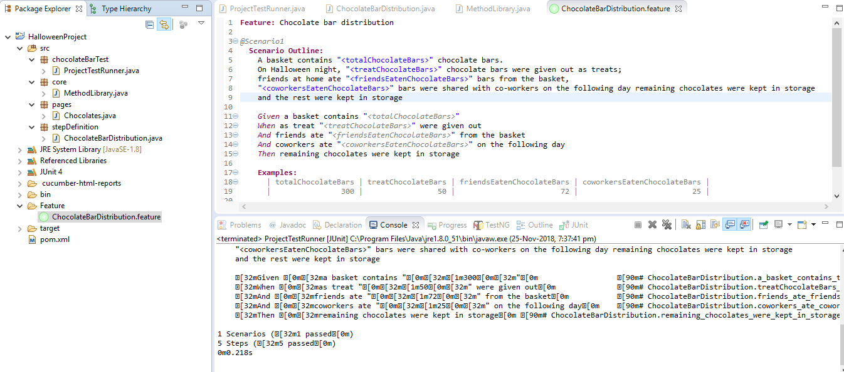

**Html Result**

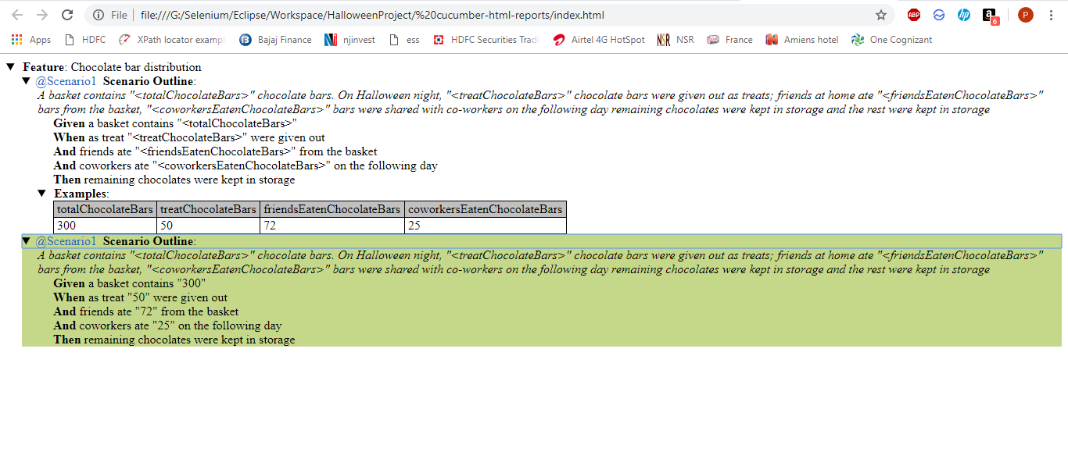

**Project details:**

1. Project contains src folder containing below 4 packages:

* chocolateBarTest package -> contains ProjectTestRunner.java

1. ProjectTestRunner class contains below within CucumberOptions

tags = {"@Scenario1"},

features = {"Feature"},

glue = {"stepDefinition"},

~~format~~ = { "pretty","html: cucumber-html-reports","json: cucumber-html-reports/cucumber.json" }

* core package -> contains MethodLibrary.java

1. MethodLibrary class contains a method calculateRemainingChocolates() where actual calculation part is performed on the chocolate distribution
2. Here I have considered various test conditions as-
3. If TotalChocolates count is a negative number, fail the test
4. If sum of counts(treatChocolates, friendsEatenChocolates, coworkersEatenChocolates) is greater than totalChocolates count, fail the test
5. Last step is to calculate the remaining chocolates count

* pages package -> contains Chocolates.java

1. Chocolates class contains variables for each of the chocolate distributions done(treatChocolates, friendsEatenChocolates, coworkersEatenChocolates, totalChocolates)
2. It also contains getter-setter methods for each of these variables

* stepDefinition package -> contains ChocolateBarDistribution.java file

1. ChocolateBarDistribution class contains all the step definitions for Given, When, Then steps mentioned in the feature file
2. Feature folder -> contains ChocolateBarDistribution.feature file

* ChocolateBarDistribution.feature file contains 1 scenario denoted with @Scenario1 tag
* @Scenario1 tag is used in TestRunner file under tags section for junit to understand that Scenario1 needs to be executed
* I have parameterized the scenario, and I am taking test data through Examples section

