DSDV ROUTING TABLE - BEFORE TOPOLOGY CHANGE
Destination Next Hop Hop Count Sequence Number Status
B B 1 2 VALID
C C 1 2 VALID
D B 2 2 VALID
E B 3 2 VALID
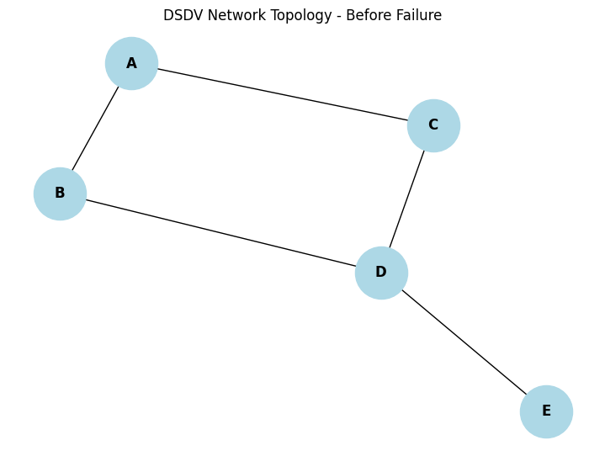
LINK FAILURE: B - D

DSDV ROUTING TABLE - AFTER UPDATE
Destination Next Hop Hop Count Sequence Number Status
B B 1 2 VALID
C C 1 2 VALID
D C 2 2 VALID
E C 3 2 VALID
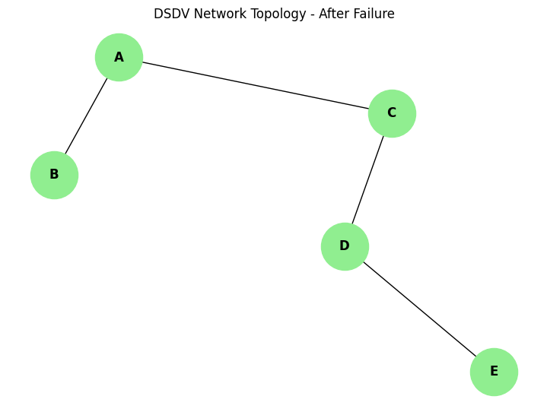
DSDV routing table updated successfully.

