AODV ROUTE DISCOVERY

SOURCE: S
DESTINATION: D

RREQ: Route Request Broadcast
Checking node: S
Checking node: A
Checking node: B
Checking node: D
Checking node: C

RREP: Route Reply Received
Established Route: S -> C -> D
Hop Count: 2
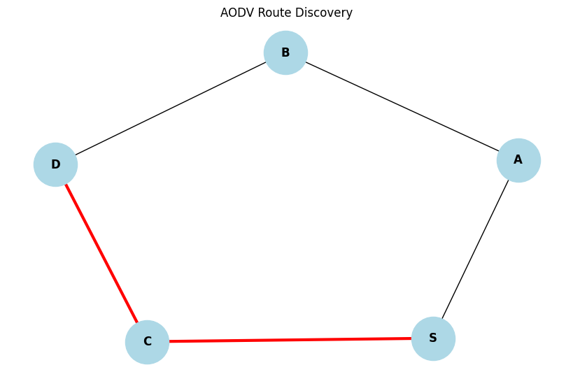
SIMULATING LINK FAILURE: B-D

ROUTE MAINTENANCE
Broken route detected
RERR message generated

SOURCE: S
DESTINATION: D

RREQ: Route Request Broadcast
Checking node: S
Checking node: A
Checking node: B
Checking node: D
Checking node: C

RREP: Route Reply Received
Established Route: S -> C -> D
Hop Count: 2

UPDATED ROUTE: ['S', 'C', 'D']

DSDV VS AODV

DSDV:
1. Maintains routing tables continuously.
2. Uses periodic routing updates.
3. Routes are available before transmission.
4. Can introduce continuous control overhead.

AODV:
1. Discovers routes on demand.
2. Uses RREQ, RREP and RERR.
3. Reduces periodic route updates.
4. Introduces route discovery delay.

AODV simulation completed.

