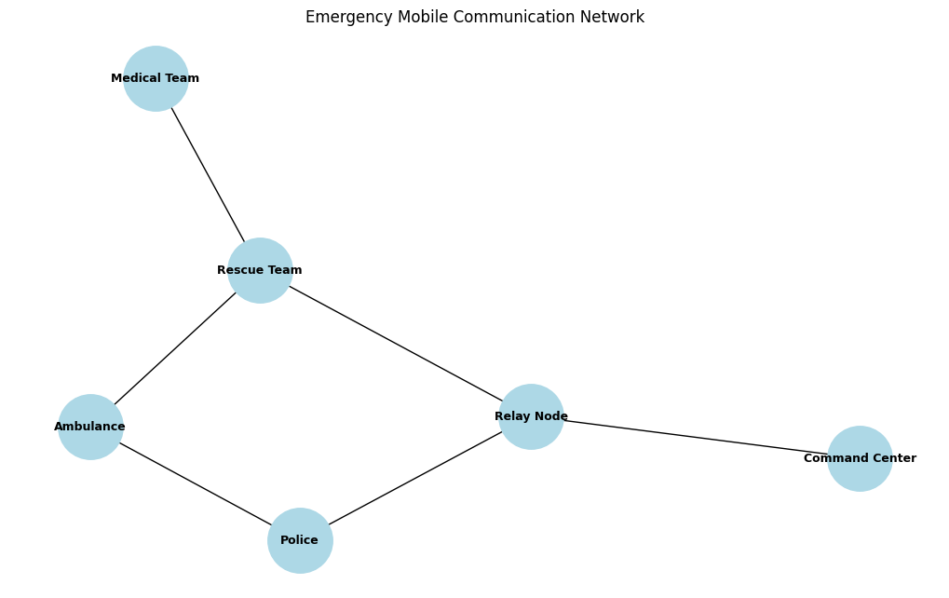
EMERGENCY MESSAGE TRANSMISSION

Source: Ambulance
Destination: Command Center
Communication Path: Ambulance -> Police -> Relay Node -> Command Center
Hop Count: 3
Message Delivered Successfully

SIMULATING RELAY NODE FAILURE

Source: Ambulance
Destination: Command Center
No Route Available

PERFORMANCE EVALUATION
Scenario Packet Delivery Hop Count
Normal Network Successful 3
Relay Node Failure Failed 0
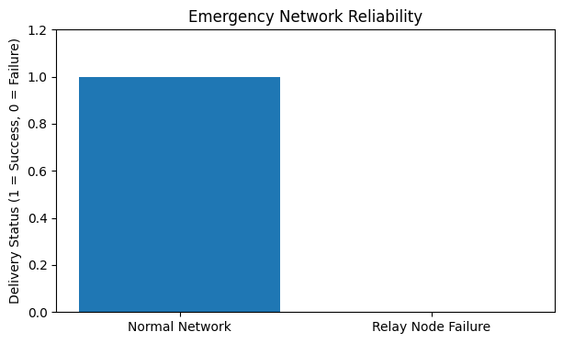
Emergency network simulation completed.

