Table of content
Contents
Linux File and Directory Management Commands 3
GCC Compiler Version and Package Search in Linux 4
Program Compilation and Execution in Linux 5

Table of figure
Figure 1- Execution of Basic Linux File and Directory Management Commands 3
Figure 2-Checking GCC Version and Searching for Python3 Packages Using APT 4
Figure 3-Creating, Compiling, Executing, and Verifying a C Program Using GCC 5

Linux File and Directory Management Commands
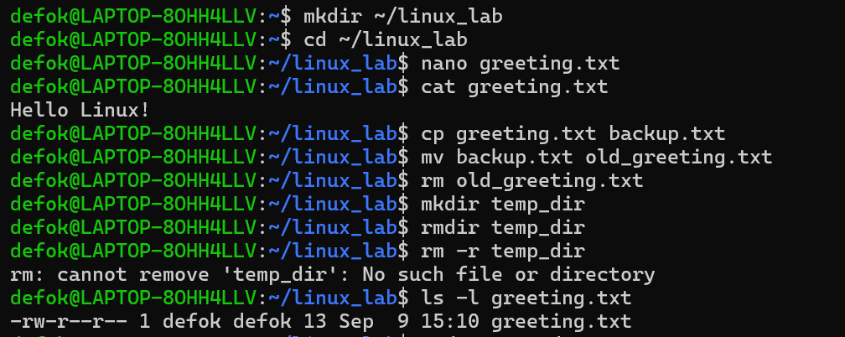
Figure 1- Execution of Basic Linux File and Directory Management Commands

GCC Compiler Version and Package Search in Linux
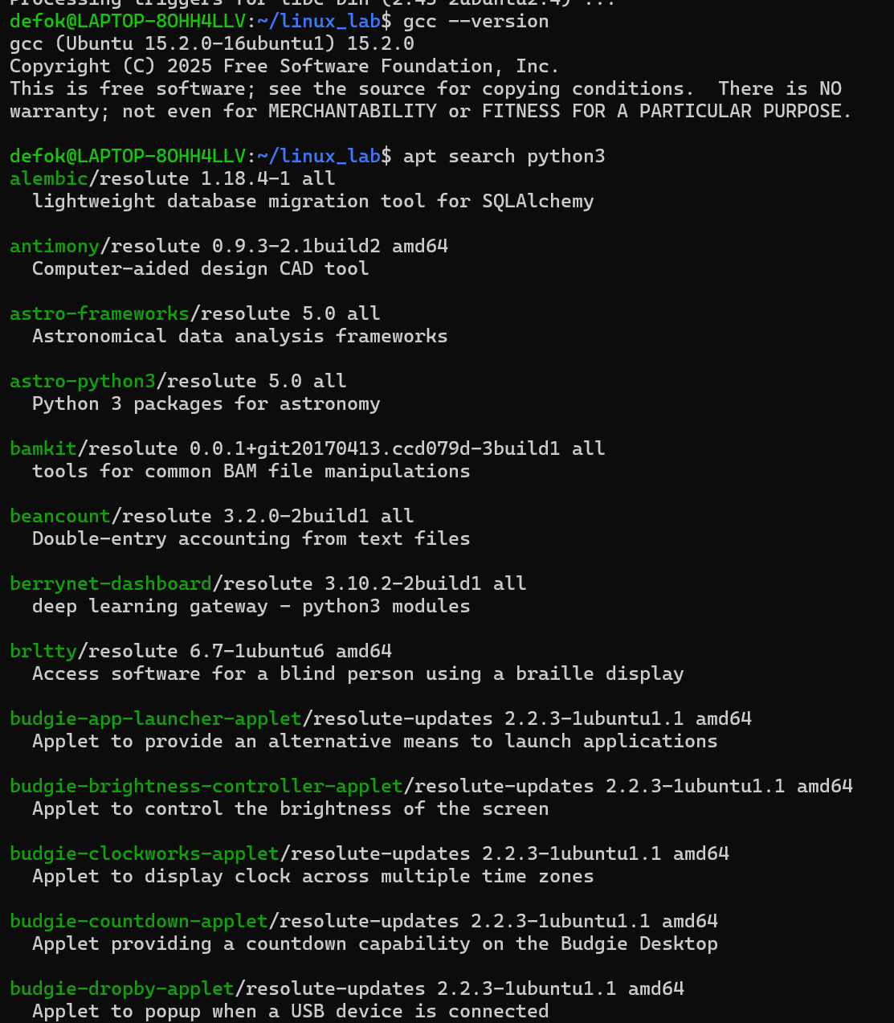
Figure 2-Checking GCC Version and Searching for Python3 Packages Using APT

Program Compilation and Execution in Linux
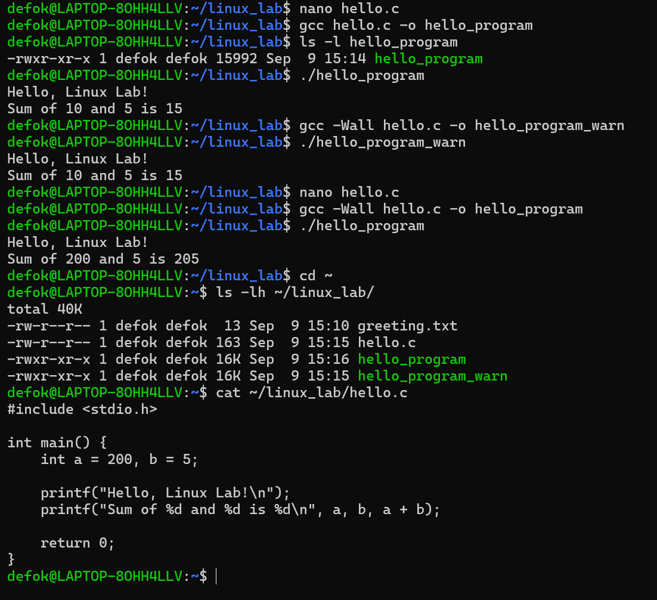
Figure 3-Creating, Compiling, Executing, and Verifying a C Program Using GCC

