LABORATORY REPORT
Auditing of Text and Initialized Data Segments via Hardware Disassembly

Student Name | Prajanya singh
Lab / Assignment | Lab 4.1
Date | October-2

1. Learning Objectives
The objectives of this laboratory are to evaluate the structural composition and isolation boundaries between the Text segment (.text, .rodata) and the Initialized Data segment (.data), and to disassemble compiled application subroutines into machine opcodes while tracking hardware instruction addresses.

2. Introduction
An executing application separates instructions from program state. The .text segment stores executable machine code and is normally mapped as read-only/non-writable to protect program instructions during runtime. Read-only constants and string literals are stored in the adjacent .rodata section. In contrast, initialized global variables are stored in the read-write .data section. GDB and related binary-analysis tools can be used to inspect these sections, their virtual address ranges, and the actual memory representation of stored values.

3. Source Code Used
#include <stdio.h>
int data_global_var = 0x12345678;
const char *text_string_literal = " Text_Segment_Verification";
void check_execution() {
printf("Executing within the text segment instruction block.\n");
}
int main() {
printf("Addresses:\n");
printf("Data (Global Initialized): %p\n", (void*)&data_global_var);
printf("Text String (ROData): %p\n", (void*)text_string_literal);
printf("Text Code (Function): %p\n", (void*)&check_execution);
check_execution();
printf("Ready for Text/Data segment inspection!\n");
return 0;
}
Save the source file as demo2.c.

4. Task A – Building with Debugging Symbols
The program was compiled with GCC using the -g option. This preserves debugging symbols and source-level information required by GDB.
gcc -g demo2.c -o demo2
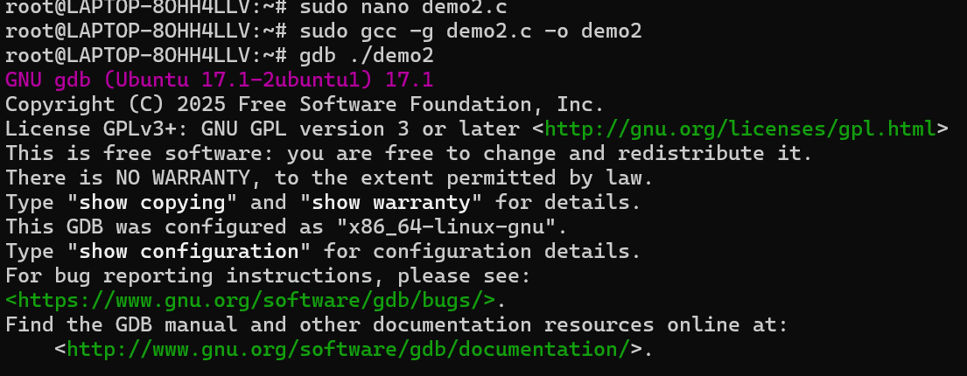
Figure 1-compiling

5. Task B – Breakpoint and Runtime Positioning
The executable was opened in GDB and a breakpoint was configured near the final printf statement.
gdb ./demo2
(gdb) break 22
(gdb) run
The supplied laboratory execution trace reports the following runtime addresses:
Object | Address | Segment
data_global_var | 0xaaaaaaac0010 | .data
text_string_literal | 0xaaaaaaaa0888 | .rodata
check_execution | 0xaaaaaaaa07d8 | .text

Verification answers:
1. Hardware architecture: The GDB trace identifies the executable as AArch64/ARM64. The host library path contains lib/aarch64-linux-gnu and the executable file type is elf64-littleaarch64.
2. Initialized global variable address: The runtime address of data_global_var is 0xaaaaaaac0010.
3. Data versus Text Code: data_global_var is at 0xaaaaaaac0010, while check_execution is at 0xaaaaaaaa07d8. Therefore, the Text Code address is lower than the initialized Data address in the shown virtual address layout.
4. Breakpoint line difference: GDB reports the breakpoint at the next source line because source-line information is associated with the generated machine instruction boundaries. The requested breakpoint at line 22 corresponds to the instruction position immediately before the printf statement, and GDB identifies the executable source location as line 23.
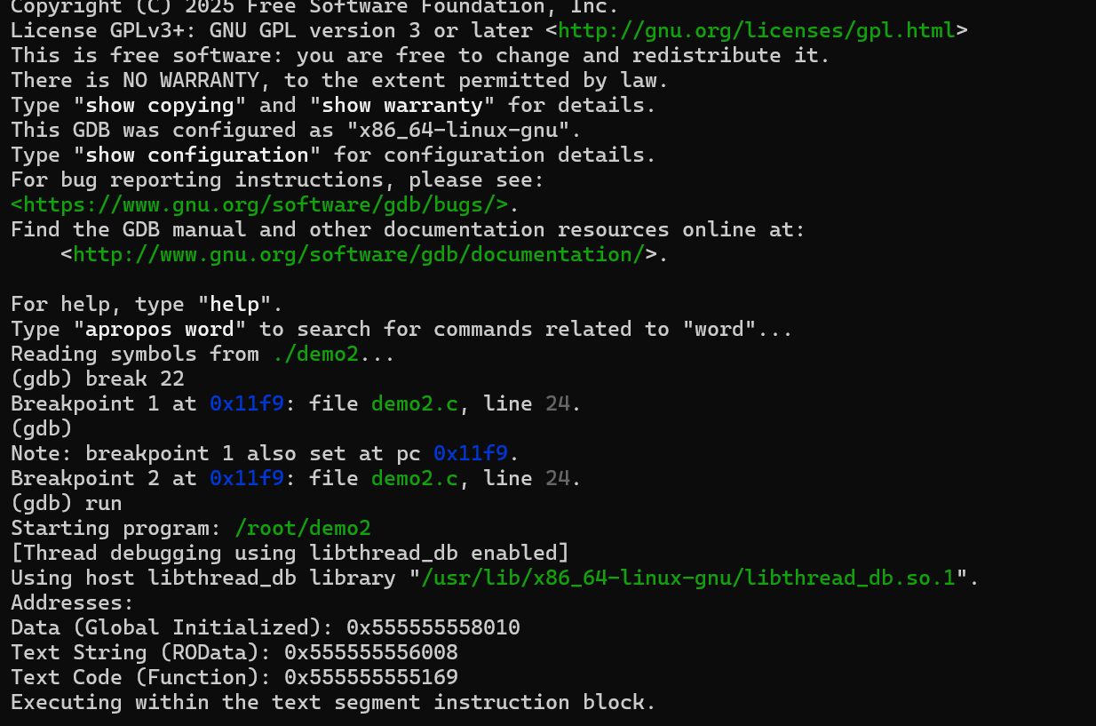
Figure 2-gdb startup

6. Task C – Mapping Static Text and Data Section Bounds
The section layout was inspected using:
(gdb) info files
The relevant section ranges from the supplied laboratory trace are:
Section | Start Address | End Address | Purpose
.text | 0xaaaaaaaa06c0 | 0xaaaaaaaa086c | Executable instructions
.rodata | 0xaaaaaaaa0880 | 0xaaaaaaaa0978 | Read-only constants/string literals
.data | 0xaaaaaaac0000 | 0xaaaaaaac0020 | Initialized read-write global data
.bss | 0xaaaaaaac0020 | 0xaaaaaaac0028 | Uninitialized/zero-initialized data

1. Meaning of elf64-littleaarch64: elf64 indicates a 64-bit ELF executable format; little indicates little-endian byte ordering; aarch64 identifies the 64-bit ARM architecture.
2. .text boundary and function check: The .text range is 0xaaaaaaaa06c0–0xaaaaaaaa086c. The function address 0xaaaaaaaa07d8 lies within this range, so check_execution is correctly mapped into .text.
3. .rodata verification: The .rodata range is 0xaaaaaaaa0880–0xaaaaaaaa0978. The string pointer 0xaaaaaaaa0888 lies inside this interval, confirming that the literal is stored in .rodata.
4. .data verification: The .data range is 0xaaaaaaac0000–0xaaaaaaac0020. The global variable address 0xaaaaaaac0010 lies inside this range, confirming that data_global_var is stored in .data.
5. .data versus .bss: The .data section occupies the lower address range. It ends at 0xaaaaaaac0020, which is exactly where .bss begins.
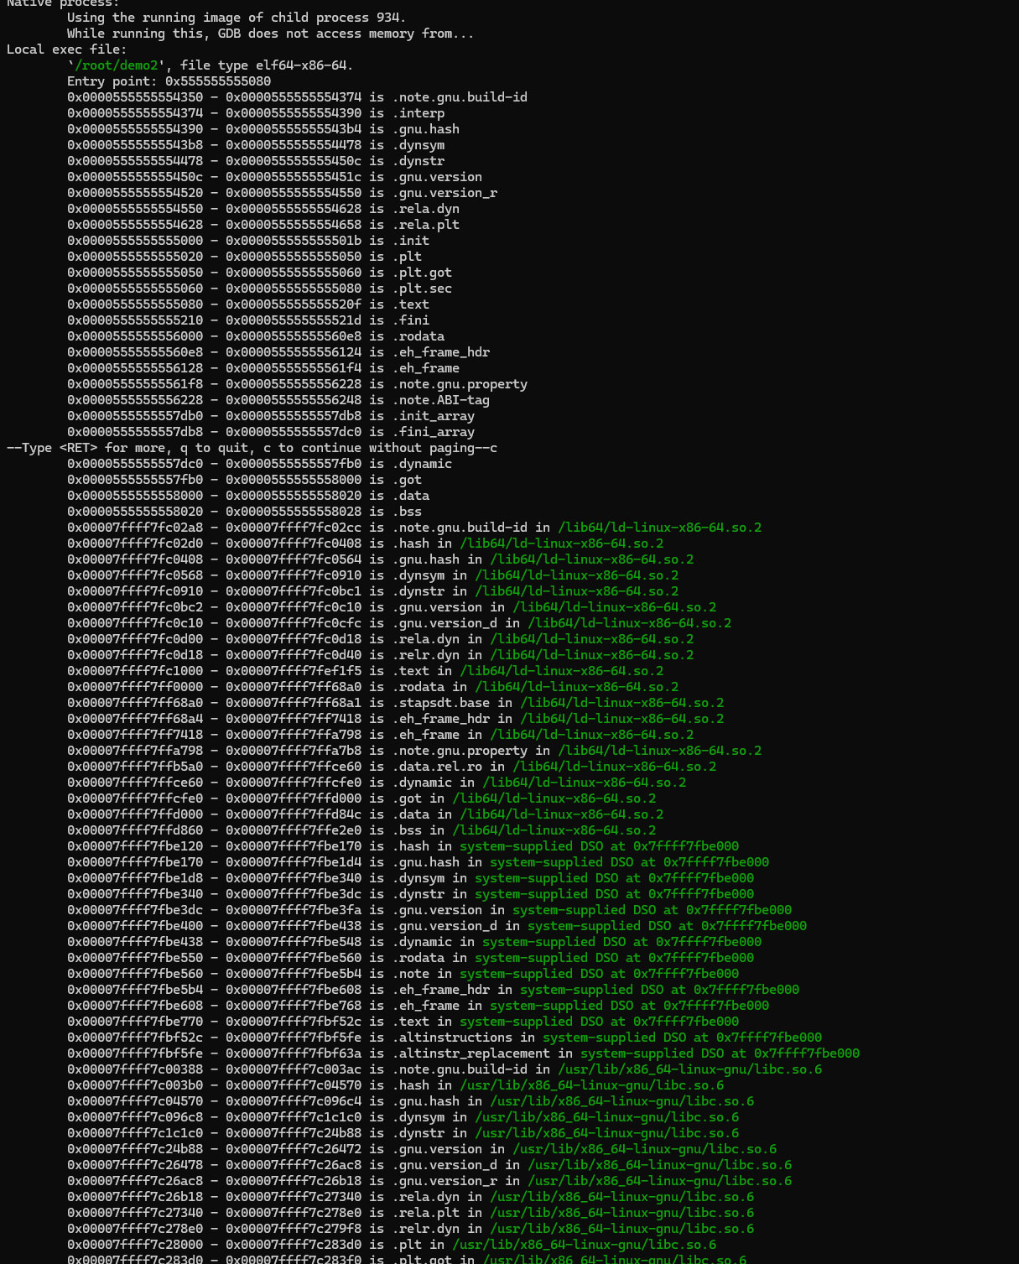
Figure 3-gbd info files

7. Task D – Auditing Initialized Data Memory Layouts
The following GDB commands were used to inspect the stored global value and string:
(gdb) print &data_global_var
(gdb) x/wx &data_global_var
(gdb) print text_string_literal
(gdb) x/s text_string_literal
(gdb) print &text_string_literal
The supplied trace shows:
$1 = (int *) 0xaaaaaaac0010 <data_global_var>
0xaaaaaaac0010 <data_global_var>: 0x12345678
$2 = 0xaaaaaaaa0888 " Text_Segment_Verification"
0xaaaaaaaa0888: " Text_Segment_Verification"
$3 = (const char **) 0xaaaaaaac0018 <text_string_literal>
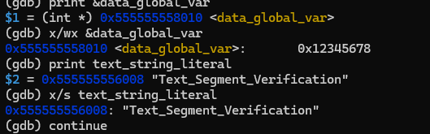
Figure 4-gdb memory examination

8. Task D Analysis – Byte Order
The examined 32-bit word is displayed by GDB as 0x12345678. On an AArch64 system identified as elf64-littleaarch64, the target uses little-endian byte serialization. Therefore, the individual bytes are stored in memory from the least significant byte to the most significant byte: 78 56 34 12.
This demonstrates the distinction between the numerical value written in source code (0x12345678) and the order in which its bytes are serialized in memory.

9. Task E – Workspace Demobilization
(gdb) continue
(gdb) quit
The debugger session was continued and then terminated cleanly.
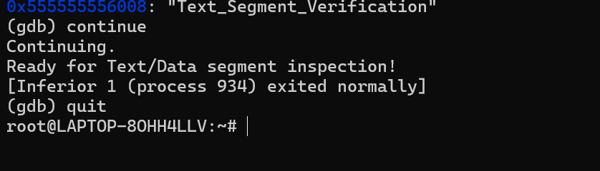
Figure 5- continue, end

10. Segment Address Matrix
Segment | Start | Stop | Observed Object
.text | 0xaaaaaaaa06c0 | 0xaaaaaaaa086c | check_execution @ 0xaaaaaaaa07d8
.rodata | 0xaaaaaaaa0880 | 0xaaaaaaaa0978 | string @ 0xaaaaaaaa0888
.data | 0xaaaaaaac0000 | 0xaaaaaaac0020 | data_global_var @ 0xaaaaaaac0010

11. Post-Lab Technical Assessment
1. Little-Endian or Big-Endian? The system is Little-Endian. The executable is identified as elf64-littleaarch64, and the memory serialization of 0x12345678 follows little-endian ordering, where the least significant byte 0x78 is placed at the lowest memory address, followed by 0x56, 0x34 and 0x12.
2. Why separate .text and .rodata if both are read-only? Although both sections can be protected against writes, they have different roles and access characteristics. .text contains executable instructions and is primarily consumed by the processor's instruction-fetch path and instruction cache (I-Cache), while .rodata contains data such as string literals and constants that are accessed through ordinary data-memory operations. Keeping them separate allows the operating system and linker to apply appropriate memory permissions and mapping attributes, supports efficient paging and cache behavior, and maintains a clear boundary between executable code and read-only data.

12. Conclusion
This laboratory successfully demonstrates how a compiled C program is divided into distinct ELF sections. The runtime addresses and linker map show that executable instructions are placed in .text, the string literal is placed in .rodata, and the initialized global variable is placed in .data. GDB provides direct evidence of these mappings through runtime addresses and memory examination commands. The examined target is an AArch64 64-bit little-endian environment, and the observed section boundaries are consistent with the corresponding runtime addresses.

END OF LABORATORY REPORT

