C:\Users\admin>hostname DESKTOP-I53U2KN

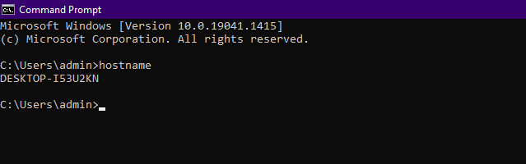

C:\Users\admin>ipconfig

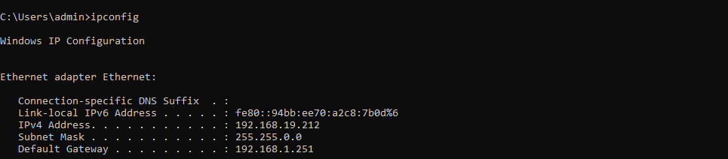

C:\Users\admin>ipconfig/all

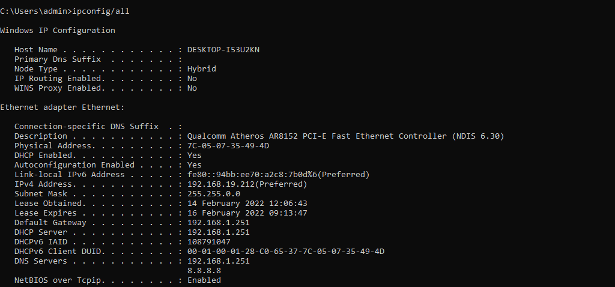

C:\Users\admin>nslookup

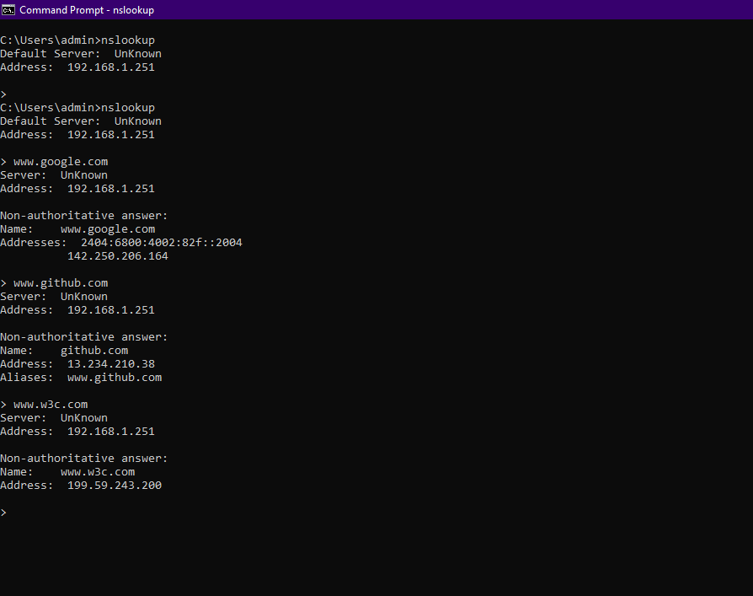

C:\Users\admin>ping [www.google.com](http://www.google.com/)

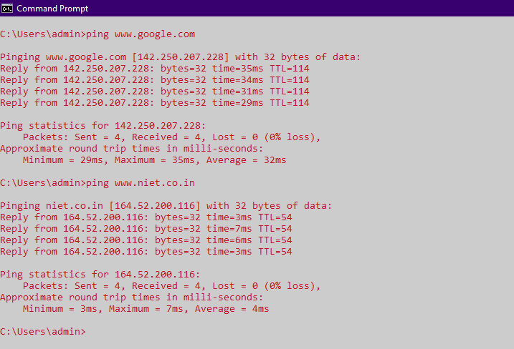

C:\Users\admin>tracert [www.google.com](http://www.google.com/) C:\Users\admin>tracert [www.niet.co.in](http://www.niet.co.in/)

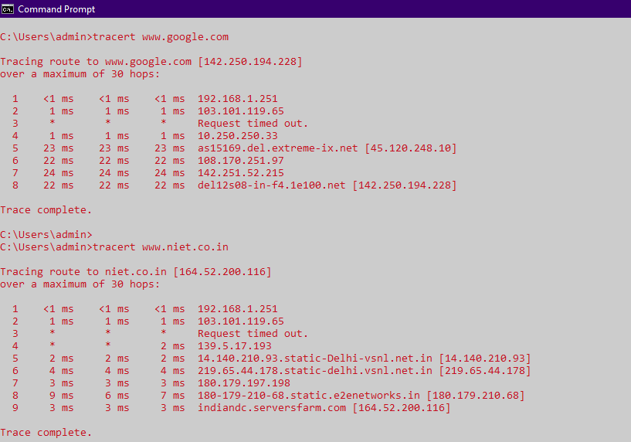

C:\Users\admin>systeminfo

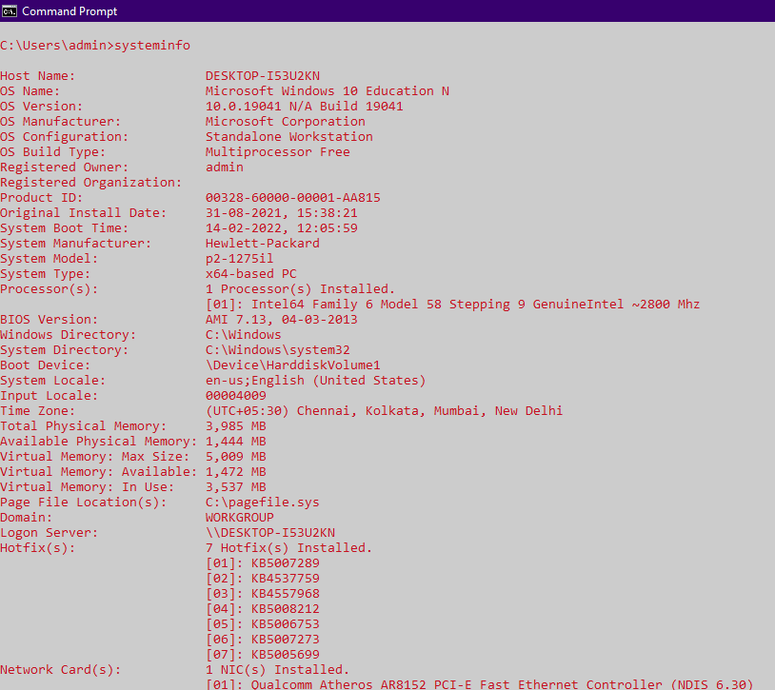

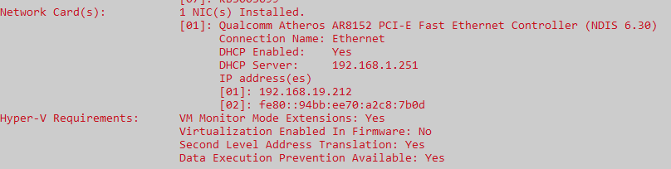

C:\Users\admin>netstat

