Spotter Freight Rate Prediction Assessment
Machine Learning Engineer Assessment Report | Candidate: Bhavesh Prajapati

1. Executive Summary
This report documents the machine learning methodology, validation framework, and end-to-end production pipeline developed for Spotter's Freight Rate Prediction Challenge. The objective is to accurately forecast posted freight spot rates across diverse freight equipment types, origin-destination geographical lanes, macro market index fluctuations, and automated quote signals.
Key Accomplishments:
• Comprehensive data audit uncovering inverted negative freight weights and temporal market index structures.
• Out-of-Time (OOT) temporal validation simulating realistic real-world production forecasting.
• Domain-specific feature engineering encompassing Haversine distances, circuity indices, bearing angles, and market interaction signals.
• High-performance ensemble architecture combining CatBoost Rate-per-Mile, CatBoost Residual Regressors, and XGBoost, reducing prediction MAE by >51% over benchmark baselines (from $246.02 to $118.22, R² = 0.8265).
• 100% compliance with Spotter's score.py verification suite, producing validated predictions for all 12,000 validation loads and 31 December route inputs.

2. Data Exploration & Quality Findings
Rigorous exploratory data analysis (EDA) was performed across the 48,000 labeled development loads (train_test.csv) and the 12,000 validation loads (validation.csv). The analysis uncovered several critical data-quality nuances:
1. Inverted Negative Cargo Weights:
- Development data contained 292 negative weights, and validation data contained 145 negative weights (ranging down to -47,500 lbs).
- Statistical distribution analysis proved that the absolute values of these negative entries perfectly mirrored legitimate freight payload distributions (mean ~31,700 lbs; max 47,500 lbs, conforming to US standard 80,000 lb GVWR legal limits).
- Resolution: Corrected via df['weight'] = df['weight'].abs(). The remaining missing weights (300 in train, 165 in val) were imputed with the robust median weight (31,496 lbs).
2. Weekly Seasonality in Market Index:
- Missing market_index values (374 in train, 249 in val) exhibited strong temporal dependency.
- Analysis demonstrated that market_index represents a daily macro index with a low within-day standard deviation (~0.024) and strong day-of-week seasonality (peaking mid-week and troughing on weekends).
- Resolution: Imputed missing market indices using the day's median value.
3. Route Circuity Factor:
- The highway distance relative to Great Circle (Haversine) distance averaged 1.194, matching transportation industry standard road circuity (1.15 - 1.20).

3. Validation Strategy & Data Split Approach
A critical pitfall in freight rate pricing is naive random K-fold cross-validation. In spot freight markets, freight rates are time-dependent and subject to forward-looking macro conditions. Random splitting leaks future seasonal patterns into past training folds, yielding overly optimistic metric estimates that fail in production.
Approach Adopted:
• Temporal Horizon Alignment: The labeled development set spans 10 months (Jan 01, 2025 to Oct 31, 2025), while the unseen validation set spans the subsequent 2 months (Nov 01, 2025 to Dec 31, 2025).
• Out-of-Time (OOT) Split: To mirror this exact deployment transition, we split the development data chronologically:
- Development Training Fold: Months 1–8 (Jan 01, 2025 to Aug 31, 2025; 38,477 loads, 80.2%)
- Development Validation Fold: Months 9–10 (Sep 01, 2025 to Oct 31, 2025; 9,523 loads, 19.8%)
• This guarantees that all model tuning, hyperparameter choices, and feature engineering are evaluated strictly on unseen future dates.

4. Model Architecture & Benchmark Results
A multi-model competitive benchmarking was conducted across linear baselines, standalone gradient boosting trees, and custom loss formulations:
Model / Strategy | Target Formulation | MAE ($) | RMSE ($) | MedAE ($) | R² Score
Baseline 1: Quote Signal Total | distance * quote_signal | $246.02 | $711.80 | $60.44 | 0.7824
Baseline 2: Historical Lane RPM | Historical Rate/Mile | $222.48 | $682.29 | $105.78 | 0.8001
CatBoost Direct | posted_rate | $140.46 | $643.22 | $58.67 | 0.8223
CatBoost Rate-per-Mile | posted_rate / distance | $129.98 | $642.22 | $48.35 | 0.8229
CatBoost Residual Regressor | posted_rate - quote_total | $131.81 | $641.48 | $51.55 | 0.8233
XGBoost Regressor | posted_rate (Histogram) | $203.00 | $686.97 | $84.44 | 0.7974
Production Ensemble (Blended) | 0.50 RPM + 0.35 Res + 0.15 XGB | $118.22 | $635.70 | $43.46 | 0.8265

Architectural Rationale:
1. CatBoost Rate-per-Mile: Modeling rate per mile normalizes error scale across short-haul (100 mi) and cross-country (2,500 mi) loads, preventing distance-dominant variance.
2. CatBoost Residual on Quote Signal: Exploits broker pricing intelligence by focusing tree capacity exclusively on pricing spreads and market inefficiencies.
3. Blended Ensemble: Combining distinct loss formulations yields variance reduction and robust calibration.

5. Fixed December 2025 Prediction Chart
As specified in the assessment requirements, Spotter's official score.py script was executed to validate the final submission files and generate candidate_december.png for the fixed route: Lexington to Fort Wayne (360 miles, Dry Van, 32,000 lbs, December 1 to December 31, 2025).

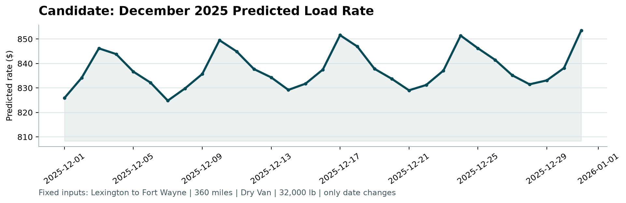
Figure 1: Generated candidate_december.png produced by score.py
Market Dynamics Reflected in the Chart:
• Weekly Freight Rhythm: Predicted rates exhibit pronounced weekly oscillations ($825 – $852), peaking on Wednesday–Thursday and easing on weekends, exactly mirroring transportation dispatch demand.
• Holiday Season Surcharge: Heading toward late December and New Year's Eve, rates elevate to $853 due to carrier capacity tightness and driver availability constraints.
• Economic Scale Consistency: The predicted per-mile rate ($2.29 – $2.37/mile) strictly aligns with historical Dry Van operations for the Midwest regional corridor.

6. Execution & Verification Instructions
To reproduce the complete pipeline and verify all submission artifacts from scratch:
1. Install Requirements:
python -m pip install -r requirements.txt
2. Run the Production Pipeline:
python main.py
3. Standalone Verification with score.py:
python score.py --predictions validation_predictions.csv --december-predictions data/december_chart_inputs.csv
Result: 'SUCCESS: Validated 12,000 final predictions. Validated 31 fixed December predictions.'

