A typical application development tools contains layered approach as shown in below –

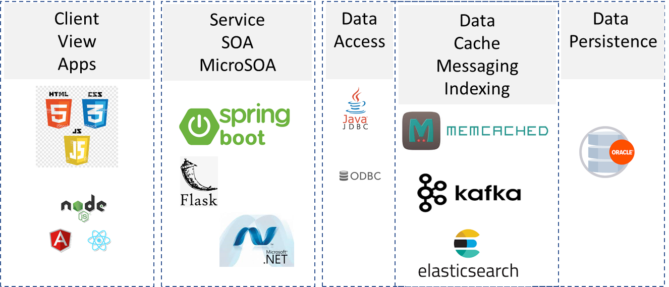

This is only illustration. In reality the tech stacks are very vast if you put them together. But for a given application its basically one one in each of the layer.

Below is the deployment over AWS cloud artifacts –

