MINI-PROJECT REPORT
LumiTrack
Real-Time Motion-Responsive Virtual Lighting System
using Classical Image and Video Processing
Course: Image and Video Processing
Student Name(s) | Prerna Prajapati
Roll Number(s) | H006
Programme / Semester / Division | MBA tech CE 5th semester
Faculty Name | Dr. RajGaurav Mishra
Institute / Department | NMIMS INDORE
Academic Year | 2026-27

Abstract
Lighting that follows a moving subject normally needs motorised fixtures and an operator, which is out of reach for classrooms, video calls and small stages. LumiTrack is a desktop application that creates such a light in software from an ordinary webcam or video file. Each frame is converted to grayscale, smoothed with a Gaussian filter and compared with a running-average background. The difference is thresholded, cleaned with morphological opening and closing, and the largest contour is located. Its centroid, computed from image moments and smoothed exponentially, positions a radial mask that is Gaussian-blurred, tinted warm, cool or white and alpha-blended with a dimmed copy of the frame. No machine learning is used.
On a 12-second 640×480 test clip with known ground truth, motion was detected in 100 % of frames, the raw centroid had a median error of 3.1 px, and one frame was processed in 15.8 ms (about 63 frames/s) on a 2-vCPU CPU. Stress tests also exposed failure cases: a stationary subject fades into the background and a learnt object leaves a “ghost”.
Keywords: motion detection, background subtraction, morphological filtering, image moments, alpha blending, OpenCV.

1. Introduction

1.1 Background of the problem
In theatre, television and film, a follow-spot operator keeps a pool of light on a performer as they move. Automated moving-head lights do the same job but need tracking hardware, control software and a budget. Most everyday video situations – an online lecture, a classroom presentation, a small stage show, a video call – have only a plain webcam and uneven room light, so the person speaking is not visually separated from the background.

1.2 Why the problem is relevant
Directing the viewer’s attention to the moving subject improves the legibility of lectures, demonstrations and streams, and gives low-budget productions a polished look. A software solution needs no extra equipment, can be switched on at any time, and works on recorded footage as well as live video. The same machinery – detecting and locating motion – is also the first stage of surveillance, people counting and interactive installations, so understanding it has wider value.

1.3 Role of image and video processing
Both halves of the problem are image-processing problems. Finding the subject is a segmentation task: separate the pixels that change over time (foreground) from those that do not (background), using grayscale conversion, filtering, differencing, thresholding and morphology, then reduce the foreground to a single position with contour analysis and image moments. Lighting the subject is an image-synthesis task: build a soft radial mask with a Gaussian filter, change brightness and colour channel by channel, and composite the lit and dimmed versions with alpha blending. Because frames arrive continuously, temporal operations (running-average background, exponential smoothing of the trajectory) are needed to keep the result stable.

1.4 Motivation for selecting the project
The project was chosen because it exercises most of the techniques of the Image and Video Processing course inside one working, visible system, and because its result is immediately intuitive: the light either follows the person or it does not. It was deliberately restricted to classical methods, with no trained model, so that every step can be explained, measured and tuned, and so that it runs in real time on an ordinary laptop CPU without a GPU or internet connection.

2. Problem Statement and Objectives

2.1 Real-world problem
- Follow-spot lighting needs expensive motorised lights and a human operator.
- Presenters, teachers and small-stage performers using only a webcam have no simple way to keep attention on themselves as they move.
- Problem: design a low-cost software system that, from a webcam or video file and using only traditional image-processing methods, detects where movement occurs and automatically renders a smooth, realistic virtual light that follows it in real time.

2.2 Objectives
The objective of this project is to detect the largest moving region in a live or recorded video using background differencing and morphological filtering, and to render a soft, colour-adjustable virtual spotlight that follows it in real time. Specifically:
- Capture frames from a webcam or video file and show the original, motion-mask and processed views in a responsive GUI.
- Detect moving regions using grayscale conversion, Gaussian filtering, running-average background differencing, thresholding and morphological opening/closing.
- Locate the centre of the largest moving region with contours and image moments, and smooth the trajectory so the light glides rather than jumps.
- Generate a soft radial light with a Gaussian-blurred circular mask and blend it with the frame using warm, cool or white colour, brightness gain and alpha compositing, with adjustable intensity and radius.
- Evaluate the system quantitatively (detection rate, position error, mask overlap, frame time) and identify the conditions in which it fails.

3. Scope of the Project

3.1 What the project covers
- Input from a webcam (DirectShow backend on Windows) or an uploaded video file, optionally looped.
- Motion detection with classical image processing and tracking of the single largest moving region.
- Virtual lighting: radial soft mask, warm / cool / white tint, intensity, radius and ambient-dimming controls, and a motion-threshold control.
- A Tkinter desktop GUI with live Original, Processed and Motion-Mask views, live statistics (FPS, centre, area), screenshot capture, MP4 recording and a reset button.
- Automatic unit tests of the detector and renderer, and a quantitative evaluation on a clip with known ground truth.

3.2 What the project does not cover
- Recognition of what is moving – no face, person or object detection, no machine or deep learning.
- Tracking several subjects with several lights: only the largest moving region receives light.
- Tracking subjects that stand perfectly still, shadow removal, 3-D or depth-aware lighting, and audio-driven effects.
- Quantitative evaluation on real webcam footage or public benchmarks (see Chapter 9, Dataset limitations).

3.3 Type of images / videos used
Colour (BGR) video, resized to a working width of 640 px, from a fixed camera with a mostly static background. The evaluation uses a 640×480, 30 fps, 12-second clip in which a human-like figure moves across a textured grey background, plus controlled variants with noise, flicker, illumination change, a stopped subject, a second object and a learnt “ghost” object.

3.4 Application domain
Education and online teaching, video conferencing and live streaming, small stage and presentation effects, interactive art and retail displays, video post-production (a virtual follow-spot), and as a teaching demonstration of motion detection. The same detection stage is directly reusable for surveillance-style motion highlighting.

4. Dataset / Input Description
LumiTrack is a real-time effect rather than a classifier, so it has no training set and no public benchmark that measures “spotlight quality”. Evaluation therefore uses the clip generated by the project’s own script make_test_video.py, whose moving figure follows a known mathematical path. This gives exact ground truth for position and silhouette, which a hand-recorded webcam clip would not. The tool also accepts any user video file or live webcam stream.
Table 1: Description of the input data used for evaluation
Property | Value
Source | Synthetic clip produced by make_test_video.py (OpenCV drawing; fixed random seed 1)
Dataset name | None (project test clip sample_video.mp4); no external dataset
Content | Blurred random-texture grey background (intensity 60–110); a figure (82×140 px orange body + circular head) moving on a sinusoidal path
Number of videos / frames | 1 base video, 360 frames; plus 6 in-memory variants of 360 frames each (Table 2)
Frame resolution | 640 × 480 pixels (processed at 640 px width, so no resizing needed)
Video format / codec | MP4 container, MPEG-4 Part 2 (mp4v), 3 colour channels, 8 bit
Frame rate and duration | 30 fps, 12.0 s (file size 322 KB)
Live input | Webcam via cv2.VideoCapture (indexes 0, 1); frames resized to 640 px width and mirrored

Table 2: Stress-test variants derived from the base clip (same background and figure path)
Variant | Modification
Gaussian noise | Zero-mean Gaussian noise, σ = 15 grey levels, added to every frame
Brightness flicker | Global brightness × (1 + 0.08 sin 2π·3t), i.e. 3 Hz, ±8 %
Illumination jump | All pixels multiplied by 1.7 from t = 6 s (auto-exposure change)
Subject stops | Figure stops moving at t = 4 s and stays still until 12 s
Second object | A smaller green circle (r = 22 px) also moves across the lower part of the frame
Ghost | Figure stands still for the first 2.5 s (so it is learnt as background), then walks away

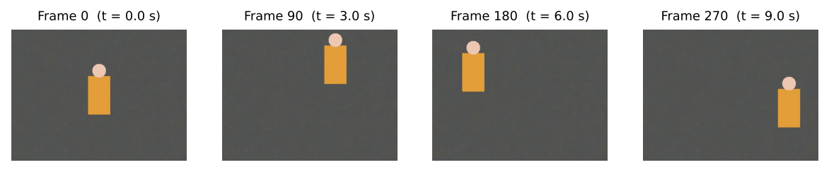
Figure 1: Sample input frames from the base test clip (frames 0, 90, 180, 270).

5. Methodology / Proposed Approach
The system is a three-layer pipeline: an input layer (video_source.py) delivers frames; a processing layer (motion_detector.py, lighting.py) detects motion and renders the light inside a background thread (processor.py); and a presentation layer (app.py) displays the newest result every ~15 ms. Sliders write to a shared settings object that the worker thread reads, so changes act immediately without restarting.
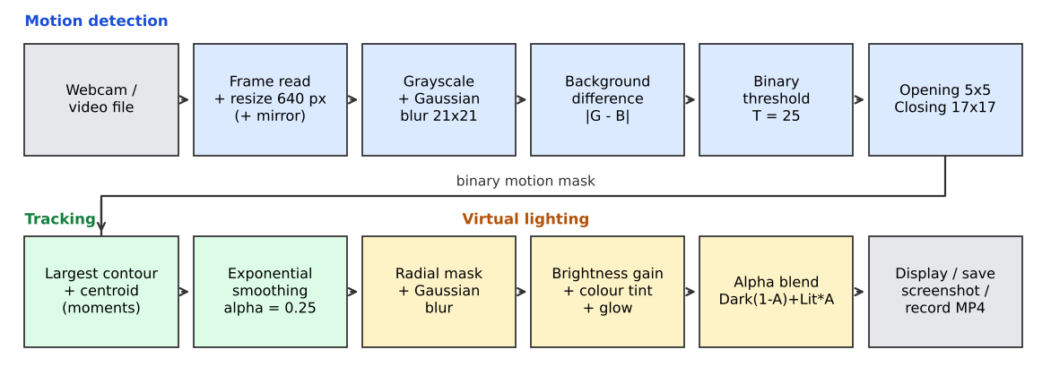
Figure 2: Block diagram of the LumiTrack processing pipeline.

Algorithm (pseudocode)
initialise background B = none; smoothed position S = frame centre; presence p = 0
for each frame F from the webcam / video file:
resize F to width 640; mirror it if it comes from a webcam
G = GaussianBlur( Grayscale(F), 21x21 )
if B is none: B = G; continue
D = | G - B | # background differencing
M = (D > T) ? 255 : 0 # binary threshold, T = 25 (adjustable)
B = (1 - a)*B + a*G # a = 0.5 for 15 warm-up frames, then 0.02
if warm-up or count(M) > 60 % of pixels: relearn / skip; continue
M = Closing( Opening(M, ellipse 5x5), ellipse 17x17 )
C = largest external contour of M
if area(C) >= 0.3 % of frame:
(cx, cy) = (m10/m00, m01/m00) # centroid from image moments
S = 0.25*(cx, cy) + 0.75*S # exponential smoothing
p = min(1, p + 0.25)
else: p = max(0, p - 0.03) # light fades when nothing moves
A = GaussianBlur( filledCircle(S, radius R) ) # soft mask, 0..1
Lit = F * (1 + 0.8k) * tint + glow * 0.18k # k = intensity / 100
Dark = F * ambient / 100
Out = Dark * (1 - s*A) + Lit * (s*A), s = 0.30 + 0.70*p
show Original | Mask | Out; optionally save screenshot / write MP4

Design choices. (i) A running-average background is preferred to two-frame differencing because it yields complete silhouettes rather than only moving edges. (ii) A fast learning rate for the first 15 frames builds the reference quickly; the slow rate afterwards (2 %) absorbs gradual lighting drift. (iii) A global-change test (more than 60 % of pixels changed) treats exposure jumps as scene changes instead of one giant object. (iv) The mask is built at quarter resolution and enlarged, because large Gaussian blurs are expensive and the mask is smooth anyway.

6. Techniques / Algorithms Used

6.1 Image processing techniques
Table 3: Image-processing techniques used in LumiTrack
Technique | Where / parameters | Purpose
Grayscale conversion | cvtColor; Y = 0.299R + 0.587G + 0.114B | Single intensity channel: 3× less data; motion found from brightness change
Gaussian filtering | 21×21 before differencing; on the light mask (kernel ≈ 2.4 × radius) | Suppress sensor noise; give the spotlight a soft, natural edge
Thresholding | THRESH_BINARY, T = 25 (slider 5–80) | Segment changed pixels (foreground) from unchanged ones
Morphological operations | Opening (5×5 ellipse), then closing (17×17 ellipse) | Remove small specks; fill holes inside the moving region
Image segmentation | Differencing + threshold + contours (findContours, RETR_EXTERNAL) | Isolate connected moving regions; keep the largest
Feature extraction | Contour area, bounding box, centroid from moments m10/m00, m01/m00 | Reduce the region to the position that drives the light
Colour / brightness adjustment | Per-channel BGR gain (warm / cool / white), gain 1 + 0.8k, additive glow | Create coloured, brighter light inside the mask
Alpha blending | Out = Dark·(1 − A) + Lit·A | Composite lit and dimmed images through the soft mask
Resizing / interpolation | INTER_AREA for shrinking frames, INTER_LINEAR for the ¼-size mask | Fixed cost per frame; fast mask generation

Histogram equalisation, edge detection and the DFT/DCT are not used in this project: the task needs change detection rather than contrast enhancement or edge maps, and a spatial-domain Gaussian is cheaper than frequency-domain filtering at this kernel size.

6.2 Video processing techniques
Table 4: Video-processing techniques used in LumiTrack
Technique | Where / parameters | Purpose
Frame extraction | cv2.VideoCapture.read() in a worker thread; video files paced at their native fps | Obtain a continuous stream of frames without freezing the GUI
Background subtraction (running average) | accumulateWeighted, rate 0.5 (15 frames) then 0.02 | Adaptive reference image; separates moving from static content
Motion detection | absdiff + threshold + area test (≥ 0.3 % of frame) | Decide whether something is moving in each frame
Global-change detection | > 60 % of pixels changed → relearn background | Handle camera auto-exposure jumps
Object tracking (single object) | Largest-contour centroid + exponential moving average, α = 0.25 | Follow the subject; low-pass filter the trajectory (stops jitter)
Temporal presence fading | Presence +0.25 on motion, −0.03 per idle frame; light strength 0.30 + 0.70·presence | Dim the light smoothly when motion stops
Video writing | cv2.VideoWriter, mp4v; 20 fps for webcam | Save the processed video

Optical flow, Kalman filtering and learned trackers were not used; they are listed as future scope. The smoothing step plays the role of a very simple tracker: the new state is a weighted blend S = αC + (1 − α)S of the measurement C and the previous state.

7. Implementation
Table 5: Implementation environment
Item | Details
Programming language | Python 3 (project supports 3.9–3.12; the experiments in this report were run with Python 3.13)
Libraries / frameworks | OpenCV (opencv-python ≥ 4.5; results here use 5.0.0), NumPy (2.5.3), Pillow (image → Tk conversion), Tkinter (GUI), threading, unittest; Matplotlib 3.11.2 for the report’s plots
Tools | Visual Studio Code, venv, pip; PyTorch / deep-learning frameworks are not used
Hardware | Evaluation machine: 2 vCPU Intel Xeon @ 2.1 GHz, 7 GB RAM, no GPU. Any laptop with a webcam is enough to run the application
Code size | ≈ 970 lines in 6 modules in lumitrack/, plus main.py, a 4-test unit-test file and a test-video generator

Table 6: Module structure
Module | Responsibility
video_source.py | Wraps cv2.VideoCapture for webcam (tries indexes 0, 1 with DirectShow, then default backend) or file; exposes read, rewind, release
motion_detector.py | MotionDetector.process(frame): grayscale → blur → differencing → threshold → morphology → contours → centroid → smoothing; returns a MotionResult
lighting.py | SpotlightRenderer: radial mask, Gaussian blur, tint, glow, dimming and alpha blending
processor.py | VideoProcessor thread: read, resize, detect, render, record; publishes the latest FrameData under a lock
app.py, config.py | Tkinter dark-theme GUI (buttons, sliders, three views, statistics); constants and the shared Settings object

Important implementation steps
- Python, OpenCV, NumPy, Pillow and Tkinter were installed in a virtual environment (pip install -r requirements.txt).
- VideoSource opens the webcam or file; every frame is resized to 640 px width (webcam frames are also mirrored).
- MotionDetector learns the background during the first 15 frames, then differences, thresholds, cleans the mask and returns the smoothed centroid of the largest region.
- SpotlightRenderer builds the soft mask at ¼ resolution, enlarges it, and blends the tinted/brightened and dimmed images in float32 before converting back to 8-bit.
- VideoProcessor runs steps 2–4 in a daemon thread; the Tkinter main loop polls it with root.after(), so the window never freezes. A finally: block always releases the camera.
- Unit tests (python -m unittest discover -s tests) check tracking within 25 px, no detection on a static scene, a brighter centre than edge, and warm = red-dominant / cool = blue-dominant. All four pass.
- An evaluation script ran the unmodified MotionDetector and SpotlightRenderer on the test clip and its variants, compared against ground truth, and timed each stage with time.perf_counter.

8. Results and Discussion
All numbers below come from running the project’s own detector and renderer (default settings: T = 25, α = 0.25, radius 110 px, intensity 70 %, ambient 35 %) on the 360-frame test clip. Position error is the Euclidean distance (pixels) between the tracked centre and the exact centroid of the drawn figure; the first 16 frames (background warm-up) are excluded.

8.1 Intermediate processing results
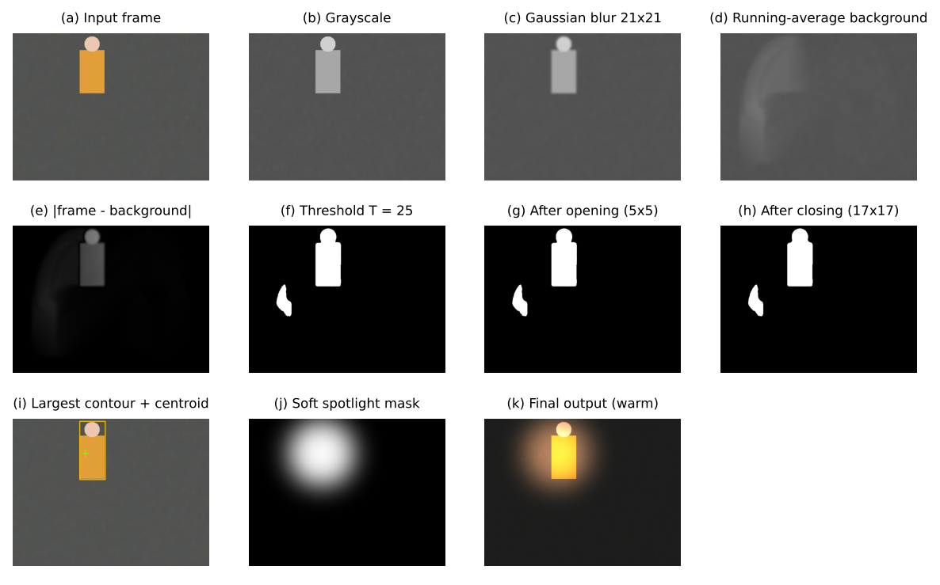
Figure 3: Processing stages for frame 200: (a) input, (b)–(c) grayscale and blur, (d) learnt background, (e) difference, (f) threshold, (g)–(h) morphology, (i) detected region and centroid, (j) light mask, (k) output.
Panel (d) shows the running-average background carrying a faint trail of where the figure has recently been. This trail is why panel (f) contains a second small blob to the left of the figure: pixels the figure just left differ from the slowly updating background. The opening step shrinks and the closing step solidifies the blobs, and the largest-contour rule correctly selects the figure rather than the trail.

8.2 Input versus output
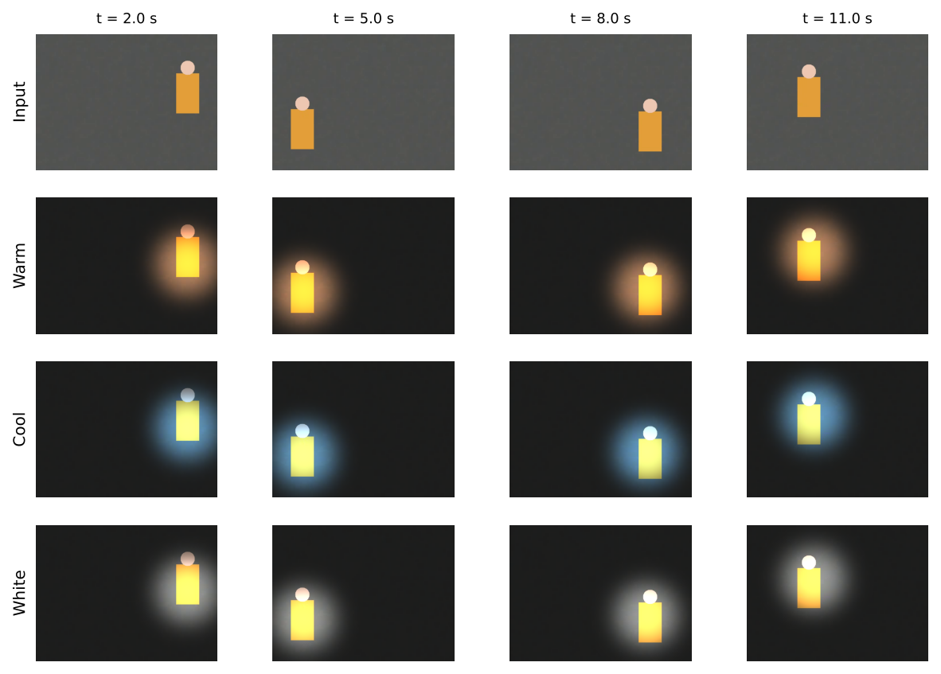
Figure 4: Input frames (top row) and processed output in warm, cool and white modes at t = 2.0, 5.0, 8.0 and 11.0 s.
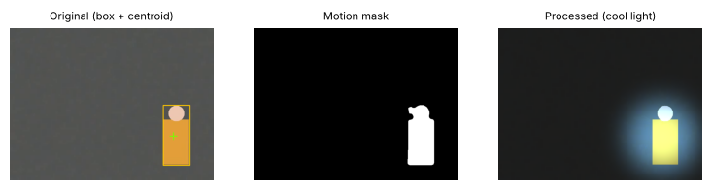
Figure 5: The three views produced by the application for one frame: original with detection box and centroid, motion mask, and processed output.
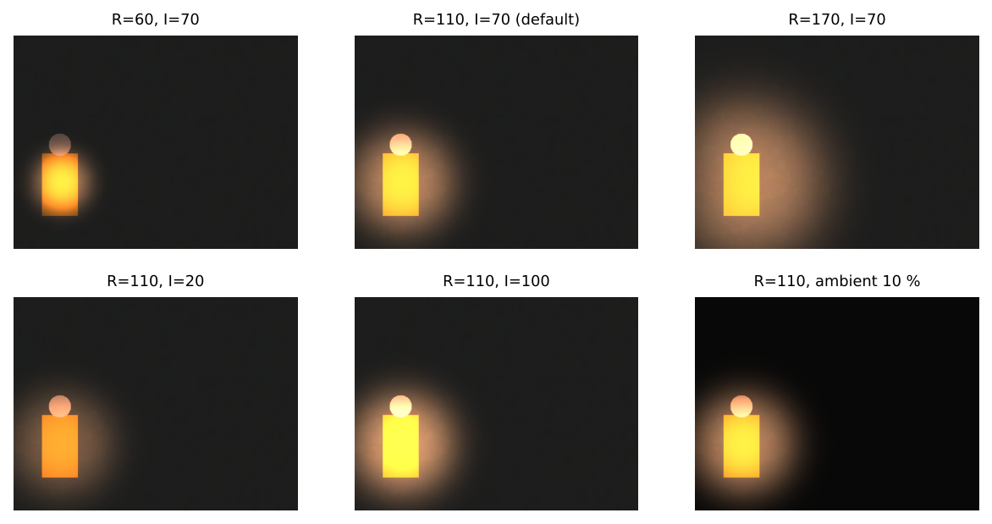
Figure 6: Effect of the user controls: radius (60, 110, 170 px), intensity (20, 70, 100 %) and ambient level (10 %).
The light remains centred on the figure through the whole clip, its colour changes with the mode, and the surroundings are dimmed to the ambient level. Radius changes the size of the lit pool, intensity its brightness and glow, and ambient the contrast between lit and unlit areas.

8.3 Tracking accuracy
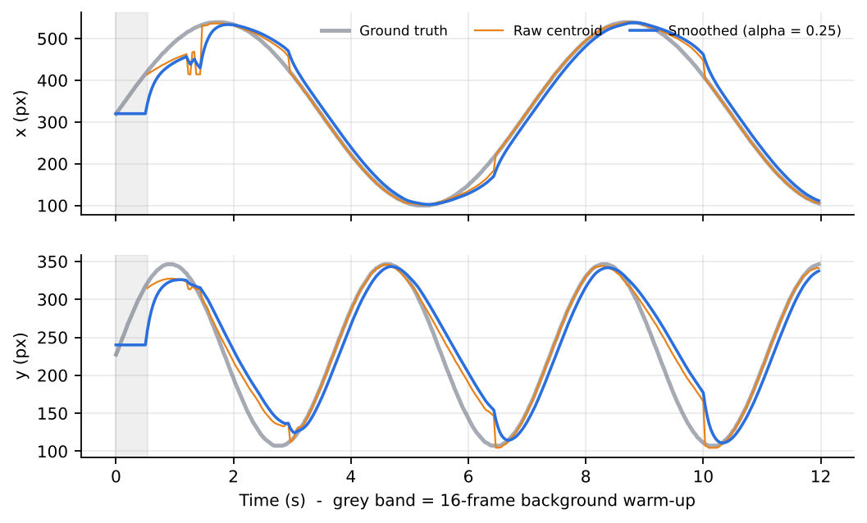
Figure 7: Ground-truth, raw-centroid and smoothed trajectories (x and y) over the 12-second clip.
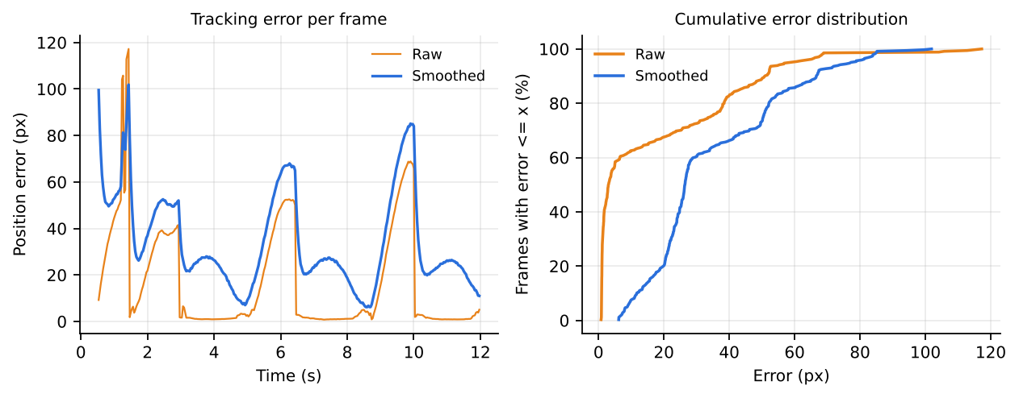
Figure 8: Left: position error per frame. Right: cumulative distribution of the error.
Table 7: Tracking and mask-quality metrics on the base clip (frames 17–360)
Measure | Raw centroid | Smoothed (light position)
Detection rate (frames with motion found) | 100.0 % | —
Mean position error (px) | 17.0 | 34.7
Median position error (px) | 3.1 | 26.5
95th-percentile error (px) | 58.3 | 77.2
Maximum error (px) | — | 101.9
Frames with error < 25 px | 69.8 % | —
Speed jitter (std of per-frame step error, px/frame) | 9.1 | 2.9
Mask IoU with true silhouette (mean / median) | 0.74 / 0.83 | —
Mask precision / recall | 0.75 / 0.98 | —

The raw centroid is accurate in the typical frame (median 3.1 px) but its mean (17.0 px) is pulled up by short episodes where the trailing background blob briefly attracts the centroid; these appear as the small steps in Figure 7 and the tail of the error distribution. The mask has high recall (0.98) but lower precision (0.75) because the mask includes the wake of recently vacated pixels. Smoothing cuts the speed jitter from 9.1 to 2.9 px/frame, so the light glides, but it adds lag: at the clip’s speeds (up to ≈ 200 px/s) a first-order filter with α = 0.25 trails the subject by roughly v(1 − α)/α ≈ 3 frames of motion, which explains the 26.5 px median error of the light position. The lag is a deliberate trade-off between smoothness and responsiveness (Section 8.4).

8.4 Parameter sensitivity
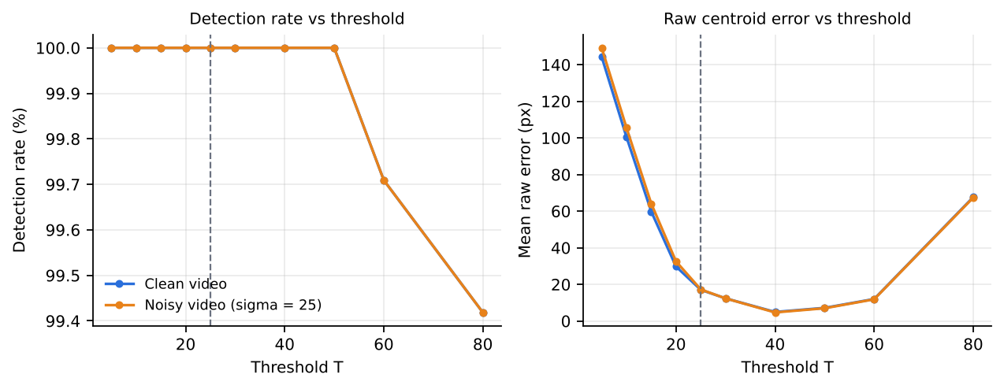
Figure 9: Effect of the motion threshold T on detection rate and raw position error, for the clean clip and a noisy clip (σ = 25). Dashed line: default T = 25.
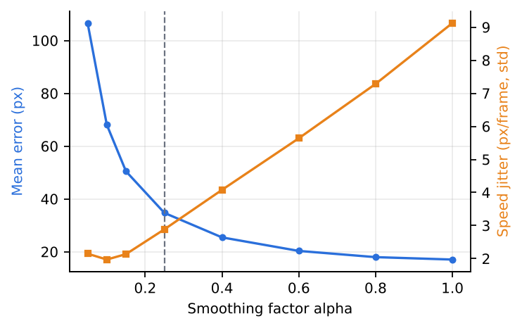
Figure 10: Effect of the smoothing factor α on light-position error (blue) and jitter (orange). Dashed line: default α = 0.25.
Threshold. Very low thresholds (T ≤ 15) include the faint background trail and large parts of the textured background, giving raw errors of 60–145 px. Error is lowest at T = 40–50 (about 5–7 px) and rises again at T = 80 (≈ 68 px) as the subject itself starts to be missed. The default T = 25 is therefore not optimal for this high-contrast synthetic subject (raw error 17.0 px at T = 25 versus 4.9 px at T = 40); it is a more conservative choice for real, lower-contrast subjects, and the GUI slider lets the user raise it. The curves for the clean and noisy clips are almost identical, showing that the 21×21 Gaussian blur already removes this noise.
Smoothing factor. Error falls from 107 px at α = 0.05 to 17 px at α = 1 (no smoothing), while jitter rises from 2.1 to 9.1 px/frame. α = 0.25 gives a middle point (34.7 px, 2.9 px/frame): visibly smooth but with a lag of a few frames.
Table 8: Ablation of the morphological step (mean mask IoU / detection rate, %)
Configuration | Clean clip | Noisy clip (σ = 25)
No morphology | 0.748 / 100 | 0.747 / 100
Opening only (5x5) | 0.750 / 100 | 0.750 / 100
Closing only (17x17) | 0.740 / 100 | 0.733 / 100
Opening + Closing (used) | 0.744 / 100 | 0.741 / 100

On this synthetic data the morphological step makes no measurable difference (IoU 0.73–0.75 in every configuration) because the Gaussian pre-filter has already removed the noise and the clip has no fine clutter. The step is kept as a safeguard for real webcam noise, but this experiment does not by itself demonstrate its benefit.

8.5 Computational performance
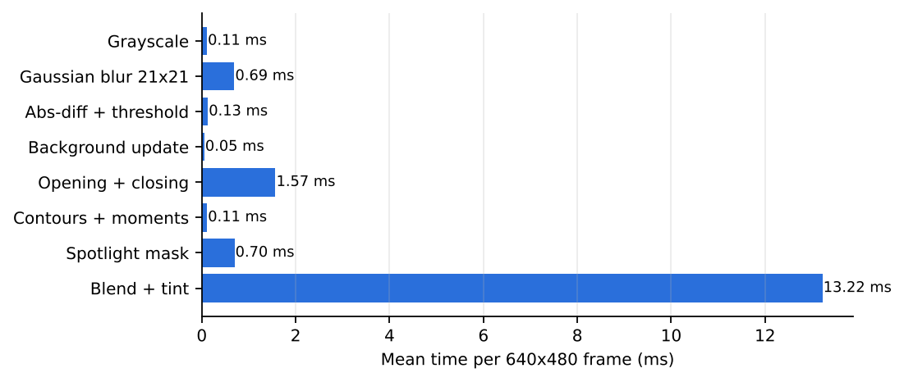
Figure 11: Mean processing time per 640×480 frame for each stage (2-vCPU CPU).
Table 9: Per-frame processing time
Stage | Mean time (ms)
Grayscale | 0.11
Gaussian blur 21×21 | 0.69
Abs-diff + threshold | 0.13
Background update | 0.05
Opening + closing | 1.57
Contours + moments | 0.11
Spotlight mask | 0.70
Blend + tint | 13.22
Whole pipeline (detect + render) | 15.8
Equivalent throughput | 63 frames/s

The whole pipeline takes 15.8 ms per frame, i.e. ≈ 63 frames/s, comfortably above the 30 fps of a typical webcam. Motion detection itself costs only ≈ 2.7 ms; the float32 blend and tint over all three channels costs 13.2 ms, about 83 % of the total, and is the obvious target for optimisation. Video decoding and Tkinter drawing are not included in these figures.

8.6 Robustness under stress conditions
Table 10: Results for the base clip and the stress variants (frames 17–360)
Scenario | Detection rate (%) | Raw mean error (px) | Light mean error (px) | Light max error (px)
Baseline (video file) | 100.0 | 17.0 | 34.7 | 101.9
Gaussian noise (sigma=15) | 100.0 | 17.3 | 35.0 | 99.5
Brightness flicker (3 Hz, 8 %) | 100.0 | 21.6 | 38.7 | 103.3
Sudden illumination jump (x1.7 at 6 s) | 99.7 | 22.5 | 40.5 | 164.0
Subject stops moving at 4 s | 51.7 | 22.8 | 53.7 | 106.0
Second smaller moving object | 100.0 | 19.9 | 37.0 | 106.0
Ghost (object learnt, then leaves) | 82.8 | 29.7 | 35.9 | 207.4

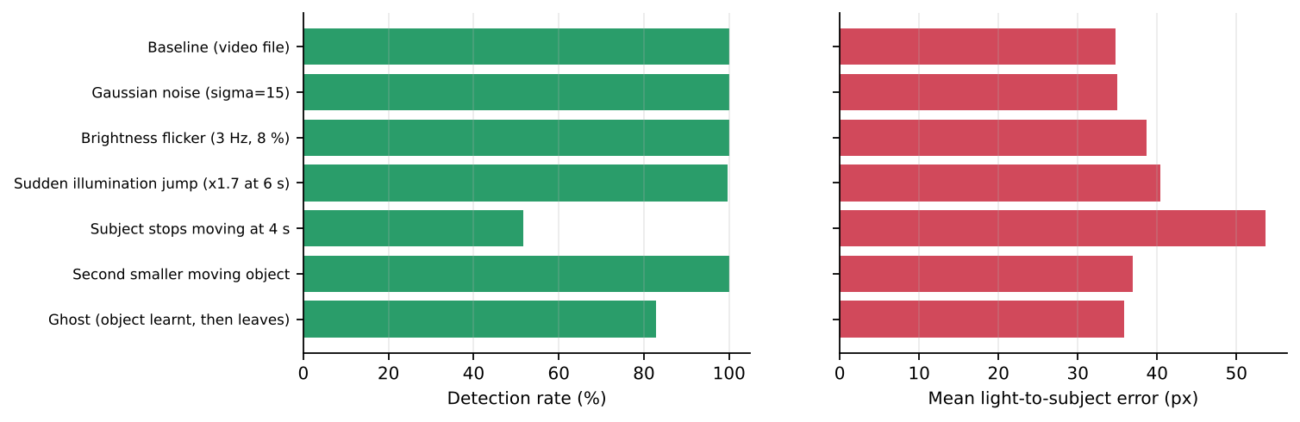
Figure 12: Detection rate (left) and mean light-to-subject error (right) for each scenario.
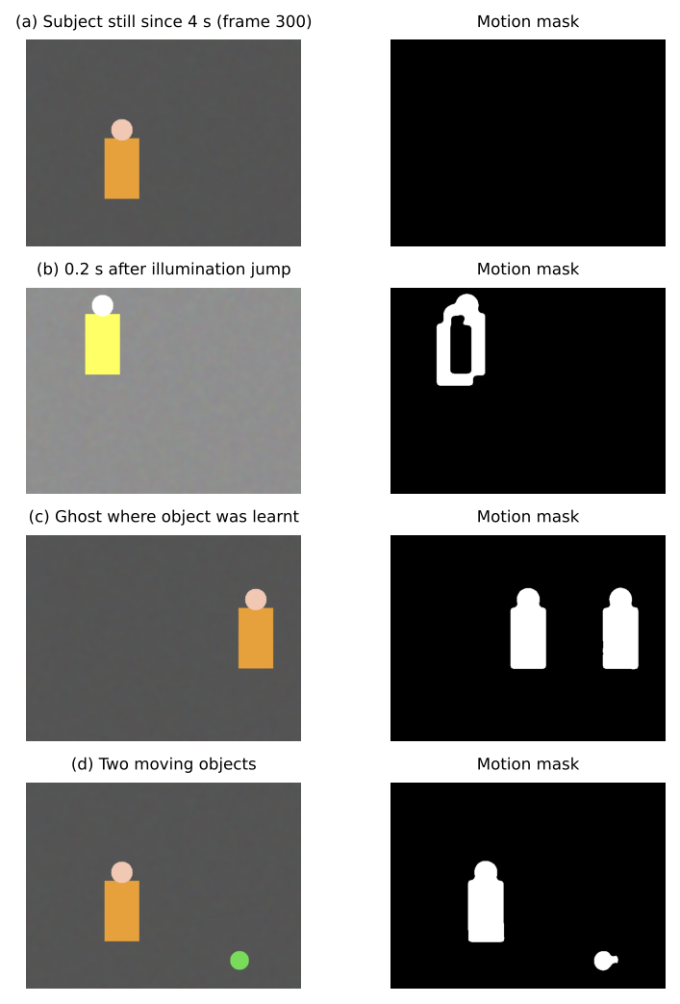
Figure 13: Failure and difficult cases (frame and motion mask): (a) stopped subject, (b) after illumination jump, (c) ghost of a learnt object, (d) two moving objects.
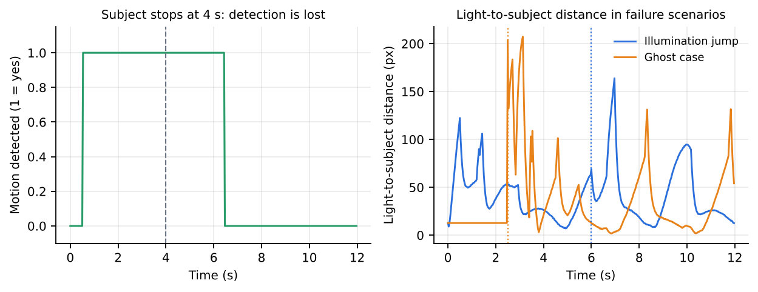
Figure 14: Left: motion detection over time when the subject stops at 4 s. Right: light-to-subject distance in the illumination-jump and ghost scenarios.
Noise (σ = 15) leaves all measures essentially unchanged, and the 8 % flicker raises the raw error moderately (17.0 → 21.6 px) and the jitter (9.1 → 16.1 px/frame). A large illumination jump is caught by the global-change test and detection continues (99.7 %), but for a few frames the freshly relearned background makes the mask hollow (Figure 13b), and the light error peaks at 164 px. When the subject stops, detection continues for about 2.5 s while the background absorbs the figure and is lost from t = 6.4 s; afterwards only 51.7 % of frames have detection and the light stays at the last position. A second, smaller object does not disturb tracking because only the largest region is used, so the second object is never lit. In the ghost case nothing is detected for the first 2.5 s (the still object is learnt as background, hence the 82.8 % detection rate); when it walks away it leaves a false blob that competes with the real subject (Figure 13c) and the light error reaches 207 px.

8.7 Functional testing
The four automatic unit tests pass (0.6 s). The README additionally records an end-to-end run of the GUI and worker thread on a video file: recording produced a valid MP4, and after the window closed the worker thread had ended and the source was released. The live-webcam path uses the same cv2.VideoCapture interface but was not measured in this report.

9. Challenges / Limitations

Problems encountered
- GUI freezing: Tkinter is not thread-safe and per-frame processing blocked the window; solved with a worker thread, a lock-protected “latest frame” slot and polling via root.after().
- Expensive soft mask: a Gaussian blur with a kernel as large as the light is slow at 640×480; building the mask at ¼ resolution and enlarging it keeps the mask cost at ≈ 0.7 ms per frame.
- Exposure jumps: camera auto-exposure changes looked like a giant moving object; solved with the 60 % global-change test and background relearning.
- Webcam access: the camera is released only if every exit path closes it; a finally: block and window-close handler guarantee this. Backend differences (DirectShow) required trying several indexes.

Difficult cases and cases where the method failed
- Stationary subject: absorbed into the background in ≈ 2.5 s; the light then stays at the last position and fades (Figure 13a).
- Ghosts: an object that was present while the background was learnt leaves a false blob when it leaves; error up to 207 px (Figure 13c).
- Sudden illumination change, flicker, shadows and reflections: produce false or hollow masks and extra jitter (Figure 13b, Table 8).
- Multiple subjects: only the largest region is lit (Figure 13d); a larger moving background object would steal the light.
- Trailing mask: the running-average background makes mask precision only 0.75 and lets the centroid briefly jump to the wake (Section 8.3).

Computational and dataset limitations
- Performance depends on the CPU; the 63 frames/s figure is for a 2-vCPU server without display or decoding overhead. Slower laptops are protected by the fixed 640 px working width.
- The evaluation clip is synthetic: one high-contrast figure, a clean textured background, a fixed camera, no real shadows, no camera noise and no compression history beyond MPEG-4. The best threshold (T ≈ 40) and the absence of a morphology benefit may differ on real webcam footage.
- Ground truth comes from the generator, not from human annotation, and only one run per scenario was made; no confidence intervals are reported. No live-webcam measurements are included.

10. Conclusion
What was implemented. LumiTrack, a Python desktop application that watches a webcam or video file, finds the largest moving region and keeps a soft, colour-adjustable virtual spotlight on it, with live original / mask / processed views, adjustable intensity, radius, ambient and sensitivity, screenshots and MP4 recording, and a GUI that stays responsive because processing runs in a background thread.
Techniques used. Grayscale conversion, Gaussian filtering, running-average background subtraction (frame differencing), binary thresholding, morphological opening and closing, contour-based segmentation, centroid extraction with image moments, exponential smoothing of the trajectory, radial mask generation, per-channel colour and brightness adjustment, and alpha blending – all classical, with no machine learning.
What was achieved. On the 360-frame test clip, motion was detected in every frame, the raw centroid had a median error of 3.1 px, the smoothed light followed the subject with a median lag-induced offset of 26.5 px and a threefold reduction in jitter, and each frame was processed in 15.8 ms (≈ 63 frames/s). Sensitivity studies showed how the threshold and smoothing factor trade accuracy against robustness and smoothness, and stress tests identified clear failure modes (stationary subjects, ghosts, illumination jumps) that match the known limits of background subtraction.
Learning. The project showed how a handful of simple operations combine into a working real-time system, and that the numbers matter: default parameters were not optimal on the test clip, and one expected benefit (morphology) could not be shown on clean data. It also taught the practical side of video processing – temporal filtering, thread-safe GUI design, the cost of each stage – and the value of ground-truth tests. Future work includes multiple subjects with several lights, Kalman prediction to remove lag, shadow suppression, adaptive thresholds, and evaluation on real webcam recordings.

References
[1] R. C. Gonzalez and R. E. Woods, Digital Image Processing, 4th ed. New York, NY, USA: Pearson, 2018.
[2] R. Szeliski, Computer Vision: Algorithms and Applications, 2nd ed. Cham, Switzerland: Springer, 2022.
[3] G. Bradski, “The OpenCV Library,” Dr. Dobb’s Journal of Software Tools, 2000. Documentation: https://docs.opencv.org
[4] M. Piccardi, “Background subtraction techniques: a review,” in Proc. IEEE Int. Conf. Systems, Man and Cybernetics, 2004, pp. 3099–3104.
[5] C. Stauffer and W. E. L. Grimson, “Adaptive background mixture models for real-time tracking,” in Proc. IEEE CVPR, 1999, pp. 246–252.
[6] S. Suzuki and K. Abe, “Topological structural analysis of digitized binary images by border following,” Computer Vision, Graphics, and Image Processing, vol. 30, no. 1, pp. 32–46, 1985.
[7] M.-K. Hu, “Visual pattern recognition by moment invariants,” IRE Trans. Information Theory, vol. 8, no. 2, pp. 179–187, 1962.
[8] J. Serra, Image Analysis and Mathematical Morphology. London, U.K.: Academic Press, 1982.
[9] T. Porter and T. Duff, “Compositing digital images,” in Proc. ACM SIGGRAPH, 1984, pp. 253–259.
[10] C. R. Harris et al., “Array programming with NumPy,” Nature, vol. 585, pp. 357–362, 2020.
[11] Python Software Foundation, “tkinter – Python interface to Tcl/Tk” and “threading – Thread-based parallelism,” Python documentation, https://docs.python.org/3/
[12] LumiTrack project source code, README and docs/PROJECT_REPORT.md (course mini-project), 2026.

