**Assignment:-1**

***Module:-1***

**SE—Overview of it industry**

1. **What is software? What is software engineering?**

**Ans.**

* **Software**
* software is a set of instructions, data or programs.
* that is used to operate computers and execute specific tasks.
* It is the opposite of hardware which describes the physical aspects of a computer.
* Software is a generic term used to refer to applications, scripts and programs that run on a device.

**Software Engineering:-**

* **Software engineering** is theprocess of designing, developing, testing and maintaining software.
* it is a systematic and disciplined approach to software development that aims to create high-quality, reliable and maintainable software.
* **Software engineering** includes a variety of techniques, tools and methodologies including requirements analysis, design, testing and maintenance.
* it is a rapidly evolving field and new tools and technologies are constantly being developed to improve the software development process.
* The main goal of software engineering is to develop software applications for improving quality, budget and time efficiency.

1. **Explain types of software**

**Ans.**

* **There are two types of software system.**

1. **System software**
2. **Application software**

* **1)System software:-**
* **System software** is software that directly operates the ***computer hardware*** and provides the basic functionality to the users as well as to the other software to operate smoothly.
* In other words, system software basically controls a computer’s internal functioning and also controls hardware devices such as monitors, printers and storage devices, etc.
* It is like an interface between hardware and user application.
* It help them to communicate with each other because hardware understands machine language whereas user application are work in human-readable language into machine language and vice versa.
* **In system software there are three types of system software.**
* **1) Operating system**
* **2) language processor**
* **3) device driver**
* **Features of system software**
* System software is closer to the computer system.
* System software is written in a low-level language in general.
* System software is difficult to design and understand.
* System software is fast in speed.
* **2)application software**
* **Software** that performs special function or provides functions are much more than the basic operation of the computer is known as **application software.**
* **application software** is designed only to fulfill end-users requirements.
* It includes word processors, **spreadsheets**, database management, inventory, etc.
* **There are three types of application software**

1. **Customized software**
2. **Utility software**

* **Features of application software**
* An important feature of application software is it performs more specialized tasks like word processing, spreadsheet, email, etc.

* Mostly, the size of the software is big, so it requires more storage space.
* Application software is more interactive for the users, so it is easy to use and design.
* The application software is easy to design and understand.
* Application software is written in a high-level language in general**.**

**3) what is SDLC? Explain each phase of SDLC**

**Ans.**

* **SDLC stands for software development life cycle.**
* **software development life cycle** is a structured process that is used to design, devlop, and test good-quality software.
* **software development life cycle** is a methodology that defines the entire procedure of software development step-by-step.

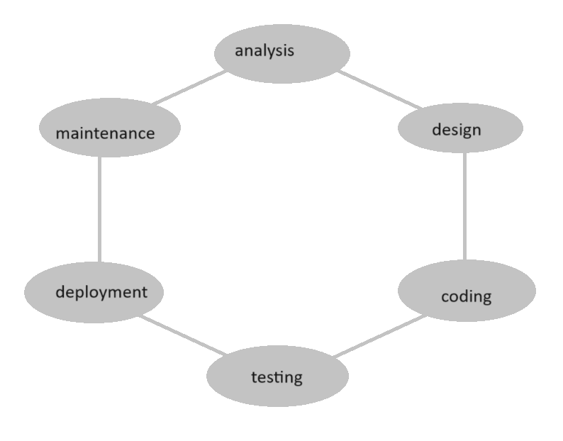

**Software development life cycle**

* The goal of the SDLC life cycle model is to deliver high-quality, maintainable software that meets the users requirements.
* SDLC in software engineering models outlines the plan for each stage so that each stage of the software development model can perform its task efficiently to deliver the software at a low cost within a given frame that meets user’s requirements.
* **SDLC Phases**



* **Given below are the various phases:-**

**1) analysis**

**2) design**

**3) coding or implementation**

**4) testing**

**5) deployment**

**6) maintenance**

**1) analysis:-**

* During this phase, all the relevant information is collected from the customer to devlop a product as per their expectation.
* Any ambiguities must be resolved in this phase only.
* Business analyst and project manager set up a meeting with the customer to gather all the information like what the customer wants to build, who will be the end-user, what is the purpose of the product.
* Before building a product a core understanding or knowledge of the product is very important.

**2) design**

* In this phase, the requirement gathering in the SRS document is used as an input and software architecture that is used for implementing system development is derived

**3) coding**

* Coding starts once the developer gets the design document.
* The software design is translates into source code.
* All the component of the software are implemented in this phase.

**4) testing**

* Testing starts once the coding is complete and the modules are released for testing.
* In this phase, the developed software is tested thoroughly and defects found are assigned to devlopers to get them fixed**.**

**5) deployment**

* Once the product is tested, it is deployed in the production environment first UAT(user acceptance testing) is done depending on the customer expectation.
* In the case of UAT, a replica of the production environment is created and the customer along with the devlopers does the testing.
* If the customer finds the application as expected, then sign off is provided by the customer to go live.

**6) maintenance**

* After the deployment of a product on the production environment, maintenance of the product i.e.
* If any issue comes up and needs to be fixed or any enhancement is to be done is taken care by the devlopers.

**4) What is DFD? Create a DFD diagram on Flipkart**

**Ans.**

* **DFD**
* **DFD** is the abbreviation for **data flow diagram.**
* The flow of data of a system or a process is represented by **DFD**.
* It also given insight into the inputs and outputs of each entity and the process itself.
* **DFD** does not have control flow and no loops or decision rules are present.
* Specific operations depending on the type of data can be explained by a flowchart.

**DFD(data flow diagram)**

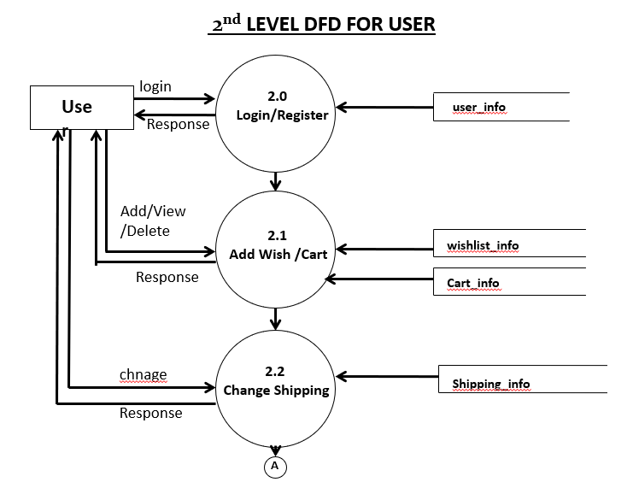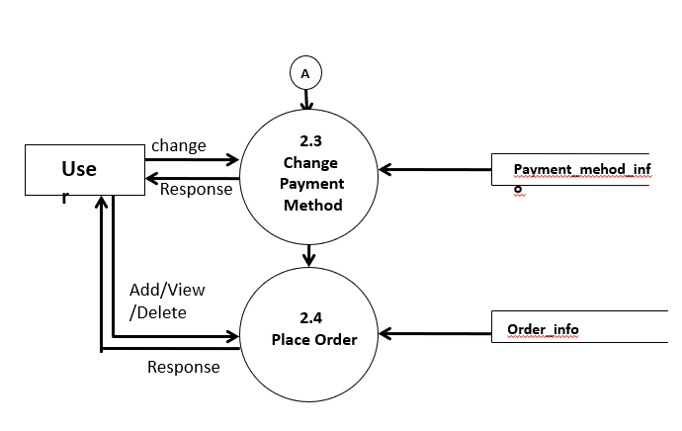

user



**5) what is flow chart? Create a flowchart to make addition of two numbers**

**Ans.**

* **Flow-chart**
* A flow-chart is a diagram that decipts a process, system or computer algorithm
* They are widely used in multiple fields to document, study, plan, improve and communicate often complex processor in clear, easy-to-understand diagrams.
* Flow-chart, sometimes spelled as flow charts, use rectangles, ovals, diamonds and potentially numerous other shapes to define the type of step, along with connecting arrows to define flow and sequence.
* They can range from simple, hand-drawn charts to comprehensive computer-drawn diagram depicting multiple steps and routes.
* **Flow-chart**

A=50

B=20

Sum=50+20

Sum=70

* **Flow-chart diagram**

**6) what is use case diagram? Create a use-case on bill payment on paytm**

**Ans.**

* **Use case**
* a use case is a methodology used is system analysis to identify, clarity and organize system requirement.
* The use case is made up of a set of possible sequences of interections between systems and users in a particular environment and related to a particular goal.
* The method creates a document that describes all the steps taken by a user to complete an activity.
* A use case document can help the development team identify and understand where errors may occur during a transaction so they can resolve them.
* **Use-case**

