**Social GPS**

**BoldeanuSilviu**

**silviu\_boldeanu@yahoo.com**

**Student Nr.: 1156226**

**Pap Melinda**

**pap.melinda@gmail.com**

**Student Nr.:1156244**

**Gómez-Pérez Pablo**

**pablogp87@gmail.com**

**Student Nr.: 1156248**

**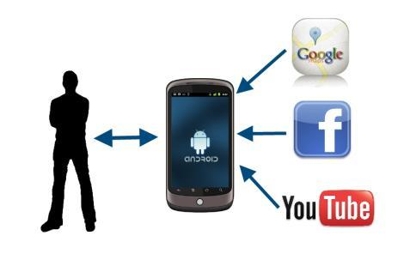**

Contents

1. A document that describes the project with the following sections 3

a. Application Name 3

b. User group and usage model 3

c. Application Description 3

d. Application Category 4

e. Icon for your application 4

f. Main pictures (up to 5) of your application 4

g. An appendix listing the source code with appropriate 5

# 1. A document that describes the project with the following sections

## a. Application Name

SocialGPS

## b. User group and usage model

Any person who is in an unknown city so it has the need to see certain information, such as places of interest, friends, videos or Wikipedia.

Internet connection is required.

## c. Application Description

The goal of the current application is allowing the tourists, professionals, researchers to find more information about the location where they are: friends in town gathered from facebook, information about the town gathered from Wikipedia and also videos from youtube. Moreover, they will be able to see interesting places nearby, like restaurants, banks, café, shops. Giving users the opportunity to set up a route to the selected place. Within a frequency of 15 seconds the position on map will be updated. Therefore, users will see their exact position anytime. The application will also allow users to display those friends of them, who are living, working or studying there in order to send it to them a facebook e-mail, e.g announcing them that they are in town.

The application will start with a general menu from which we have the possibility to click on Geolocation button in order to see the map and start enjoying the application.

Once in the map users will see their current position. If they open the infowindow of users current position marked with the following icon:

smiley_happy

An infowindow will be shown with the exact address of the users location and also the possibility to show any available information about the town/city in Wikipedia as well as in Youtube.

At the bottom there are the following buttons:

* **Places:** This is a select menu, if the user click on it a list of places will appear, all the selected places in the list selected by the user will be appear in the map around the position of the user within a radius of 5Km.

Once the user select the places he wants to see, he will be able to open an infowindo over the place which will give the opportunity to the user to set up a route on the map to that place from the current position of the user as well as to see any available videos on youtube.

* **GetFriends:** From this button we will go the configuration page of facebook to login in order to select the nearby friends we want to see on the map. The first time we log into facebook it will ask us to grant permissions to the socialgps application in order to be able to access our facebook profile.

Once we have friends selected, those will appear on the map with the profile picture as icon. If we click on their picture an infowindo will be opened which will show us the name of the user and the great opportunity to send them a facebook email.

* **Videos:**From this button we will be ableto go to the videos screen in which we will be able to select the category of videos we want to see.The shown videos will be related to the city of our current position.

## d. Application Category

Mashup Web Applicacion. “Write Less Do More”

## e. Icon for your application

## f. Main pictures (up to 5) of your application

## g. An appendix listing the source code with appropriate documentation and comment

### SEQUENCE DIAGRAMS

#### SHOW MY LOCATION,VIDEOS AND WIKI

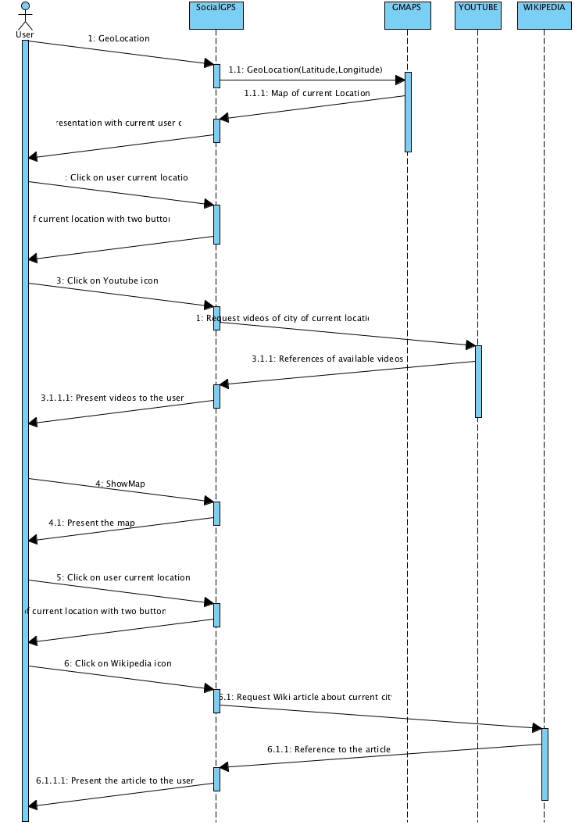

#### SHOW PLACES AND VIDEOS

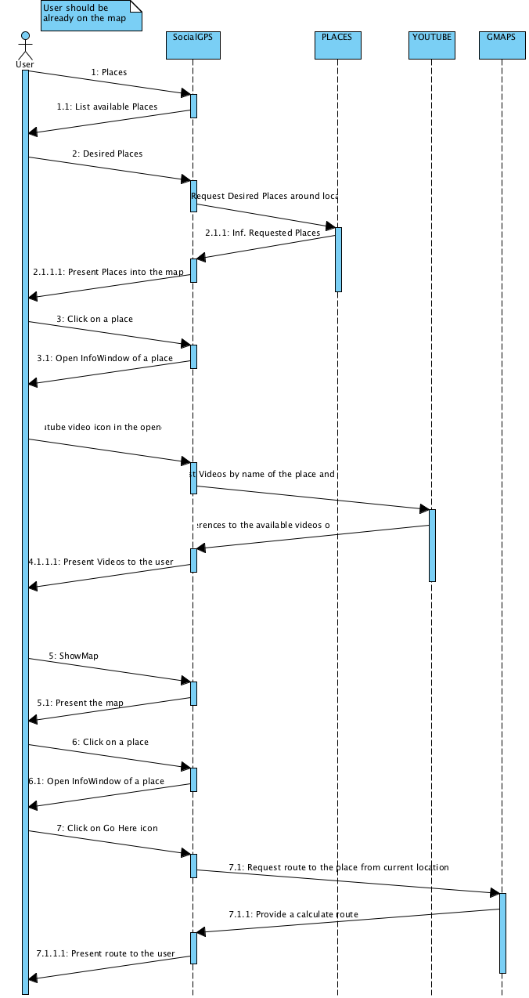

#### FACEBOOK INTERACTION

