CSP-585 Object Oriented Design Patterns

Final Exam Submission

**Design Prototype**

My game is inspired from a lot of other games.

Some of them include Mortal Kombat.

The design Prototype of Arena, Fighter Selection, gameplay , Power Bar and Experience bar and Summary after game.

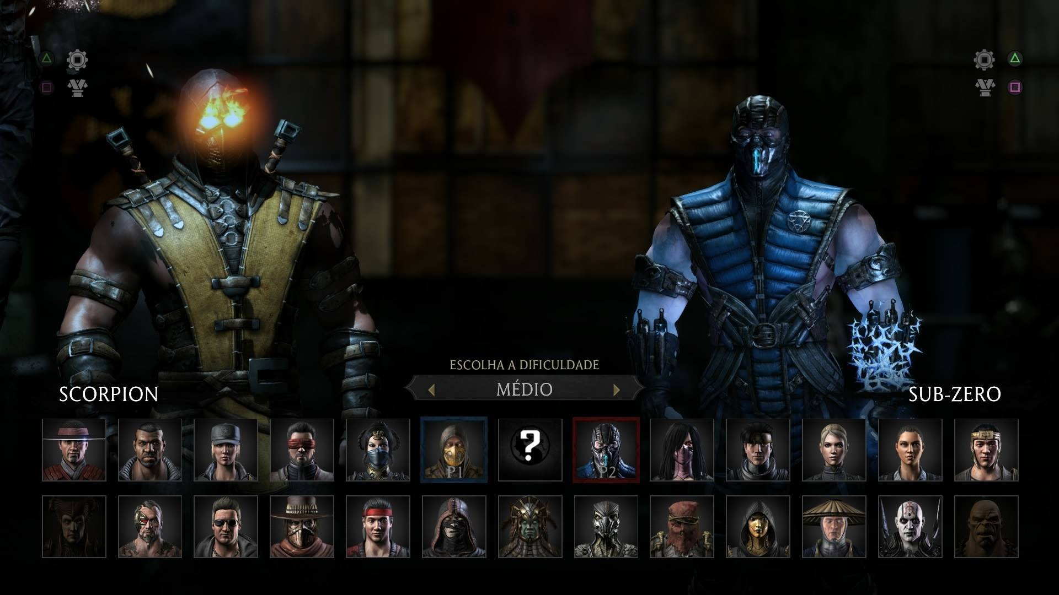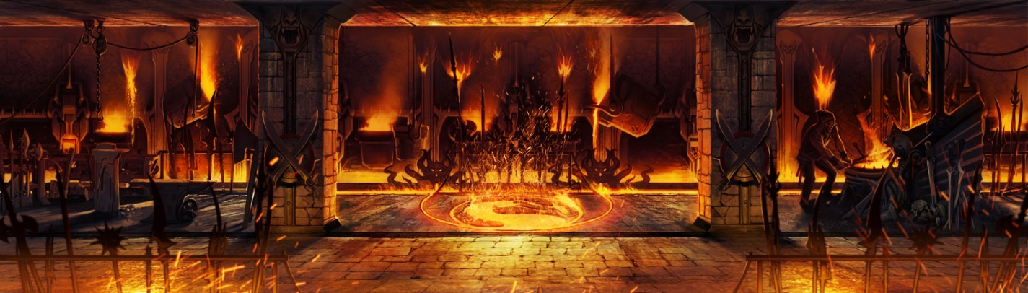Arena: Plates of Fire

Fighter Selection Page

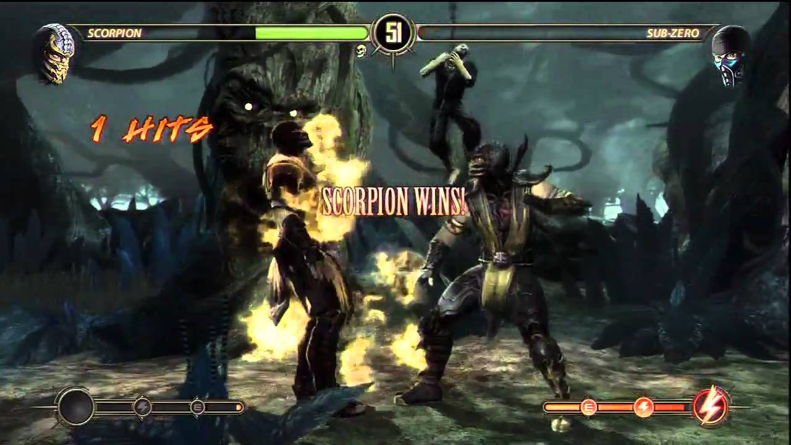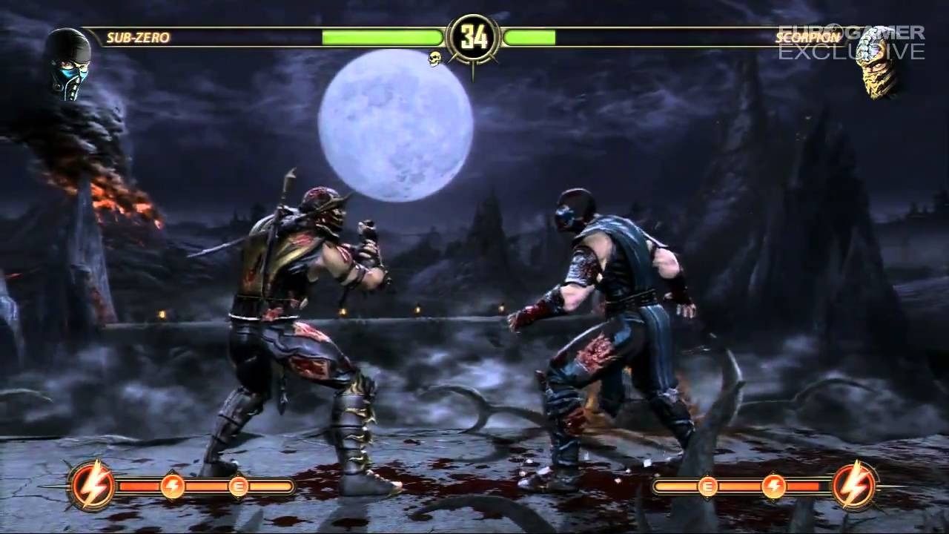Game Play with Special Bar at bottom filled after a few Simple Kicks and Combo. Power Level at top denoting the power of each Player.

Player Win Game

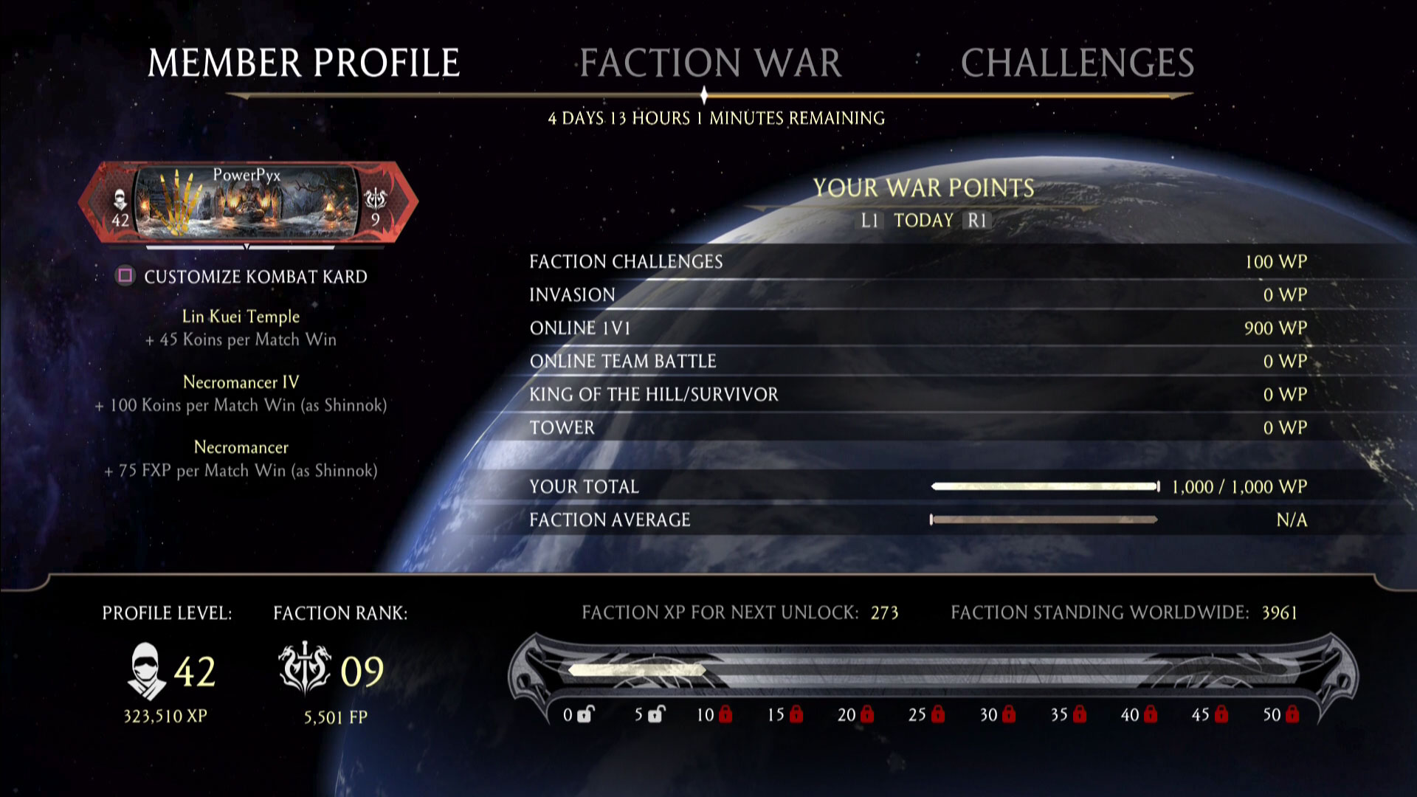

War/Game XP calculated for each player at bottom

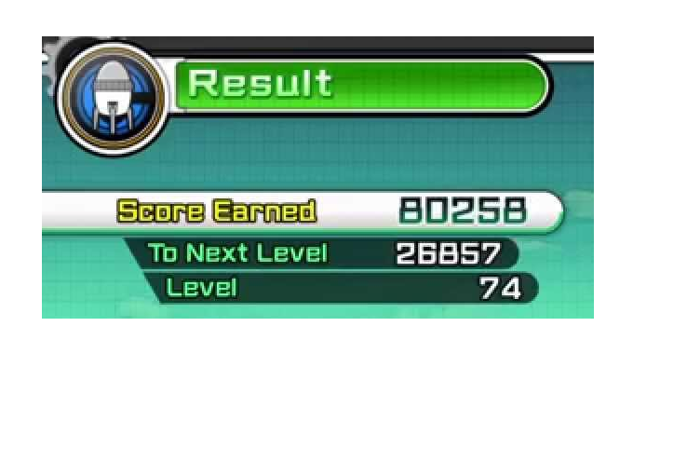

3

Result Showing the Score/Experience Earned and also showing the level.

**Game Rules**

1. The game has 3 pairs of fighters pitted against each other Batman-Joker, Flash-Zoom and Scorpion-Subzero (from Mortal Kombat).
2. The game has a timer game timer and it is 60 seconds. In case of a draw, where both the fighters don’t die and the power of the fighters are the same when the clock runs out, an extra timer of 30 seconds duration starts until the game finishes.
3. Game is in the Plates of arena and the fighters stay in the arena throughout the game.
4. Game is a one match knockout, winner of the first match is the game winner.
5. Game Fighters have some common basic moves like Kick, Punch, Move, Block, Jump and Defend.
6. These are also the states of the fighter along with Idle.
7. Game characters have their own special Moves which is unlocked after 4 basic moves or a Combo move (comprising of 4 basic moves).
8. Power level of each player is fixed and increases with Game wins
9. Experience is gained by player/fighter i.e. greater XP if won and smaller if lost.
10. There are 4 levels all players are initially in the level 0 and gain levels by gaining XP after every game.100-200 XP qualifies for level 1, 200-300 for level 2 and >300 for level 3.
11. User chooses his player and based on my fighter pairs algorithm the enemy/opponent is chosen automatically.
12. The fight happens only by checking whether both the fighters are of the same level.
13. The power of the player increases to a pre-determined algorithm which depends on number of moves made, game timer etc.
14. The players of Different levels have access to different Weapons like Bomb, Sword and Gun for levels 1, 2 and 3 respectively.
15. Most importantly there can be one and only one instance of each fighter.

**Algorithms:**

Algorithms Used for the game are as follows:

1. Fighter Selection

Start Game

Gaming menu

Select a Game Character

Singleton and abstract factory to create a fighter.

Enemy selection happens through another algorithm.

Game Timer Starts

Fight begins

End Game

1. Opponent Selection

Start Game

Gaming menu

After the user selects a Game Character to fight, based on the selection his opponent is automatically chosen using Strategy pattern where Batman always fights Joker, Scorpion fights SubZero and Flash fights Zoom and Vice versa is also true.

Game Timer Starts

Fight begins

End Game

1. Level Calculation

Game Starts

Set level=0 if not set.

Get experience base value.

This happens using Composite Pattern.

Check if experience is between 0-100 then set the level as 1

Similarly if it is between 101-200 then set level as 2

And finally if it is between 201-300 then set level as 3.

Game Timer Starts

Fight begins

End Game

1. Power Bar Calculation

Game Starts

Set power to 50 if not set.

Get Power base value.

Game Timer Starts

Fight begins

This happens using Composite Pattern.

Moves are declared pre-defined values such as

Punch = 3

Kick = 5

Special = 10

Bomb = 8

Sword = 10

Gun = 12

Reduce the power for every successful move and declare winner who still has power left (i.e. not depleted to 0).

Game Ends

1. Experience bar calculation

Game Starts

Set power to 50 if not set.

Get Power base value.

Game Timer Starts

Fight begins

This happens using Composite Pattern.

Moves are declared pre-defined values to gain XP such as

Punch = 3

Kick = 5

Special = 10

Bomb = 8

Sword = 10

Gun = 12

And the winner gets additional bonus of 1 point for every second left in the game timer plus an additional 20 points for Winning.

Game Ends

Get The Experience Points of the fighter and update the points earned.

1. Weapons

Game Starts

Game Timer Starts

Check the Level of the players

If Level=1 unlock and add weapon Bomb to both the players

If Level=2 unlock and add weapon Sword to both the players

If Level=3 unlock and add weapon Gun to both the players

Fight begins

Game Ends

**Design Patterns applied for designing this game are:**

|  |  |  |
| --- | --- | --- |
| **Type** |  |  |
| Creational | Singleton | Abstract Factory |
| Structural | Composite | Decorator |
| Behavioral | Strategy | Observer and State |

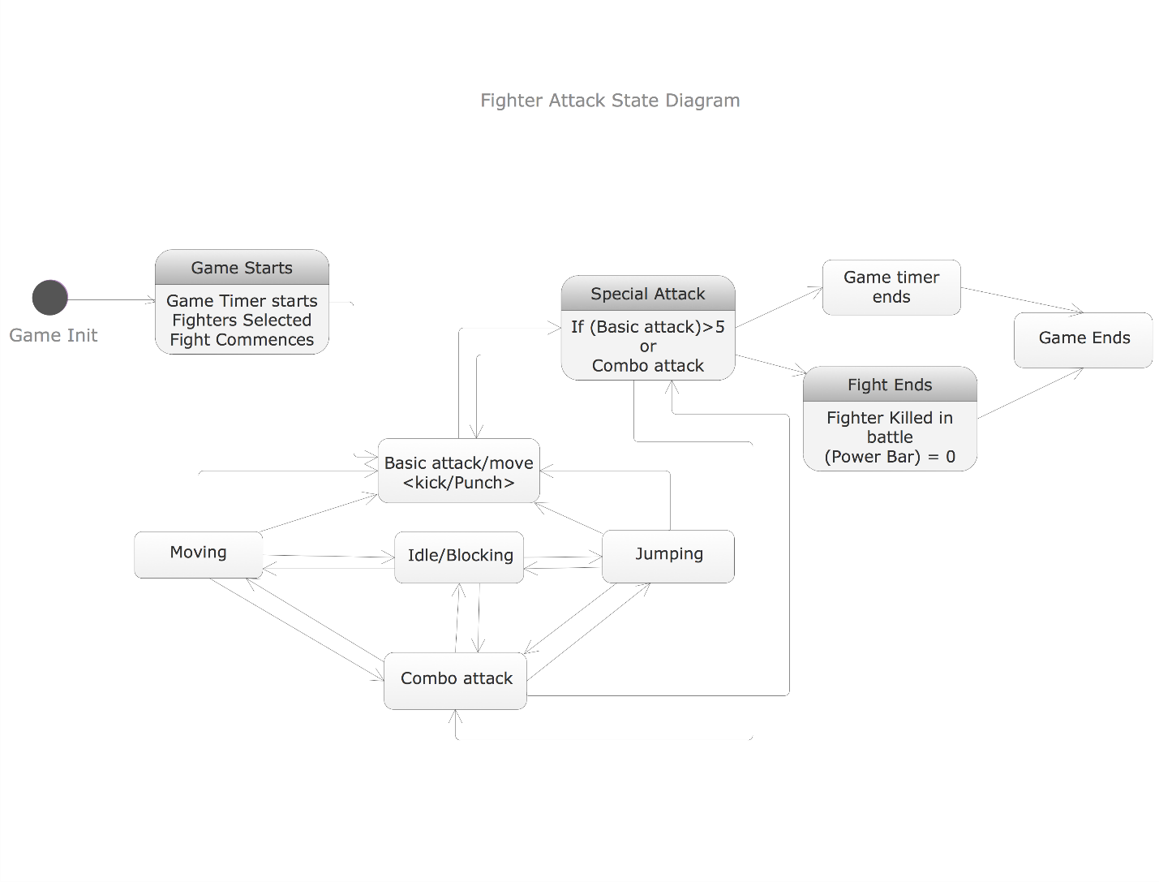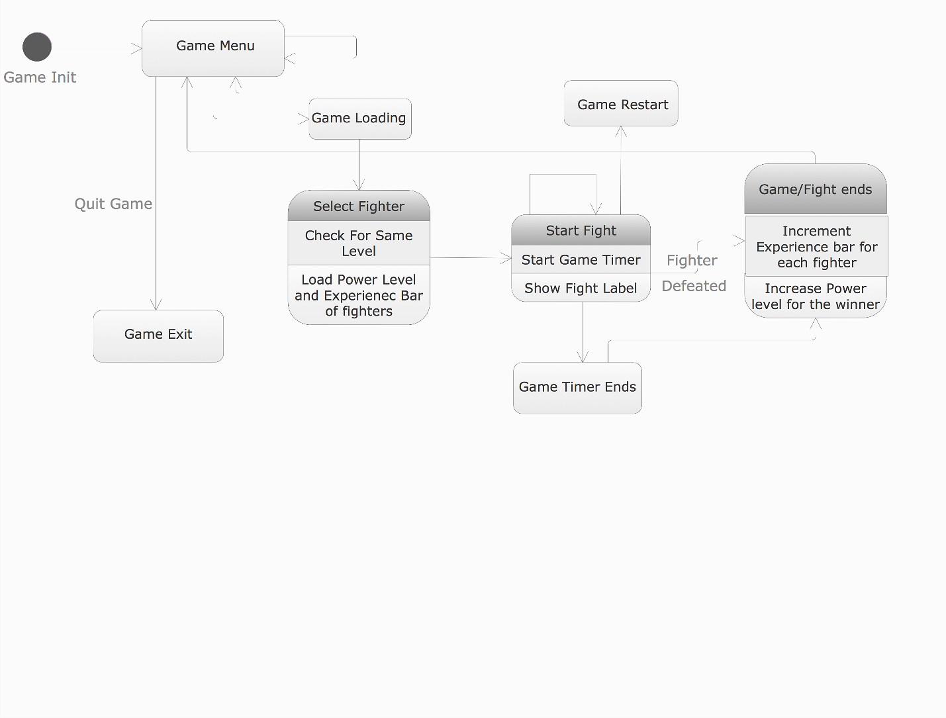**State Diagrams:**

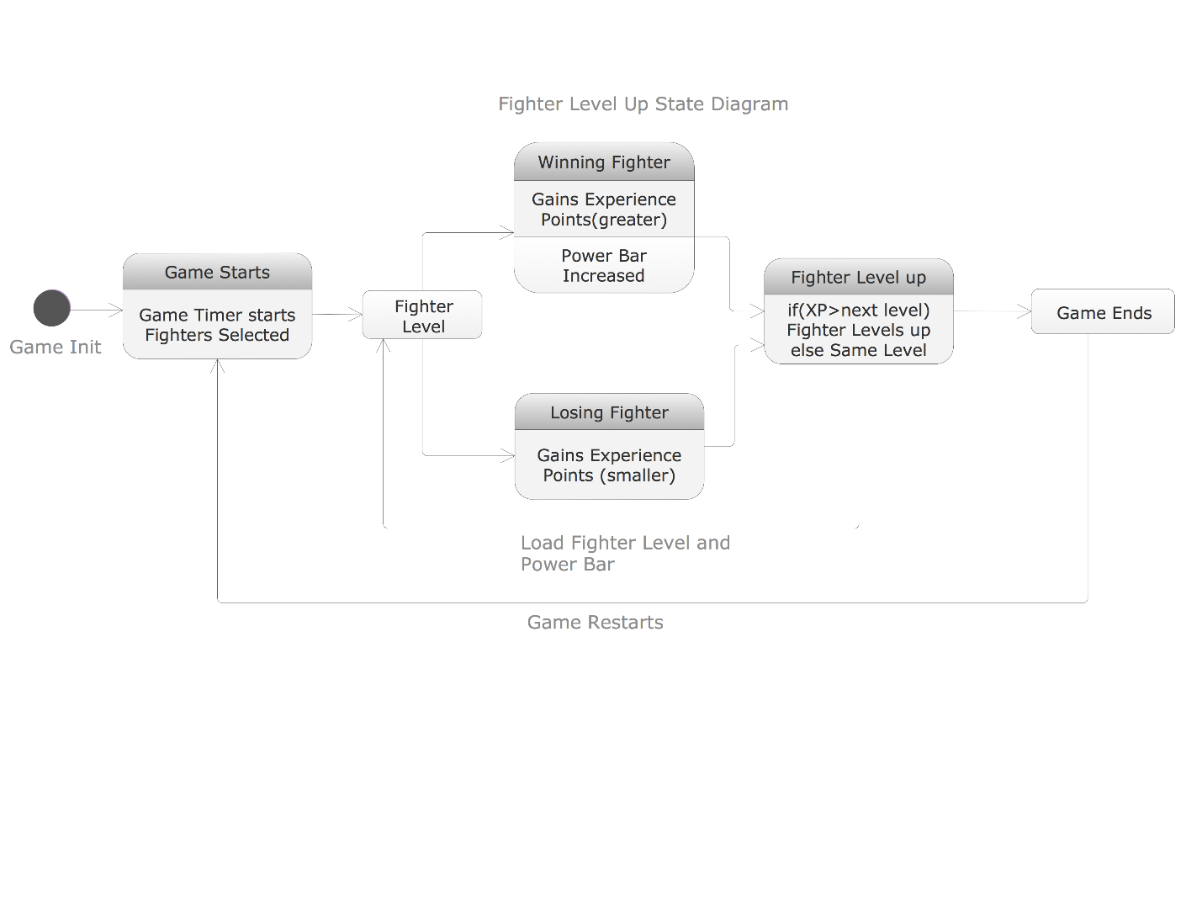

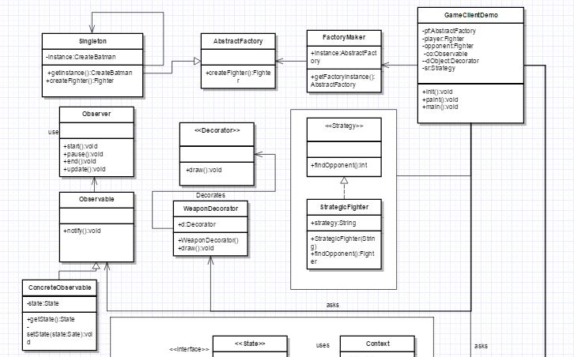**Class Diagrams:**

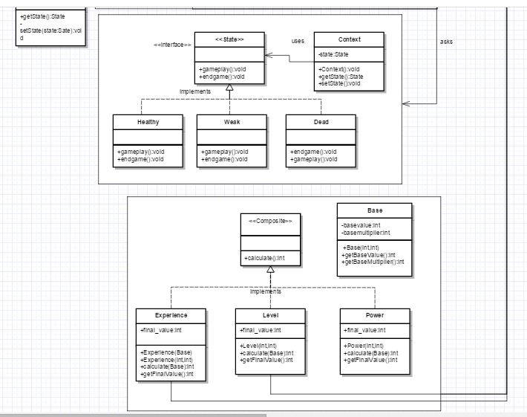

**Singleton and Abstract Factory**

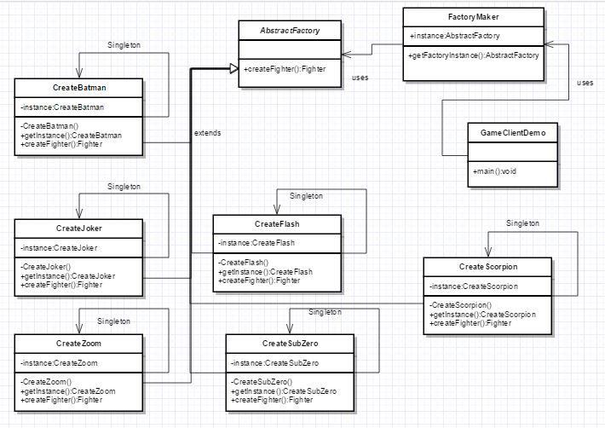

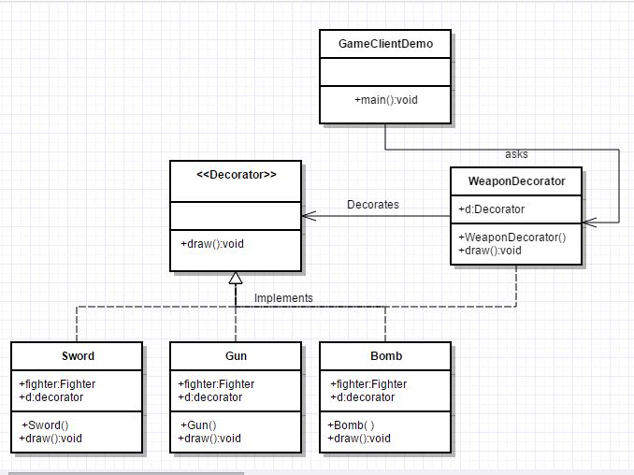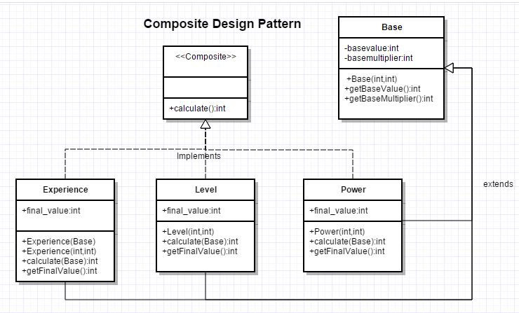**Decorator**

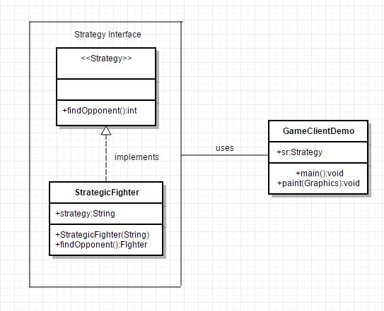**Strategy**

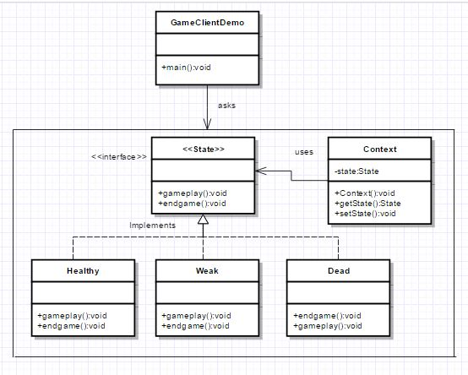**State**

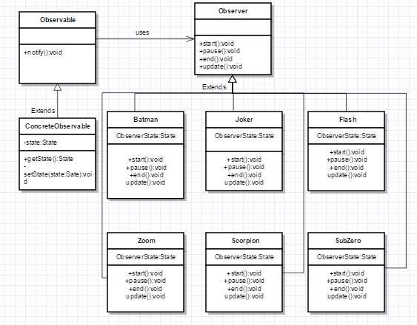**Observer**

**Code Snippets: Game Client Demo Class:**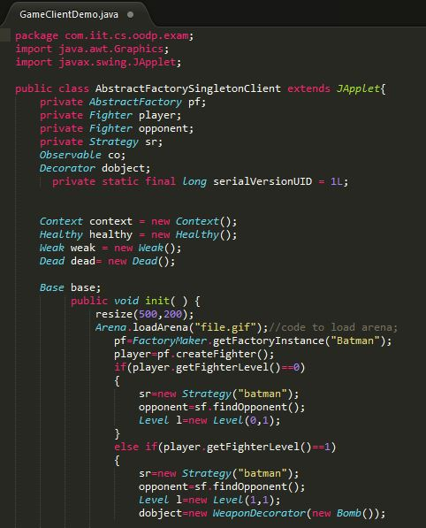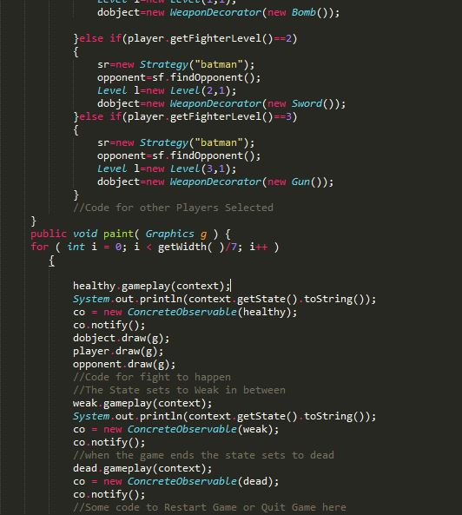

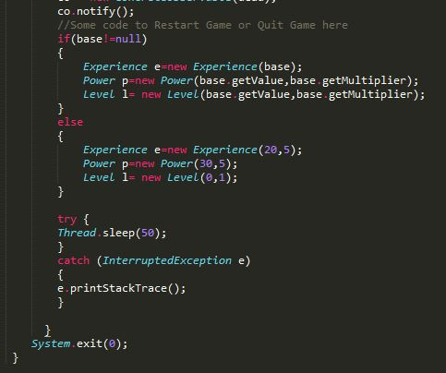

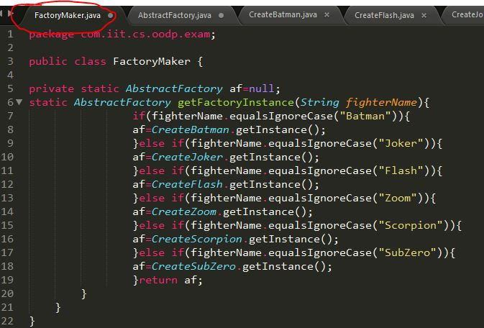**Singleton and Abstract Factory**

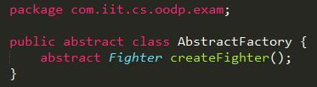

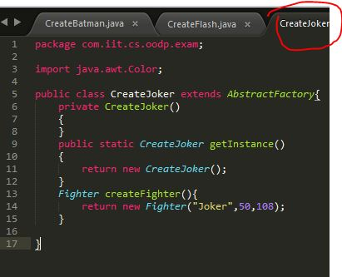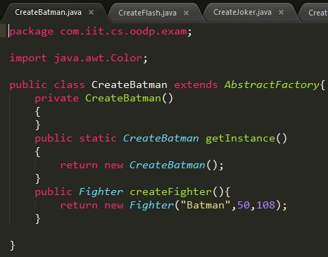

Similarly For other Fighters

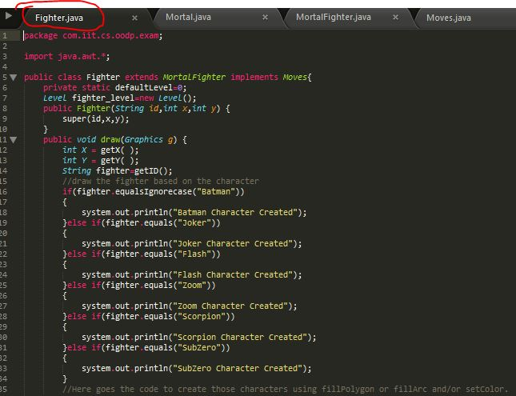

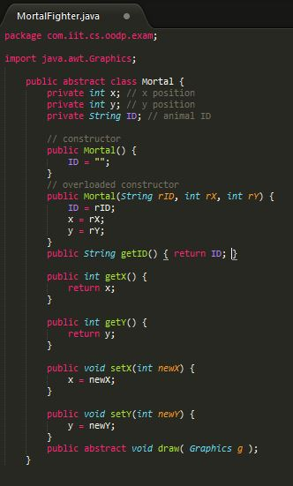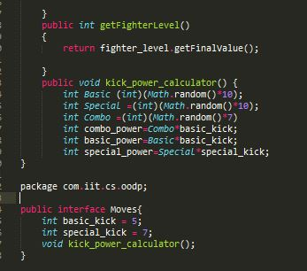

**Composite Pattern**

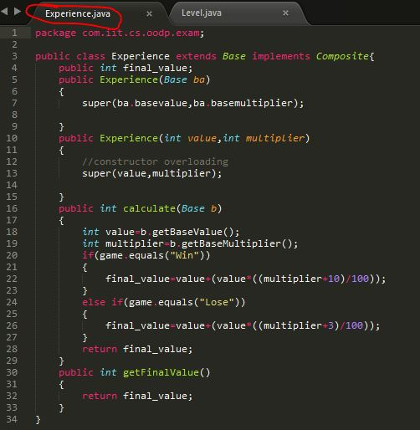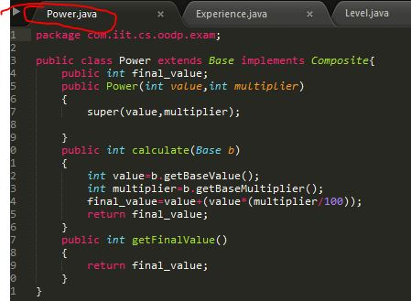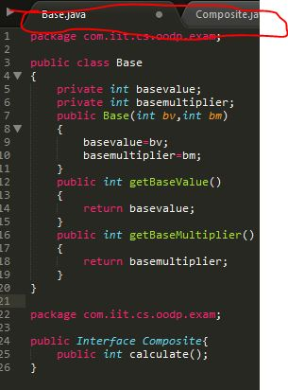

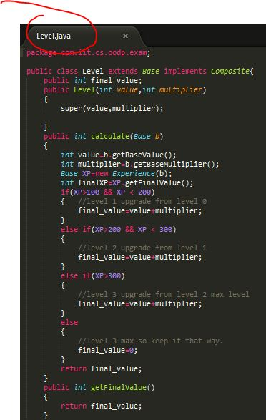

**Decorator Design Pattern**

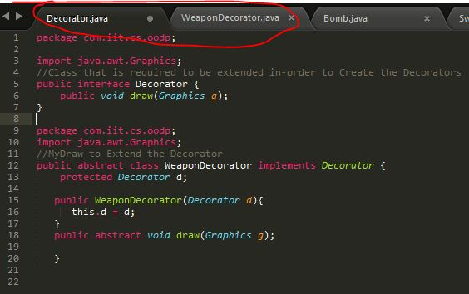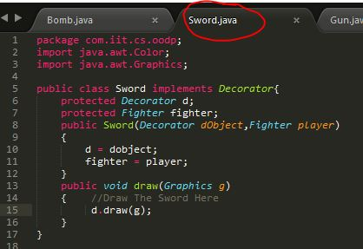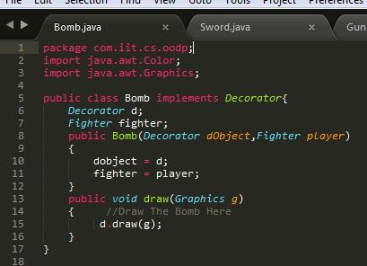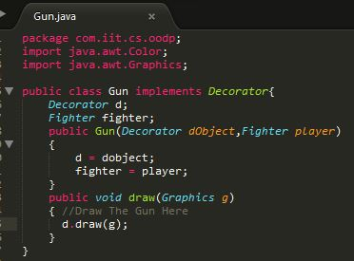

**Strategy Design Pattern:**

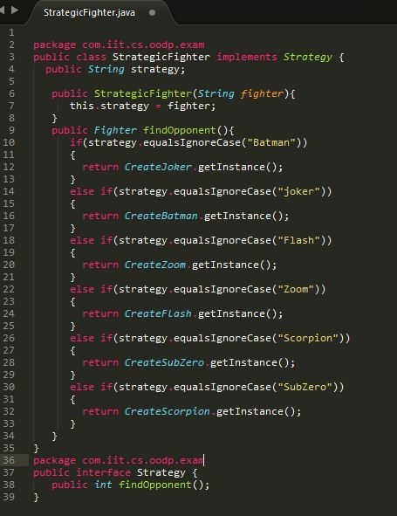

**Observer Design Pattern**

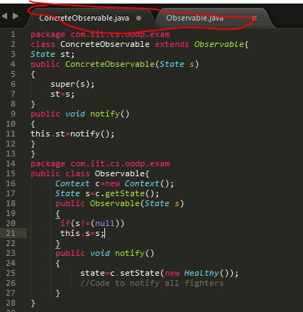

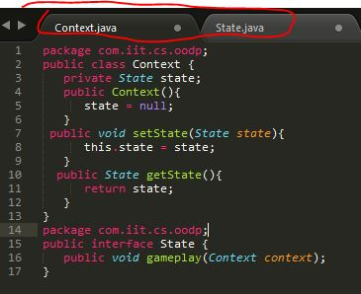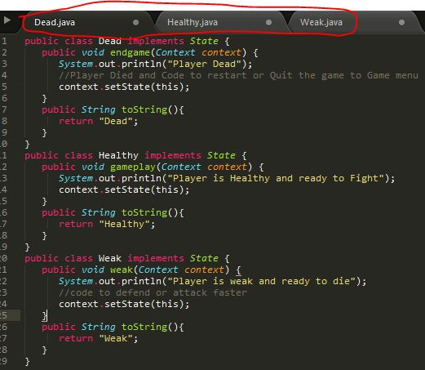**State Design Pattern:**