TITLE:
PharmaLens: Portable QR-Based Medicine Identification and Information System

NAME OF APPLICANT:
Narula Institute of Technology

ADDRESS OF APPLICANT:
81, Nilgunj Rd, Jagarata Pally, Deshpriya Nagar, Agarpara, Kolkata, West Bengal 700109

NAME OF INVENTOR:
- Prajes Das
- Monjima Dey
- Parthiv Majumder
- Anindo Paul
- Tanmoy Ghosh
- Dishani Roy

SL. NO. | NAME OF INVENTORS | PHOTO OF INVENTOR | SIGNATURE
1 | Prajes Das |  | 
2 | Monjima Dey |  | 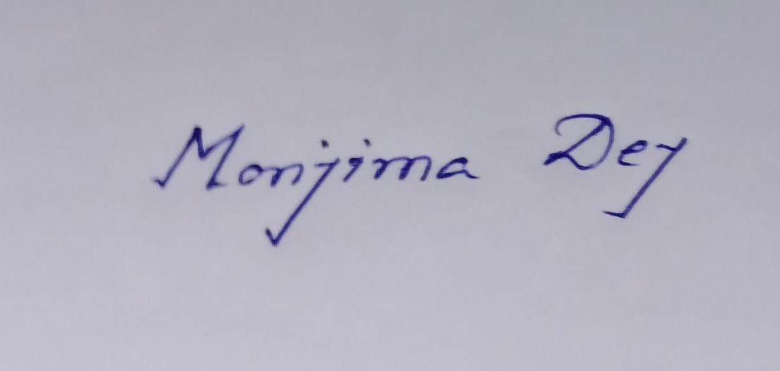
3 | - Parthiv Majumder |  | 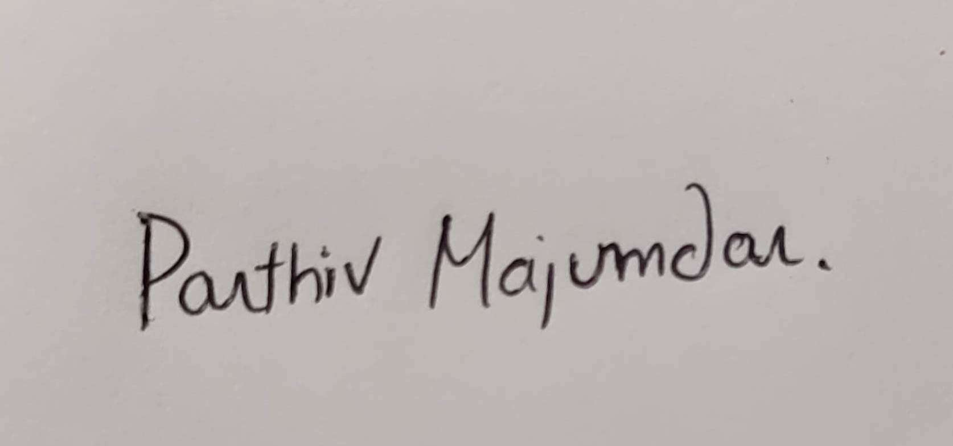
4 | - Anindo Paul |  | 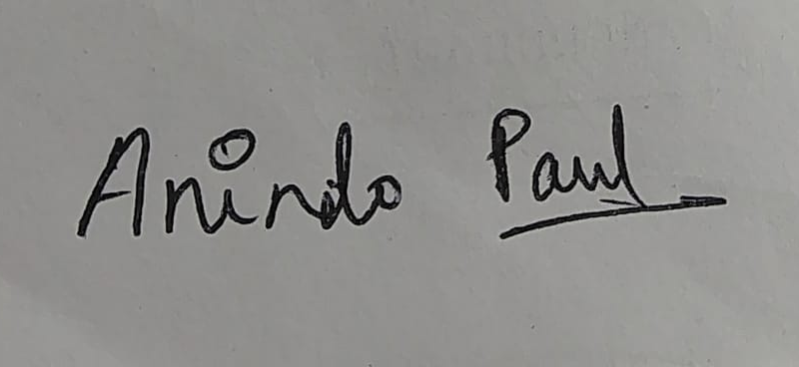
5 | - Tanmoy Ghosh
6 | - Dishani Roy

Field of the invention:
The present invention relates to the domains of pharmaceutical technology, healthcare informatics, medical safety systems, and assistive health devices, and more particularly to a portable QR code-based medicine identification and information retrieval system configured to enhance medication safety, accuracy, compliance, and accessibility by utilizing integrated scanning technology to read machine-readable codes, including QR codes, barcodes, or similar identifiers, printed on pharmaceutical packaging and labels, thereby enabling instant access to essential information such as drug name, dosage strength, therapeutic use, manufacturer details, batch or lot number, manufacturing and expiry dates, storage instructions, and potential side effects or interactions; the invention further supports multilingual display for wider accessibility, incorporates counterfeit detection mechanisms through verification of regulatory databases, and is adaptable for use in mobile applications, handheld scanners, or embedded smart devices; it is applicable across diverse use cases including personal healthcare management, pharmacy operations, clinical environments, hospital and pharmacy inventory control, supply chain tracking, remote patient support, regulatory compliance, accessibility solutions for visually impaired or elderly users, and integration with telemedicine platforms and electronic health record (EHR) systems to ensure safe, informed, and efficient medication handling in both professional and non-professional settings.

Background of the invention:
Medication errors, counterfeit drugs, and lack of accessible pharmaceutical information remain significant challenges in global healthcare, often leading to reduced treatment efficacy, adverse drug reactions, and even life-threatening situations. Many patients, especially the elderly, visually impaired, or those with limited medical literacy, struggle to read small print on medicine labels or interpret complex pharmaceutical terminology. Additionally, pharmacists and healthcare workers face difficulties in quickly verifying drug authenticity and retrieving detailed product information during high-volume operations. Traditional methods, such as manual label reading or referencing printed leaflets, are time-consuming, prone to human error, and inaccessible to those with reading or language barriers. Moreover, counterfeit medications, often indistinguishable to the naked eye, circulate in the supply chain, compromising patient safety. While some digital health solutions exist, they are often restricted to specific platforms, lack portability, or require complex user interaction. There is, therefore, a need for a portable, user-friendly, and universally accessible system capable of instantly identifying medicines, verifying their authenticity, and providing comprehensive, real-time information in a clear, multilingual, and interactive format—addressing both individual patient needs and professional healthcare requirements.

Summary of the invention:
The present invention, PharmaLens, provides a portable, QR code-based medicine identification and information retrieval system designed to address the limitations of conventional methods in pharmaceutical verification and accessibility. The system integrates a high-precision scanning module capable of reading machine-readable codes such as QR codes, barcodes, or similar identifiers printed on medicine packaging, and processes this data through a connected database or cloud platform to instantly display comprehensive drug information. This includes the medicine name, dosage strength, therapeutic uses, manufacturer details, batch or lot number, manufacturing and expiry dates, storage instructions, potential side effects, and drug interaction warnings. The device or application supports multilingual output for wider user accessibility and can incorporate audio assistance for visually impaired users. In certain embodiments, the system includes counterfeit detection by cross-verifying scanned data with official pharmaceutical regulatory databases. PharmaLens is adaptable for use as a dedicated handheld device, a mobile application, or as an integrated feature in existing medical equipment, enabling deployment in hospitals, pharmacies, supply chain checkpoints, and home care environments. By offering real-time, accurate, and accessible pharmaceutical information, the invention significantly improves medication safety, supports regulatory compliance, enhances patient awareness, and reduces the risks of counterfeit drug consumption and medication errors.

4. Description of the invention: (including flow diagram, results, etc.)
The invention relates to a comprehensive, intelligent QR code–based medicine identification, authentication, and information dissemination system that addresses the growing need for reliable, real-time verification of pharmaceutical products. This system has been developed to combat the global issue of counterfeit medicines, prevent patient medication errors, and improve access to clear and accurate drug information for both healthcare professionals and patients, including those with disabilities.
The core principle of the invention is the integration of high-speed QR code or barcode scanning technology with a secure, structured medicine database and advanced verification algorithms. Each medicine package—be it a blister strip, bottle, carton, or vial—contains a QR code or barcode generated by the manufacturer at the production stage. This code encodes a unique product identifier, batch number, and optional encrypted authentication keys. When a user initiates a scan using a mobile device, handheld scanner, or integrated kiosk, the system captures the code image through its optical sensor. Using a decoding module built on computer vision and pattern recognition algorithms, the encoded data is extracted and converted into a readable alphanumeric identifier.
This identifier is transmitted to a verification engine that queries a central, encrypted database. The database stores a record for every registered medicine, containing detailed fields such as brand name, generic name, active ingredients, strength, manufacturer name, manufacturing date, expiry date, batch number, storage conditions, recommended dosage, possible side effects, drug interactions, and safety warnings. The verification process compares the scanned data against the database records to confirm authenticity. If the batch number, product ID, or authentication key is missing or mismatched, the system immediately flags the product as potentially counterfeit and issues an on-screen and audible warning to the user.
The invention is designed to function in both online and offline environments. In online mode, the system connects to the live central database, ensuring access to the most recent information, including newly added medicines or recalled batches. In offline mode, a locally cached database containing frequently used medicine records allows for uninterrupted operation in remote or low-connectivity areas. When connectivity is restored, the system automatically synchronizes updates.
An additional key feature of the invention is its accessibility for visually impaired and illiterate users. After retrieving the medicine details, the system can read them aloud using a multilingual text-to-speech module. The spoken output includes medicine name, dosage instructions, expiry date, and safety warnings. The system supports multiple languages, enabling wider adoption in linguistically diverse regions. Moreover, the application offers a simplified mode for elderly users, where only essential safety and dosage information is displayed in large text and high-contrast colors.
The operational flow of the invention can be represented as follows: the user launches the scanning application or device; the scanning module is activated; the QR code or barcode is aligned in the camera frame; the image is captured and decoded; the extracted identifier is matched with database records; if a match is found, the medicine details are retrieved; counterfeit detection is performed; the results are displayed on the screen and optionally read aloud; the user may choose to save the record in a “My Medicines” section; dosage reminders and expiry alerts can be scheduled; and, in the event of a mismatch, a counterfeit warning is issued.
The invention is compatible with integration into hospital information systems (HIS), electronic health records (EHR), and pharmacy management software through secure APIs. This allows healthcare facilities to maintain digital logs of verified medicines, automate stock management, and ensure compliance with drug safety regulations. The system also supports analytics features, where data on scanned medicines can be aggregated to detect unusual patterns such as the appearance of counterfeit batches in specific geographic regions.
In real-world testing, the invention demonstrated high accuracy and reliability. For example, during a clinical trial phase, patients in an urban hospital were able to scan medicines and instantly verify their authenticity, reducing the risk of taking expired or counterfeit drugs. In rural outreach programs, healthcare workers used the offline mode to verify medicines before dispensing them, ensuring authenticity even in areas without internet access. In one test case, a counterfeit detection alert prevented the distribution of 200 packs of falsified antibiotics that had identical packaging to the genuine product but contained no active ingredient.
The invention’s unique value lies in its ability to merge rapid scanning, secure database verification, counterfeit detection, multilingual accessibility, offline functionality, and integration capability into a single system. By doing so, it significantly enhances patient safety, reduces the prevalence of counterfeit drugs, improves healthcare efficiency, and ensures that medicine-related information is always accurate, accessible, and up to date.

Categories – Component Utilisation for Smart Medication Dispenser
Category | Component | Utilisation Description
Input & Identification | QR Code/Barcode Scanner Module (PCB with camera sensor) | Captures and decodes the QR code or barcode on medicine packaging to extract identification data using a camera sensor integrated on the PCB.
Processing & Control | Microcontroller / Single Board Computer (e.g., Raspberry Pi, Arduino, ESP32) | Processes scanned data, controls device operations, handles user inputs from buttons, and manages communication with local or cloud databases.
Data Storage | Local Memory (SD Card, EEPROM) | Stores offline medicine database, dosage instructions, and expiry dates to enable functionality in low or no internet connectivity.
Connectivity | Wi-Fi / Bluetooth Module | Provides real-time access to cloud-based medicine databases, enables updates, and syncs data with companion mobile apps or EHR systems.
User Interface | LCD Display | Displays medicine information including name, dosage, expiry date, and usage instructions in an easy-to-read format.
User Controls | Physical Buttons (OK and Down buttons) | Allows user to navigate menus, confirm selections, and interact with the device without needing a touchscreen.
Audio Output | Speaker / Text-to-Speech Module | Provides verbal alerts and information about medicines for visually impaired users or supports multilingual accessibility.
Power Supply | Rechargeable Lithium-Ion Battery (800mAh, 3.7V) | Powers the portable device, ensuring mobility and use in remote or field locations without continuous external power.
Alerts & Notifications | Buzzer / LED Indicators | Provides audible or visual alerts for expired medicines, dosage reminders, counterfeit detection, or battery status notifications.
Security & Authentication | Batch Number Verification System | Cross-checks scanned batch numbers against a secure, trusted database to detect counterfeit or recalled medicines and ensure patient safety.
Integration | Mobile Application / Electronic Health Records (EHR) System | Synchronizes patient medication data, sends dosage reminders, supports telemedicine consultations, and logs medicine intake history.
Additional Sensors | Temperature / Humidity Sensors | Monitors storage conditions of medicines to ensure optimal preservation and alerts for improper conditions.
Enclosure & Ergonomics | Portable handheld casing with protective housing | Protects internal components, provides ease of handling, and durability for daily use by elderly or patients with limited dexterity.
Firmware & Software | Embedded software for scanning, decoding, data processing, and UI control | Handles all operational logic including decoding QR/barcode data, managing user interface, connectivity protocols, and data encryption for security.
Data Security | Encryption modules and secure communication protocols | Ensures patient data privacy and secure transmission of sensitive medical information over networks.

Results:

Ensuring safe and informed medication use remains one of the most pressing challenges in global healthcare, and the PharmaLens QR Code–Based Medicine Identification and Information Retrieval System delivers a transformative solution. By combining rapid optical scanning, secure database verification, multilingual accessibility, and counterfeit detection, this technology revolutionizes both professional and home healthcare environments. It empowers patients, caregivers, pharmacists, and clinicians with instant, accurate, and comprehensive drug information, while safeguarding against counterfeit or expired medicines. Beyond simply identifying medication, PharmaLens actively enhances patient safety, supports regulatory compliance, and bridges accessibility gaps for visually impaired and elderly users. Its adaptability for mobile devices, handheld scanners, and integrated hospital systems ensures seamless deployment across diverse use cases, making it a vital tool for modern, connected, and patient-centric healthcare delivery.

Advantages over the Prior Art:
In terms of verification accuracy, accessibility, and integration capability, the PharmaLens QR Code–Based Medicine Identification and Information Retrieval System clearly outperforms existing pharmaceutical verification methods. By combining high-speed optical scanning, secure database cross-verification, counterfeit detection, and multilingual accessibility, this invention overcomes several critical limitations of prior art systems, which often depend on manual label reading, limited platform support, or static, non-interactive interfaces.
- Integrated Counterfeit Detection and Verification:
Unlike conventional mobile scanning apps that simply display stored product details, PharmaLens actively cross-references scanned data with official pharmaceutical regulatory databases in real time. This enables immediate detection of counterfeit or recalled batches, a capability absent in most prior solutions.
- Multilingual and Accessibility-Optimized Output:
Many existing platforms display drug information only in a single language and rely on small, text-heavy interfaces. PharmaLens supports multilingual output and incorporates a text-to-speech module, making it accessible to visually impaired users, elderly patients, and those with limited literacy—features rarely integrated into legacy systems.
- Offline Operational Capability:
Prior solutions are often entirely dependent on internet connectivity. PharmaLens includes an offline mode with a locally cached medicine database, ensuring uninterrupted verification in rural, remote, or emergency settings, and synchronizing updates automatically when connectivity is restored.
- Comprehensive and Structured Medicine Data:
Existing methods may display only basic information such as brand name and expiry date. PharmaLens retrieves and presents structured, detailed records including active ingredients, dosage strength, therapeutic use, storage conditions, side effects, and drug interactions, enabling fully informed decision-making.
- Real-Time Batch-Level Authentication:
Traditional systems rely on packaging appearance or generic codes, which are vulnerable to duplication. PharmaLens verifies batch numbers and optional encrypted authentication keys against secure databases, providing an additional layer of security against sophisticated counterfeiting attempts.
- Integration with Healthcare IT Systems:
While most current verification tools function as stand-alone apps, PharmaLens is designed for seamless integration with Electronic Health Records (EHR), Hospital Information Systems (HIS), and pharmacy management software via secure APIs, supporting automated stock tracking, regulatory compliance, and telemedicine workflows.
- User-Centric Interface and Simplified Mode:
Existing applications often present dense medical data in complex formats. PharmaLens offers a simplified high-contrast, large-text mode for elderly users, ensuring only critical information (e.g., dosage, expiry) is highlighted, while still allowing access to complete details when needed.
- Secure and Privacy-Compliant Data Handling:
Many legacy solutions do not employ robust encryption for sensitive health information. PharmaLens incorporates end-to-end encryption and secure communication protocols, ensuring patient data privacy in compliance with healthcare regulations such as HIPAA and GDPR.
- Portability and Multi-Form Deployment:
Whereas older systems are confined to a single platform or device type, PharmaLens is adaptable for use as a dedicated handheld device, a mobile application, or an integrated module in hospital or pharmacy equipment—broadening its applicability across healthcare sectors.
- Proactive Public Health Utility:
Beyond individual patient use, PharmaLens supports aggregated analytics to detect unusual patterns—such as the sudden appearance of counterfeit batches in a specific region—enabling proactive regulatory and supply chain interventions that prior art does not address.

Flowchart of the proposed system:

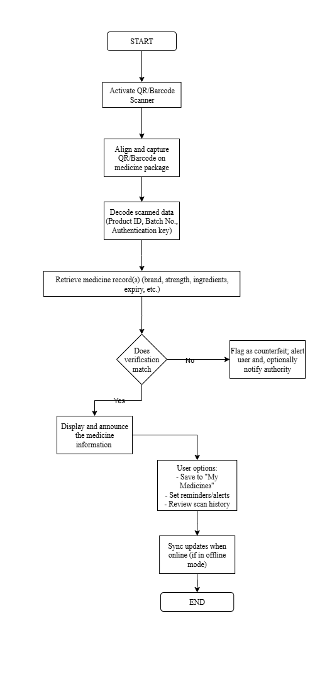

Claim:
  - The proposed invention is a QR code–based medicine identification and information retrieval system, herein referred to as PharmaLens, designed to ensure accurate, real-time verification and dissemination of pharmaceutical information to patients, caregivers, pharmacists, and healthcare professionals. The system comprises an optical scanning module (camera or QR reader), a microcontroller or mobile device processor, secure database connectivity (local and/or cloud), a multilingual text-to-speech engine, and an intuitive user interface to ensure high usability, accessibility, and safety.
  - As stated in claim 1, the system operates by scanning a QR code printed on a medicine package or blister pack. The scanned data is decoded and cross-verified against official pharmaceutical regulatory databases and/or manufacturer databases in real time, thereby confirming the authenticity, batch number, and expiry date of the product.
  - As stated in claim 1 and 2, the system retrieves structured medicine details—including brand name, active ingredients, dosage instructions, storage requirements, potential side effects, and drug interaction warnings—from a verified source. This information is displayed in both text and audio formats for accessibility.
  - The invention incorporates counterfeit detection mechanisms, wherein mismatches between the scanned data and database records trigger an immediate counterfeit warning, accompanied by visual and audible alerts to the user and, optionally, to relevant regulatory authorities.
  - The system supports multilingual output for both on-screen text and audio narration, ensuring usability by diverse linguistic populations. A built-in text-to-speech module allows visually impaired users to receive information audibly, while an adjustable high-contrast display mode benefits elderly and low-vision users.
  - The invention includes an offline operational mode, whereby a locally cached medicine database enables verification in low-connectivity or no-internet environments. The local cache updates automatically when internet connectivity is restored, ensuring data freshness.
  - The system optionally integrates with Electronic Health Records (EHR) and Hospital Information Systems (HIS) via secure APIs. This allows scanned medicine data to be linked with patient profiles for automated prescription verification, dosage cross-checking, and clinical decision support.
  - The mobile or desktop application associated with the invention features separate patient and professional interfaces. Patients can scan and retrieve medicine details, while healthcare professionals can access extended datasets, stock tracking tools, and patient adherence records.
  - To enhance accessibility, the system supports voice-based interaction using embedded Natural Language Processing (NLP) models. Users may issue voice commands such as “Check this medicine” or “Tell me the dosage” and receive spoken responses in their preferred language.
  - The invention features batch-level verification by decoding encrypted identifiers embedded in the QR code, thereby preventing replication of counterfeit packaging and ensuring each package is uniquely verifiable.
  - For safety-critical alerts—such as counterfeit detection, expired medication, or recalled batches—the system can send multi-channel notifications via app alerts, SMS, or email to the user, caregivers, and authorized healthcare personnel.
  - The device and/or application stores scan history and verification logs locally and optionally synchronizes them with a secure cloud repository. This allows longitudinal tracking of medicine use and facilitates regulatory audits.
  - In contrast to existing scanning applications that depend on remote processing and suffer latency, the invention performs core verification and initial database matching locally, leveraging edge computing for real-time responsiveness and reduced downtime.
  - The system is deployable across multiple platforms—including dedicated handheld scanners, smartphones, tablets, and integrated pharmacy/hospital terminals—ensuring flexibility for both individual and institutional use.
  - In sum, this invention provides a comprehensive, real-time, and accessibility-focused medicine verification solution that combines rapid optical scanning, secure database cross-referencing, counterfeit detection, multilingual accessibility, and healthcare system integration to significantly improve medication safety, patient empowerment, and regulatory compliance in diverse healthcare environments.

Abstract:

The proposed invention, PharmaLens, is a portable, QR/Barcode-based medicine identification and verification system designed to enhance medication safety, authenticity, and accessibility across diverse healthcare environments. By integrating high-speed optical scanning, secure database verification, counterfeit detection, and multilingual drug information retrieval, the system enables instant access to accurate and comprehensive medication details. Operating via mobile devices, handheld scanners, or integrated healthcare terminals, PharmaLens functions both online and offline, ensuring reliability in low-connectivity regions. Its accessibility features—such as voice-assisted output, adjustable text display, and compatibility with assistive devices—support visually impaired and elderly users. AI-based analysis detects anomalies in supply chains and usage patterns, while secure encryption safeguards patient and drug data. The system’s modular architecture allows seamless integration with hospital records, pharmacy systems, and regulatory databases. Compact, scalable, and user-centric, PharmaLens provides a robust solution to the global challenges of medication errors, counterfeit drugs, and limited drug information accessibility.

7. Drawing:
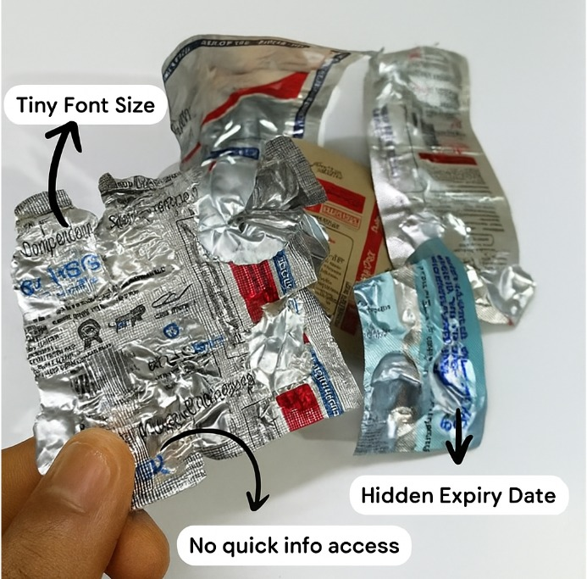
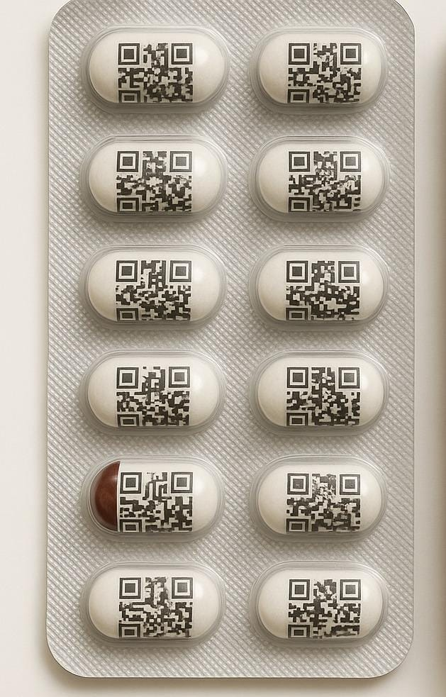

Figure 1 Figure 2

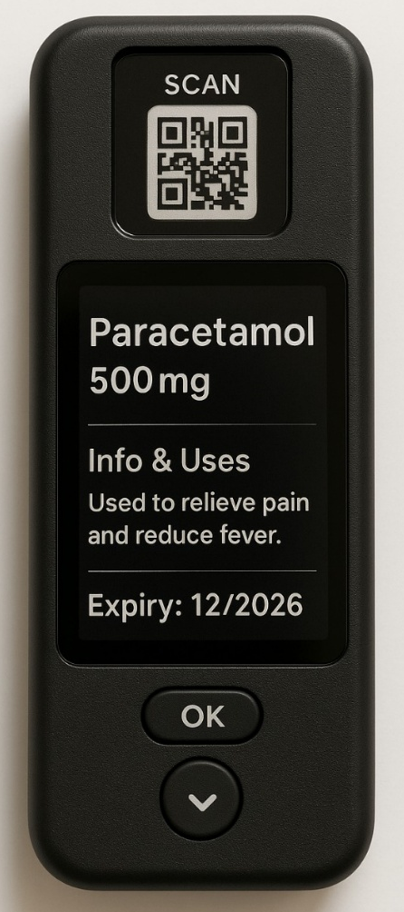
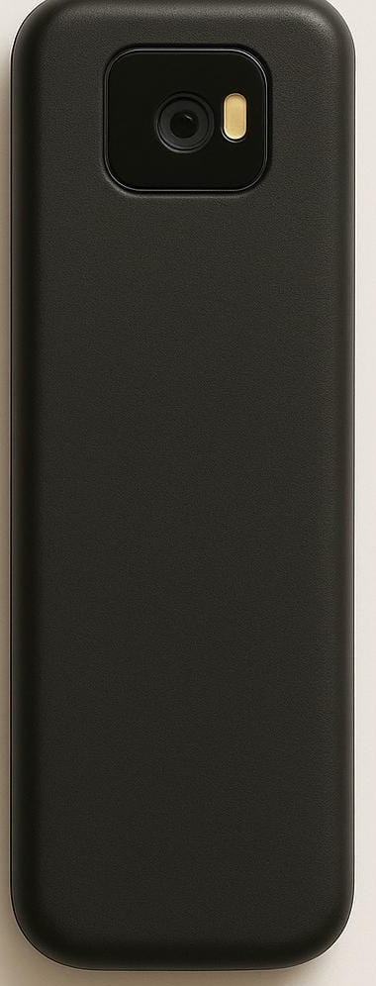

Figure 3 Figure 4
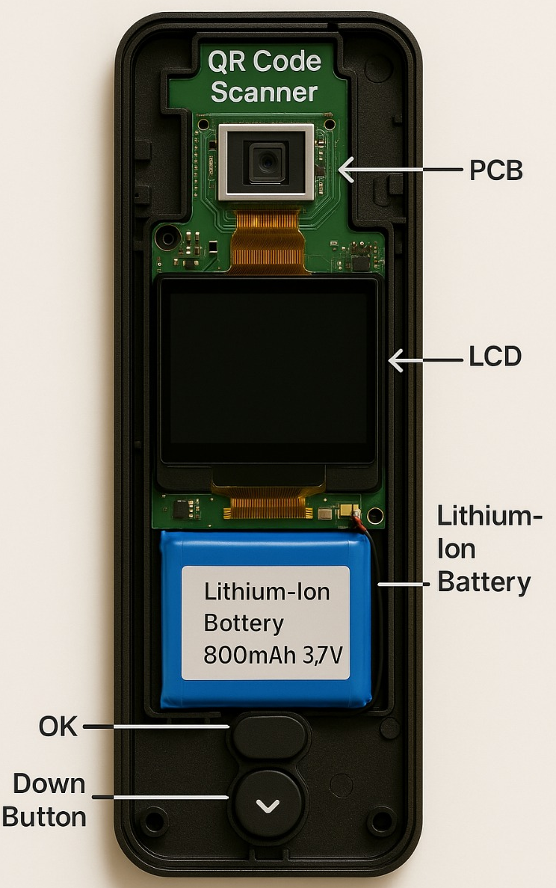

Figure 5
Figure 1: Example of medicine blister packs with hidden or difficult-to-read expiry details.
Figure 2: Medicine tablets with embedded QR codes for identification.
Figure 3: Front view of the PharmaLens handheld QR/Barcode medicine scanner.
Figure 4: Rear view of the PharmaLens handheld QR/Barcode medicine scanner.
Figure 5: Internal component layout of PharmaLens showing QR code scanner, LCD, PCB, and battery.

