Tree View

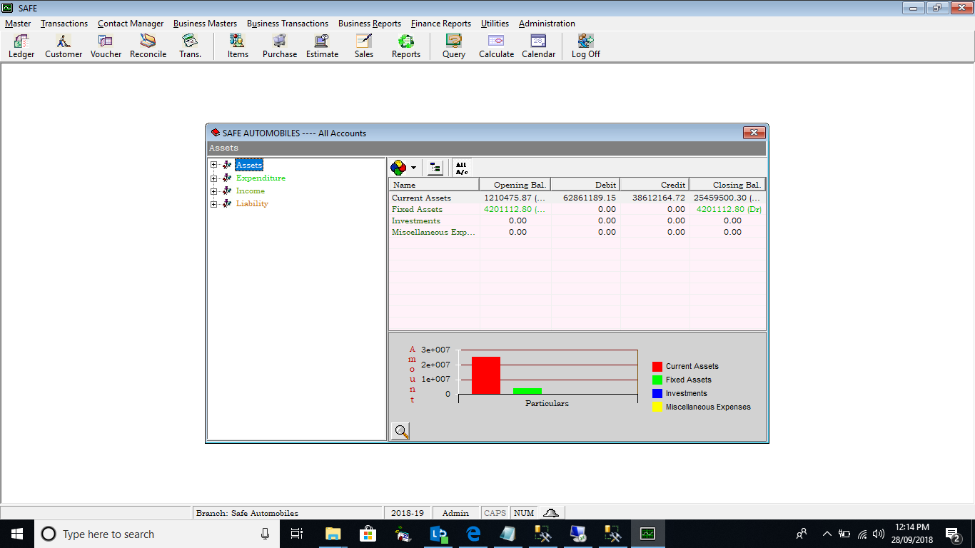

Expanded View

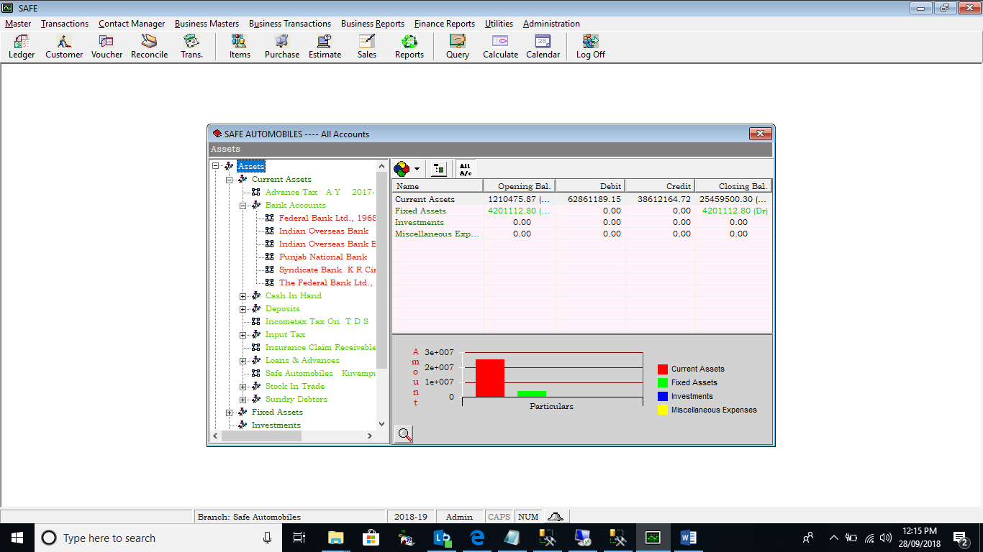

Right Click Add Ledgers

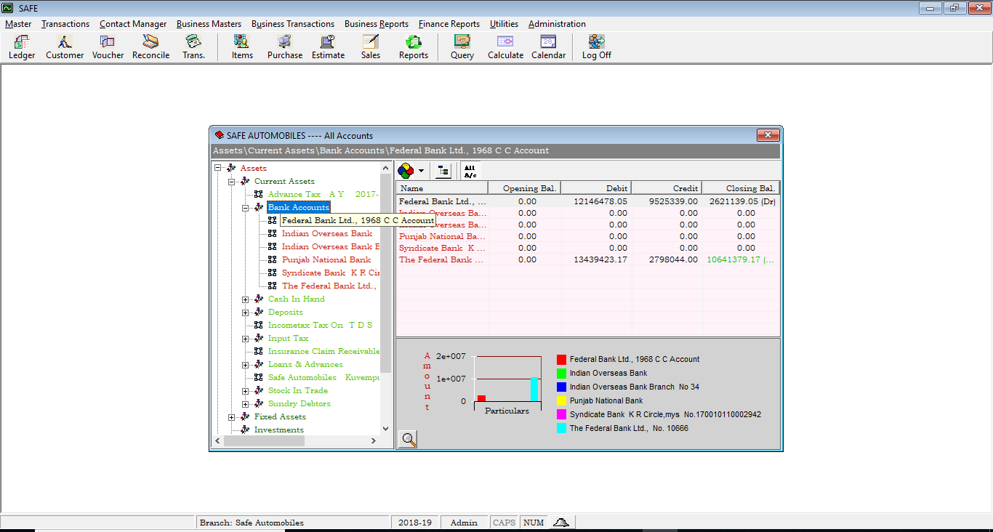

Account Summary of selected or all groups in the right pane

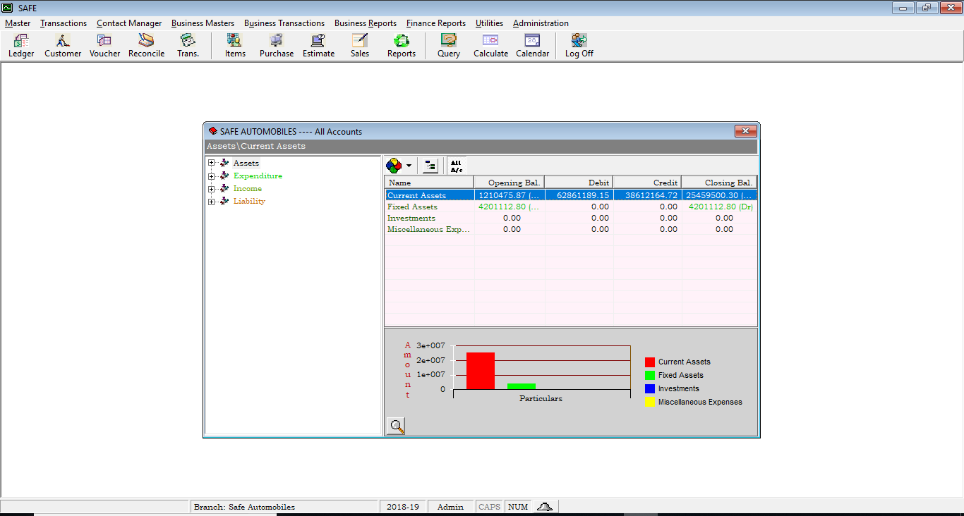

Drilling Down to Ledger Level

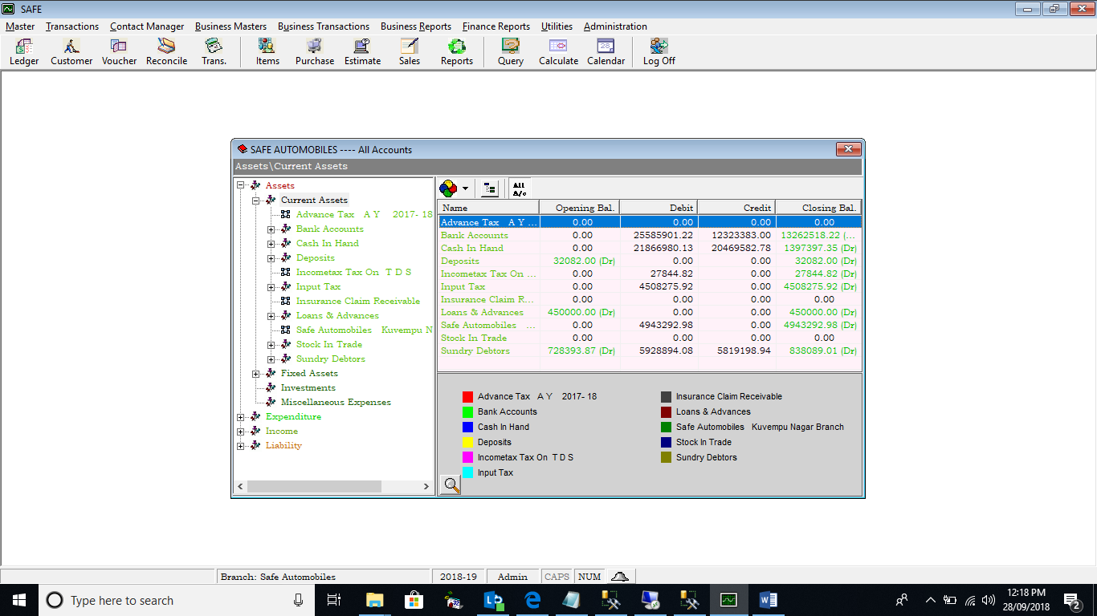

Drilling Down a Particular Lader: Monthly Transaction Summary

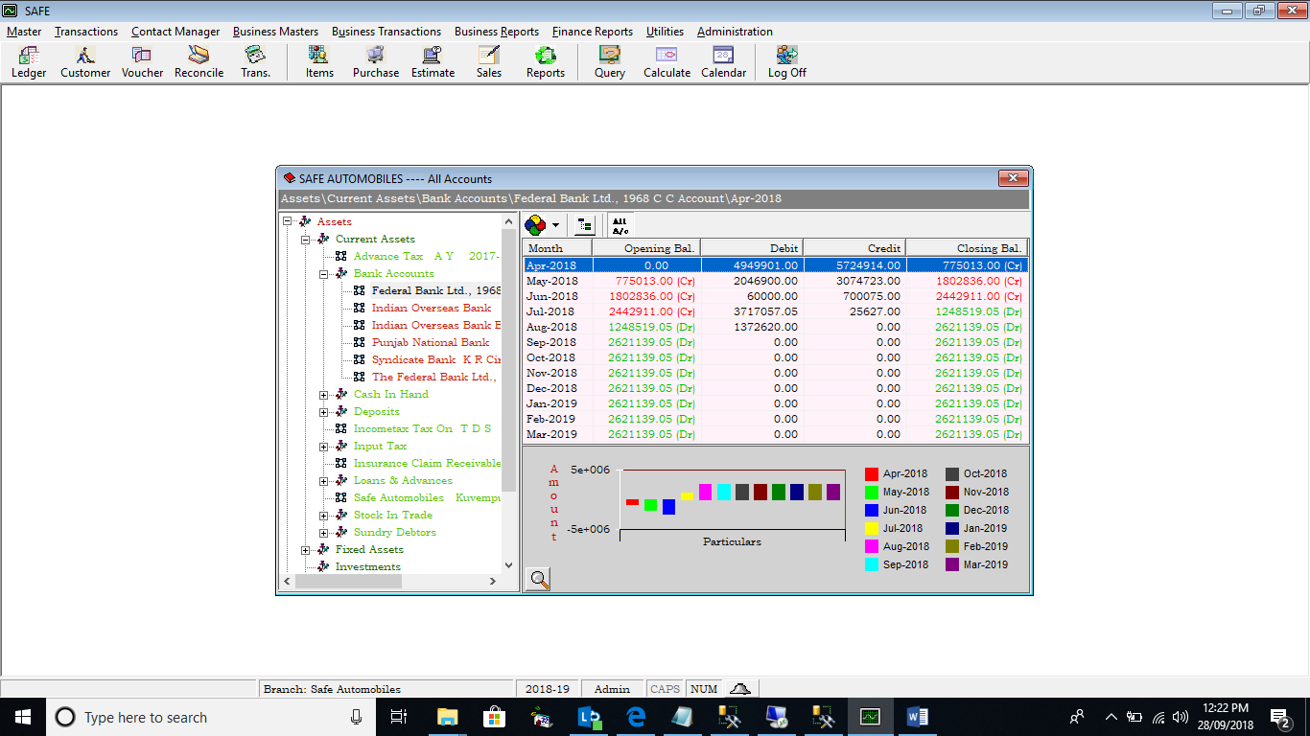

Drilling Down a selected month to Date Wise Summary

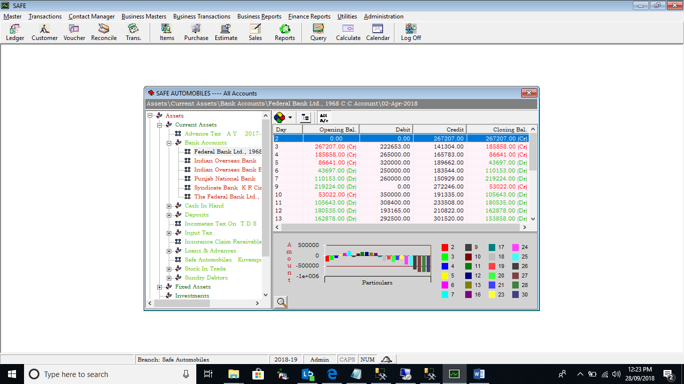

Drilling Down a Particular Date to All the Transactions

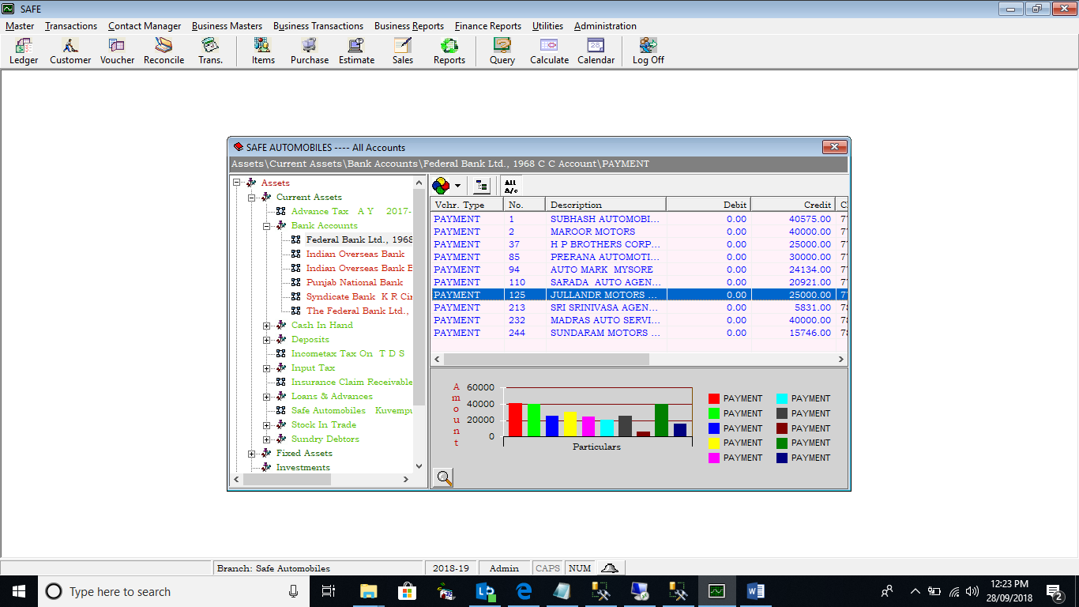

Drilling Down to open the selected Transaction

