* Firstly we configuration on github use the below comman
* git config --global user.name “Prajjal”
* git config --global user.email [prajjalsaxena@gmail.com](mailto:prajjalsaxena@gmail.com)
* If we want to see all this detail write the below command

git config --global --edit

* ls -lart : This command shows the hidden file too.
* Then open the vim window now we have all info but how we exit the vim window

For exit the vim window we click q and then click on esc to quit and write :wq and enter to exit the vim window

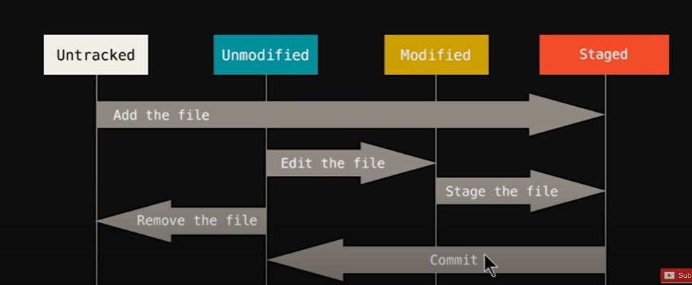

1. **git init :** For initialize. Jab hum starting sa start krta ha project
2. **touch about.html :** Ya file create karna ka lia vs code ma. Ya 1 blank file ko bna detti ha.
3. **git add about.html:** upar about.html unauthorized file ha usa staged ma bhejna hoga jissa hum modified karka commit kar saka toh ya command use hoti ha

**or if we have many files so use below command**

**git add -A** OR we use **git add .**

1. **git commit -m “Added html files” :** jab hum staged sa unmodified ma bhejta ha toh ya command use karta ha or save karna ka lia jo humna changes karra ha mainly us lia use hoti ha ya command
2. **git checkout contact.html :** agar kissi na hamari file ma changes kardia ha or save bhi krdia ha toh hum phali file ma es command sa ja aga

**or agar sari file modified krdi ha kissi na toh use command**

**git checkout -f**

1. **git log :** jo humna commit last ma sarra commit kia ha uski saari info dagga

**or agar hamma last commit dekhna ha bss**

**git log -p -1 ya 2 jitna commit dekhna ha utha number**

1. **git diff:** working tree ko compare karta ha staging area sa

**or agar hamma last staging sa match karna ha toh use command**

**git diff --staged**

1. **git commit -a -m :** agar hamma direct commit karna ha toh staging par binna jaa a hua jo use thi command
2. **git rm index.html :** agar hamma koi file staging sa or commit sgit rma delete karni ha koi bhi file
3. **git rm --cached**

agar ma chata hu staging area sa heee delete krna toh ya command use karga.

1. **git status:** hamma status btata ha or btata ha ki aap konsi branch ma ho

**or if we need the status in summarize so we can use the below command**

**git status -s**

1. **.gitignore folder :** agar hamma koi folder ya file ignore karani hoti ha toh hamma ignore naam ka folder bnana hota ha .gitignore

**BRANCHES**

* **When we use the git status command so from this command we know that we have a branch and the main branch is Master branch.**
* **Main branch is master branch. Suppose we have received some changes from the client side so we don’t do that changes in the main branch so that time we make the new branch and work on that branch and after the changes have been done then we can merge that branch from the main branch (master branch)**
* **Command to make new Branch**

**git branch feature1**

* **If we want to change the branch so we use the below command**

**git checkout feature1**

* **git merge feature1 :** we use this command when we merge the changes into master branch.

**GITHUB**

Github is a hosting service. Jo hum git repo bnata ha unha host hum github par karta ha.

There are many hosting service same as Github like bitbucket, matlb and many more.

Hum remote repository ma apni local repository ma dalaga mtlb push karaga

Remote ka mtlb kya ha 1 asi url jaha par hum apni repository ko host karaga

1. Copy the below url from the git hub and paste it on the gitBash.

git remote add origin git@github.com:Naman9259/repoPrac.git

Ab humna upar wala link ko origin naam da dia ha agar hamma janna ha kii origin naam hua

ya nahi hua toh hum command use karaga

**git remote**

1. **git remote -v**

This command provide us the url of push or fetch

1. Now we want to push our Repo on the github so follow the below steps:

* Firstly at the top we click on profile and go to the setting and click on SSH and GPG Key

**Q: What the use of SSH Key?**

**The work of SSH key is all the work which we done on the local repo. It gives the access**

**of github to read/ write our local repo.**

* **For Generating SSH key click on the below SSH Key** [generating SSH keys](https://docs.github.com/articles/generating-an-ssh-key/)
* **Then click on the link SSH generating a new SSH key here we go with the step 2**

**Write this link on the gitbash**

**ssh-keygen -t ed25519 -C "nmansingh569@gmail.com"**

* **Then in the below of the steps on the github look the below command and put that command on the git bash**

eval "$(ssh-agent -s)"

* After that write this command on gitBash

**ssh-add ~/.ssh/id_ed25519**

* **cat ~/.ssh/id_ed25519.pub** then use this command

**cat commands gives all the detail**

* Then we write this command

git remote set-url origin [**git@github.com:Naman9259/repoPrac.git**](mailto:git@github.com:Naman9259/repoPrac.git)

**this is the SSH link**

* **Now we push our code on the github so use the below command**

**git push -u origin master**

* But hamma branch nii show hogi toh usa bhi push karna padaga tab show hogi branch phala branch par ja aga jo push karni ha then use the below command

**git push -u origin feature1**