Final Project Report

for

NaviCopter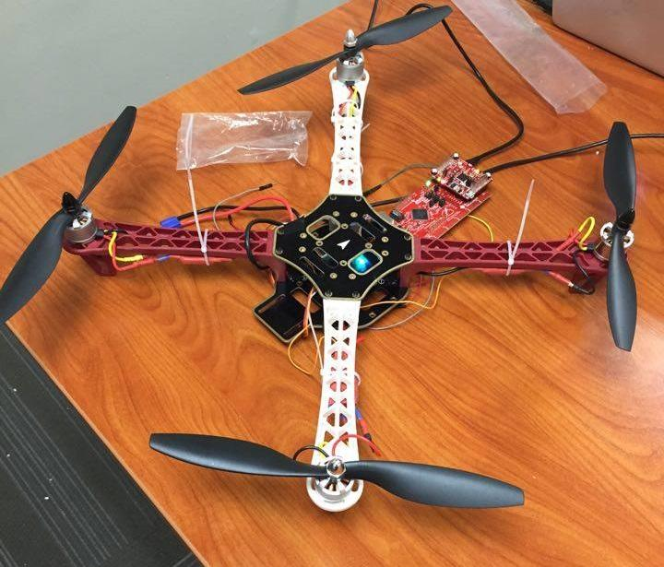

**Table of Contents**

Table of Contents ii

Group Members

1. Project Description v

Background v

Objectives iv

Methodology iv

a) Hardware Design v

b) Software Architecture and Code i

c) Testing………………………………………………………………….. vi

2. Result

3. Conclusion

4. Bibliography and References ix

5. Acknowledgement x

**Group Members**

|  |  |  |
| --- | --- | --- |
| **Name** | **Role** | **Responsibilities\*** |
| Saurav Keshari Aryal | Team Leader & Project Manager | Oversee project activities, supervise solution integration |
| Samman Thapa | Hardware SME | Assemble the drone parts and other hardware components |
| Utsab Khakurel | Hardware SME | Work extensively with drone physics |
| Ashok Tamang | Software SME | Integrating Wi-Fi and other hardware components using C |
| Prajjwal Dangal | Software SME | Worked with drone flight controller firmware, RC protocols and other software |

*\*The aforementioned responsibilities only highlight the key contributions of each member for the project. In retrospect, all members have contributed more or less equally to all aspects of the project.*

**Project Description**

**Background**

Guide dogs are assistant or service dogs that have been trained to lead the visually impaired. However, even though dogs can be trained to navigate through many obstructions, most of them are color blind. As such, they are incapable of interpreting street signs. With advancement in drone technology, we can provide the same navigation potential provided by guide dogs as well as the ability to decipher colored street signals. NaviCopter is based on this very ideal.

**Objectives**

The main aim of this project is to implement an efficient and convenient replacement for guide dogs with new drone technologies and embedded systems.

**Methodology**

NaviCopter was designed to be a part of the Texas Instrument North America Design Challenge 2016. We decided to implement our own flight controller using the TI EK-TM4C1294XL Launchpad with the CC3100 Wi-Fi Boosterpack as an Access Point. We used the DIY Q450 V3 Glass Fiber Quadcopter Framedrone kit for rapid development of the drone body. A mobile web interface was implemented to allow the users to control the drone from any device connected to the WiFi Access Point provided by the Launchpad and the Boosterpack.

1. **Hardware Design**

The hardware design for the project used the following components:

* Texas Instrument EK-TM4C1294XL Launchpad: Used as the flight controller.
* Texas Instrument CC3100 Wi-Fi BoosterPack: Used for enabling WiFi.
* Q450 V3 Glass Fiber Quadcopter Frame: Used for implementing the Drone body.
* Drone peripherals: 11.1 V Rechargeable Li-Po Battery for power, servo motors for propellers, ESCs, power distribution board etc.
* BreadBoard boosterpack and BreadBoard: Used for wiring parallel connections.

The hardware schematic for the project can be seen in the figure below:

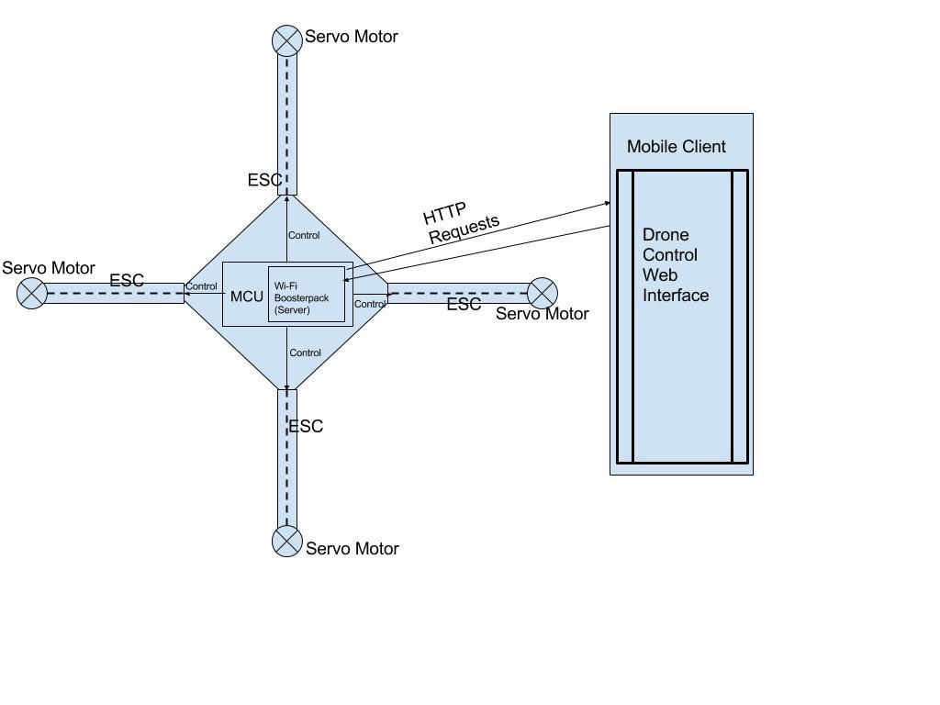

1. **Software Architecture and Code Snippets**

The code was almost exclusively written in C using the energia IDE and it’s inbuilt libraries. The web client html was also served by the MCU server. Internally, the software does the following:

* Connects a phone as a client and the Launchpad w/ Wi-Fi as the server.
* The user sends HTTP requests to the server’s IP.
* Upon receiving the requests, the server sends the appropriate control signals to the ESCs to control each motor. Control signals are generated in parallel, so all motors rotate at the same time whilst avoiding complex multithreading.
* Based on the control signals, the flight controller will change the motion of the drone as required.

All of the code can be accessed from our bitbucket repo linked below:

<https://bitbucket.org/Aryal_SauravK/csci202_finalproject>

1. **Testing**

The project underwent numerous field tests. The optimum rotational speed/required voltage for the motors was obtained by hit and trial method. The boards were tested for functionality using examples provided by the Energia IDE and from the examples from the Texas Instrument official website. Before running the high voltage servo motors for our drone, we tested the voltage on the simple DC servo motor that came with the Launchpad bundle. After extensive testing, we were able to get the required lift for the drone.

**Results**

The following results were obtained by the end of the semester:

* Mobile and MCU connection was successfully established via Wi-Fi.
* Data transmission between the mobile client and Launchpad server.
* Synchronous rotation of all four motors on the quadcopter with an external power source.
* Mobile web client UI to interact with the Wi-Fi Server was successful.
* Interaction between the MCU and ESC was controlled by control signals. The drone now acts according to the control signals sent by the MCU.
* All in all, an MVP of the Drone is ready, the drone can currently perform take-off and landing.

**Conclusion**

Although we were unable to reach our goal of building a navigation quadcopter for the visually impaired, we were happy with outcome of our MVP. Building a drone is a challenging task and even more challenging when we use the TI Launchpad as our flight controller. However, we were successful in implementing the flight controller despite the obvious lack of resources and documentation. This has encouraged us to further work and improve upon the project before officially submitting it to the TI North America Innovation Challenge 2016.

We took on this project for we thought that it would be better to aim high and fail than to succeed immensely at a lesser complicated project. Fairly enough, we learnt some fundamental concepts about hardware engineering (control signals, hardware compatibility), networking (protocols to communicate between two devices), wired communication which are also the objectives of this assignment. As for future work, we hope to complete our NaviCopter which will be able to navigate reading GPS co-ordinates, detect/avoid obstructions and also will be able to take pictures along with the videos. We hope our product will be able to help and enhance the life of visually impaired people.

# References

The following resources were hugely beneficial while building the NaviCopter:

<https://librepilot.atlassian.net/wiki/display/LPDOC/Developer+Manual>

<http://opwiki.readthedocs.io/en/latest/user_manual/cc3d/cc3d.html>

<http://www.headsuphobby.com/media/CC3D%20Basic%20Set-Up%20Guide%20-%20HURC%20-%2011.20.14.pdf>

<http://www.ti.com/lit/ug/spruhu5d/spruhu5d.pdf>

<http://energia.nu/pin-maps/guide_cc3100boosterpack/>

<http://processors.wiki.ti.com/index.php/Video_Tutorials_CCSv5>

<https://github.com/energia/Energia/tree/master/hardware/lm4f/libraries/WiFi>

<https://github.com/energia/Energia/blob/master/hardware/lm4f/libraries/WiFi/examples/SimpleWebServerWiFi/SimpleWebServerWiFi.ino>

<http://processors.wiki.ti.com/index.php/CC31xx_HTTP_Client>

<http://www.ti.com/lit/ug/swru368a/swru368a.pdf>

<http://www.ti.com/tool/cc3100simplestudio>

<https://github.com/BrianSidebotham/cc3100-sdk-cmake/tree/master/examples/sls_email>

<http://processors.wiki.ti.com/index.php/CC31xx_Quick_Start_Guide?DCMP=cc3100cc3200&HQS=cc3100booststart>

<https://github.com/benripley/Arduino-Quadcopter>

<https://www.youtube.com/watch?v=eSCvCAC7Q-c>

<https://www.youtube.com/watch?v=u3jeBseWkFI>

[http://iotdesign.embedded-computing.com/articles/build-an-internet-connected-bluetooth-wearable-with-arduino-and-cordova-part-one/#](http://iotdesign.embedded-computing.com/articles/build-an-internet-connected-bluetooth-wearable-with-arduino-and-cordova-part-one/)

<https://www.youtube.com/watch?v=kvZGA6dJQJs>

**Acknowledgment**

The team NaviCopter would like to express the deepest appreciation to Dr. Gedare Bloom without whose guidance and assistance the project would have not been successful.

We would also like to thank the TAs of the class and Dr. Charles Kim whose prompt help has helped us stay on track to complete the project on time.

Finally, we would like to thank our friends and professors from the Computer Science Department at Howard University for helping us in putting together the resources for the sake of this project.