Programming In Java
Submission For
CSE310 CA3



Submitted To: Md. Ataullah

Submitted By: Prajjwal Mishra
Reg. No: 11802287
Section: K18GX
Roll: B-64
Email: prajjwalgeek@gmail.com
Email: https://github.com/prajjwalgeek/Java-Result-Management-System

Code Component
import java.util.*;
import java.io.*;

abstract class result_management
{
abstract void input();
abstract void run();
}

class Student extends result_management
{
File f1=new File("C:\\Users\\Prajjwal Mishra\\Desktop\\new\\Marks1.java.csv");
String name;
int reg_no;
int maths, phy, comp, eng;

String cont;
void input()
{
do{
Scanner sc=new Scanner(System.in);
System.out.print("Name: ");
name=sc.nextLine();
System.out.print("Registration Number: ");
reg_no=sc.nextInt();
System.out.println("Enter Subject Marks");
System.out.print("Maths: ");
maths=sc.nextInt();
System.out.print("Physics: ");
phy=sc.nextInt();
System.out.print("Computer: ");
comp=sc.nextInt();
System.out.print("English: ");
eng=sc.nextInt();

try{
PrintWriter pw=new PrintWriter(new FileOutputStream(f1,true));
pw.append("\n"+reg_no+","+name+","+maths+","+phy+","+comp+","+eng);
pw.close();}
catch (Exception e) {}

System.out.println("Press N for main window or Press Y for another input:");

cont = sc.next();

}
while(cont.equalsIgnoreCase("y"));
}

void run() {

do{
BufferedReader br = null;
String line = "";
String cvsSplitBy = ",";
File file = new File("C:\\Users\\Prajjwal Mishra\\Desktop\\new\\Marks1.java.csv");
Scanner in = null;
Scanner sc=new Scanner(System.in);
System.out.print("Enter Registration Number: ");
String reg=sc.nextLine();

try {

br = new BufferedReader(new FileReader(file));
while ((line = br.readLine()) != null) {
String[] student = line.split(cvsSplitBy);

for (int i = 0; i < student.length; i++) {

if (student[i].equals(reg)) {
System.out.println("\tReg_no: "+student[0] +"\tName: "+ student[1] +"\tMaths:" +student[2]+"\tPhysics: "+student[3]+"\tComputer: "+student[4]+"\tEnglish: "+student[5]); //Matching the string and printing.
}
}

}

} catch (FileNotFoundException e) {
e.printStackTrace();
} catch (IOException e) {
e.printStackTrace();
} finally {
if (br != null) {
try {
br.close();
} catch (IOException e) {
e.printStackTrace();
}
}
}
System.out.println("Press N for main window or Press Y for another input:");

cont = sc.next();

}
while(cont.equalsIgnoreCase("y"));

}
}
class find
{
public static void main(String[] args) {

do{
System.out.println("Welcome to Result Management System");
Student s=new Student();
System.out.println("\t\t1. Input the result");
System.out.println("\t\t2. Fetch the result");
Scanner scan=new Scanner(System.in);
System.out.print("Enter your choice: ");
int choice=scan.nextInt();
switch (choice) {
case 1:
s.input();
break;
case 2:
s.run();
default:
break;
}
}while(true);
}
}
Sample Output

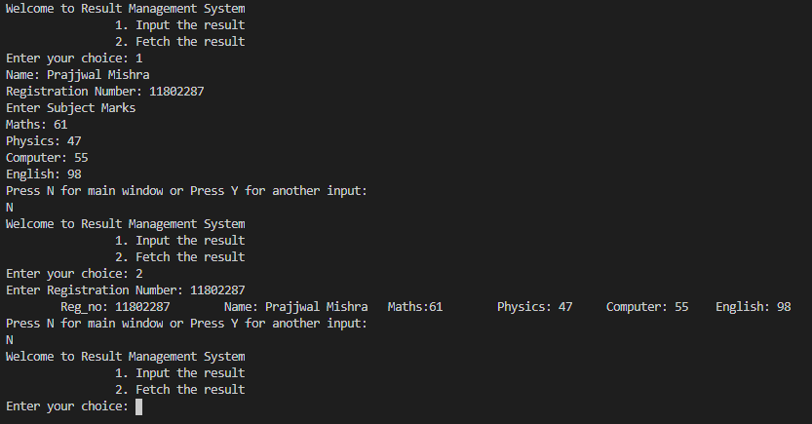

References
- Reading a CSV file in Java using OpenCV
- Read CSV file column by column
- Java Slides LPU

