Affiliated to Pokhara University

**UNITED TECHNICAL COLLEGE**



**A Major Project Proposal**

**on**

**SMART CANTEEN SYSTEM (more specific)**

**[Code No:…….]**

**(For partial fulfillment of _______ Year/Semester in Computer Engineering)**

**Submitted by**

**Prajjwal Adhikari [BEC-2020-20] symbol no.**

**Rozal Dahal [BEC-2020-27]**

**Aman Paudel [BEC-2020-03]**

**Raj Gurung [BEC-2020-23]**

**Submitted to**

**Department of Computer Engineering**

**January 22, 2025**

# Abstract

This project proposes the development of a smart canteen system designed to streamline order management and provide comprehensive data visualization. The system will allow users to place orders via an interactive web interface, process payments using NFC-enabled student ID cards and passkey authentication, and automatically send email notifications to parents, the canteen, and the college for record-keeping. A visual dashboard will display real-time sales data, monthly expenditure summaries, and itemized order histories to enhance decision-making for administrators.

The system will be built using Raspberry Pi as the server and peripherals such as an NFC reader and Pi Camera for operational functionality. Python-based frameworks (Flask/Django) and MySQL will serve as the software backbone, ensuring scalability and reliability. This solution aims to optimize canteen workflows, increase transparency, and deliver a user-friendly experience for students, administrators, and stakeholders.

**Keywords:** *Smart canteen system,* *Web-based system, NFC, Order automation, Data visualization, IoT integration, etc.*

Table of Contents

Abstract ii

List of figures iv

Abbreviation and Acronyms vi

Chapter 1: Introduction 1

1.1 Background 1

1.2 Problem Statement 1

1.3 Objectives 2

1.4 Motivation and Significance 2

1.5 Scope of Work 2

Chapter 2: Related Works 4

2.1 Overview of Existing Systems 4

2.2 Comparison of Features 5

2.3 Gaps in Existing Systems 8

2.4 Significance of Proposed Work 8

Chapter 3: Methodology 9

3.1 Requirements Gathering 9

3.2 System or Model Design 9

3.3 Technology Stack 10

3.4 Development Process 10

Chapter 4: Expected Outcomes 11

Chapter 5: Conclusion 12

References 13

Appendices 14

Appendix A: Gantt Chart 14

Appendix B: Hardware Cost Breakdown 15

# List of figures

Figure 1: System Flow Diagram of Smart Canteen System 9

Figure 2: Gantt Chart for Smart Canteen System 14

**List of tables**

Table 1: Hardware cost breakdown 15

# Abbreviation and Acronyms

|  |  |
| --- | --- |
| API | Application Programming Interface |
| DB | Database |
| GUI | Graphical User Interface |
| HTTP | Hypertext Transfer Protocol |
| ID | Identification |
| IoT | Internet of Things |
| NFC | Near Field Communication |
| SQL | Structured Query Language |
| UI | User Interface |
| UX | User Experience |
|  |  |
|  |  |
|  |  |

# Chapter 1: Introduction

## ****1.1 Background****

Traditional canteen management systems depend on manual operations, leading to inefficiencies such as delayed order processing, errors in billing, and lack of transparency in financial tracking (Khairunnisa, K., Johari, A., Wahab, M., Erdi, M., & Ayob, A., 2009). Recent advancements in IoT and web-based applications offer a unique opportunity to automate and streamline these processes (Sadiku, M., Ashaolu, T. J., Ajayi-Majebi, A., & Musa, S., 2020). By leveraging these technologies, canteens can improve user experience and operational efficiency (Qianyu, 2014).

The proposed system integrates a web application with IoT devices like NFC-enabled ID cards, Raspberry Pi, and real-time data visualization tools (Chee-Chun Wong, Lee-Ying Chong, Siew-Chin Chong, Check-Yee Law, 2023). The inclusion of passkey authentication ensures secure payments and an added layer of accountability (Sharma, 2017). Automated email notifications enhance transparency and keep stakeholders informed about transactions.

## ****1.2 Problem Statement****

Canteens relying on manual operations (Bhavani, August,2022) face the following challenges:

* Slow order processing and payment handling.
* Limited visibility into sales and inventory data.
* Difficulty in tracking and auditing transactions.

This project aims to address these issues by developing a web-based canteen system that incorporates automation, visualization, and secure payment mechanisms.

## 1.3 Objectives

* To design and implement a web-based interface for placing and managing orders.
* To enable NFC-based payment processing linked to student ID cards.
* To develop a visual dashboard to monitor real-time sales and push email notification to stakeholders.

## **1.4 Motivation and Significance**

The inefficiencies of manual canteen systems, such as delayed order fulfillment and lack of accurate records, highlight the need for automation. This project is motivated by the potential to revolutionize canteen management through technology. By integrating IoT and web-based platforms (Khan, M., & Desai, J, 2017), the system will not only reduce operational overhead but also enhance transparency and user satisfaction.

The proposed solution has significant implications for modernizing institutional canteens, ensuring timely service, and providing stakeholders with actionable insights. This combination of functionality and transparency sets a new standard for canteen operations.

1.5 Scope of Work  
The scope of this project includes the following:

* Development of a responsive web interface for user interaction.
* Integration of NFC readers to facilitate cashless transactions.
* Implementation of a real-time visual dashboard to display key performance metrics.
* Automated email notifications for order summaries and monthly expenditure reports.
* Rigorous testing to ensure compatibility across hardware components (Raspberry Pi, NFC devices).

# Chapter 2: Related Works

## 2.1 Overview of Existing Systems

1. **Online Canteen Management System**

According to (Bhavani, August,2022), the Online Canteen Management System digitized food ordering through web-based menus and payment integration, streamlining order preparation and administrative management. Users can log in using their institutional email IDs to place orders, which are directly queued for preparation. Administrators manage menu updates, transactions, and user profiles using a secure, encrypted database.

1. **Cashless & Online QR-Code-Based Canteen System**

Similarly, (Tejaswini Sharma, Swati Jha, Shubhi Gupta, Vishakha Singh, Shipra Gautam, 2021) introduced a Cashless & Online QR-Code-Based Canteen System to address contactless transactions. Their system employed QR codes for menu access, real-time order updates, and UPI-based payments. Users scan QR codes to access a web platform, where they can browse the menu, place orders, and pay via UPI or e-wallets. Notifications keep users updated about their order status.

1. **Cashless Canteen Management System**

The RFID-Based Cashless Canteen System by (M. Ambika, Saravana Kumar R, Sandhya S Nair, Ranjith Kumar S, 2020) utilized RFID cards for cashless payments and integrated encryption for secure transactions. This system integrates RFID cards for cashless transactions, enabling users to recharge cards and make payments seamlessly. Orders placed online or at the counter are displayed in real-time in the kitchen. Security is ensured through encryption and SSL protocols.

1. **Development and Evaluation of a Comprehensive Web-Based Canteen Food Ordering System**

(Sushank Pandey, Rayaan Quraishi, Aditya Salian, Swapnil Bhagat, 2024) developed a Comprehensive Web-Based Canteen Food Ordering System focusing on real-time inventory updates and centralized dashboards. This system focuses on automating food ordering and inventory management in educational and workplace cafeterias. It allows users to browse menus, place orders, and pay online. Admins have access to a centralized dashboard for monitoring operations and generating reports.

1. **QR Food Ordering System with Data Analytics**

Finally, (Chee-Chun Wong, Lee-Ying Chong, Siew-Chin Chong, Check-Yee Law, 2023)developed a QR Food Ordering System designed to automate the ordering process in restaurants and provide insightful business analytics. Customers scan a QR code on their table to access a digital menu and place orders, which are automatically processed for billing. The system allows restaurant administrators to manage the menu, generate QR codes, and analyze sales data through visualized charts. It utilizes machine learning to forecast demand, enhancing decision-making and resource allocation.

## 2.2 Comparison of Features

1. **Online Canteen Management System**

**Features:**

* Web-based e-menu for easy access to food options.
* Online payment integration streamlining order processing.
* Real-time notifications to kitchen staff for immediate order updates.

**Drawbacks:**

* Limited scalability for large institutions.
* Lacks parental notifications and multi-factor authentication for added security.

1. **Cashless & Online QR-Code-Based Canteen System**

**Features:**

* QR-code-based contactless ordering for a seamless user experience.
* UPI and e-wallet payment options enhance convenience.
* SMS notifications provide real-time order updates.

**Drawbacks:**

* Relies heavily on QR-code technology, which can be unreliable if codes are damaged.
* Scalability issues when handling high user volumes.

1. **Cashless Canteen Management System**

**Features:**

* RFID-based cashless payments simplify transactions.
* Encrypted payment processing ensures secure operations.
* Real-time order display in the kitchen improves workflow efficiency.

**Drawbacks:**

* Susceptible to operational issues from lost or damaged RFID cards.
* Lacks multi-device support, parental notifications, and comprehensive reporting tools.

1. **Comprehensive Web-Based Canteen Food Ordering System**

**Features:**

* Scalable web-based platform for managing high transaction volumes.
* Real-time inventory updates streamline stock management.
* Centralized admin dashboard for efficient monitoring and reporting.

**Drawbacks:**

* Requires advanced infrastructure, which may not be feasible for smaller canteens.
* Lacks multi-factor authentication and does not provide parental notification features.

1. **Food Ordering System with Data Analytics**

**Features:**

* QR-code-based ordering for a contactless dining experience.
* Automated billing to reduce human error.
* Data analytics integration for visualized insights on sales and customer behavior.
* Machine learning for demand forecasting and strategic decision-making.

**Drawbacks:**

* Requires a reliable internet connection and mobile devices for all users.
* High initial setup cost due to the integration of data analytics and machine learning.
* Potential learning curve for restaurant staff to fully utilize the analytics dashboard and forecasting features.

2.3 Gaps in Existing Systems  
Despite their contributions, these systems fail to:

* Combine IoT hardware (e.g., NFC readers) with web-based functionality in a cost-effective way.
* Provide robust visualization tools for tracking sales, expenditures, and real-time data.
* Automate notifications to stakeholders to enhance transparency and accountability.

2.4 Significance of Proposed Work  
This project addresses these gaps by:

* Developing an integrated system that combines IoT and web-based technologies.
* Offering a comprehensive dashboard for real-time and historical data visualization.
* Automating communication through email notifications to improve stakeholder engagement.

# Chapter 3: Methodology

## 3.1 Requirements Gathering

* Conduct surveys and consultations to identify user requirements.
* Define hardware specifications (Raspberry Pi, NFC reader) and software needs (Flask, MySQL).

## 3.2 System or Model Design

* Develop modular components for order management, payment processing, and data visualization.
* Prototype the user interface using Figma or similar tools.

The following diagram illustrates the system flow of the Smart Canteen System, highlighting the interaction among key components and the database for seamless operation.

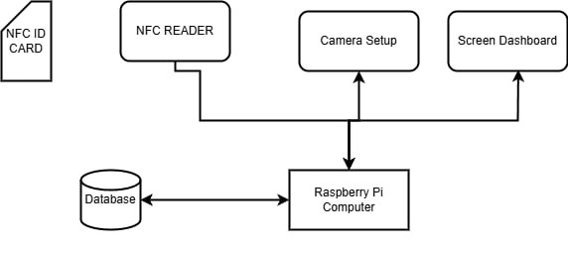

*Figure 1: System Flow Diagram of Smart Canteen System*

## 3.3 Technology Stack

* **Backend:** Python (Flask/Django)
* **Frontend:** HTML, CSS, JavaScript
* **Database:** MySQL
* **Hardware:** Raspberry Pi, NFC Reader, Pi Camera, Monitor

## 3.4 Development Process

* Use Agile methodology for iterative development and continuous testing.
* Employ Git for version control and collaborative development.

Chapter 4: Expected Outcomes

The project will deliver:

* A fully functional, web-based canteen system with NFC-enabled payments.
* Automated email notifications to stakeholders for improved transparency.
* A user-friendly dashboard for tracking real-time sales and monthly expenditure summaries.

Chapter 5: Conclusion

The proposed web-based canteen system represents a transformative approach to managing canteen operations. By integrating IoT devices and web-based technologies, the system improves efficiency, reduces manual effort, and enhances transparency. The visual dashboard and automated notifications provide valuable insights for decision-making, while the NFC-enabled transactions simplify user interactions. This project sets a benchmark for modernizing institutional canteens with scalable, cost-effective solutions.

The outcomes of this project have the potential to influence similar implementations in other institutional or commercial settings, paving the way for a broader adoption of automated systems.

# References

Bhavani. (August,2022). *Canteen Management System.* BMS College of Commerce and Management, BCA. Bangalore: IJARSCT. doi:10.48175/568

Chee-Chun Wong, Lee-Ying Chong, Siew-Chin Chong, Check-Yee Law. (2023, Sept). QR Food Ordering System with Data Analytics. *Journal of Informatics and Web Engineering*. doi:10.33093/jiwe.2023.2.2.18

Khairunnisa, K., Johari, A., Wahab, M., Erdi, M., & Ayob, A. (2009). The Application of Wireless Food Ordering System. *MASAUM Journal of Computing*.

Khan, M., & Desai, J. (2017). *IoT and QR-Code-Based Food Ordering System.* Journal of Informatics and Web Engineering.

M. Ambika, Saravana Kumar R, Sandhya S Nair, Ranjith Kumar S. (2020, MAY). Cashless Canteen Management System. *International Journal of Innovative Technology and Exploring Engineering (IJITEE)*. Retrieved from https://www.ijitee.org/wp-content/uploads/papers/v9i7/G5095059720.pdf

Qianyu, J. (2014). *Exploring the Concept of QR Code and the Benefits of Using QR Code for Companies.* Lapland University of Applied Sciences.

Sadiku, M., Ashaolu, T. J., Ajayi-Majebi, A., & Musa, S. (2020). *Big Data in Food Industry.* International Journal of Scientific Advances.

Sharma, D. (2017). *A Review of QR Code Structure for Encryption and Decryption Process.* International Journal of Innovative Science and Research Technology.

Sushank Pandey, Rayaan Quraishi, Aditya Salian, Swapnil Bhagat. (2024, NOV). Development and Evaluation of a Comprehensive Web-Based Canteen Food Ordering System. *International Journal for Research in Applied Science & Engineering Technology (IJRASET)*. doi:10.22214/ijraset.2024.65046

Tejaswini Sharma, Swati Jha, Shubhi Gupta, Vishakha Singh, Shipra Gautam. (2021, MARCH). CASHLESS & ONLINE QR-CODE BASED CANTEEN MANAGEMENT SYSTEM. *International Research Journal of Modernization in Engineering Technology and Science*. Retrieved from https://www.irjmets.com/uploadedfiles/paper/volume3/issue_3_march_2021/6833/1628083291.pdf

# Appendices

## Appendix A: Gantt Chart

The following Gantt chart outlines the timeline for the Smart Canteen System project, showing task durations, start and end dates, and dependencies between tasks.

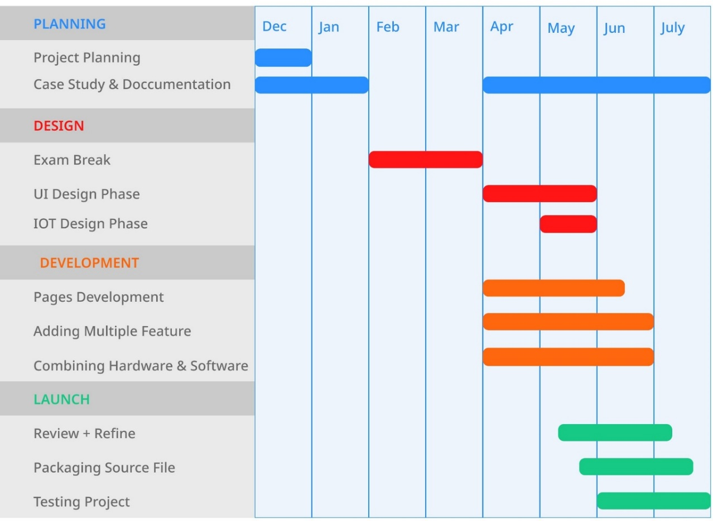

*Figure 2: Gantt Chart for Smart Canteen System*

## Appendix B: Hardware Cost Breakdown

The table below provides a detailed breakdown of the hardware components required for the project, including their quantities, estimated costs per unit, and total costs in NPR.

|  |  |  |  |
| --- | --- | --- | --- |
| **Component** | **Quantity** | **Estimated Cost per Unit (NPR)** | **Total Cost (NPR)** |
| Raspberry Pi 5 (8GB RAM) | 1 | 16,000 | 16,000 |
| NFC Reader | 1 | 3,990 | 3,990 |
| NFC Cards (for users) | 10 | 250 | 2,500 |
| Pi Camera | 1 | 3,325 | 3,325 |
| Monitor (for display) | 1 | 13,300 | 13,300 |
| Power Supply & Cables | 1 | 3,990 | 3,990 |
| MicroSD Card (64GB, for Raspberry Pi) | 1 | 2,500 | 2,500 |
| Piezo Buzzer | 1 | 300 | 300 |
| Speaker (for payment success notification) | 1 | 2,500 | 2,500 |
| Miscellaneous (Connectors, PCB, Sensors, Enclosures, Wiring, etc.) | - | 3,990 | 3,990 |
| **Total Hardware Cost** |  |  | **51,395** |

*Table 1: Hardware cost breakdown*