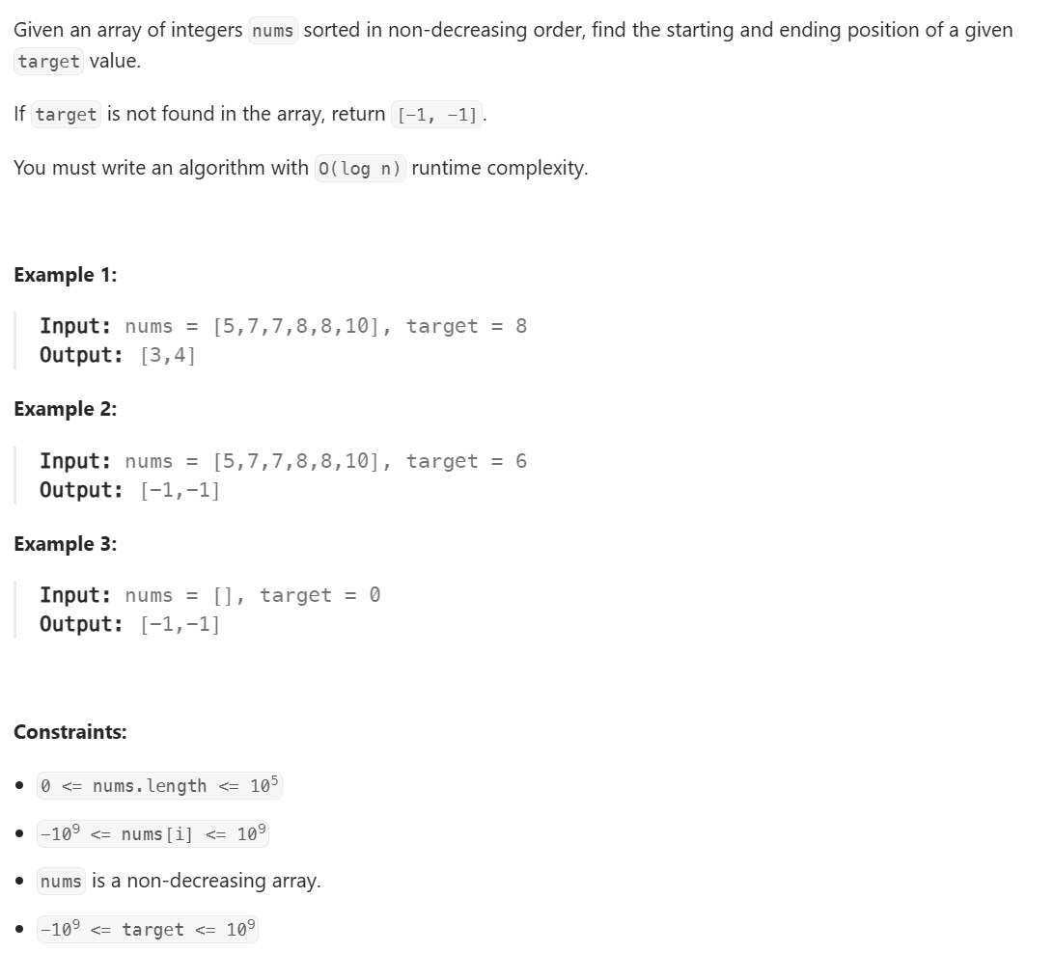

Solution
1. Logic to Find First Occurrence
If found, keep searching LEFT to see if there is an earlier one.
FUNCTION findFirst(arr, target):
start = 0
end = length of arr - 1
result = -1

WHILE start <= end:
mid = start + (end - start) / 2
IF arr[mid] == target:
result = mid // Store index
end = mid - 1 // Move Left
ELSE IF arr[mid] < target:
start = mid + 1
ELSE:
end = mid - 1
RETURN result

2. Logic to Find Last Occurrence
If found, keep searching RIGHT to see if there is a later one.
FUNCTION findLast(arr, target):
start = 0
end = length of arr - 1
result = -1
WHILE start <= end:
mid = start + (end - start) / 2
IF arr[mid] == target:
result = mid // Store index
start = mid + 1 // Move Right
ELSE IF arr[mid] < target:
start = mid + 1
ELSE:
end = mid - 1
RETURN result
3. Main
FUNCTION searchRange(arr, target):
first = findFirst(arr, target)
IF first == -1:
RETURN {-1, -1} // Target not found
last = findLast(arr, target)
RETURN {first, last}

