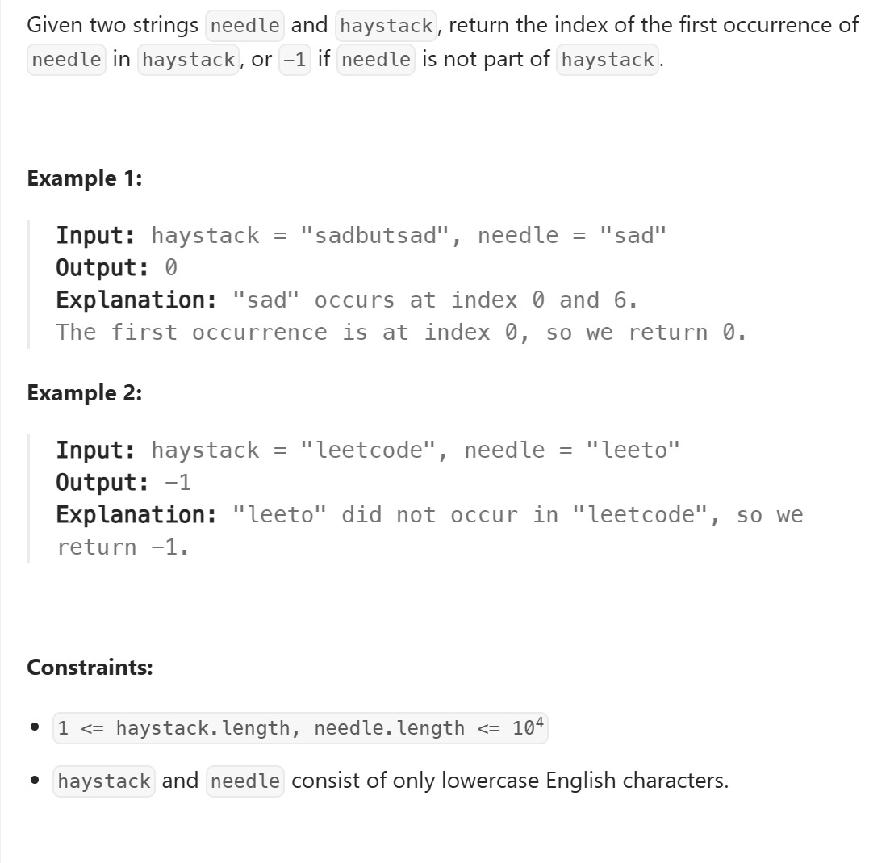

Solution
class Solution {
public int strStr(String haystack, String needle) {

// l1 = length of needle (pattern we want to find)
// l2 = length of haystack (bigger string)
int l1 = needle.length();
int l2 = haystack.length();

// If needle is empty, answer should be 0.
// But since your code returns -1, keeping your logic unchanged.
if (l1 == 0)
return 0;

// Loop only till (l2 - l1), because beyond that
// remaining characters would be fewer than needle's length.
for (int i = 0; i <= l2 - l1; i++) {

int j = 0;

// Compare each character of needle with haystack starting at index i.
// Continue while characters match.
while (j < l1 && haystack.charAt(i + j) == needle.charAt(j)) {
j++;
}

// If j reached l1, it means all characters matched → substring found.
if (j == l1)
return i; // return starting index
}

// If no match found in entire haystack
return -1;
}
}

