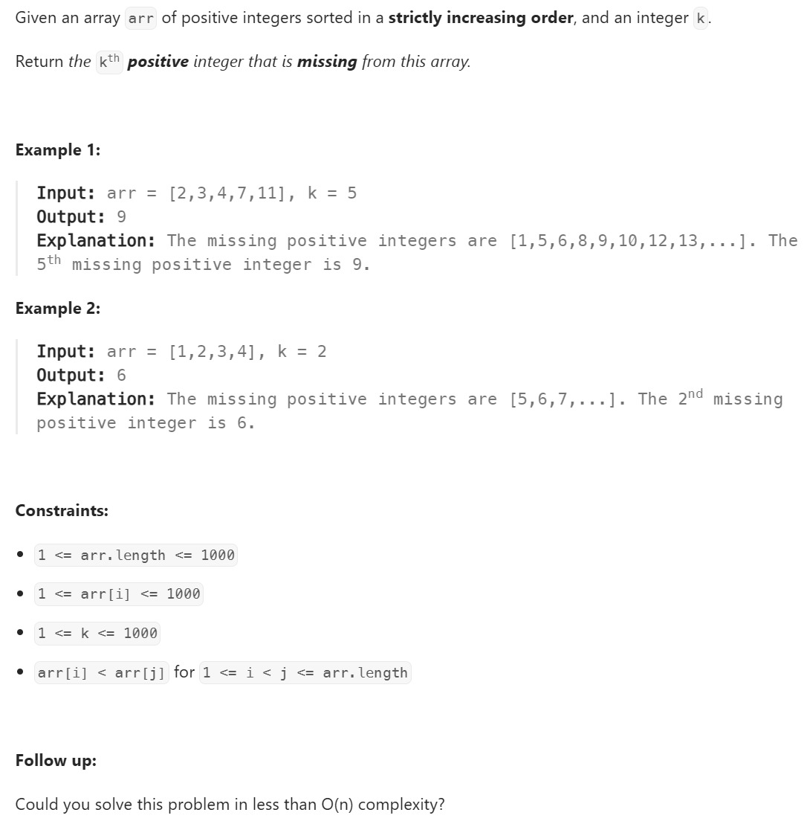

Solution
1. Brute Force Approach (O(n))
class Solution {
public int findKthPositive(int[] arr, int k) {
int current = 1; // Start checking from 1
int index = 0;

while (k > 0) {
if (index < arr.length && arr[index] == current) {
index++; // Number exists in arr
} else {
k--; // Number is missing
if (k == 0) {
return current;
}
}
current++;
}
return -1;
}
}

2. Optimal Approach — Binary Search + Maths (O(log n))

class Solution {
public int findKthPositive(int[] arr, int k) {
int left = 0;
int right = arr.length - 1;

// If k-th missing is before the first array element
if (arr[0] > k) {
return k;
}

while (left <= right) {
int mid = left + (right - left) / 2;

// missing numbers till index mid
int missing = arr[mid] - (mid + 1);

if (missing < k) {
left = mid + 1;
} else {
right = mid - 1;
}
}

return left + k ; // Final answer: add how many elements of arr are <= the result
}}

