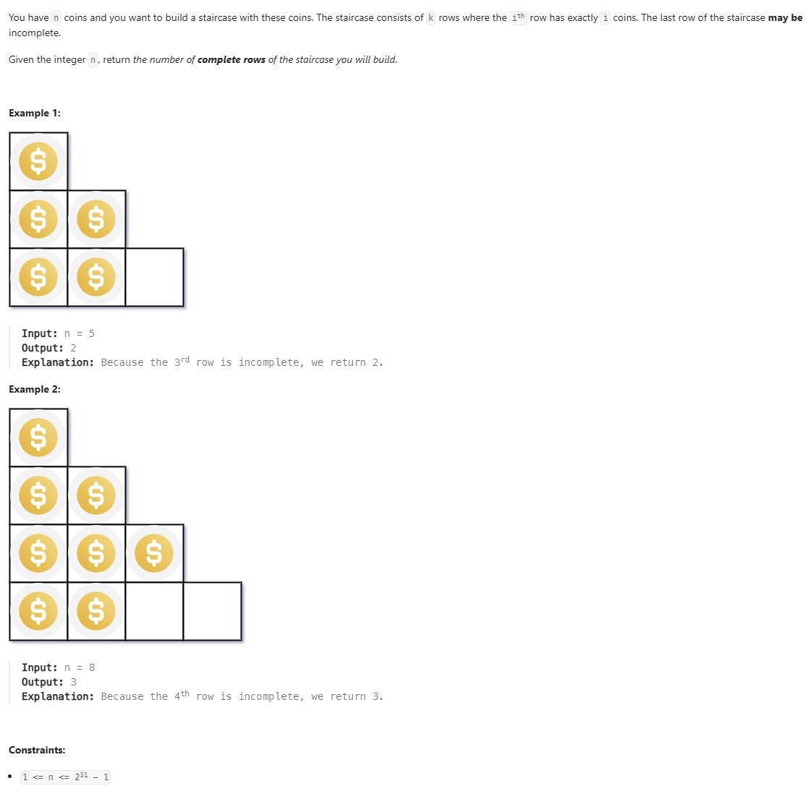

Solution
class Solution {
public int Coins(int n) {
long low = 0, high = n;
int answer = 0;
// We apply binary search on the number of rows (k)
while (low <= high) {
long mid = low + (high - low) / 2;
// coins required to build 'mid' complete rows
long coinsNeeded = mid * (mid + 1) / 2; //We use long for mid (and also for coinsNeeded) to avoid integer overflow in Java.
if (coinsNeeded == n) {
// perfect match → 'mid' full rows can be built
return (int) mid;
}
if (coinsNeeded < n) {
// we can complete 'mid' rows, try for more
answer = (int) mid;
low = mid + 1;
} else {
// too many coins required → reduce rows
high = mid - 1;
}
}
// answer stores the maximum full rows possible
return answer;
}}

