*Assignment No.3*

*Looping Statement(****While Loop)***

Q.1 Write a program to display number from 1 to 10?

Output:-

ut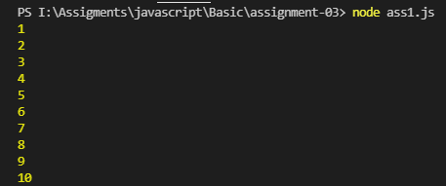

Q2.Write a program to display first 10 even number?

o

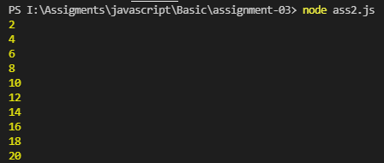

Q3.Write a program to display table of 5?

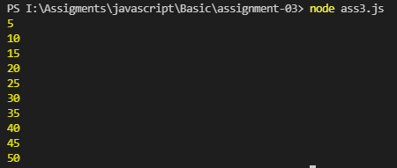

Q4. Write a program to display the following pattern?

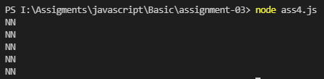

Q5. Write a program to display table of 4?

