**DAILY ONLINE ACTIVITIES SUMMARY**

|  |  |  |  |  |  |  |  |  |
| --- | --- | --- | --- | --- | --- | --- | --- | --- |
| **Date:** | **15/06/2020** | | | | | **Name:** | **Prajna** | |
| **Sem & Sec** | **6th & A** | | | | | **USN:** | **4al17cs059** | |
| **Online Test Summary** | | | | | | | | |
| **Subject** | | **Python (workshop quiz)** | | | | | | |
| **Max. Marks** | | **20** | | **Score** | | | **16** | |
| **Certification Course Summary** | | | | | | | | |
| **Course** | 9:00 am to 11:00 am - Programming in C  11:00 am to 1:00pm - Applications of python in DA and ML | | | | | | | |
| **Certificate Provider** | | | **Vivek Sharma**  **Dr. Mohideen**  **Badusha** | | **Duration** | | | **4hours** |
| **Coding Challenges** | | | | | | | | |
| **Problem Statement:** 2 Programs | | | | | | | | |
| **Status: Solved** | | | | | | | | |
| **Uploaded the report in Github** | | | | | **yes** | | | |
| **If yes Repository name** | | | | | <https://github.com/prajna-nayak-098/Daily-Report> | | | |
| **Uploaded the report in slack** | | | | | **yes** | | | |

Python Quiz:

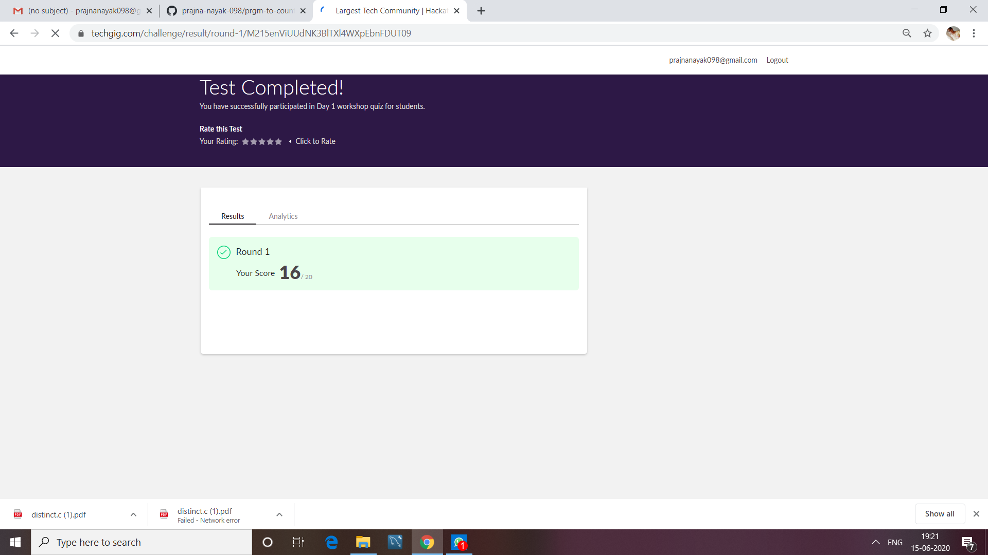

**SNAPSHOTS**

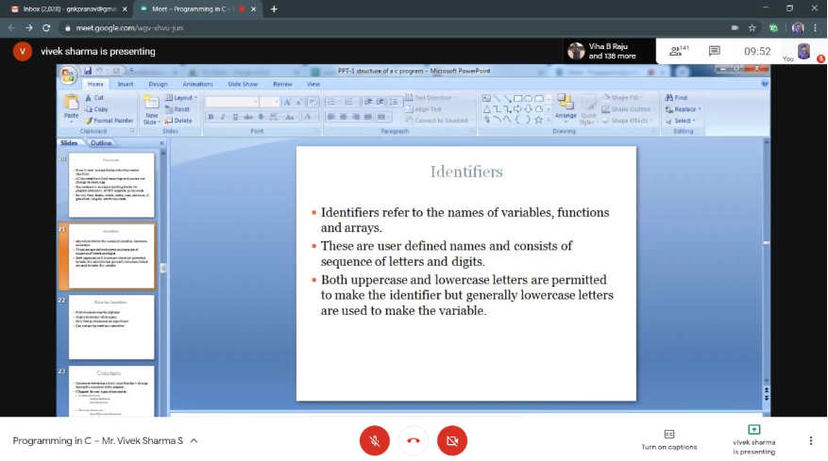

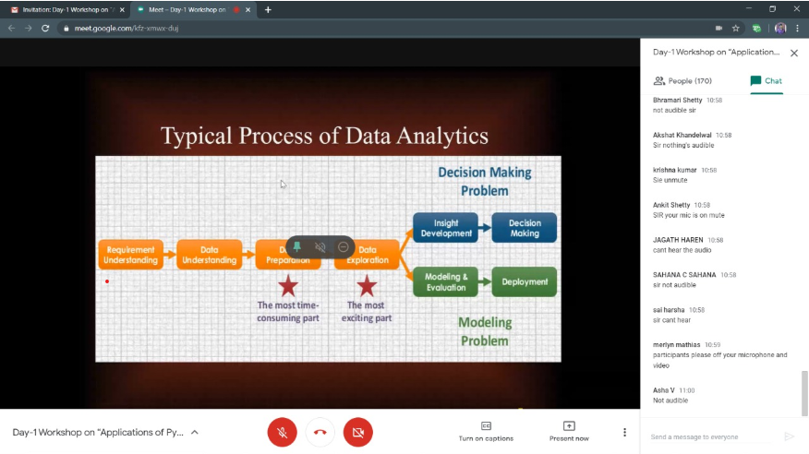

ONLINE CODING

**1. Write a Java Program to Find the Middle Node of a Linked list in a Single-pass**

public class LinkedListTest {

public static void main(String args[]) {

//creating LinkedList with 5 elements including head

LinkedList linkedList = new LinkedList();

LinkedList.Node head = linkedList.head();

linkedList.add( new LinkedList.Node("1"));

linkedList.add( new LinkedList.Node("2"));

linkedList.add( new LinkedList.Node("3"));

linkedList.add( new LinkedList.Node("4"));

LinkedList.Node current = head;

int length = 0;

LinkedList.Node middle = head

while(current.next() != null){

length++;

if(length%2 ==0){

middle = middle.next();

}

current = current.next();

}

if(length%2 == 1){

middle = middle.next();

}

System.out.println("length of LinkedList: " + length);

System.out.println("middle element of LinkedList : " + middle);

}

}

class LinkedList{

private Node head;

private Node tail;

public LinkedList(){

this.head = new Node("head");

tail = head;

}

public Node head(){

return head;

}

public void add(Node node){

tail.next = node;

tail = node;

}

public static class Node{

private Node next;

private String data;

public Node(String data){

this.data = data;

}

public String data() {

return data;

}

public void setData(String data) {

this.data = data;

}

public Node next() {

return next;

}

public void setNext(Node next) {

this.next = next;

}

public String toString(){

return this.data;

}

}

}

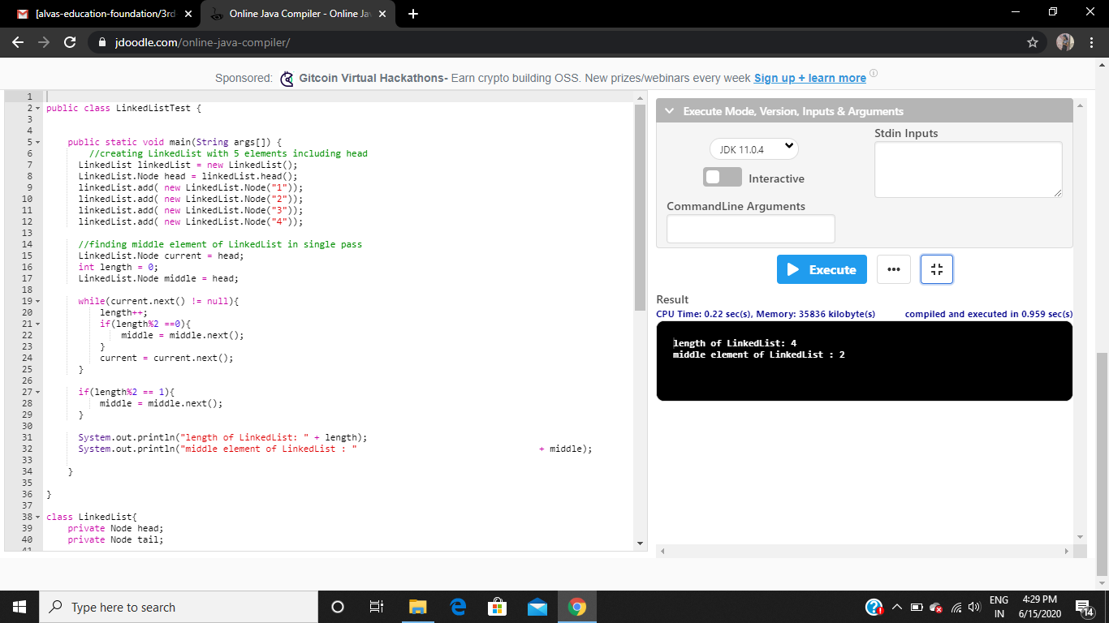

**2. Python Program to Remove the Characters of Odd Index Values in a String.**

def odd_values_string(str):

result = ""

for i in range(len(str)):

if i % 2 == 0:

result = result + str[i]

return result

print(odd_values_string('abcdef'))

print(odd_values_string('python'))

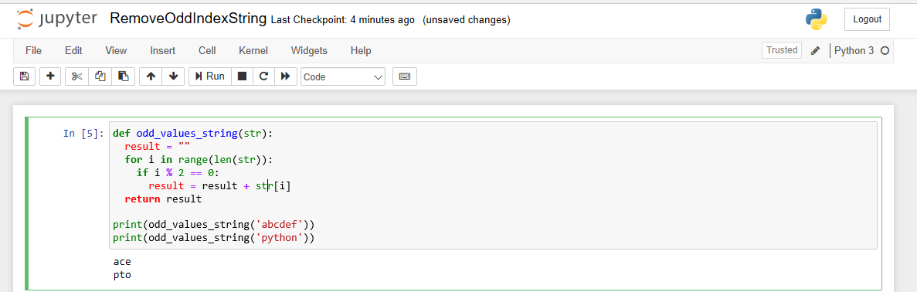

**Uploaded in Github**

