**DAILY ONLINE ACTIVITIES SUMMARY**

|  |  |  |  |  |  |  |  |  |
| --- | --- | --- | --- | --- | --- | --- | --- | --- |
| **Date:** | **16/07/2020** | | | | | **Name:** | **Prajna** | |
| **Sem & Sec** | **6th & A** | | | | | **USN:** | **4al17cs059** | |
| **Online Test Summary** | | | | | | | | |
| **Subject** | | **-** | | | | | | |
| **Max. Marks** | | **-** | | **Score** | | | **-** | |
| **Certification Course Summary** | | | | | | | | |
| **Course** | **SDP on LATEX** | | | | | | | |
| **Certificate Provider** | | | **-** | | **Duration** | | | **2hours** |
| **Coding Challenges** | | | | | | | | |
| **Problem Statement**: **Python Program to Check if binary representation is palindrome** | | | | | | | | |
| **Status: Solved** | | | | | | | | |
| **Uploaded the report in Github** | | | | | **yes** | | | |
| **If yes Repository name** | | | | | <https://github.com/prajna-nayak-098/Daily-Report> | | | |
| **Uploaded the report in slack** | | | | | **yes** | | | |

**ONLINE COURSE**

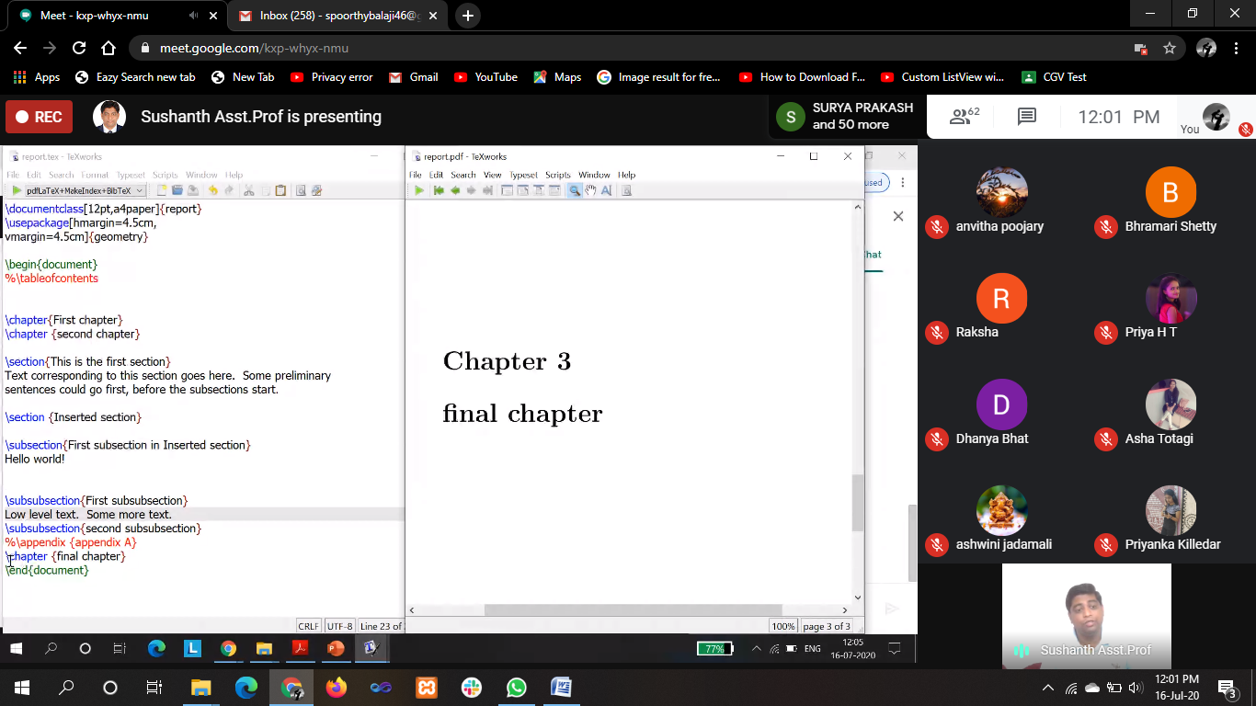

**ONLINE CODING**

**Python Program to Check if binary representation is palindrome**

def binaryPallindrome(num):

binary = bin(num)

binary = binary[2:]

return binary == binary[-1::-1]

if __name__ == "__main__":

num = 9

print(binaryPallindrome(num))

