**DAILY ONLINE ACTIVITIES SUMMARY**

|  |  |  |  |  |  |  |  |  |
| --- | --- | --- | --- | --- | --- | --- | --- | --- |
| **Date:** | **19/05/2020** | | | | | **Name:** | **Prajna** | |
| **Sem & Sec** | **6th & A** | | | | | **USN:** | **4al17cs059** | |
| **Online Test Summary** | | | | | | | | |
| **Subject** | | **Computer Graphics and Visualization** | | | | | | |
| **Max. Marks** | | **60** | | **Score** | | | **56** | |
| **Certification Course Summary** | | | | | | | | |
| **Course** | **Python for Machine Learning** | | | | | | | |
| **Certificate Provider** | | | **Great Learning Academy** | | **Duration** | | | **5hours** |
| **Coding Challenges** | | | | | | | | |
| **Problem Statement:**  1.Java code to find shortest palindrome for the given string.  2. Write a simple code to identify given linked list is palindrome or not by using stack.  First take a Stack. Traverse through each node of the linked list and push each node value to  Stack. | | | | | | | | |
| **Status: Solved** | | | | | | | | |
| **Uploaded the report in Github** | | | | | **yes** | | | |
| **If yes Repository name** | | | | | <https://github.com/prajna-nayak-098/prajna--online-code> | | | |
| **Uploaded the report in slack** | | | | | **yes** | | | |

IA TEST

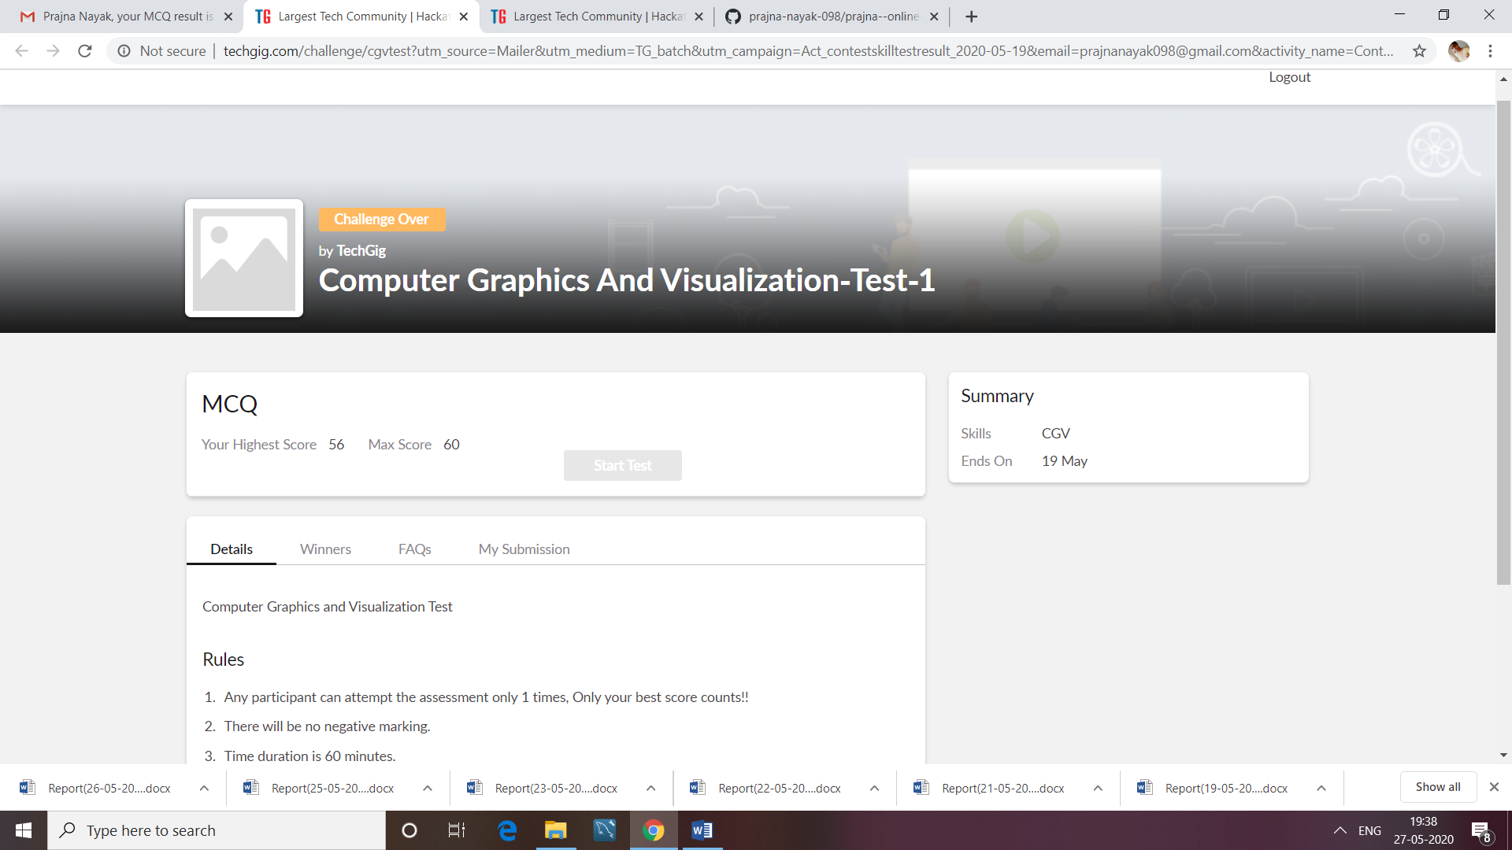

CERTIFICATION COURSE

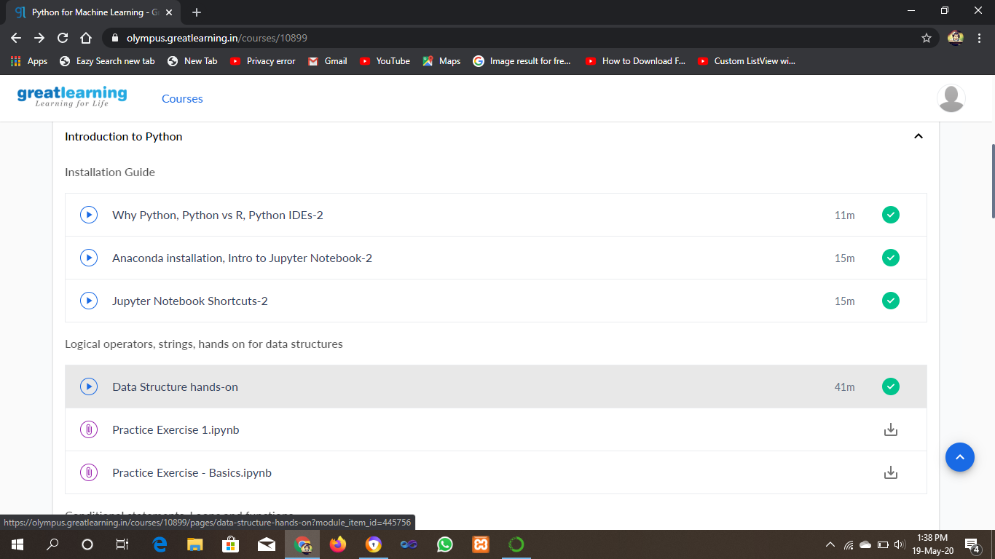

ONLINE CODING

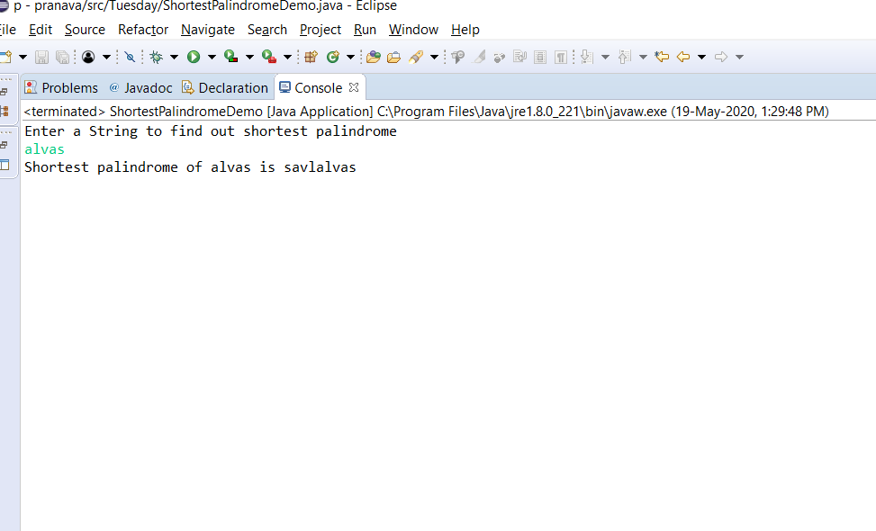Program 1 output:

Program 2 :

