**DAILY ONLINE ACTIVITIES SUMMARY**

|  |  |  |  |  |  |  |  |  |
| --- | --- | --- | --- | --- | --- | --- | --- | --- |
| **Date:** | **22/06/2020** | | | | | **Name:** | **Prajna** | |
| **Sem & Sec** | **6th & A** | | | | | **USN:** | **4al17cs059** | |
| **Online Test Summary** | | | | | | | | |
| **Subject** | |  | | | | | | |
| **Max. Marks** | |  | | **Score** | | |  | |
| **Pre-placement Training Summary** | | | | | | | | |
| **Course** | **Programming in C/C++** | | | | | | | |
| **Certificate Provider** | | | **Shilpa**  **Anikitha Shetty** | | **Duration** | | | **3hours** |
| **Coding Challenges** | | | | | | | | |
| **Problem Statement:** 3 programs | | | | | | | | |
| **Status: Solved** | | | | | | | | |
| **Uploaded the report in Github** | | | | | **yes** | | | |
| **If yes Repository name** | | | | | <https://github.com/prajna-nayak-098/Daily-Report> | | | |
| **Uploaded the report in slack** | | | | | **yes** | | | |

**SNAPSHOTS**

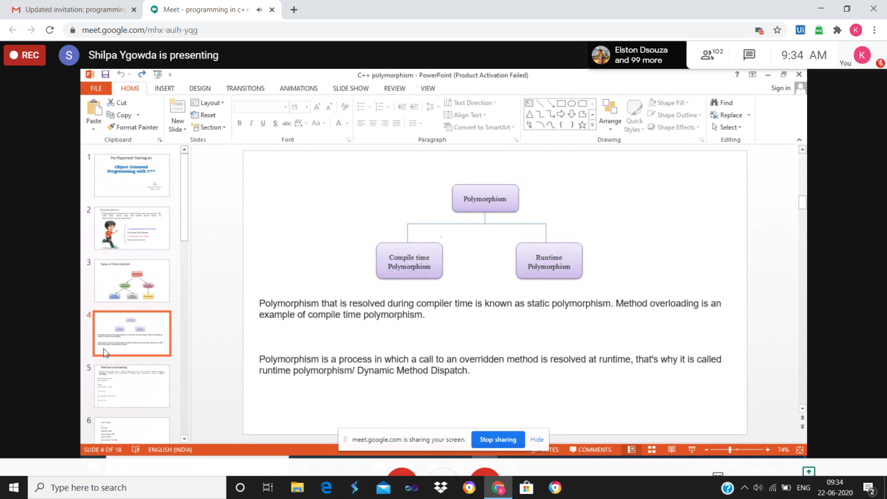

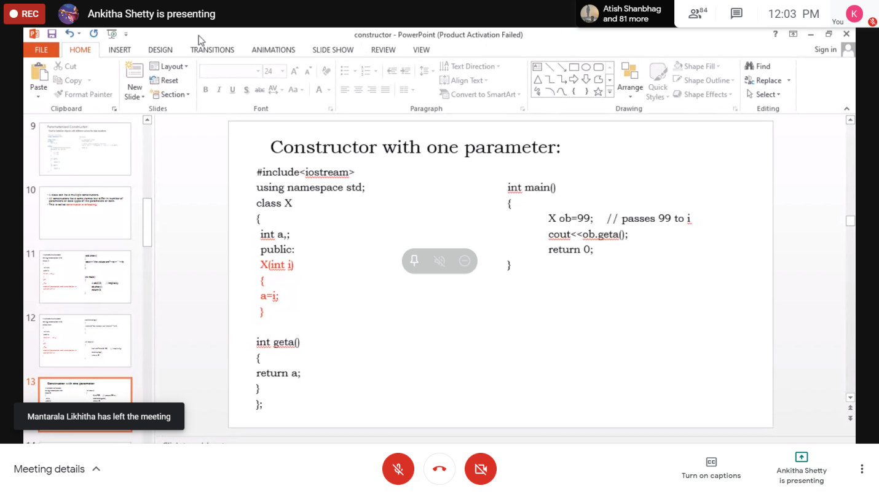

ONLINE CODING

**1. Write a Java program to find maximum repeated words from a file.**

import java.io.BufferedReader;

import java.io.FileReader;

import java.util.ArrayList;

public class MostRepeatedWord {

public static void main(String[] args) throws Exception {

String line, word = "";

int count = 0, maxCount = 0;

ArrayList<String> words = new ArrayList<String>();

FileReader file = new FileReader("data.txt ");

BufferedReader br = new BufferedReader(file);

while((line = br.readLine()) != null) {

String string[] = line.toLowerCase().split("([,.\\s]+) ");

for(String s : string){

words.add(s);

}

}

for(int i = 0; i < words.size(); i++){

count = 1;

for(int j = i+1; j < words.size(); j++){

if(words.get(i).equals(words.get(j))){

count++;

}

}

if(count > maxCount){

maxCount = count;

word = words.get(i);

}

}

System.out.println("Most repeated word: " + word);

br.close();

}

}

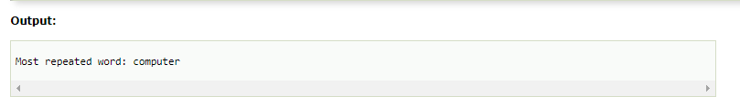

**2.  Python Program to Read a Text File and Print all the Numbers Present in the Text File**

fname = input("Enter file name: ")

with open(fname, 'r') as f:

for line in f:

words = line.split()

for i in words:

for letter in i:

if(letter.isdigit()):

print(letter)

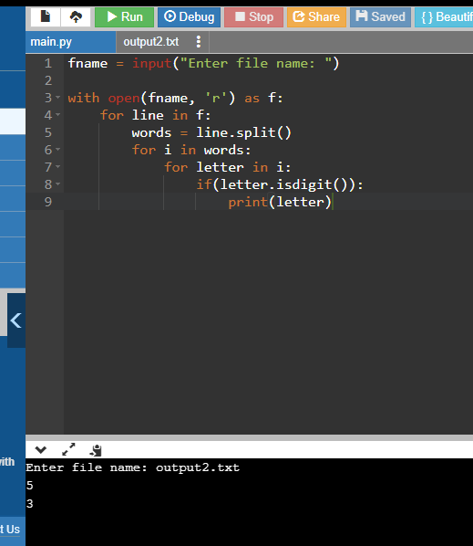

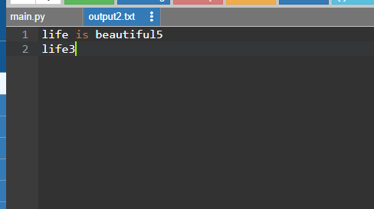

**3. Python Program to Read the Contents of a File in Reverse Order**

**filename=input("Enter file name: ")**

**with open (filename,'r') as f:**

**for line in f:**

**l=line.split()**

**l.reverse()**

**out= " ".join(l)**

**print (out)**

