**DAILY ONLINE ACTIVITIES SUMMARY**

|  |  |  |  |  |  |  |  |  |
| --- | --- | --- | --- | --- | --- | --- | --- | --- |
| **Date:** | **31-05-2020** | | | | | **Name:** | **Prajna** | |
| **Sem & Sec** | **6th & A** | | | | | **USN:** | **4AL17CS057** | |
| **Online Test Summary** | | | | | | | | |
| **Subject** | |  | | | | | | |
| **Max. Marks** | |  | | **Score** | | |  | |
| **Certification Course Summary** | | | | | | | | |
| **Course** | **Introduction to Information Security** | | | | | | | |
| **Certificate Provider** | | | Greate learning | | **Duration** | | | 6 hours |
| **Coding Challenges** | | | | | | | | |
| **Problem Statement:**  1.Write a c program to convert decimal number to binary.  2. Write a c program to print alphabet triangle.  3.Write a python program to print the multiplication table of number. | | | | | | | | |
| **Status: Completed** | | | | | | | | |
| **Uploaded the report in Github** | | | | | **YES** | | | |
| **If yes Repository name** | | | | | <https://github.com/prajna-nayak-098/Daily-Report> | | | |
| **Uploaded the report in slack** | | | | | **YES** | | | |

.

**Certification Course Details:**

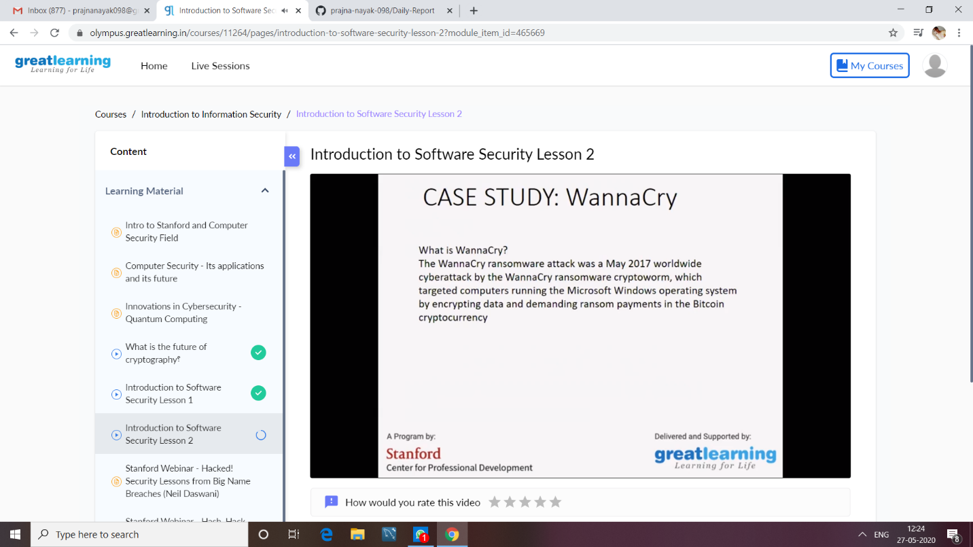

.

**Coding Challenges Details:**

<https://github.com/prajna-nayak-098/prajna--online-code>