DAILY ONLINE ACTIVITIES SUMMARY

|  |  |  |  |  |  |  |  |
| --- | --- | --- | --- | --- | --- | --- | --- |
| **Date:** | **13-06-2020** | | | | **Name:** | **Prajna** | |
| **Sem & Sec** | **6th&A** | | | | **USN:** | **4AL17CS059** | |
| Online Test Summary | | | | | | | |
| **Subject** | | **PAP** | | | | | |
| **Max. Marks** | | **30** | | **Score** | | **8** | |
| Certification Course Summary | | | | | | | |
| **Course** | **Introduction to Cloud** | | | | | | |
| **Certificate Provider** | | | **COGNITIVE CLASS .ai** | **Duration** | | | **6hr** |
| Coding Challenges | | | | | | | |
| **Problem Statement:**   1. Write a C Program to calculate Electricity Bill 2. How to find the first non repeated character of a given String? 3. Write a Java program to find maximum width of a binary tree 4.Python Program to print the pattern | | | | | | | |
| **Status: completed** | | | | | | | |
| **Uploaded the report in Github** | | | | **Yes** | | | |
| **If yes Repository name** | | | | <https://github.com/prajna-nayak-098/Daily-Report> | | | |
| **Uploaded the report in slack** | | | | **Yes** | | | |

### Online test details:

Subject: PAP



Certification course details:

**Introduction to Cloud**

### Today I have studied following topics:

* Introduction to objects
* Cloud adaption
* Internet of things in cloud
* Artificial intelligent on the cloud
* Blockchain and analytics on the cloud

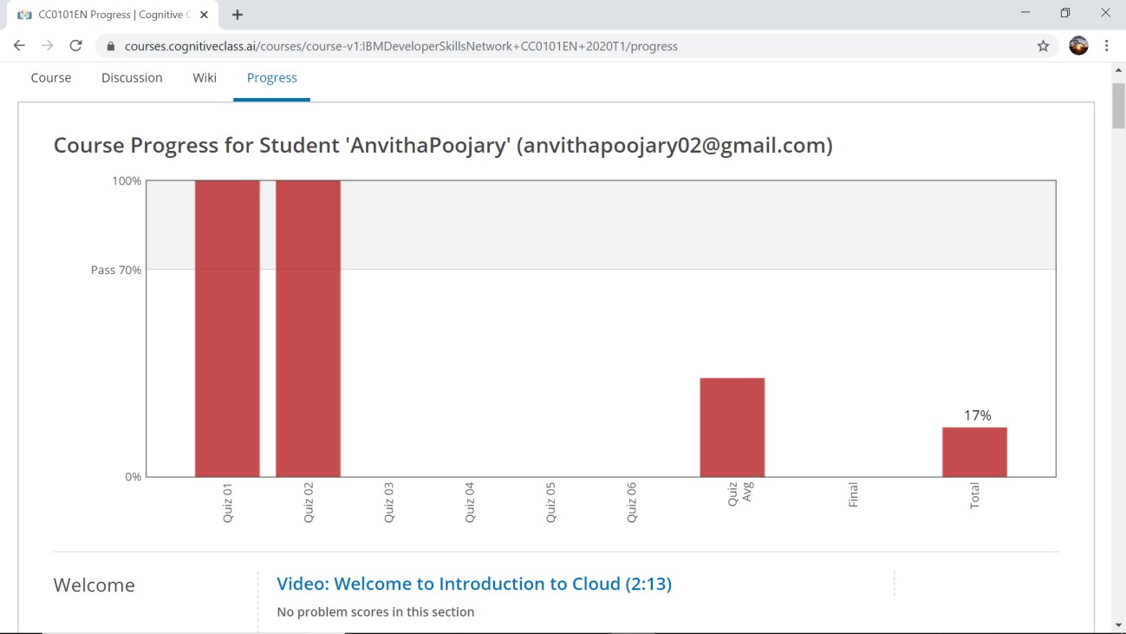

**Coding Challenges Details:**

1. Write a C Program to calculate Electricity Bill

Given an integer U denoting the amount of KWh units of electricity consumed, the task is to calculate the electricity bill with the help of the below charges:

* 1 to 100 units – Rs. 10/- Per Unit
* 100 to 200 units – Rs. 15/- Per Unit
* 200 to 300 units – Rs. 20/- Per Unit
* above 300 units – Rs. 25/- Per Unit Examples:

Input: U = 250 Output: 3500

Explanation:

Charge for the first 100 units – 10*100 = 1000 Charge for the 100 to 200 units – 15*100 = 1500 Charge for the 200 to 250 units – 20*50 = 1000 Total Electricity Bill = 1000 + 1500 + 1000 = 3500

#include <stdio.h> #include <stdlib.h> int main()

{

int unit;

printf("U=");

scanf("%d",&unit); if(unit<=100){ printf("%d",unit*10);

}

else if(unit<=200){ printf("%d",(100*5)+(unit-100)*15);

}

else if(unit<=300){ printf("%d",(100*10)+(100*15)+(unit-200)*20);

}

else if(unit>300){ printf("%d",(100*10)+(100*15)+(100*20)+(unit-300)*25);

}

else{

printf("No value");

}

getch(); return 0;

}

# Output:

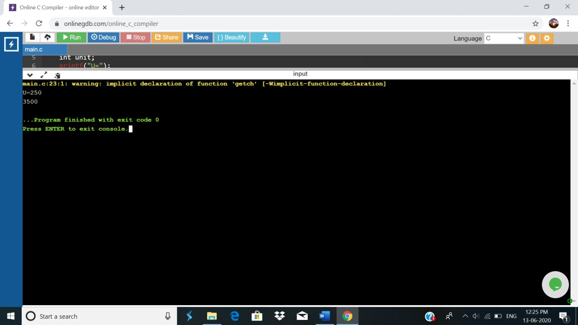

## How to find the first non repeated character of a given String?

import java.util.*; public class Main {

public static void main(String[] args) { String str1 = "gibblegabbler";

System.out.println("The given string is: " + str1); for (int i = 0; i < str1.length(); i++) {

boolean unique = true;

for (int j = 0; j < str1.length(); j++) {

if (i != j && str1.charAt(i) == str1.charAt(j)) { unique = false;

break;

}

}

if (unique) {

System.out.println("The first non repeated character in String is: " + str1.charAt(i)); break;

}

}

}

}

# Output:

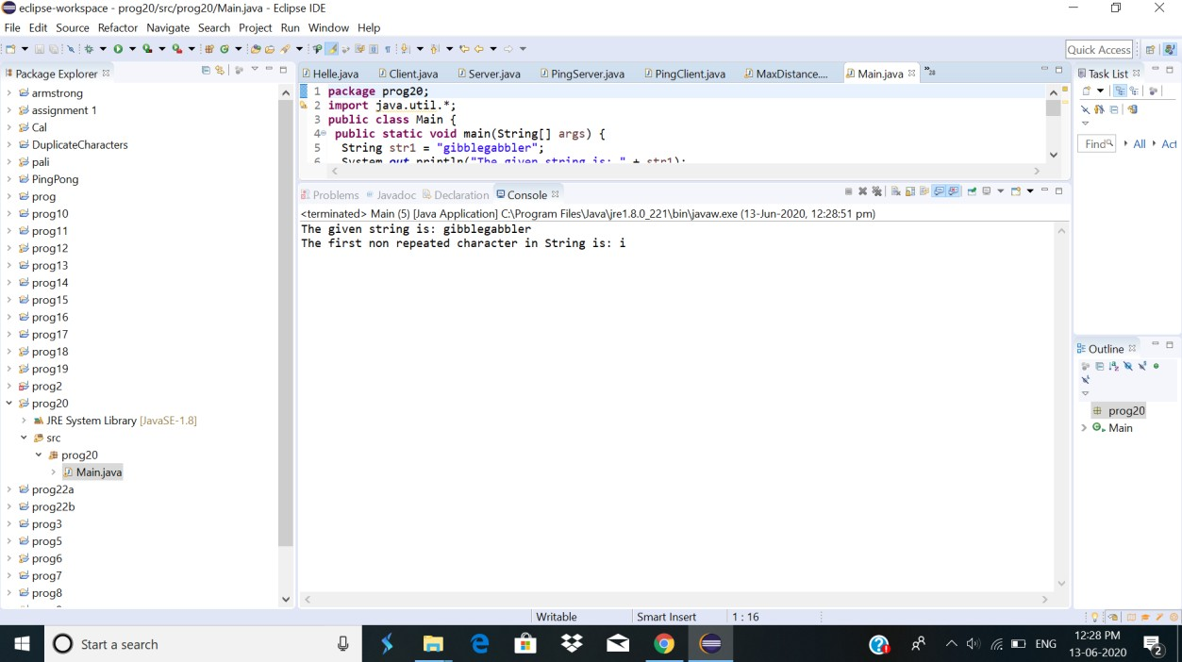

## Write a Java program to find maximum width of a binary tree

Description:

Algorithm

Define Node class which has three attributes namely: data left and right. Here, left represents the left child of the node and right represents the right child of the node.

When a node is created, data will pass to data attribute of the node and both left and right will be set to null.

Define another class which has an attribute root.

Root represents the root node of the tree and initializes it to null.

a. findMaximumWidth() will find out the maximum width of the given binary tree:

Variable maxWidth will store the maximum number of nodes present in any level. The queue is used for traversing binary tree level-wise.

It checks whether the root is null, which means the tree is empty.

If not, add the root node to queue. Variable nodesInLevel keeps track of the number of nodes in each level.

If nodesInLevel > 0, remove the node from the front of the queue and add its left and right child to the queue. For the first iteration, node 1 will be removed and its children nodes 2 and 3 will be added to the queue. In the second iteration, node 2 will be removed, its children 4 and 5 will be added to the queue and so on.

MaxWidth will store max(maxWidth, nodesInLevel). So, at any given point of time, it will represent the maximum number of nodes.

This will continue till all the levels of the tree is traversed.

import java.util.LinkedList; import java.util.Queue;

public class Main {

public static class Node{ int data;

Node left; Node right;

public Node(int data){ this.data = data; this.left = null; this.right = null;

}

}

public Node root;

public Main(){ root = null;

}

public int findMaximumWidth() { int maxWidth = 0;

int nodesInLevel = 0;

Queue<Node> queue = new LinkedList<Node>(); if(root == null) {

System.out.println("Tree is empty"); return 0;

}

else {

queue.add(root);

while(queue.size() != 0) { nodesInLevel = queue.size();

maxWidth = Math.max(maxWidth, nodesInLevel); while(nodesInLevel > 0) {

Node current = queue.remove(); if(current.left != null)

queue.add(current.left);

if(current.right != null) queue.add(current.right);

nodesInLevel--;

}

}

}

return maxWidth;

}

public static void main(String[] args) {

Main bt = new Main(); bt.root = new Node(1); bt.root.left = new Node(2); bt.root.right = new Node(3);

bt.root.left.left = new Node(4); bt.root.left.right = new Node(5); bt.root.right.left = new Node(6); bt.root.right.right = new Node(7); bt.root.left.left.left = new Node(8);

System.out.println("Maximum width of the binary tree: " + bt.findMaximumWidth());

}

}

# Output:

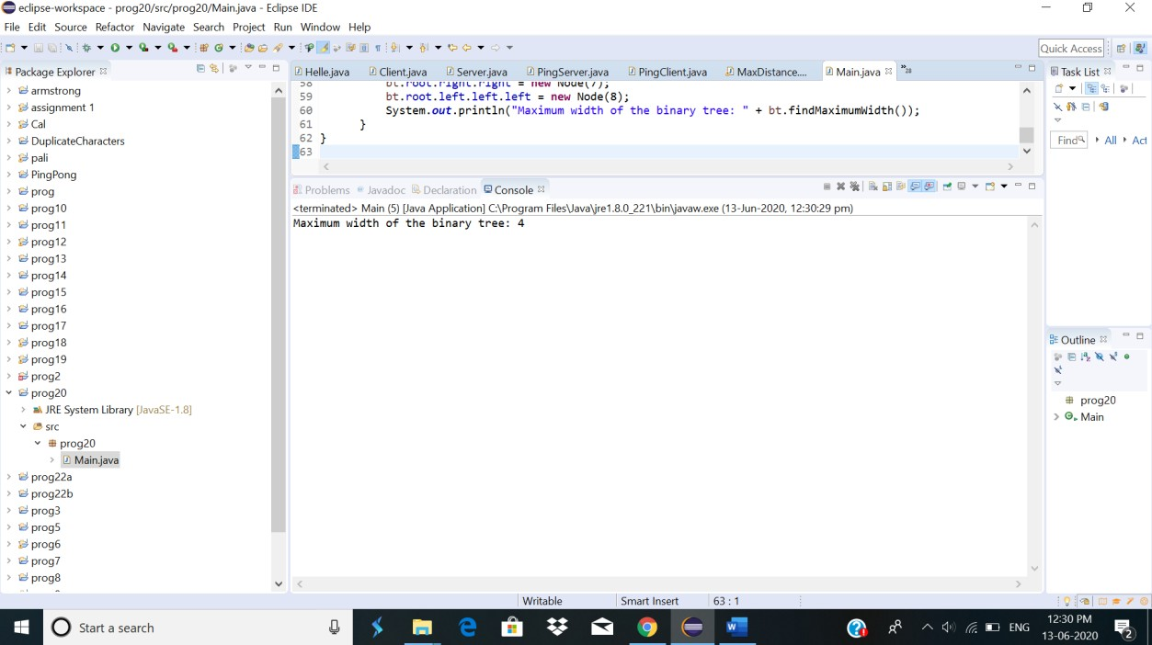

## Python Program to print the pattern

### Description: Input:

Number of rows is 5

Output Pattern is:

A

B C D E F

G H I J

K L M N O

def contalpha(n): num = 65

for i in range(0, n):

for j in range(0, i+1): ch = chr(num) print(ch, end=" ")

num = num +1 print("\r")

n = 5 contalpha(n)

# output:

