Week 3 Task: Data Visualization and Insights Communication
1. Executive Summary
This report presents a data visualization and insights communication plan for the healthcare patient readmission analysis project. The project uses the Diabetes 130-US Hospitals dataset, containing patient encounter information from hospital records. The primary objective is to transform cleaned healthcare data into meaningful visual representations that can be easily understood by non-technical healthcare stakeholders.
The visualization plan focuses on important measures such as readmission rate, patient encounters, length of hospital stay, previous inpatient visits, emergency visits, number of medications, and number of diagnoses. These metrics will be presented through appropriate charts, KPI cards, filters, and an interactive dashboard.
Power BI is selected as the primary visualization tool because it supports interactive dashboards, data filtering, KPI cards, drill-down features, and multiple visualization techniques. Excel/Power Query will support data preparation, while Python may be used for additional exploratory analysis where required.
The proposed dashboard will help stakeholders compare readmission patterns across age groups, gender, diagnosis categories, hospitalization characteristics, and previous healthcare utilization. The plan also emphasizes user-centric design, accessibility, clear terminology, and effective communication. The dashboard is intended to support problem identification and further investigation rather than provide direct clinical recommendations.

2. Introduction
Healthcare organizations generate large amounts of patient and hospital data. However, raw healthcare data is difficult for non-technical stakeholders to interpret directly. Data visualization provides an effective way to convert complex datasets into graphical representations that reveal patterns, comparisons, and areas requiring attention.
This project focuses on patient readmission analysis using the Diabetes 130-US Hospitals dataset. The visualization plan builds on the data collection and quality-assurance activities completed in Week 2. The cleaned dataset will be used to design meaningful visualizations and a dashboard for communicating healthcare insights.
The objective is to create a visualization framework that allows healthcare stakeholders to quickly understand readmission patterns and explore factors such as age, gender, hospital stay, previous inpatient visits, diagnoses, and medication counts.

3. Visualization Objectives
The main objectives of the visualization plan are:
- Present healthcare metrics in a simple and understandable format.
- Communicate patient readmission patterns effectively.
- Identify demographic and hospitalization patterns requiring further investigation.
- Allow stakeholders to compare different patient groups.
- Provide interactive filtering capabilities.
- Reduce the complexity of raw healthcare data.
- Support evidence-based healthcare decision-making.
- Present information in an accessible and user-friendly manner.

4. Dataset and Relevant Variables
The project uses the Diabetes 130-US Hospitals for Years 1999–2008 dataset.
The dataset contains patient encounter information and includes variables related to demographics, hospitalization, diagnoses, medications, and readmission outcomes.
Important variables for visualization include:
Variable | Description | Visualization Purpose
encounter_id | Hospital encounter identifier | Patient encounter count
age | Patient age group | Age-based comparison
gender | Patient gender | Demographic comparison
race | Patient race | Demographic analysis
time_in_hospital | Days spent in hospital | Length-of-stay analysis
number_inpatient | Previous inpatient visits | Healthcare utilization
number_emergency | Emergency visits | Healthcare utilization
number_outpatient | Outpatient visits | Healthcare utilization
num_medications | Number of medications | Medication analysis
number_diagnoses | Number of diagnoses | Clinical complexity
diag_1 | Primary diagnosis | Diagnosis analysis
readmitted | Readmission outcome | Main outcome metric

5. Key Healthcare Metrics
The following metrics will be prioritized in the dashboard.
5.1 Total Patient Encounters
Measures the total number of hospital encounters represented in the dataset.
5.2 30-Day Readmission Rate
Measures the proportion of patient encounters associated with readmission within 30 days.
5.3 Average Length of Hospital Stay
Calculated using time_in_hospital.
5.4 Previous Inpatient Visits
Based on number_inpatient and used to examine previous hospital utilization.
5.5 Emergency Visits
Based on number_emergency.
5.6 Outpatient Visits
Based on number_outpatient.
5.7 Average Number of Medications
Based on num_medications.
5.8 Average Number of Diagnoses
Based on number_diagnoses.

6. Key Analytical Questions
The proposed visualizations will answer the following questions:
- What is the overall distribution of readmission outcomes?
- How does readmission vary across different age groups?
- How does readmission vary by gender?
- How does readmission vary across race categories?
- Does length of hospital stay differ between readmission groups?
- Is previous inpatient utilization associated with different readmission patterns?
- Which diagnosis categories show higher levels of readmission?
- How does the number of medications vary across readmission groups?
- How does the number of diagnoses vary across readmission groups?
These questions will guide the selection of visualization techniques.

7. Visualization Tools and Technologies
Power BI
Power BI will be the primary visualization platform. It will be used to create:
- Interactive dashboards
- KPI cards
- Bar charts
- Column charts
- Donut charts
- Slicers
- Filters
- Interactive reports
Power BI is suitable because it allows healthcare stakeholders to explore data without directly working with the underlying dataset.
Excel and Power Query
Excel and Power Query will be used for:
- Data preparation
- Data transformation
- Data quality checks
- Basic data exploration
Python
Python with Pandas and visualization libraries may be used for additional exploratory analysis and preparation where required.
GitHub
GitHub will be used for:
- Project documentation
- Version control
- Storing project files
- Tracking project development

8. Justification for Power BI
Power BI is selected as the primary visualization tool because it provides an effective combination of data visualization and interactive reporting capabilities. Healthcare stakeholders can use filters and slicers to examine specific patient groups without requiring programming or database knowledge.
The tool also supports KPI cards, multiple chart types, interactive filtering, drill-down capabilities, and dashboard layouts. These features make Power BI appropriate for communicating healthcare analytics to non-technical users.

9. Raw Data to Visualization Process
The proposed visualization workflow is:

Data Cleaning
Missing values, duplicate records, inconsistent values, and data-type issues are reviewed before visualization.
Data Transformation
The cleaned data will be grouped and summarized according to the requirements of each visualization.
KPI Calculation
Important healthcare indicators such as readmission rate and average hospital stay will be calculated.
Visualization Selection
A suitable visualization type will be selected based on the question being answered.
Dashboard Design
The visualizations will be arranged into a logical dashboard that presents the most important information first.

10. Visualization Techniques
Visualization | Variables | Purpose
KPI Cards | Encounter count, readmission rate, average stay | Display important metrics
Bar Chart | Readmission status | Compare readmission outcomes
Bar Chart | Age + readmission | Compare age groups
Stacked Bar Chart | Gender + readmission | Compare demographic patterns
Bar Chart | Race + readmission | Compare demographic groups
Horizontal Bar Chart | Diagnosis + readmission | Compare diagnosis categories
Column/Box Plot | Hospital stay + readmission | Compare length of stay
Bar Chart | Previous inpatient visits + readmission | Examine utilization patterns
Box Plot/Column Chart | Medications + readmission | Compare medication counts

11. Visualization-to-Decision Mapping
Visualization | Problem Identification | Decision Support
Readmission Distribution | Shows overall readmission pattern | Helps determine whether readmission requires further investigation
Readmission by Age | Identifies differences between age groups | Supports targeted investigation of demographic patterns
Readmission by Gender | Highlights gender-based differences | Supports demographic comparison
Readmission by Race | Identifies differences across demographic groups | Supports further investigation of disparities
Length of Stay | Highlights differences in hospitalization duration | Supports analysis of hospital utilization
Previous Inpatient Visits | Shows previous healthcare utilization | Helps identify repeated utilization patterns
Diagnosis Analysis | Highlights diagnosis categories requiring attention | Supports further clinical and operational investigation
Medication Analysis | Shows differences in medication counts | Supports exploration of treatment-related patterns
The visualizations will support investigation and decision-making rather than establish direct causal relationships.

12. Dashboard Design
The dashboard will use a simple and structured layout.
The top section will contain KPI cards showing the most important summary measures.
The middle section will contain visualizations related to readmission patterns across age, gender, diagnosis, and healthcare utilization.
The bottom section will provide additional analysis and interactive filters.

13. Dashboard Wireframe
Include the following mock-up in the DOC:
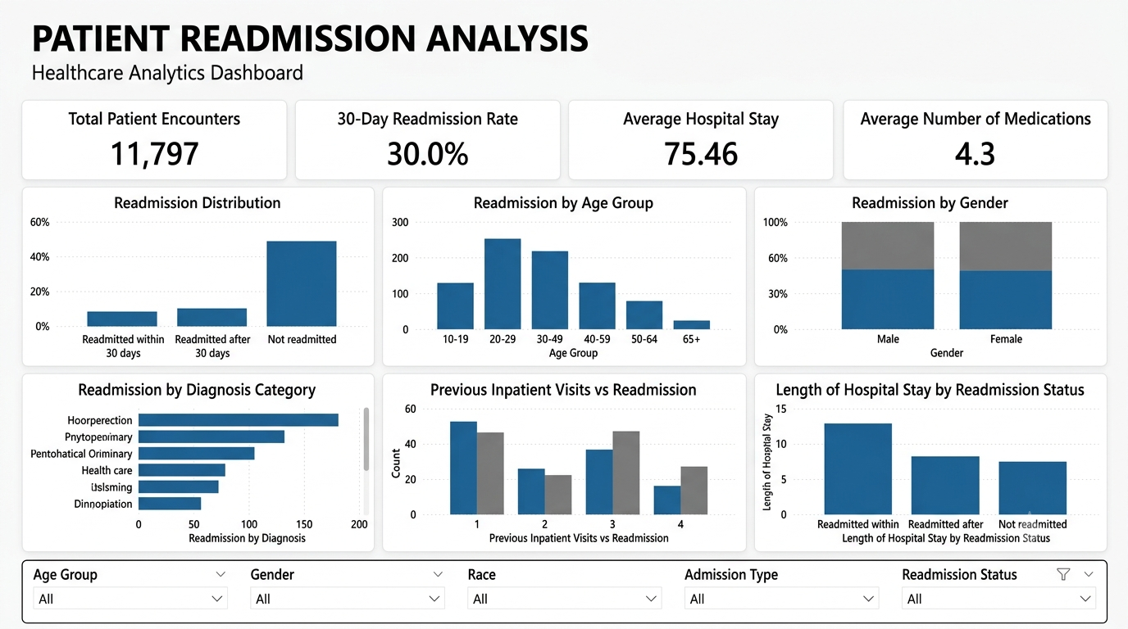

Caption: Proposed dashboard wireframe for patient readmission analysis.

14. Interactive Features
The proposed Power BI dashboard will include interactive features such as:
Slicers
Users can filter the dashboard by:
- Age
- Gender
- Race
- Admission type
- Readmission status
Tooltips
Hovering over a visualization can display additional information such as patient encounter count, percentages, or average values.
Drill-down
Users may move from an overall readmission view to more detailed demographic or diagnosis-level analysis.
These features will allow stakeholders to explore the information according to their specific requirements.

15. User-Centric Design
The dashboard will be designed for healthcare stakeholders who may not have technical or programming knowledge.
Technical column names will therefore be replaced with understandable labels.
For example:
Technical Name | Dashboard Label
number_inpatient | Previous Inpatient Visits
time_in_hospital | Length of Hospital Stay
num_medications | Number of Medications
number_diagnoses | Number of Diagnoses
readmitted | Readmission Status
The dashboard will prioritize important information and avoid unnecessary visual elements.

16. Accessibility Considerations
The visualization design will follow basic accessibility principles.
These include:
- Clear and descriptive chart titles.
- Readable font sizes.
- Simple terminology.
- Consistent labels.
- Sufficient visual contrast.
- Avoiding reliance on color alone.
- Clear legends.
- Appropriate data labels.
- Logical dashboard organization.
- Avoiding excessive charts or decorative elements.
The purpose is to ensure that stakeholders can understand the dashboard without requiring specialized technical knowledge.

17. Expected Insights
The planned visualizations are expected to help identify:
- Overall readmission patterns.
- Differences in readmission across age groups.
- Demographic patterns.
- Differences in hospitalization duration.
- Previous healthcare utilization patterns.
- Diagnosis categories requiring further investigation.
- Differences in medication and diagnosis counts.
These observations will later be validated through detailed analysis. The Week 3 visualization plan does not assume that a particular factor causes readmission.

18. Limitations
Several limitations should be considered:
- The dataset represents historical hospital encounters.
- Missing values may affect some visualizations.
- The dataset may not represent all healthcare populations.
- Observed patterns do not automatically indicate causation.
- Diagnosis codes may require appropriate grouping before visualization.
- Visualizations depend on the quality of the cleaned dataset.
- Healthcare decisions should not be based solely on dashboard results.

19. Conclusion
This visualization and insights communication plan provides a structured approach for converting healthcare patient readmission data into understandable graphical representations. The plan identifies key healthcare metrics, analytical questions, appropriate visualization techniques, and a proposed Power BI dashboard structure.
The dashboard will combine KPI cards, charts, interactive filters, and clear terminology to communicate information effectively to non-technical stakeholders. Each visualization is linked to a specific analytical question and is intended to support problem identification and further investigation.
User-centric design and accessibility are incorporated to ensure that the final dashboard is simple, readable, and practical. The visualization plan will provide the foundation for developing the actual dashboard and communicating the analytical findings in later stages of the project.

20. References
- UCI Machine Learning Repository. Diabetes 130-US Hospitals for Years 1999–2008.
- Microsoft Power BI Documentation.
- World Health Organization. Data and Digital Health Resources.
- Centers for Disease Control and Prevention. Public Health Data Resources.

