**ASSESSMENT-2:**

**1.In logistic regression, what is the logistic function (sigmoid function) and how is it used to compute probabilities?**

In logistic regression, the logistic function (also known as the sigmoid function) is a mathematical function that maps any real-valued number to a value between 0 and 1where *z* is the linear combination of the predictor variables and their coefficients:

***z*=*β*0​+*β*1​*x*1​+*β*2​*x*2​+⋯+*βn*​*xn*​**

The logistic function takes the form of an "S" shaped curve, which is useful for binary classification problems because it models the probability that a given input belongs to a certain class. Here's how it works to compute probabilities in logistic regression:

1. **Linear Combination**: First, the logistic regression model computes a linear combination of the predictor variables and their corresponding coefficients.
2. **Logistic (Sigmoid) Function**: The linear combination is then passed through the logistic function (sigmoid function), which squashes the output into the range [0, 1]. This output represents the probability that the given input belongs to the positive class.
3. **Interpretation as Probability**: The output of the logistic function can be interpreted as the probability that the input belongs to the positive class. For binary classification, if this probability is greater than or equal to a chosen threshold (often 0.5), the input is classified as belonging to the positive class; otherwise, it is classified as belonging to the negative class.
4. **Decision Boundary**: The decision boundary, which separates the classes, is typically set at *P*(*y*=1∣*x*)=0.5. In other words, when the logistic function's output is greater than or equal to 0.5, the input is classified as belonging to the positive class; otherwise, it is classified as belonging to the negative class.
5. **Parameters Estimation**: The parameters (coefficients) of the logistic regression model are estimated using techniques such as maximum likelihood estimation or gradient descent, which aim to optimize the model's ability to predict the correct class labels based on the input data.

**2. When constructing a decision tree, what criterion is commonly used to split nodes, and how is it calculated?**

When constructing a decision tree, the criterion commonly used to split nodes is typically one of the following:

1. **Gini impurity**: Gini impurity measures the likelihood of incorrectly classifying a randomly chosen element if it were randomly labelled according to the distribution of labels in the node. It ranges from 0 (pure node) to 0.5 (impure node).
2. **Entropy**: Entropy measures the uncertainty or disorder of a set of data.
3. **Classification error**: Classification error, also known as misclassification error, calculates the proportion of training instances in a node that do not belong to the most common class.
4. **Information gain**: Information gain measures the reduction in entropy or impurity achieved by splitting a node on a particular attribute. It is calculated as the difference between the entropy or impurity of the parent node and the weighted sum of entropies or impurities of the child nodes.

Out of these criteria, Gini impurity and entropy are the most commonly used in practice. The splitting criterion is calculated as follows:

1. For each attribute or feature in the dataset, the dataset is split into subsets based on the unique values of that attribute.
2. The impurity or entropy of each subset is calculated using one of the criteria mentioned above.
3. The impurity or entropy of the overall split is calculated as the weighted average of the impurity or entropy of the subsets, where the weights are proportional to the number of instances in each subset.
4. The attribute that results in the highest information gain (or lowest impurity/entropy) is chosen as the splitting criterion for that node in the decision tree.
5. This process is repeated recursively for each subset until a stopping criterion is met, such as reaching a maximum tree depth, having all instances in a node belong to the same class, or a minimum number of instances in a node.

**3. Explain the concept of entropy and information gain in the context of decision tree construction.**

1. **Entropy**: Entropy is a measure of impurity or randomness in a set of data. In the context of decision trees, entropy is used to quantify the uncertainty associated with the distribution of class labels in a node. A node with low entropy means that the class labels are very pure (e.g., all instances belong to the same class), while a node with high entropy indicates a high degree of impurity (e.g., an equal number of instances belonging to different classes). 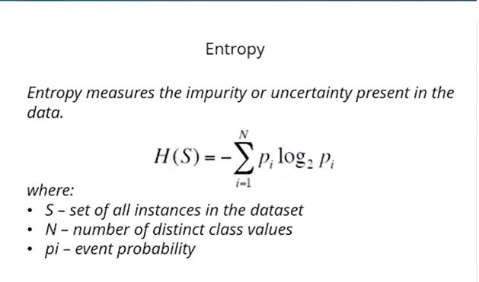
2. **Information Gain**: Information gain measures the effectiveness of an attribute in classifying the training instances at a node. It quantifies the reduction in entropy (or increase in purity) achieved by splitting the dataset on a particular attribute. The attribute that results in the highest information gain is chosen as the splitting criterion for that node. Mathematically, information gain is calculated as: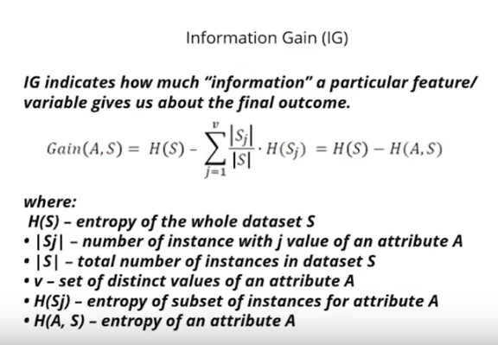

**4. How does the random forest algorithm utilize bagging and feature randomization to improve classification accuracy?**

The random forest algorithm utilizes bagging (bootstrap aggregating) and feature randomization to improve classification accuracy in the following ways:

1. **Bagging (Bootstrap Aggregating)**:
   * Bagging involves training multiple decision trees on different subsets of the training data, which are randomly sampled with replacement from the original dataset.
   * Each decision tree is trained independently on its own bootstrap sample (subset of the data).
   * Bagging helps reduce overfitting by reducing the variance of the model, as each tree is trained on a slightly different subset of data.
   * During the prediction phase, the predictions of all the individual trees are averaged (for regression) or majority-voted (for classification) to produce the final prediction.
2. **Feature Randomization**:
   * In addition to training each decision tree on a different subset of the data, random forests also introduce feature randomization.
   * When constructing each decision tree node, instead of considering all features to find the best split, random forests consider only a random subset of features for splitting at each node.
   * The number of features considered at each node is typically a tuning parameter and is much smaller than the total number of features in the dataset.
   * Feature randomization helps to decorrelate the trees, making them more diverse and reducing the likelihood of overfitting.
   * It also allows the model to capture different aspects of the data and improve the generalization performance of the random forest.

**5. What distance metric is typically used in k-nearest neighbours (KNN) classification, and how does it impact the algorithm's performance?**

The most commonly used distance metric in k-nearest neighbours (KNN) classification is the Euclidean distance. However, other distance metrics such as Manhattan distance (also known as city block distance or L1 norm) and Minkowski distance (a generalization of both Euclidean and Manhattan distances) can also be used depending on the specific requirements of the problem.

1. **Euclidean Distance**:
   * Euclidean distance is the straight-line distance between two points in Euclidean space.
   * In a two-dimensional space, the Euclidean distance between two points (*x*1​,*y*1​) and (*x*2​,*y*2​) is calculated as:

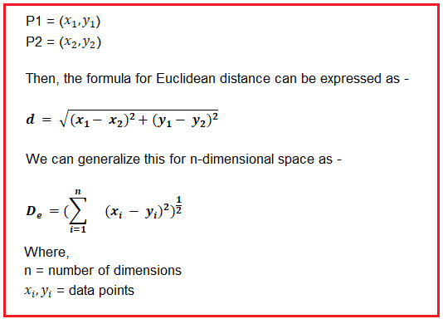

* + In higher-dimensional spaces, the formula extends accordingly.
  + Euclidean distance considers both the magnitude and direction of differences between feature values.

1. **Manhattan Distance**:
   * Manhattan distance, also known as city block distance or L1 norm, is the sum of absolute differences between corresponding coordinates of points.
   * In a two-dimensional space, the Manhattan distance between two points (*x*1​,*y*1​) and (*x*2​,*y*2​) is calculated as: 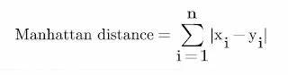
   * Manhattan distance is less sensitive to outliers and differences in magnitude compared to Euclidean distance.
2. **Minkowski Distance**:
   * Minkowski distance is a generalization of both Euclidean and Manhattan distances and is defined as:

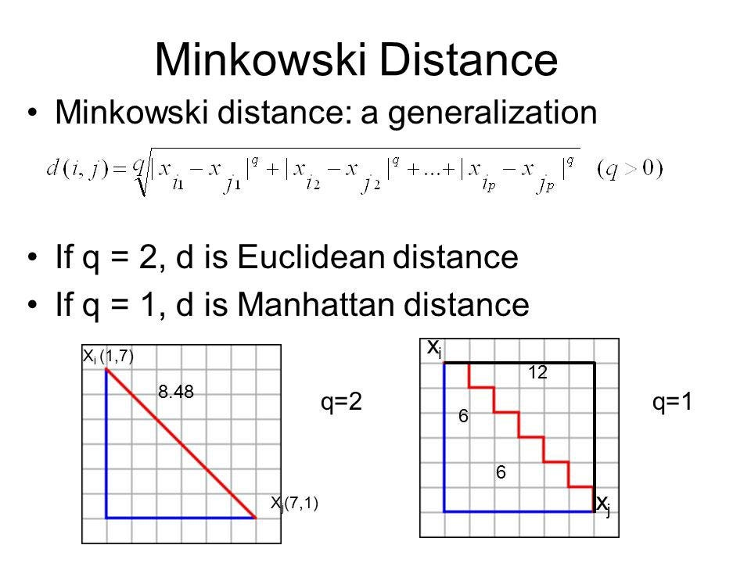

Minkowski distance provides a flexible approach where the parameter q can be tuned to adjust the sensitivity to differences in feature values.

**6. Describe the Naïve-Bayes assumption of feature independence and its implications for classification**.

The Naïve Bayes algorithm makes a strong assumption known as the "naïve" assumption or the assumption of feature independence. This assumption states that the features in the dataset are conditionally independent of each other given the class label. Mathematically, it can be represented as:

*P*(*x*1​,*x*2​,…,*xn*​∣*y*)=*P*(*x*1​∣*y*)×*P*(*x*2​∣*y*)×…×*P*(*xn*​∣*y*) where *x*1​,*x*2​,…,*xn*​ are the features, and *y* is the class label.

Implications of the Naïve Bayes assumption for classification:

1. **Simplification of Probability Estimation**:
   * The assumption of feature independence simplifies the probability estimation process.
   * Instead of estimating the joint probability distribution of all features given the class label, Naïve Bayes estimates the conditional probabilities of each feature given the class label separately.
2. **Computationally Efficient**:
   * Because Naïve Bayes models each feature independently, the computational complexity of training and inference is reduced compared to models that consider interactions between features.
3. **Potential Information Loss**:
   * The assumption of feature independence may lead to information loss if there are significant correlations or interactions between features in the dataset.
   * Features that are dependent on each other may not be accurately captured by Naïve Bayes, potentially resulting in suboptimal classification performance.
4. **Applicability to High-Dimensional Data**:
   * Naïve Bayes performs well, particularly in high-dimensional datasets where the assumption of feature independence may be less restrictive.
   * Despite its simplicity and the strong independence assumption, Naïve Bayes often performs surprisingly well in practice, especially in text classification tasks such as spam detection and document categorization.

**7. In SVMs, what is the role of the kernel function, and what are some commonly used kernel functions?**

The role of the kernel function can be summarized as follows:

1. **Mapping to Higher-Dimensional Space**:
   * The kernel function computes the inner product (dot product) between the input data points in the original feature space, implicitly mapping them to a higher-dimensional space where they might be linearly separable.
2. **Efficient Computation**:
   * Instead of explicitly transforming the input data into the higher-dimensional space, which can be computationally expensive or even infeasible for high-dimensional or infinite-dimensional spaces, the kernel function computes the inner products directly without the need to store the transformed data explicitly.
3. **Flexibility in Modeling Non-Linearity**:
   * By choosing an appropriate kernel function, SVMs can model complex decision boundaries that are non-linear in the original feature space, thus making SVMs versatile for various classification tasks.

Some commonly used kernel functions in SVMs include:

**1.Linear Kernel**:

The linear kernel is the simplest kernel function and is defined as the inner product of the original feature vectors.

**2.Polynomial Kernel**:

The polynomial kernel computes the inner product raised to a power d.

3.**Radial Basis Function (RBF) Kernel**:

The RBF kernel, also known as the Gaussian kernel, maps data points into an infinite-dimensional space.

**8. Discuss the bias-variance trade off in the context of model complexity and overfitting?**

The bias-variance trade off is a fundamental concept in machine learning that describes the relationship between the bias of a model and its variance, as well as how this trade off impacts the model's performance, particularly in the context of model complexity and overfitting.

1. **Bias**:
   * Bias refers to the error introduced by approximating a real-world problem with a simplified model.
   * High bias means the model makes strong assumptions about the form of the underlying data distribution, potentially leading to underfitting.
   * Underfitting occurs when the model is too simple to capture the underlying structure of the data, resulting in poor performance on both the training and test datasets.
2. **Variance**:
   * Variance refers to the amount by which the model's predictions would change if it were trained on a different dataset.
   * High variance means the model is sensitive to small fluctuations in the training data and captures noise along with the underlying patterns, potentially leading to overfitting.
   * Overfitting occurs when the model captures noise or random fluctuations in the training data as if they were genuine patterns, resulting in good performance on the training dataset but poor generalization to new, unseen data.
3. **Model Complexity**:
   * Model complexity refers to the flexibility or capacity of the model to capture the underlying patterns in the data.
   * Increasing the complexity of a model (e.g., adding more parameters or increasing the degree of a polynomial) generally reduces bias but increases variance.
   * Simple models (low complexity) have high bias and low variance, while complex models (high complexity) have low bias but high variance.
4. **Bias-Variance Trade off**:
   * The bias-variance trade off describes the relationship between bias and variance when tuning the complexity of a model.
   * As the complexity of a model increases, its bias decreases but its variance increases, and vice versa.
   * There is typically an optimal level of complexity that minimizes the total error (sum of bias and variance) of the model on unseen data.
   * Finding the right balance between bias and variance is crucial for achieving good generalization performance and avoiding both underfitting and overfitting.

**9. How does TensorFlow facilitate the creation and training of neural networks?**

TensorFlow is a popular open-source machine learning framework developed by Google that facilitates the creation and training of neural networks through its flexible and efficient computational graph architecture. TensorFlow offers several key features that make it well-suited for building and training neural networks:

1. **Computation Graph**:
   * TensorFlow represents computations as a directed graph called the computation graph.
   * Nodes in the graph represent mathematical operations, and edges represent the flow of data (tensors) between operations.
   * This computational graph enables TensorFlow to efficiently perform distributed computing, automatic differentiation, and optimization of neural network models.
2. **Automatic Differentiation**:
   * TensorFlow provides automatic differentiation capabilities, which are essential for training neural networks using techniques like backpropagation.
   * Through TensorFlow's computational graph, it automatically computes gradients of loss functions with respect to model parameters, enabling efficient optimization using gradient-based optimization algorithms like stochastic gradient descent (SGD) or Adam.
3. **Flexible Architecture**:
   * TensorFlow offers a flexible architecture that allows users to define and customize neural network models at various levels of abstraction.
   * Users can build models using high-level APIs like Keras, which provides a user-friendly interface for defining and training neural networks with minimal boilerplate code.
   * Alternatively, users can build custom neural network architectures using TensorFlow's lower-level API, which provides fine-grained control over model construction and training.
4. **GPU Acceleration**:
   * TensorFlow seamlessly integrates with GPUs (Graphics Processing Units) to accelerate neural network training and inference.
   * TensorFlow automatically offloads computations to GPUs when available, enabling faster training of large-scale neural network models on GPU-accelerated hardware.
5. **Rich Ecosystem**:
   * TensorFlow has a rich ecosystem of libraries, tools, and community support that facilitate various aspects of neural network development, including data preprocessing, model evaluation, and deployment.
   * TensorFlow Extended (TFX) provides end-to-end machine learning pipelines for deploying production-ready models at scale.
   * TensorFlow Hub offers pre-trained models and reusable components that can be easily integrated into custom neural network architectures.
6. **Tensorboard Visualization**:
   * TensorFlow includes Tensorboard, a powerful visualization toolkit for visualizing and analyzing the training process and model performance.
   * Tensorboard enables users to visualize metrics such as loss curves, accuracy, and model architecture graphs, facilitating model debugging, optimization, and interpretation.

**10. Explain the concept of cross-validation and its importance in evaluating model performance.**

The process of cross-validation typically involves the following steps:

1. **Partitioning the Dataset**:
   * The dataset is divided into *k* approximately equal-sized subsets or folds.
2. **Training and Evaluation**:
   * For each fold, the model is trained on *k*−1 folds (training data) and evaluated on the remaining fold (validation data).
   * This process is repeated *k* times, with each fold used exactly once as the validation data.
3. **Performance Metric Calculation**:
   * The performance metric of interest (e.g., accuracy, precision, recall, F1-score) is computed for each iteration of training and evaluation.
4. **Aggregation of Results**:
   * The performance metrics obtained from each iteration are averaged to obtain an overall estimate of the model's performance.

Cross-validation is important in evaluating model performance for several reasons:

1. **Bias-Variance Trade off**: Cross-validation helps in assessing the bias-variance trade- off by providing an estimate of a model's generalization performance on unseen data. It helps identify whether a model is overfitting or underfitting the training data.
2. **Robustness**: Cross-validation provides a more robust estimate of model performance compared to a single train-test split, as it accounts for the variability introduced by different partitioning of the data.
3. **Model Selection and Hyperparameter Tuning**: Cross-validation is commonly used for comparing different models and selecting the best performing model or for tuning model hyperparameters. It helps in choosing the model with the optimal trade-off between bias and variance.
4. **Sample Size Sensitivity**: Cross-validation helps in assessing the sensitivity of the model's performance to variations in the dataset size and distribution.

**11. What techniques can be employed to handle overfitting in machine learning models?**

Several techniques can be employed to handle overfitting and improve the generalization ability of machine learning models:

1. **Cross-Validation**:
   * Cross-validation is a technique used to assess the performance of a model on unseen data by dividing the dataset into multiple subsets (folds) and iteratively training and evaluating the model on different combinations of these folds. It helps identify overfitting by providing a more reliable estimate of the model's performance.
2. **Regularization**:
   * Regularization is a technique used to prevent overfitting by adding a penalty term to the model's loss function that penalizes large weights or model complexity. Common regularization techniques include L1 regularization (Lasso), L2 regularization (Ridge), and elastic net regularization. These techniques help to simplify the model and reduce its sensitivity to noise in the training data.
3. **Feature Selection**:
   * Feature selection involves selecting a subset of the most informative features from the original feature set to reduce model complexity and mitigate overfitting. Techniques such as forward selection, backward elimination, and recursive feature elimination can be used to identify the most relevant features for the model.
4. **Early Stopping**:
   * Early stopping is a technique used during the training process to prevent overfitting by monitoring the model's performance on a separate validation set and stopping the training process when the performance starts to degrade. This prevents the model from learning the noise in the training data and helps find the optimal point where the model generalizes well to unseen data.
5. **Data Augmentation**:
   * Data augmentation involves creating additional training data by applying transformations such as rotation, translation, scaling, and flipping to the original training data. This helps to increase the diversity of the training data and prevent overfitting by exposing the model to different variations of the input data.
6. **Ensemble Methods**:
   * Ensemble methods combine multiple base models to make predictions, often resulting in improved generalization performance compared to individual models. Techniques such as bagging, boosting, and stacking can be used to build ensemble models that are more robust to overfitting.
7. **Pruning**:
   * Pruning is a technique used in decision trees and tree-based ensemble methods to reduce overfitting by removing branches or subtrees that do not contribute significantly to improving the model's performance on the validation data. Pruning helps simplify the model and improve its generalization ability.

**12. What is the purpose of regularization in machine learning, and how does it work?**

Regularization is a technique used in machine learning to prevent overfitting by adding a penalty term to the model's loss function. The purpose of regularization is to encourage the model to learn simpler patterns that generalize well to unseen data, rather than memorizing noise or irrelevant details in the training data. Regularization works by penalizing large weights or model complexity, thereby reducing the model's sensitivity to noise and improving its generalization performance. The key idea behind regularization is to balance the trade-off between bias and variance in the model:

1. **Bias**:
   * Bias refers to the error introduced by approximating a real-world problem with a simplified model that makes strong assumptions about the form of the underlying data distribution.
   * High bias models tend to underfit the training data and have poor predictive performance on both the training and test datasets.
2. **Variance**:
   * Variance refers to the amount by which the model's predictions would change if it were trained on a different dataset.
   * High variance models are sensitive to small fluctuations in the training data and capture noise or random fluctuations in the data as if they were genuine patterns, leading to overfitting.

**13. Describe the role of hyper-parameters in machine learning models and how they are tuned for optimal performance?**

The role of hyperparameters in machine learning models includes:

1. **Model Architecture**:
   * Hyperparameters define the architecture or structure of the model, such as the number of layers and units in a neural network, the type of kernel function in a support vector machine (SVM), or the depth of a decision tree.
2. **Regularization**:
   * Hyperparameters control the degree of regularization applied to the model to prevent overfitting, such as the regularization strength in Lasso and Ridge regression or the dropout rate in neural networks.
3. **Optimization Algorithm**:
   * Hyperparameters determine the optimization algorithm used to train the model, such as the learning rate and momentum in stochastic gradient descent (SGD) or the kernel parameters in a support vector machine (SVM).
4. **Model Complexity**:
   * Hyperparameters influence the complexity of the model, such as the maximum depth of a decision tree or the number of clusters in a k-means clustering algorithm.

Tuning hyperparameters for optimal performance involves the following steps:

1. **Manual Tuning**:
   * Domain knowledge and intuition are used to manually specify hyperparameters based on prior experience or best practices.
   * Hyperparameters are selected through trial and error, and the model's performance is evaluated using techniques such as cross-validation or a separate validation set.
2. **Grid Search**:
   * Grid search is a systematic approach to hyperparameter tuning that involves specifying a grid of hyperparameter values to explore.
   * The model is trained and evaluated for each combination of hyperparameters in the grid using cross-validation.
   * The hyperparameter values that result in the best performance on the validation set are selected as the optimal hyperparameters.
3. **Random Search**:
   * Random search is an alternative to grid search that involves randomly sampling hyperparameter values from a specified distribution.
   * Hyperparameters are randomly selected and evaluated using cross-validation.
   * Random search is computationally less expensive than grid search and can be more effective in high-dimensional hyperparameter spaces.
4. **Automated Hyperparameter Optimization**:
   * Automated techniques such as Bayesian optimization, genetic algorithms, and neural architecture search can be used to efficiently search the hyperparameter space and find optimal hyperparameter values.
   * These techniques use optimization algorithms to iteratively update the hyperparameters based on the model's performance, reducing the need for manual intervention.

**14. What are precision and recall, and how do they differ from accuracy in classification evaluation?**

1. **Precision**:
   * Precision is the ratio of true positive predictions to the total number of positive predictions made by the model. It represents the ability of the model to correctly identify positive instances among all instances predicted as positive.
   * Precision is also referred to as the positive predictive value.
2. **Recall**:
   * Recall is the ratio of true positive predictions to the total number of actual positive instances in the dataset. It represents the ability of the model to capture all positive instances, including those that are missed (false negatives).
   * Recall is also known as sensitivity or true positive rate.
3. **Accuracy**:
   * Accuracy is the ratio of correctly classified instances (both true positives and true negatives) to the total number of instances in the dataset. It represents the overall correctness of the model's predictions.​

Differences between precision, recall, and accuracy:

* **Focus**: Precision focuses on the proportion of positive predictions that are correct, while recall focuses on the proportion of actual positive instances that are correctly identified. Accuracy measures overall correctness, regardless of class.
* **Trade-off**: Precision and recall are often in tension with each other, meaning that improving one metric may come at the expense of the other. For example, increasing the threshold for positive predictions may increase precision but decrease recall, and vice versa. Accuracy does not explicitly capture this trade-off and may not be sensitive to class imbalance.
* **Impact of Class Imbalance**: Precision and recall are more informative than accuracy in the presence of class imbalance, where one class is much more prevalent than the other. In such cases, accuracy may be high simply because the model predicts the majority class most of the time, while precision and recall provide insights into the model's performance on the minority class.

**15. Explain the ROC curve and how it is used to visualize the performance of binary classifiers.**

The ROC curve is constructed and interpreted:

1. **True Positive Rate (TPR)**:
   * TPR, also known as sensitivity or recall, measures the proportion of actual positive instances that are correctly identified by the classifier. ​
2. **False Positive Rate (FPR)**:
   * FPR measures the proportion of actual negative instances that are incorrectly classified as positive by the classifier.
3. **Threshold Variation**:
   * The ROC curve is constructed by varying the classification threshold of the classifier and calculating the TPR and FPR at each threshold value.
   * The threshold represents the decision boundary for classifying instances as positive or negative based on the predicted probabilities or scores produced by the classifier.
4. **Plotting the ROC Curve**:
   * The ROC curve is a plot of TPR (sensitivity) against FPR (1 - specificity) for different threshold values.
   * Each point on the ROC curve represents the TPR and FPR corresponding to a specific threshold setting of the classifier.
   * The curve typically starts at the bottom-left corner (0, 0) and ends at the top-right corner (1, 1).
5. **Interpretation**:
   * The ROC curve visualizes the trade-off between true positive rate (sensitivity) and false positive rate (1 - specificity) for different threshold settings of the classifier.
   * A classifier with perfect discrimination (perfect sensitivity and specificity) would have an ROC curve that passes through the top-left corner (1, 1).
   * The closer the ROC curve is to the top-left corner, the better the classifier's performance, indicating higher sensitivity and lower false positive rate across different threshold settings.
   * The diagonal line (y = x) represents a random classifier that makes predictions by chance, with an area under the ROC curve (AUC) of 0.5.
6. **Area Under the ROC Curve (AUC)**:
   * The AUC represents the overall performance of the classifier across all possible threshold settings.
   * AUC ranges from 0 to 1, where higher values indicate better classifier performance.
   * AUC provides a single scalar value that summarizes the performance of the classifier, with 0.5 indicating random performance and 1 indicating perfect discrimination.