NAME : Prajna Kiran Holla
SRN : PES1UG24CS329
Section F

Project : Municipal Solid Waste Route Optimizer
Software Engineering Lab 2

Project Overview
The Municipal Solid Waste Route Optimizer (MSWRO) is a project aimed at improving the management of municipal waste collection. It includes features such as managing collection routes, generating optimized routes, monitoring smart bin fill levels, recording bin collections, and reporting missed pickups.
The project was planned and managed using Agile and Scrum practices. The work was organized into a backlog, estimated using story points, and completed through simulated sprints. Progress was tracked using the board and burndown charts.

Jira Backlog with User Stories and Epics and Story Point Assignments
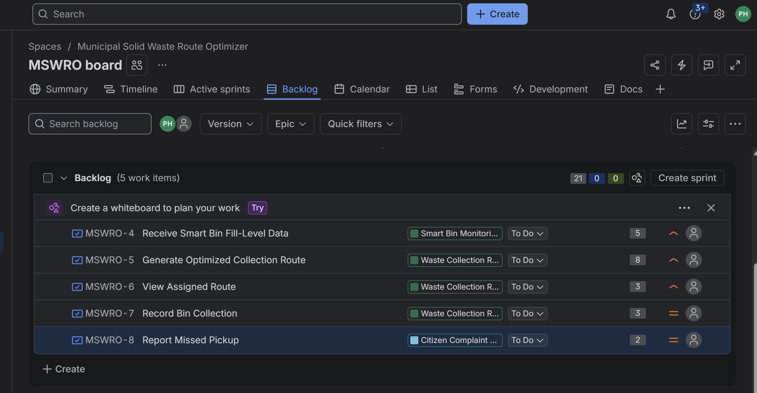

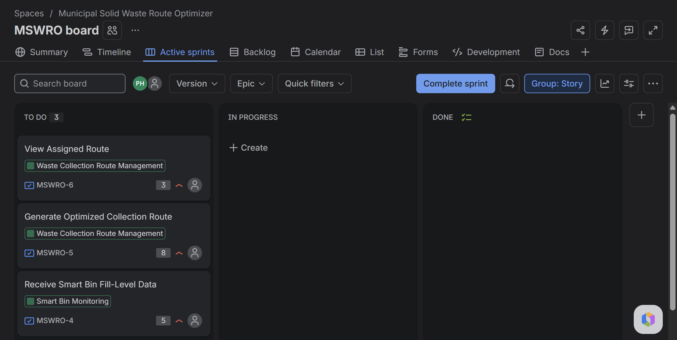
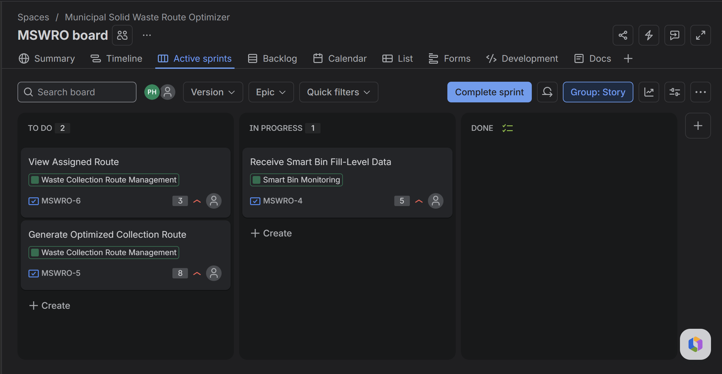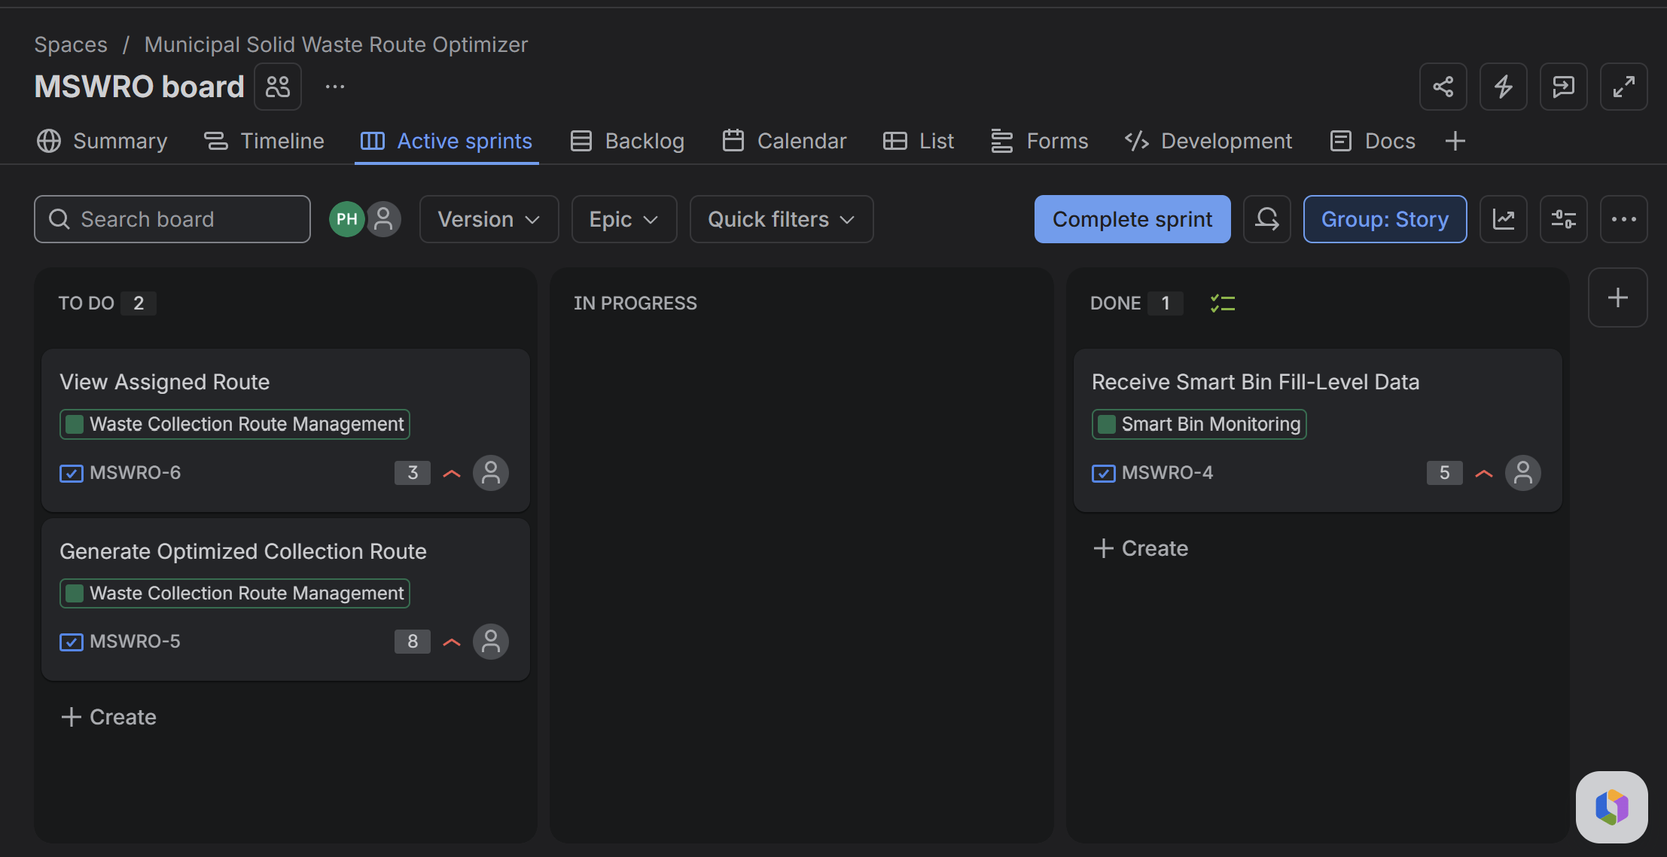
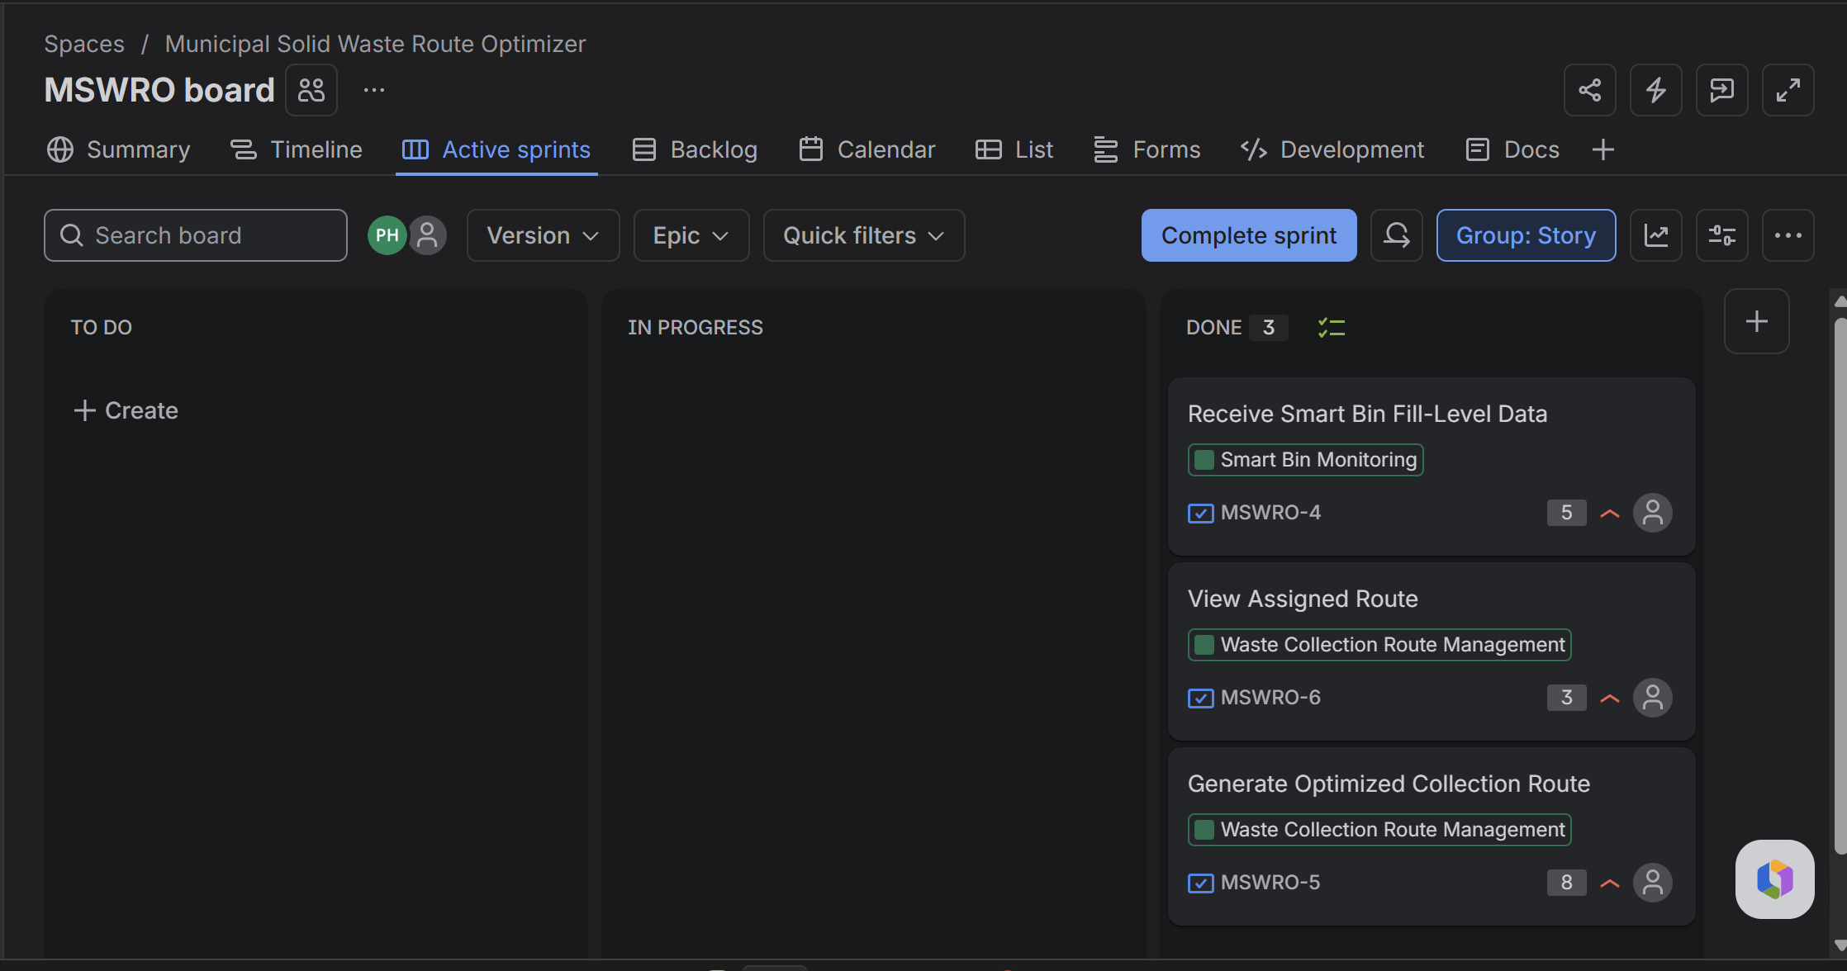
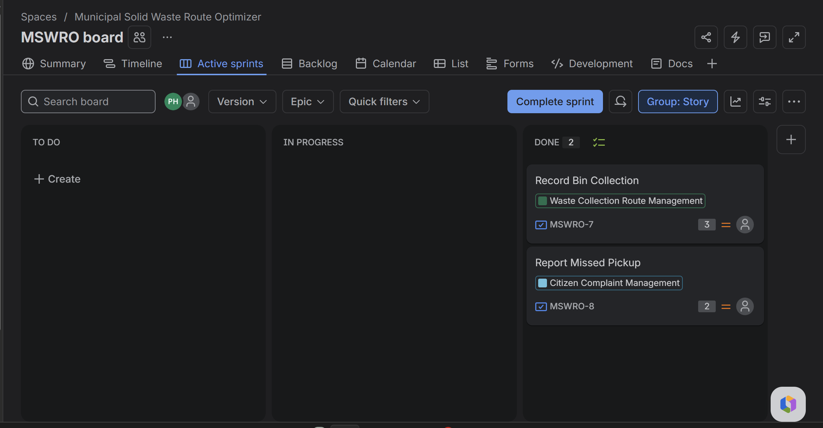

Sprint 1
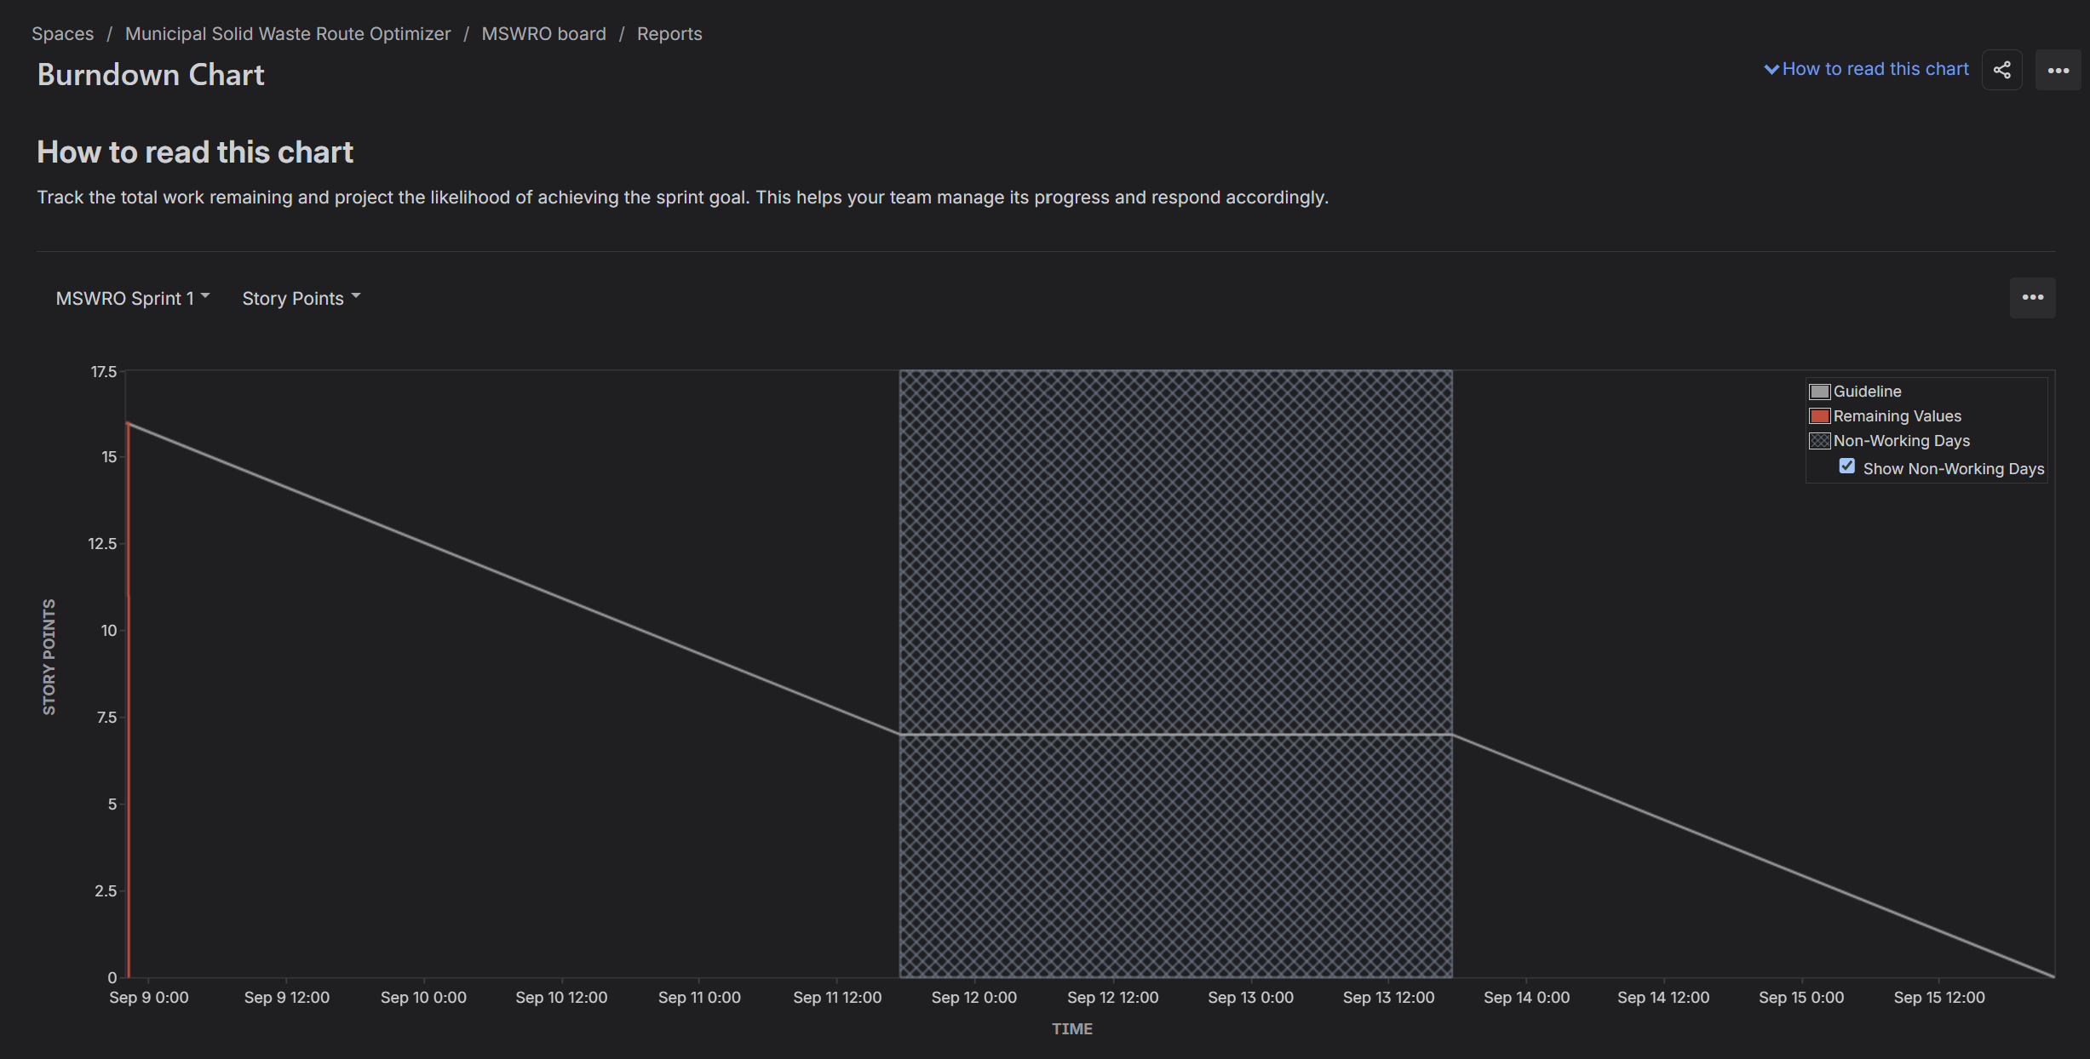
Sprint 2
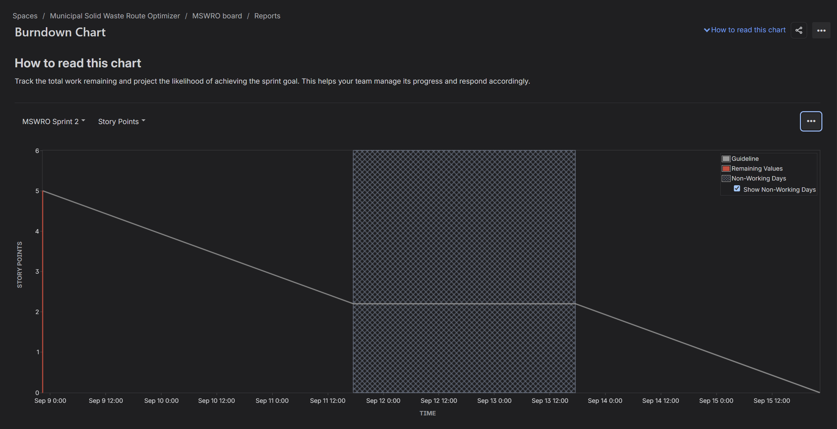

Reflection Questions
1. Did your estimations reflect the actual effort?
Mostly, yes. The story point estimates reflected the relative size of the work items, and the completed sprint work matched the planned estimates reasonably well. Sprint 1 had a larger workload (16 story points), while Sprint 2 had a smaller workload (5 story points), showing that the work was estimated and divided according to its expected effort.
2. Was your backlog well-prioritized?
Yes. The backlog was organized by importance, with the main waste collection and route management features completed first. The later sprint included additional features such as Record Bin Collection and Report Missed Pickup, allowing the core functionality to be addressed before secondary functionality.
3. How did your simulated sprint align with your plan?
The simulated sprints aligned well with the plan. The work items were moved through the sprint workflow and completed as intended. The burndown charts for both Sprint 1 and Sprint 2 show the planned amount of work decreasing toward zero by the end of each sprint, indicating that the sprint goals were achieved.
4. What insights did the burndown chart give about your team's capacity?
The burndown charts suggest that the team was able to complete the planned workload within each sprint. Sprint 1 handled approximately 16 story points, while Sprint 2 handled 5 story points. This indicates that the team's capacity can vary depending on the size and complexity of the planned work, and future sprints could use this information to avoid overcommitting.

Conclusion
In conclusion, the Municipal Solid Waste Route Optimizer project was successfully planned using Agile and Scrum practices. The work was organized into a backlog, completed through two simulated sprints, and tracked using story points and burndown charts. This project showed the importance of proper planning, prioritization, and tracking progress during software development.

