Detailed Study Report on PWM Generation Using FPGA – 2023006954,2023006866
Project Title: FPGA-Based PID Control of a Robotic Joint with IoT Interface
Software Used: Xilinx Vivado

1. Introduction to Pulse Width Modulation (PWM)
Pulse Width Modulation (PWM) is a digital control technique used for controlling the speed and power supplied to electrical devices such as DC motors and robotic actuators. In this project, PWM is used to control the speed of the motor connected to the robotic joint. The PWM signal is generated using FPGA through Verilog HDL implementation.
PWM works by rapidly switching the signal between HIGH and LOW states. Instead of varying the voltage directly, the average voltage supplied to the motor is controlled by changing the duration for which the signal remains HIGH within one complete cycle.

2. Duty Cycle and Motor Speed Control
The most important parameter in PWM is the duty cycle. Duty cycle refers to the percentage of time for which the signal remains HIGH during one complete PWM cycle.
Duty Cycle = (ON Time / Total Time) × 100
If the duty cycle increases, the motor receives more average power and rotates faster. If the duty cycle decreases, the motor receives less power and rotates slower.
Duty Cycle | Motor Speed
25% | Slow
50% | Medium
75% | Fast
In our simulation, different duty cycle values such as 4, 8, and 12 were tested using a 4-bit counter. These values approximately represented 25%, 50%, and 75% duty cycles.

3. PWM Generator Implementation Using Verilog
The PWM generator was implemented using Verilog HDL in Vivado. The implementation used a counter-based approach. The FPGA continuously increments a counter on every clock pulse. The counter value is compared with the duty cycle value. If the counter value is smaller than the duty cycle value, the PWM output remains HIGH. Otherwise, the PWM output becomes LOW.
Core PWM Logic:
if(counter < duty_cycle)
pwm_out <= 1;
else
pwm_out <= 0;
This comparison forms the main logic of PWM generation. For example, if the counter ranges from 0 to 15 and the duty cycle is set to 4, the PWM output remains HIGH for 4 counts and LOW for 12 counts, resulting in approximately 25% duty cycle.

4. Counter-Based PWM Generation
A 4-bit counter was used in the simulation. A 4-bit counter can store values from 0 to 15, resulting in 16 total count states. The counter increments on every positive edge of the clock.
The counter values form one complete PWM cycle. The duration for which the PWM signal remains HIGH depends on the duty cycle value.
Duty Cycle Value | HIGH Counts | Approximate Percentage
4 | 4 out of 16 | 25%
8 | 8 out of 16 | 50%
12 | 12 out of 16 | 75%

5. Vivado Simulation and Waveform Analysis
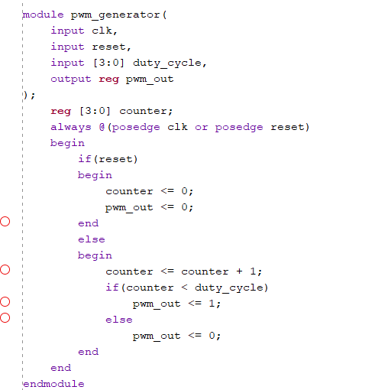
The PWM generator was simulated using Xilinx Vivado Simulator. Different duty cycle values were applied through the testbench to observe changes in the PWM output waveform.
Initially, a duty cycle value of 4 was applied. The waveform showed a smaller HIGH pulse width, representing approximately 25% duty cycle. When the duty cycle was changed to 8, the HIGH pulse width increased, representing approximately 50% duty cycle. Finally, when the duty cycle was changed to 12 (hexadecimal c), the HIGH duration became much larger, representing approximately 75% duty cycle.
Testbench
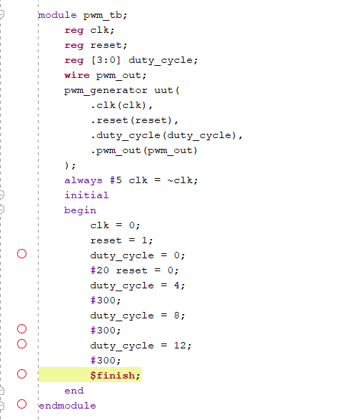
Code

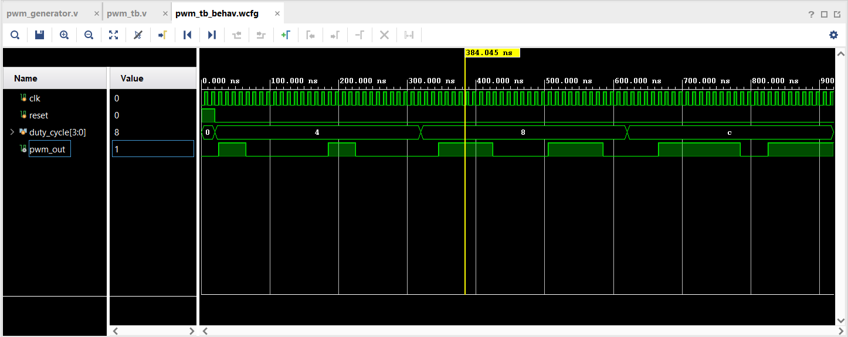
Simulation Output Graph

The waveform analysis clearly verified that the PWM generator was functioning correctly. The width of the HIGH region increased as the duty cycle increased. This
confirmed that the FPGA was correctly generating PWM signals based on the duty cycle input values.

6. PWM-Based Motor Control in Robotic Systems
PWM is commonly used in robotic systems for motor speed control. In this project, the PWM output generated from the FPGA will eventually be connected to a motor driver circuit. The motor driver will use the PWM signal to control the speed of the DC motor attached to the robotic joint.
Higher duty cycle values supply more average power to the motor, causing faster movement. Lower duty cycle values reduce motor speed. This concept is important in robotic joint positioning because the motor speed must continuously change based on the error calculated by the PID controller.

7. Future Work
The next phase of the project will focus on integrating the PID controller with the PWM generator module. The PID controller will calculate the control signal based on the error between setpoint and feedback values. This control signal will then be converted into PWM duty cycle values. The PWM generator will use these values to dynamically control motor speed.
Further work also includes sensor feedback integration, motor driver interfacing, hardware implementation on FPGA, and IoT-based remote monitoring.

