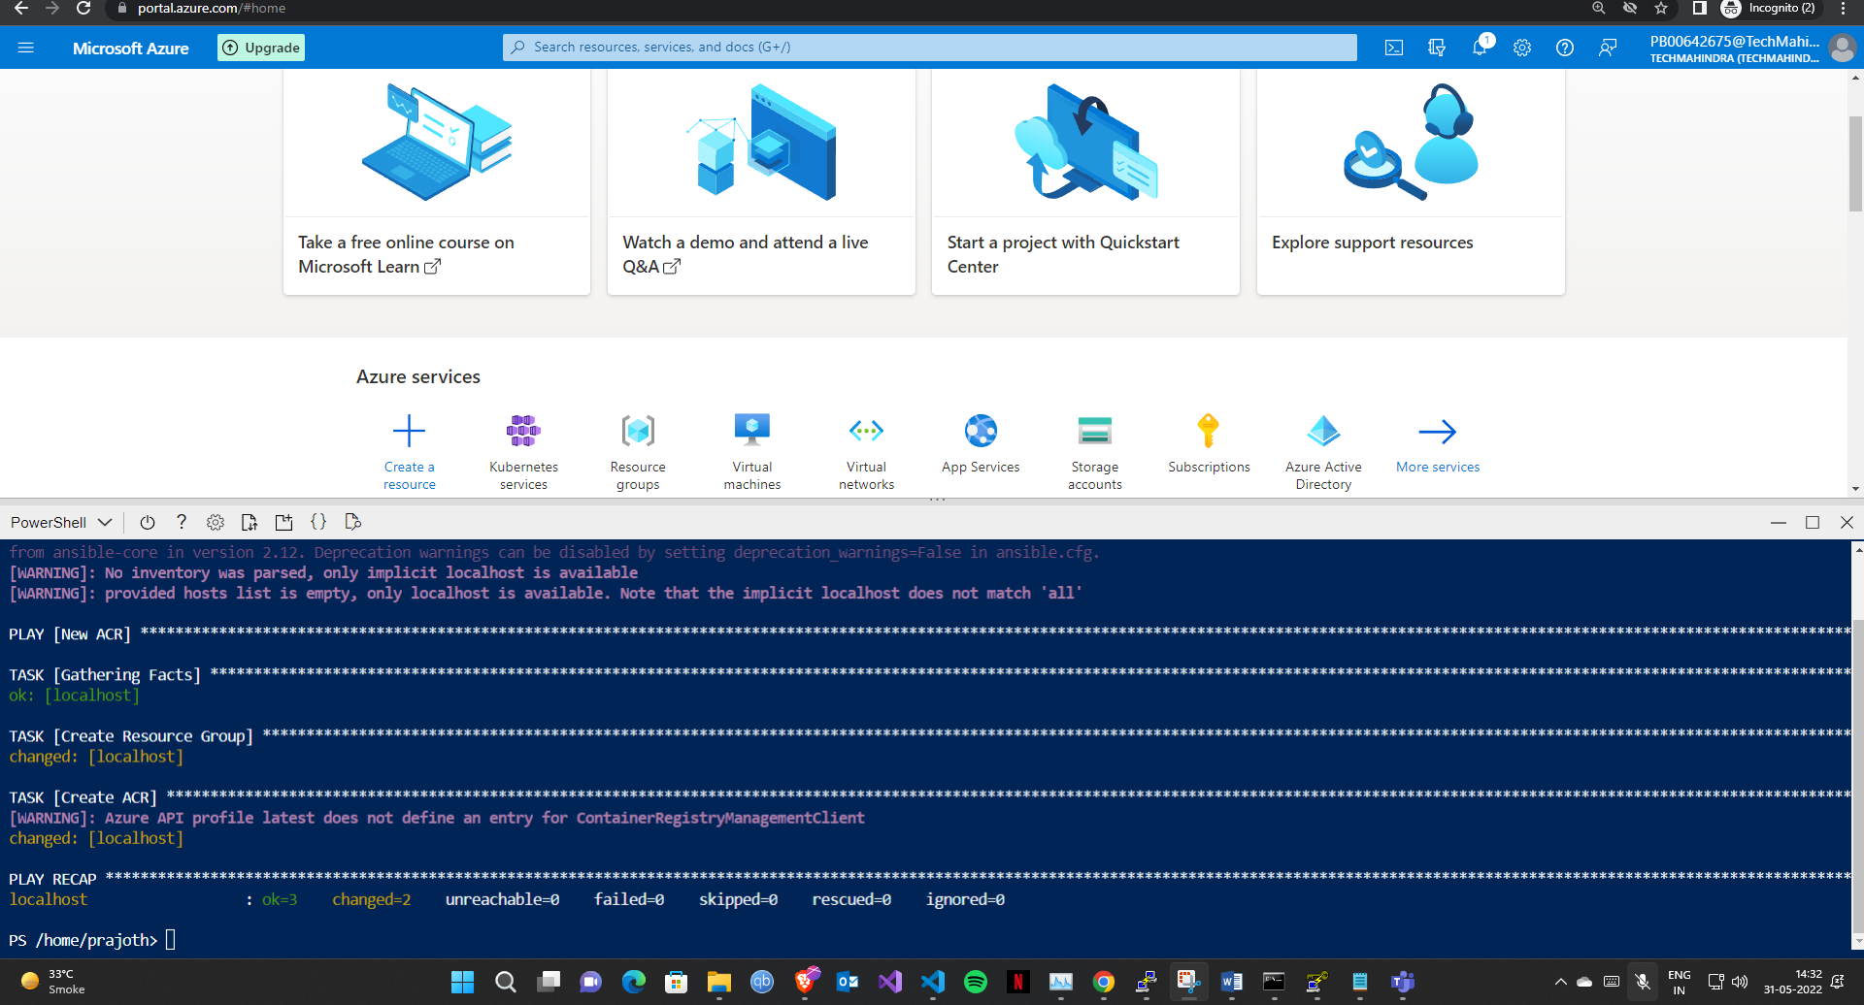

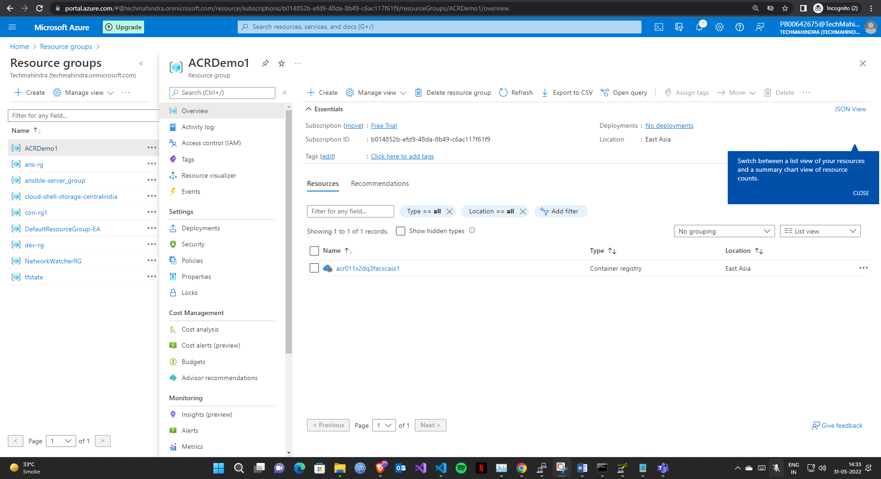

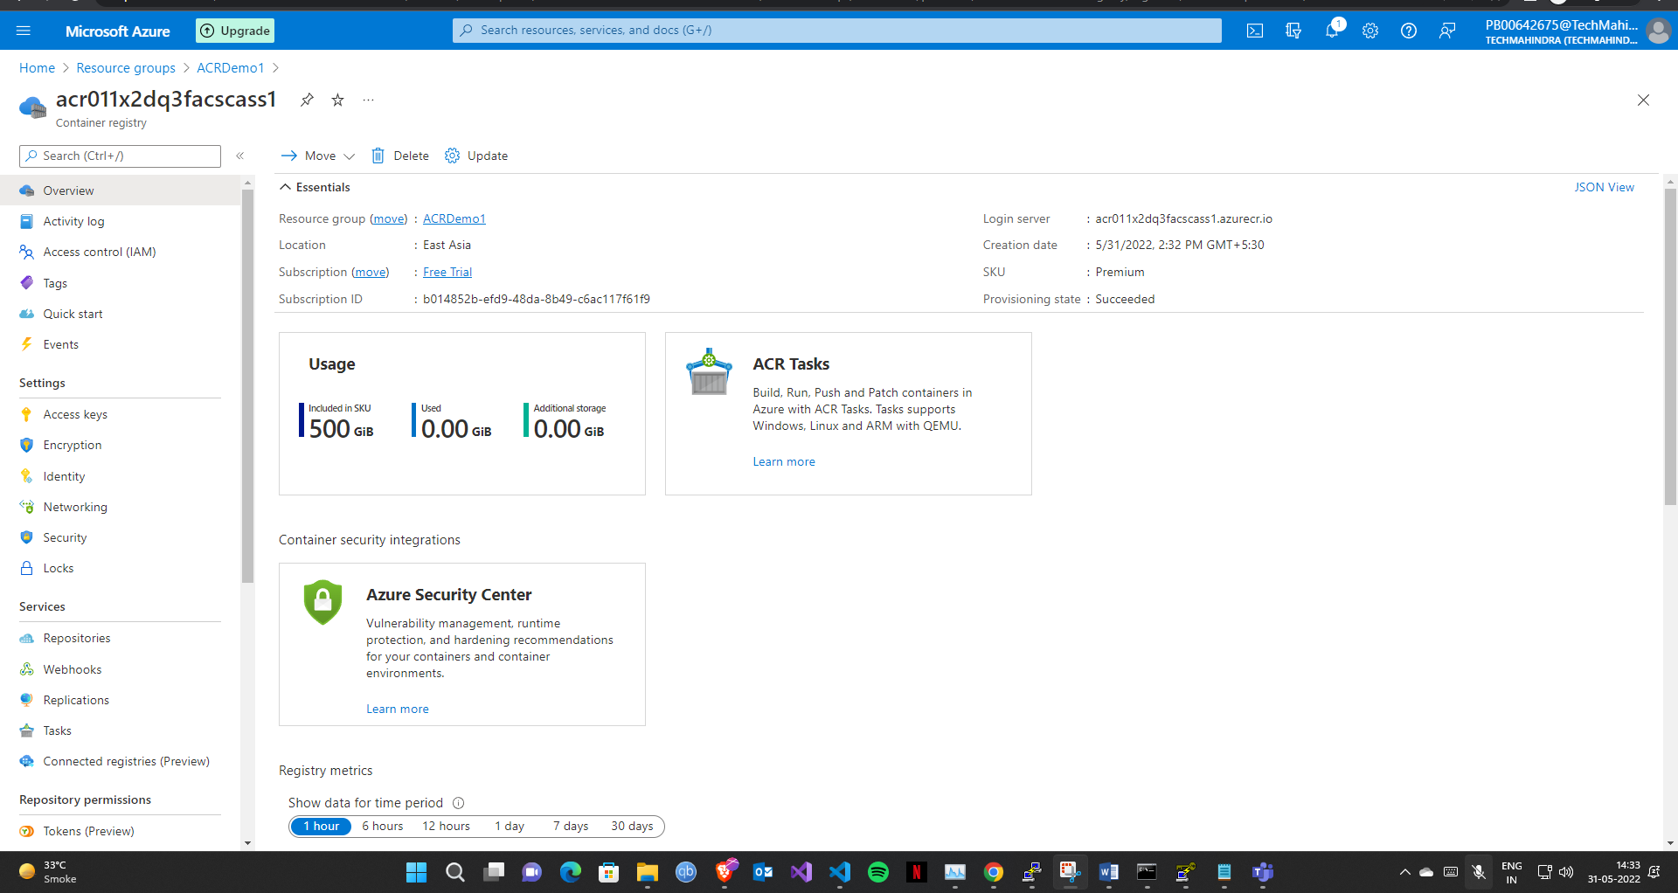

- name: New ACR

  hosts: localhost

  connection: local

  vars:

    ACR_resource_group: ACRDemo1

    ACR_location: "East Asia"

    acr_name: acr011x2dq3facscass1

  tasks:

    - name: Create Resource Group

      azure_rm_resourcegroup:

        name: "{{ ACR_resource_group }}"

        location: "{{ ACR_location }}"

    - name: Create ACR

      azure_rm_containerregistry:

        name: "{{ acr_name }}"

        location: "{{ ACR_location }}"

        resource_group: "{{ ACR_resource_group }}"

        admin_user_enabled: true

        sku: Premium

        tags:

            Release: ac0

            Environment: Dev