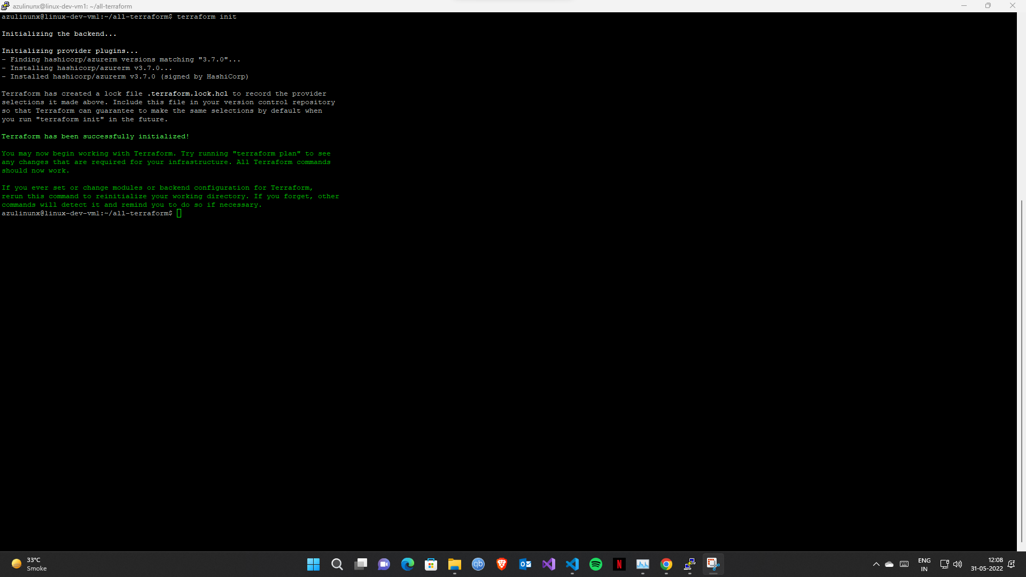

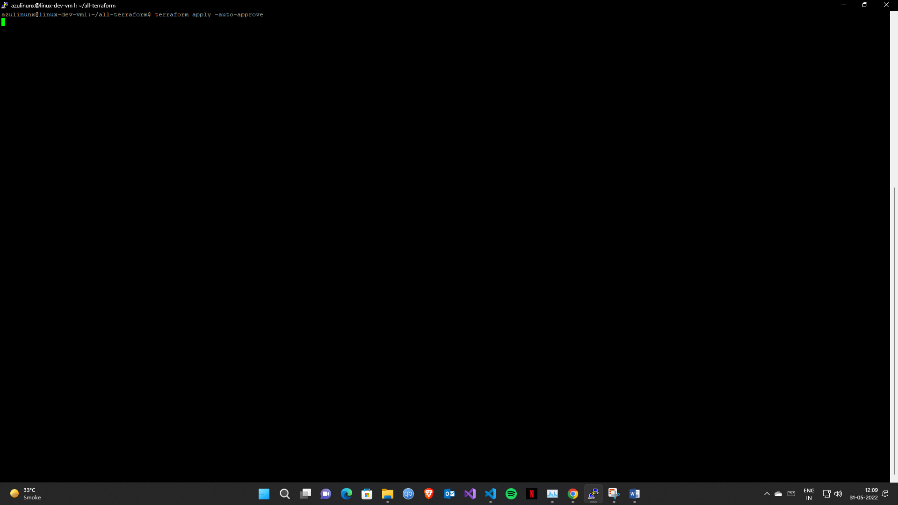

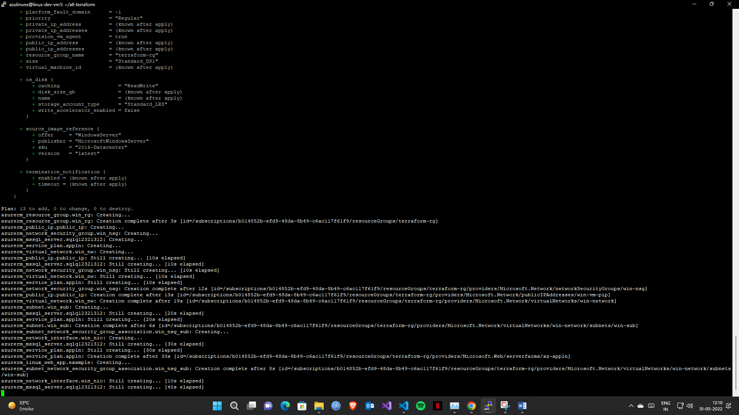

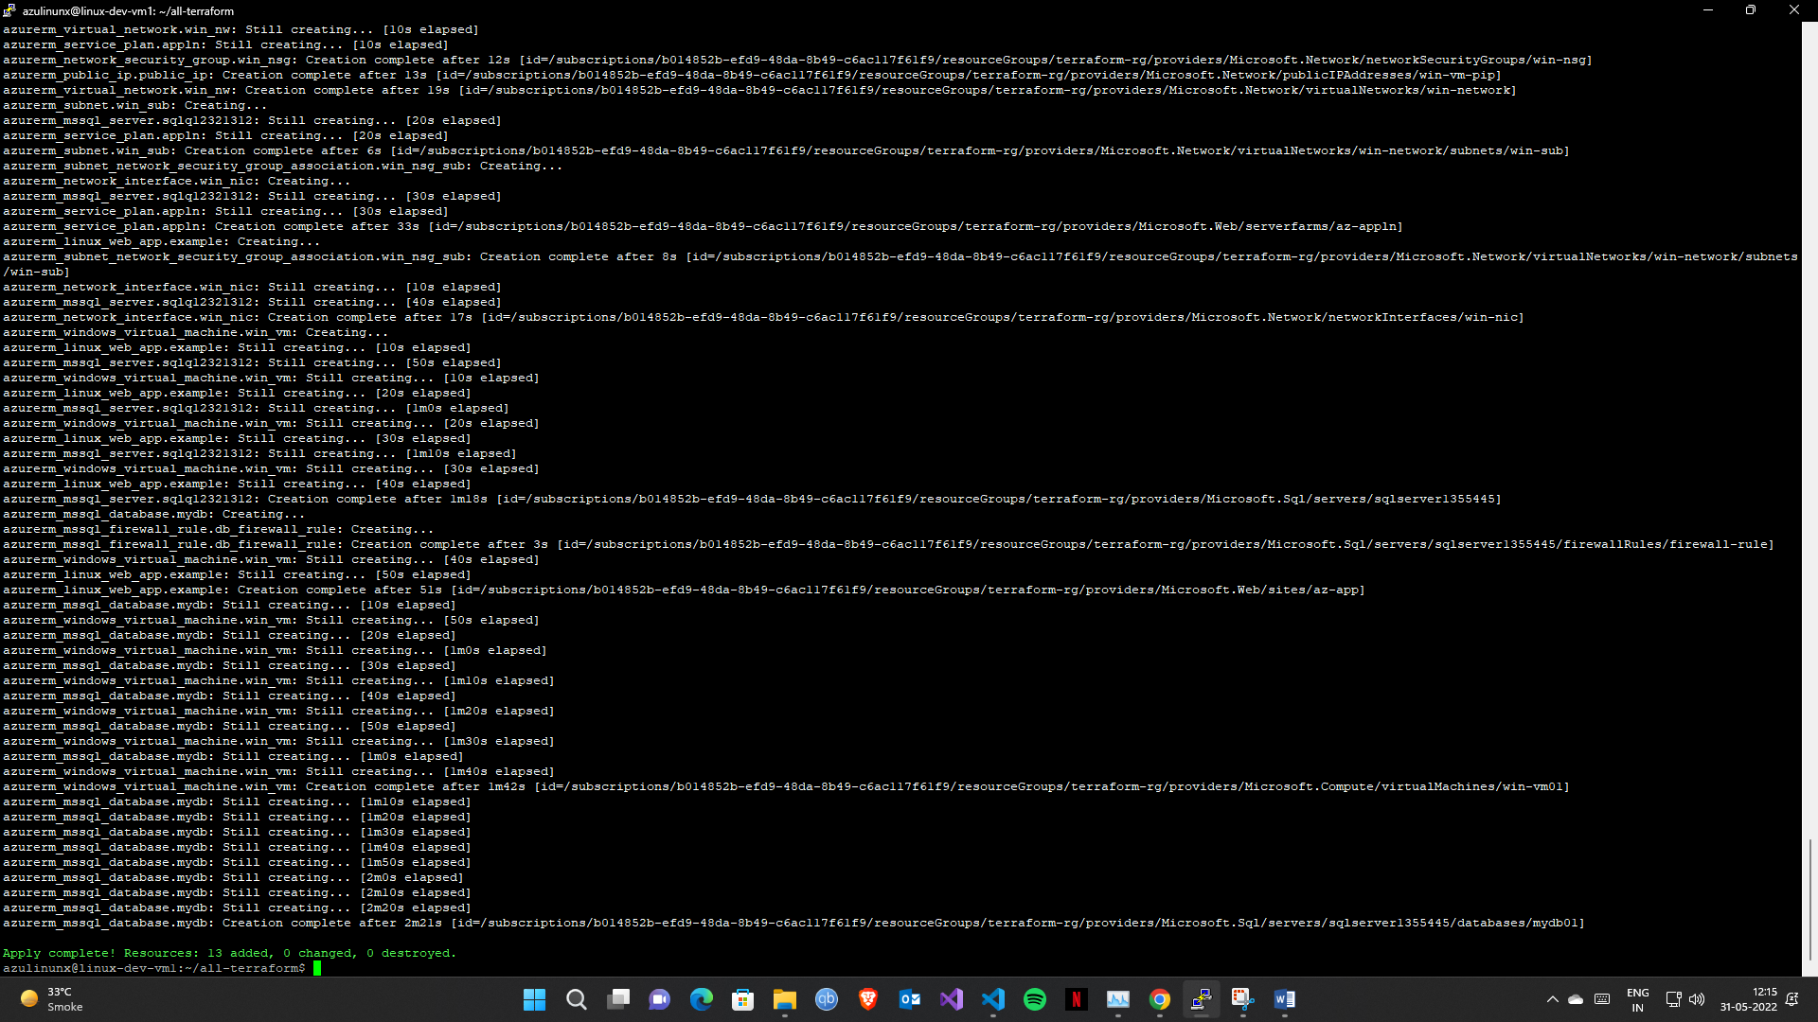

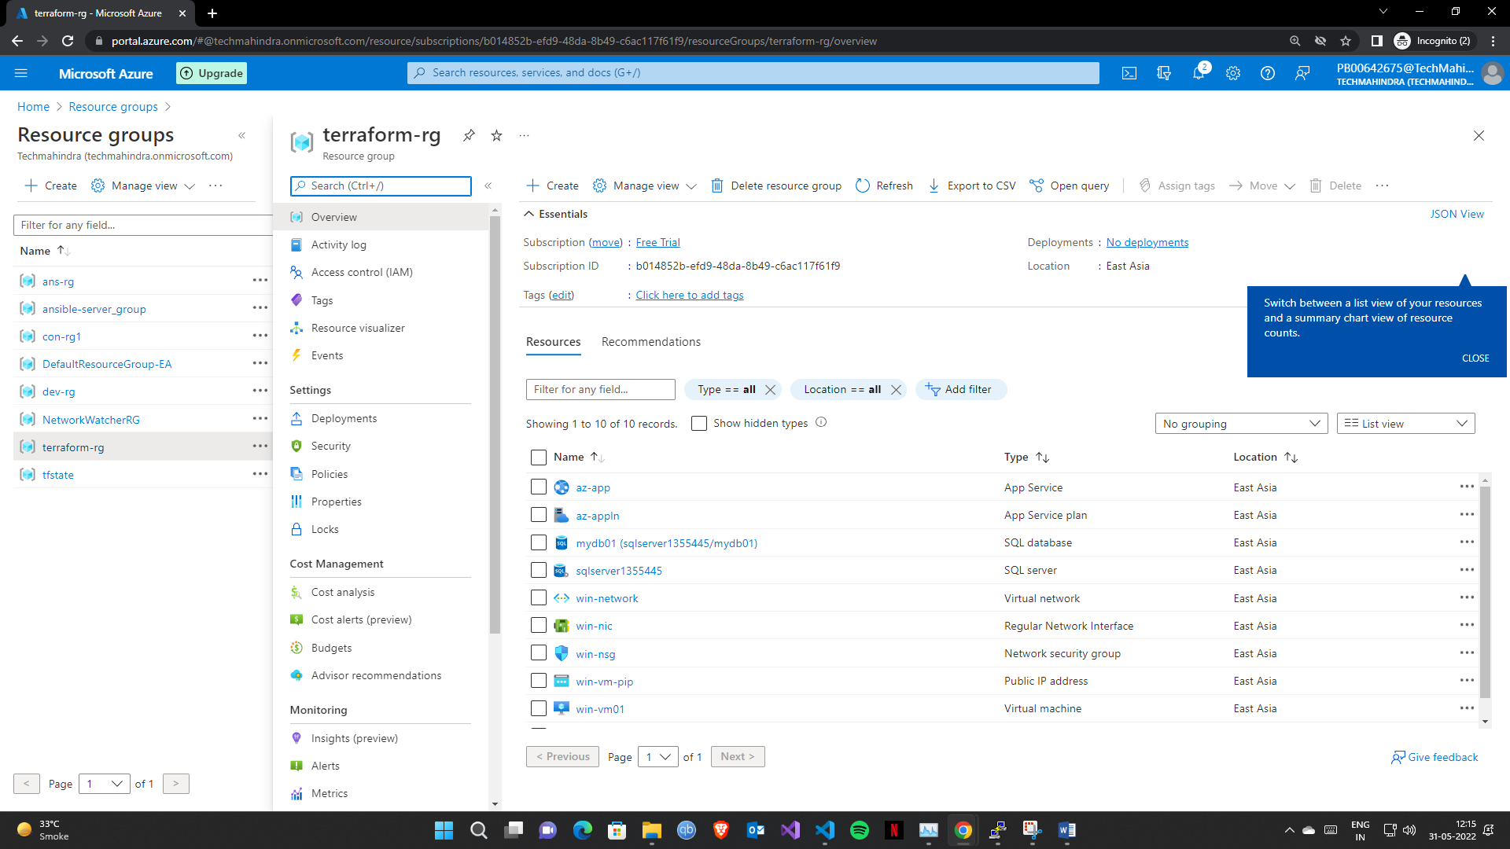

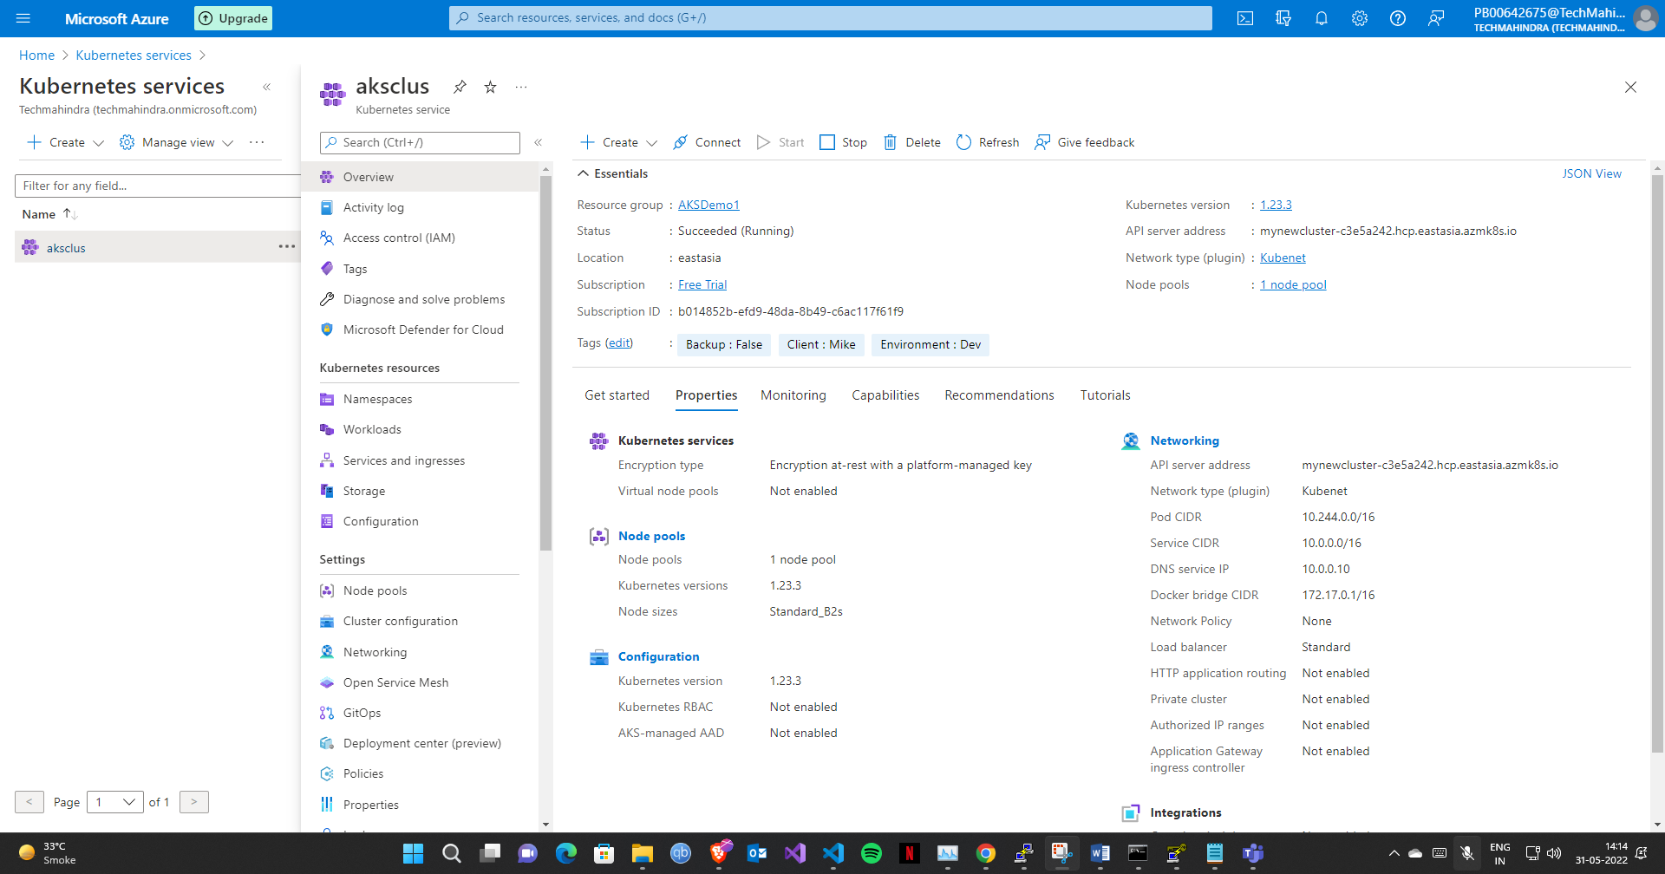

- name: New AKS Cluster

  hosts: localhost

  connection: local

  vars:

    AKS_resource_group: AKSDemo1

    AKS_location: "East Asia"

    aks_name: aksclus

    username: aksuser

    ssh_pub_key: “"

    client_id: ""

    client_secret: ""

    k8s_version: "1.23.3"

  tasks:

    - name: Create resource group

      azure_rm_resourcegroup:

        name: "{{ AKS_resource_group }}"

        location: "{{ AKS_location }}"

    - name: Create an AKS cluster

      azure_rm_aks:

        name: "{{ aks_name }}"

        location: "{{ AKS_location }}"

        kubernetes_version: "{{ k8s_version }}"

        resource_group: "{{ AKS_resource_group }}"

        dns_prefix: "mynewcluster"

        linux_profile:

          admin_username: "{{ username }}"

          ssh_key: "{{ ssh_pub_key }}"

        service_principal:

          client_id: "{{ client_id }}"

          client_secret: "{{ client_secret }}"

        agent_pool_profiles:

          - name: default

            count: 1

            vm_size: Standard_B2s

            mode: System

        tags:

          Environment: "Dev"

          Backup: "False"

          Client: "Mike"