**Project Name: Domino’s Pizza**

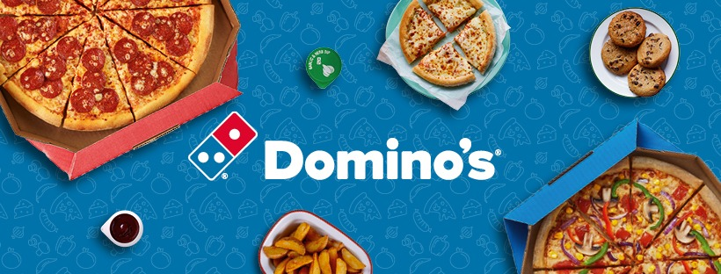

**OVERVIEW:**

The world enjoys hot, delicious Domino’s products every day. It is an e-commerce website for delicious Pizza and other. Domino's Pizza (Domino's) is a pizza restaurant chain. It provides pizza online delivery and carryout services as well as dine-in services through its restaurants. Domino's offers its customers a wide range of pizzas products.

**HOME PAGE:**

i.Domino’s Logo

ii. Navigation Bar (Hello Guest, Login and Register)

iii. Food Delivery Section

iv. Images & Name of the Pizza with Details

v. More details about Delivery and More snacks

vi. Footer Part (Menu, About, Policies, Restaurants, Ordering, Social media handle, and Domino’s App)

**Order:**

i.Select order

ii. Select Size and Crust

iii. Add to cart

iv. Check-Out

v. Choose a delivery address

**Payment:**

i. Price Details

ii. Place Order

iii. Payment Option :- (PHONEPE , GOOGLE PAY , BHIM UPI ,COD , CREDIT/DEBIT CARD, NET-BANKING , EMI , PAYTM)