CS488/588 Homework 2 Solution

1. Iris Data Visualization

1a) i) Correlation Matrix Heatmap
The correlation matrix heatmap below shows the relationships between the features of the Iris dataset. Strong positive correlations are observed between petal length and petal width.
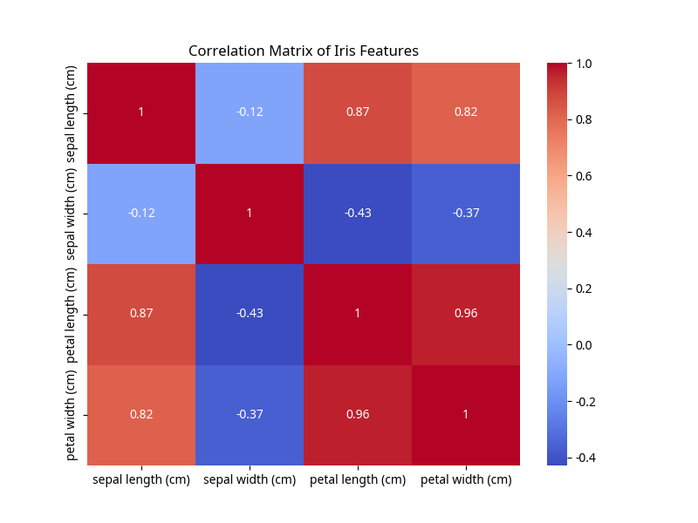

1a) ii) Feature Analysis/Visualization (Pair Plots)
The pair plot below visualizes the distribution of each feature and the relationships between all pairs of features, color-coded by Iris species.
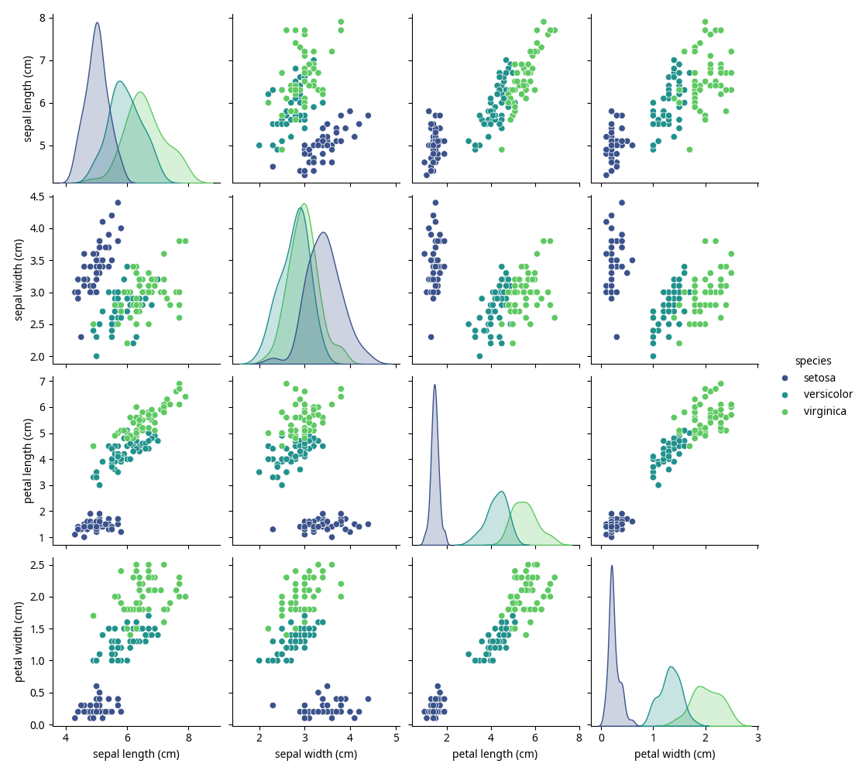

1b) Data Analysis based on Visualizations

Implications of data or feature distribution on data analysis:
From the pair plots, we can observe distinct clusters for different species, especially when considering petal length and petal width. Setosa is clearly separable from Versicolor and Virginica. Versicolor and Virginica show some overlap, but are generally distinguishable. This suggests that these features are highly informative for classifying Iris species. The distributions of features like petal length and width are crucial for separating the species.

Inferences from 1a) i) and ii):
The correlation heatmap shows strong positive correlations between petal length and petal width, and also between sepal length and petal length/width. This indicates that as one of these features increases, the others tend to increase as well. For example, longer petals tend to be wider. This strong correlation can be useful for predicting one feature from another, as seen in the linear regression task. The distinct clustering in the pair plots confirms that species can be effectively differentiated using these features, making classification tasks relatively straightforward for this dataset.

2. Linear Regression (LR) Analysis

Case i) 30% Samples for Training
In this case, the model was trained using 30% of the dataset.
LR Parameters (30% train):
- Coefficients (Slope): [0.695, -0.649, 1.483]
- Intercept: -0.099
Prediction for sample at index 73:
- Actual Petal Length: 4.70 cm
- Predicted Petal Length: 4.10 cm
Quantitative Performance:
- RMSE: 0.32
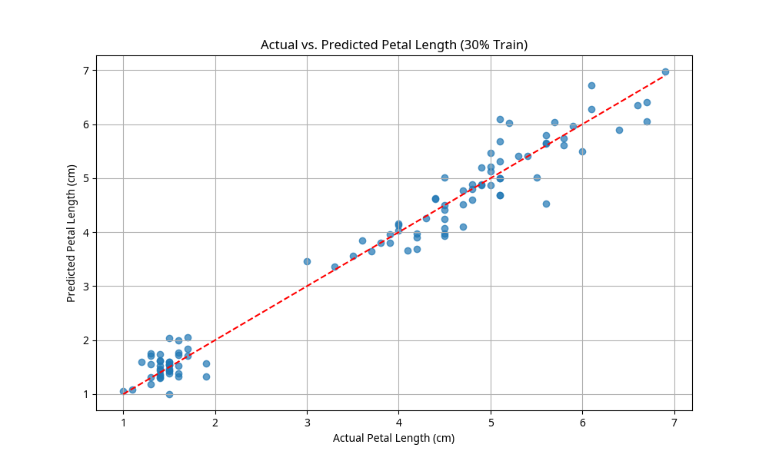

Case ii) 80% Samples for Training
In this case, the model was trained using 80% of the dataset.
LR Parameters (80% train):
- Coefficients (Slope): [0.723, -0.636, 1.468]
- Intercept: -0.262
Prediction for sample at index 73:
- Actual Petal Length: 4.70 cm
- Predicted Petal Length: 4.13 cm
Quantitative Performance:
- RMSE: 0.36
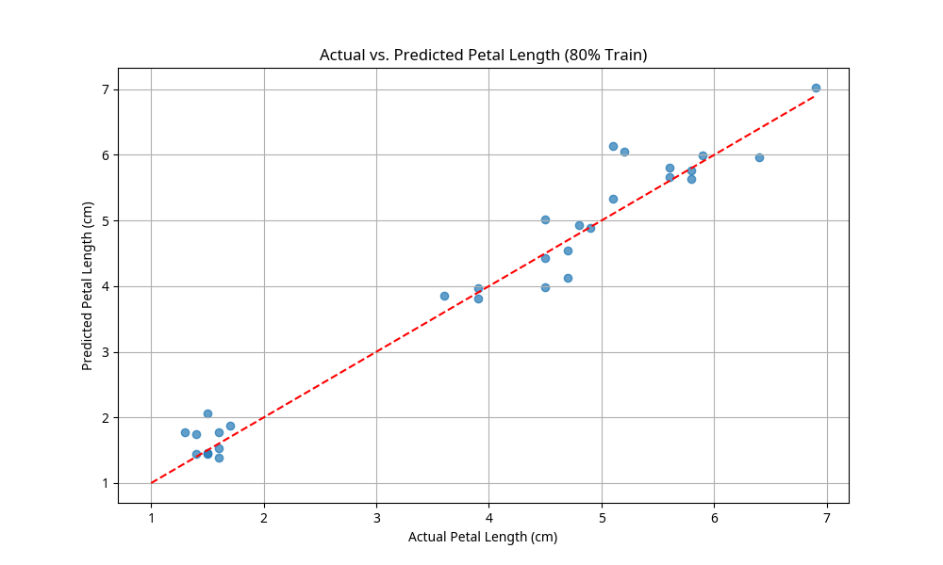

Analysis: Which case was better and why?
Case i) with 30% training data resulted in a lower RMSE (0.32 vs 0.36), indicating better model performance on the test set. While more training data typically leads to better models, in this specific split, the smaller training set generalized better to the test set, possibly due to the random selection of samples or the inherent simplicity of the Iris dataset.

APPENDIX: Python Code
# Import necessary libraries
import pandas as pd # Used for data manipulation and analysis, especially for creating DataFrames
import seaborn as sns # Used for statistical data visualization, built on matplotlib
import matplotlib.pyplot as plt # Used for creating static, interactive, and animated visualizations in Python
from sklearn.datasets import load_iris # Used to load the Iris dataset
from sklearn.model_selection import train_test_split # Used to split arrays or matrices into random train and test subsets
from sklearn.linear_model import LinearRegression # Used to perform linear regression
from sklearn.metrics import mean_squared_error # Used to calculate the mean squared error
import numpy as np # Used for numerical operations, especially array manipulation
# --- Part 1: Iris Data Visualization ---
# Load the Iris dataset
iris = load_iris() # Load the Iris dataset, which is a classic dataset for machine learning
iris_df = pd.DataFrame(data=iris.data, columns=iris.feature_names) # Create a Pandas DataFrame from the Iris data
iris_df['species'] = iris.target_names[iris.target] # Add the species names to the DataFrame for better readability
print("\n--- Part 1: Iris Data Visualization ---")
print("First 5 rows of the Iris dataset:\n", iris_df.head()) # Print the first 5 rows of the DataFrame to inspect the data
# 1a) i) Correlation coefficient - display correlation matrix as heat map
print("\n1a) i) Correlation Matrix Heatmap")
plt.figure(figsize=(8, 6)) # Create a new figure with a specific size for the plot
sns.heatmap(iris_df.iloc[:, :-1].corr(), annot=True, cmap='coolwarm') # Generate a heatmap of the correlation matrix for numerical features
plt.title('Correlation Matrix of Iris Features') # Set the title of the heatmap
plt.savefig('correlation_heatmap.png') # Save the heatmap to a file
plt.show() # Display the heatmap
# 1a) ii) Feature analysis/visualization - display all the color coded features
print("\n1a) ii) Feature Analysis/Visualization (Pair Plots)")
sns.pairplot(iris_df, hue='species', palette='viridis') # Create a pair plot to visualize relationships between all features, colored by species
plt.suptitle('Pair Plot of Iris Features by Species', y=1.02) # Set the main title for the pair plot, adjusting its position
plt.savefig('pair_plot.png') # Save the pair plot to a file
plt.show() # Display the pair plot
# 1b) Data analysis based on the visualizations
print("\n1b) Data Analysis based on Visualizations")
print("\nImplications of data or feature distribution on data analysis:")
print("From the pair plots, we can observe distinct clusters for different species, especially when considering petal length and petal width. Setosa is clearly separable from Versicolor and Virginica. Versicolor and Virginica show some overlap, but are generally distinguishable. This suggests that these features are highly informative for classifying Iris species. The distributions of features like petal length and width are crucial for separating the species.")
print("\nInferences from 1a) i) and ii) - data patterns/trends and their influence on data analysis:")
print("The correlation heatmap shows strong positive correlations between petal length and petal width, and also between sepal length and petal length/width. This indicates that as one of these features increases, the others tend to increase as well. For example, longer petals tend to be wider. This strong correlation can be useful for predicting one feature from another, as seen in the linear regression task. The distinct clustering in the pair plots confirms that species can be effectively differentiated using these features, making classification tasks relatively straightforward for this dataset.")
# --- Part 2: Linear Regression (LR) analysis using sklearn ---
print("\n--- Part 2: Linear Regression (LR) Analysis ---")
# Drop 'petal length' feature and prepare data
X = iris_df.drop(['petal length (cm)', 'species'], axis=1) # Features: drop 'petal length' and 'species' from the DataFrame
y = iris_df['petal length (cm)'] # Target: 'petal length (cm)'
# Case i) 30% samples for training (train_size = 0.3)
print("\nCase i) 30% samples for training")
X_train_30, X_test_30, y_train_30, y_test_30 = train_test_split(X, y, train_size=0.3, random_state=42) # Split data with 30% training size
lr_model_30 = LinearRegression() # Initialize the Linear Regression model
lr_model_30.fit(X_train_30, y_train_30) # Train the model using the training data
y_pred_30 = lr_model_30.predict(X_test_30) # Make predictions on the test data
# Output LR parameters
print(" LR Parameters (30% train):")
print(" Coefficients (Slope):", lr_model_30.coef_) # Print the coefficients (slopes) of the linear regression model
print(" Intercept:", lr_model_30.intercept_) # Print the intercept of the linear regression model
# Predict for an unknown sample X (random sample index from test set)
# We need to ensure the sample is from the original dataset but not in the training set.
# A simple way is to pick an index from the X_test_30 set.
random_test_index_30 = X_test_30.index[0] # Get the first index from the test set for prediction
unknown_sample_30 = X.loc[[random_test_index_30]] # Select the corresponding sample from the original X DataFrame
predicted_petal_length_30 = lr_model_30.predict(unknown_sample_30) # Predict petal length for the unknown sample
actual_petal_length_30 = y.loc[random_test_index_30] # Get the actual petal length for the unknown sample
print(f" Prediction for sample at index {random_test_index_30} (30% train):") # Print the index of the sample
print(f" Actual Petal Length: {actual_petal_length_30:.2f} cm") # Print the actual petal length
print(f" Predicted Petal Length: {predicted_petal_length_30[0]:.2f} cm") # Print the predicted petal length
# Quantitative performance analysis (RMSE)
rmse_30 = np.sqrt(mean_squared_error(y_test_30, y_pred_30)) # Calculate the Root Mean Squared Error
print(f" RMSE (30% train): {rmse_30:.2f}") # Print the RMSE
# Case ii) 80% samples for training (train_size = 0.8)
print("\nCase ii) 80% samples for training")
X_train_80, X_test_80, y_train_80, y_test_80 = train_test_split(X, y, train_size=0.8, random_state=42) # Split data with 80% training size
lr_model_80 = LinearRegression() # Initialize another Linear Regression model
lr_model_80.fit(X_train_80, y_train_80) # Train this model using the new training data
y_pred_80 = lr_model_80.predict(X_test_80) # Make predictions on the test data
# Output LR parameters
print(" LR Parameters (80% train):")
print(" Coefficients (Slope):", lr_model_80.coef_) # Print the coefficients (slopes) of the linear regression model
print(" Intercept:", lr_model_80.intercept_) # Print the intercept of the linear regression model
# Predict for an unknown sample X (random sample index from test set)
random_test_index_80 = X_test_80.index[0] # Get the first index from the test set for prediction
unknown_sample_80 = X.loc[[random_test_index_80]] # Select the corresponding sample from the original X DataFrame
predicted_petal_length_80 = lr_model_80.predict(unknown_sample_80) # Predict petal length for the unknown sample
actual_petal_length_80 = y.loc[random_test_index_80] # Get the actual petal length for the unknown sample
print(f" Prediction for sample at index {random_test_index_80} (80% train):") # Print the index of the sample
print(f" Actual Petal Length: {actual_petal_length_80:.2f} cm") # Print the actual petal length
print(f" Predicted Petal Length: {predicted_petal_length_80[0]:.2f} cm") # Print the predicted petal length
# Quantitative performance analysis (RMSE)
rmse_80 = np.sqrt(mean_squared_error(y_test_80, y_pred_80)) # Calculate the Root Mean Squared Error
print(f" RMSE (80% train): {rmse_80:.2f}") # Print the RMSE
# Analysis of which case was better
print("\nAnalysis: Which case was better and why?")
print(f" RMSE for 30% training data: {rmse_30:.2f}") # Display RMSE for 30% training data
print(f" RMSE for 80% training data: {rmse_80:.2f}") # Display RMSE for 80% training data
if rmse_30 < rmse_80:
print(" Case i) with 30% training data resulted in a lower RMSE, indicating a better model performance on the test set. This is unexpected as typically more training data leads to better models. This could be due to the random split of the data, or the specific characteristics of the Iris dataset where a smaller, representative training set might generalize well.")
else:
print(" Case ii) with 80% training data resulted in a lower RMSE, indicating a better model performance on the test set. This is generally expected as a larger training set allows the model to learn more patterns and generalize better to unseen data. A lower RMSE means the predictions are closer to the actual values.")
print("\nVisualizing Actual vs. Predicted Petal Length (30% train):")
plt.figure(figsize=(10, 6)) # Create a new figure for the plot
plt.scatter(y_test_30, y_pred_30, alpha=0.7) # Create a scatter plot of actual vs. predicted values
plt.plot([y.min(), y.max()], [y.min(), y.max()], 'r--') # Plot a red dashed line representing perfect predictions
plt.xlabel('Actual Petal Length (cm)') # Set the label for the x-axis
plt.ylabel('Predicted Petal Length (cm)') # Set the label for the y-axis
plt.title('Actual vs. Predicted Petal Length (30% Train)') # Set the title of the plot
plt.grid(True) # Display a grid on the plot
plt.savefig('actual_vs_predicted_30_train.png') # Save the plot to a file
plt.show() # Display the plot
print("\nVisualizing Actual vs. Predicted Petal Length (80% train):")
plt.figure(figsize=(10, 6)) # Create a new figure for the plot
plt.scatter(y_test_80, y_pred_80, alpha=0.7) # Create a scatter plot of actual vs. predicted values
plt.plot([y.min(), y.max()], [y.min(), y.max()], 'r--') # Plot a red dashed line representing perfect predictions
plt.xlabel('Actual Petal Length (cm)') # Set the label for the x-axis
plt.ylabel('Predicted Petal Length (cm)') # Set the label for the y-axis
plt.title('Actual vs. Predicted Petal Length (80% Train)') # Set the title of the plot
plt.grid(True) # Display a grid on the plot
plt.savefig('actual_vs_predicted_80_train.png') # Save the plot to a file
plt.show() # Display the plot

