Technical Audit Report

Synthetic Data Quality Assessment

Project | Synthetic Data Generation & Evaluation using CTGAN
Student | Prajval T Rathod (1MS24MC074)
Institution | M.S. Ramaiah Institute of Technology — Department of MCA
Academic Year | 2025-26
Date Generated | March 16, 2026 — 21:29
Dataset | iris.csv
Model Architecture | CTGAN
Synthetic Records | 100

1. Privacy & Security Audit
This section evaluates the risk of identity disclosure by computing the Distance to Closest Record (DCR) between every synthetic record and its nearest real-world counterpart.
Privacy Score | 100%
Risk Level | LOW
Mean DCR | 2.1878
Median DCR | 2.254
Min DCR (worst case) | 0.7061
Records at Risk | 0 / 100 (0.0%)

2. Statistical Comparison
Side-by-side comparison of mean and standard deviation between real and synthetic feature distributions.

Mean Comparison
 | Real Mean | Synthetic Mean | Difference
sepal_length | 5.8433 | 4.7370 | 1.1063
sepal_width | 3.0540 | 3.5280 | 0.4740
petal_length | 3.7587 | 3.9050 | 0.1463
petal_width | 1.1987 | 1.7200 | 0.5213
species | 1.0000 | 1.1300 | 0.1300

Standard Deviation Comparison
 | Real Std | Synthetic Std | Difference
sepal_length | 0.8281 | 0.6405 | 0.1876
sepal_width | 0.4336 | 0.5259 | 0.0923
petal_length | 1.7644 | 1.5878 | 0.1766
petal_width | 0.7632 | 0.8068 | 0.0436
species | 0.8192 | 0.8487 | 0.0295

3. Machine Learning Utility Evaluation
Each classifier is trained twice — once on the real data and once on the synthetic data — then tested on a held-out portion of the real dataset. Close performance indicates high data utility.

Trained on Real Data
Model | Accuracy | Precision | Recall | F1 Score
Logistic Regression | 1.0 | 1.0 | 1.0 | 1.0
Decision Tree | 1.0 | 1.0 | 1.0 | 1.0
Random Forest | 1.0 | 1.0 | 1.0 | 1.0

Trained on Synthetic Data
Model | Accuracy | Precision | Recall | F1 Score
Logistic Regression | 0.2889 | 0.0835 | 0.2889 | 0.1295
Decision Tree | 0.4 | 0.3435 | 0.4 | 0.3277
Random Forest | 0.2889 | 0.2713 | 0.2889 | 0.2663

Feature Importance Alignment (Random Forest)
Compares which features the model considers most important when trained on real vs. synthetic data.
Feature | Real Importance | Synthetic Importance | Δ Difference
sepal_length | 0.1041 | 0.174 | 0.0699
sepal_width | 0.0446 | 0.2744 | 0.2298
petal_length | 0.4173 | 0.326 | 0.0913
petal_width | 0.434 | 0.2255 | 0.2085

4. Distribution & Correlation Plots
The following plots provide visual validation of the synthetic data quality against the original distribution.

Correlation Heatmaps
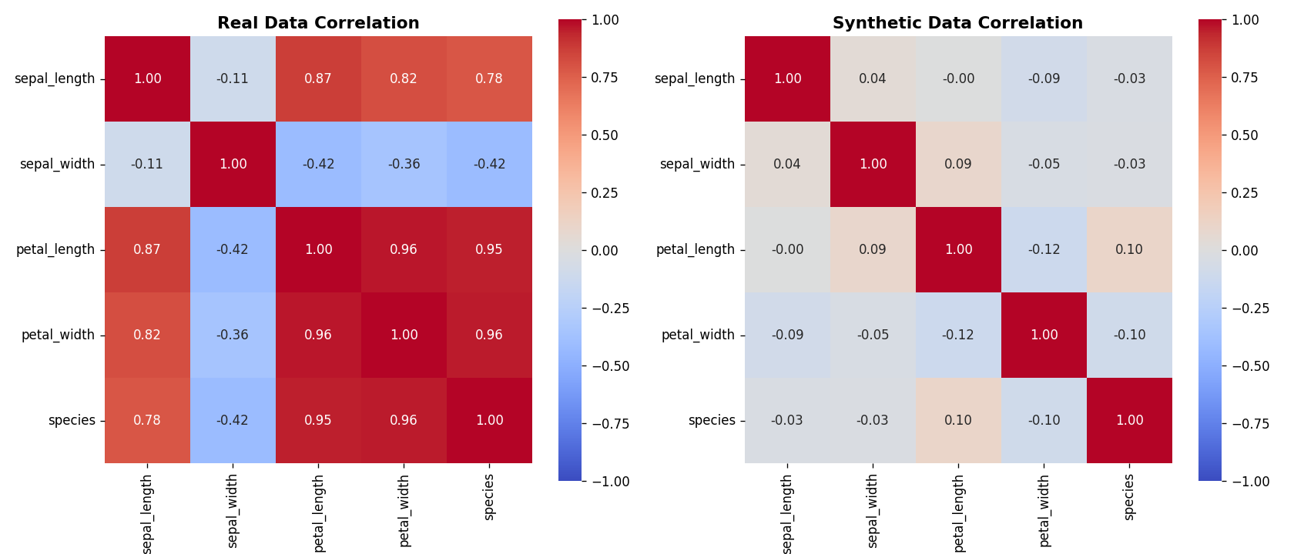

Dist Petal Length
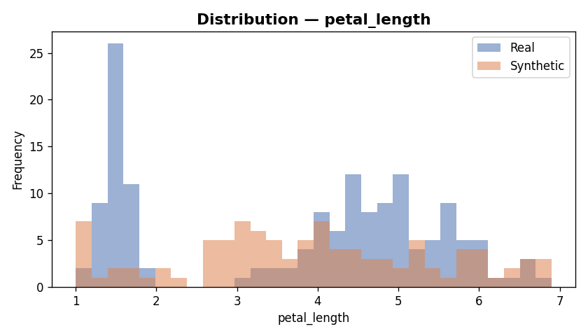

Dist Petal Width
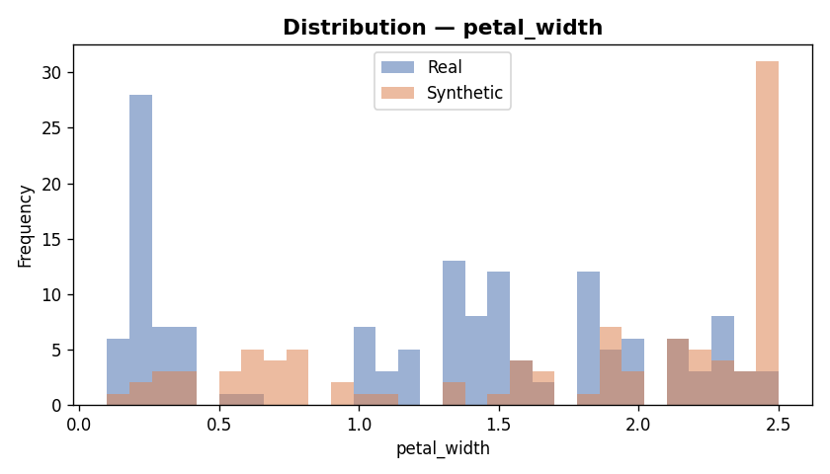

Dist Sepal Length
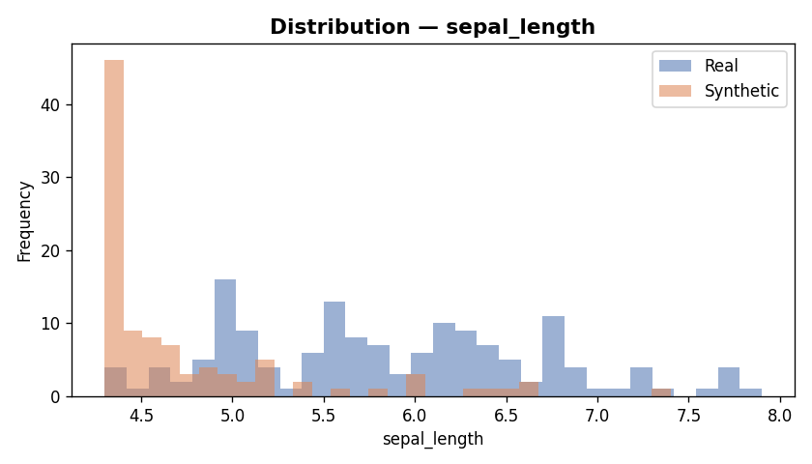

Dist Sepal Width
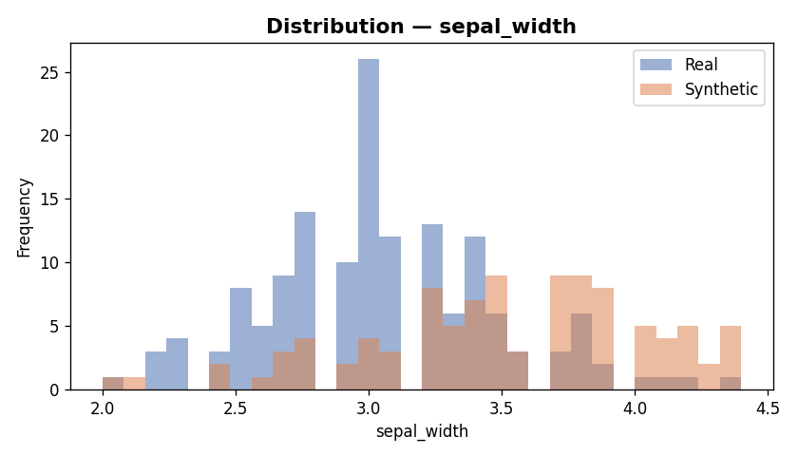

Dist Species
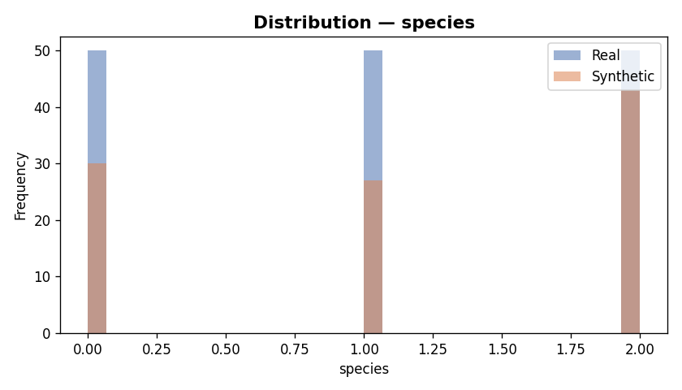

Feature Importance
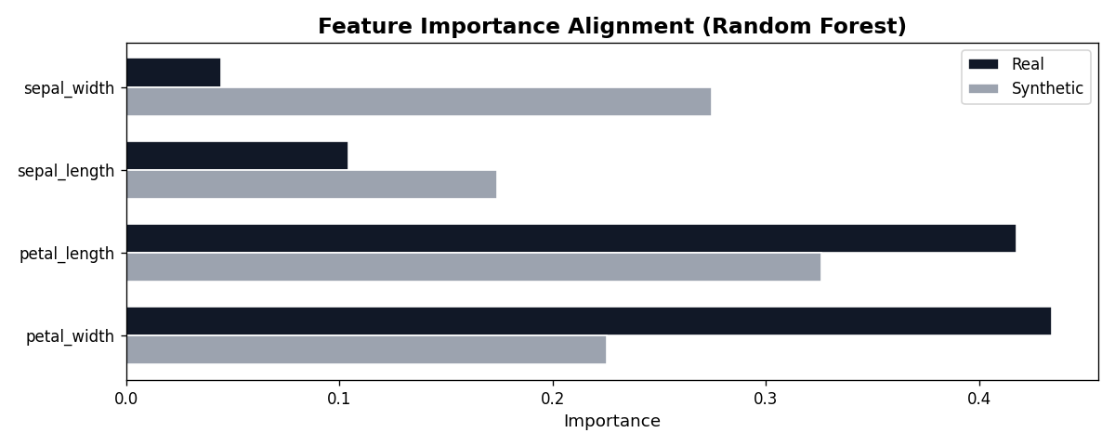

Ml Comparison
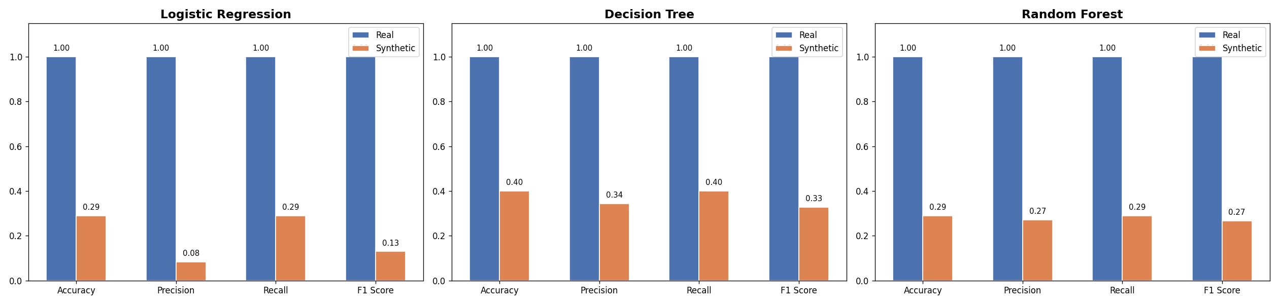

— End of Audit Report —

